Supporting Information

Synthesis and Application in Cell Imaging of a Fluorescent Probe for Detection of Zn²⁺/S²⁻ and Viscosity
Siyi WENª, Yan TANGª, Dingxin QIUª, Gong Chen^{b}, Ke Su^{c*}, Huizhen WANG^{a*}
a. School of Science, Asymmetric Synthesis and Chiral technology Key Laboratory of Sichuan Province, Xihua University, Chengdu 610039; P. R. China. E-mail: 578527840@qq.com
b. College of Flight Technology, Civil Aviation Flight University of China
c. School of Resource and Environment, Aba Teachers College, Aba 623002, P. R. China. E-mail: 1107244969@qq.com
1 The ¹H NMR、¹³C NMR、IR、HR-MS of compound DBH, and the mass pectrum of DBH+Zn²⁺
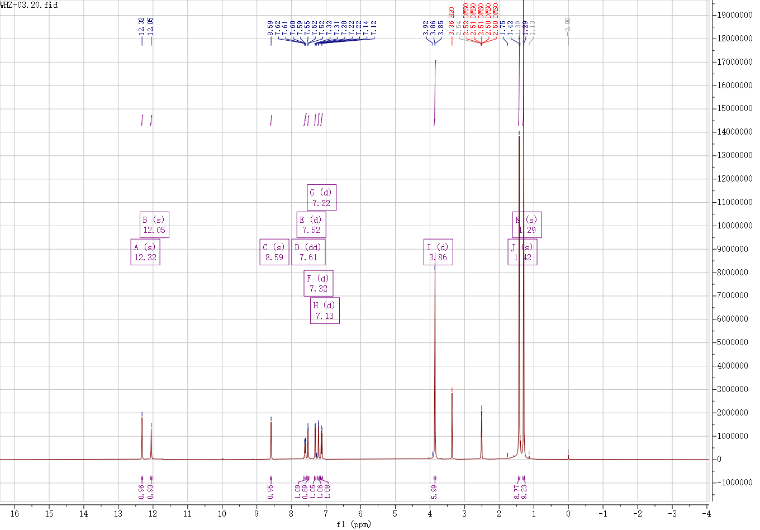
Fig. S1. ¹H NMR spectrum of probe compound DBH.
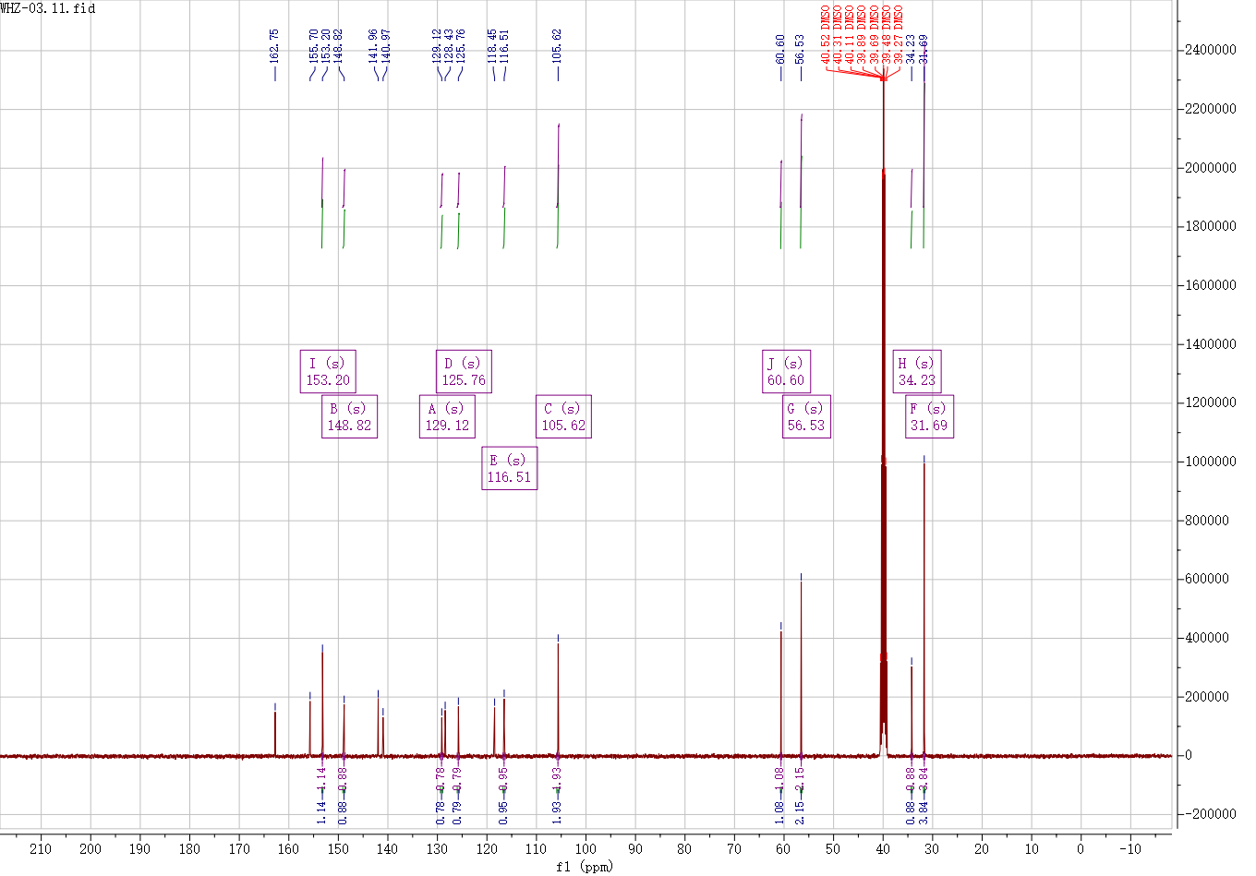
Fig. S2. ¹³C NMR spectrum of probe compound DBH.
Fig. S3. Infrared spectrum of complex DBH
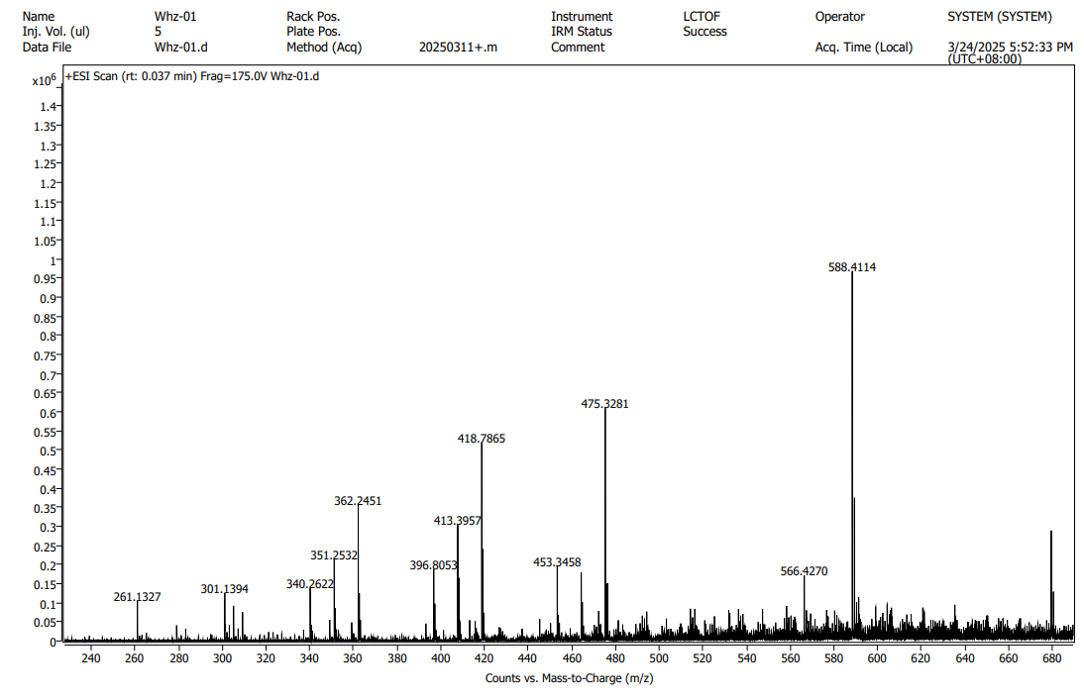
Fig. S4. The mass pectrum of DBH.
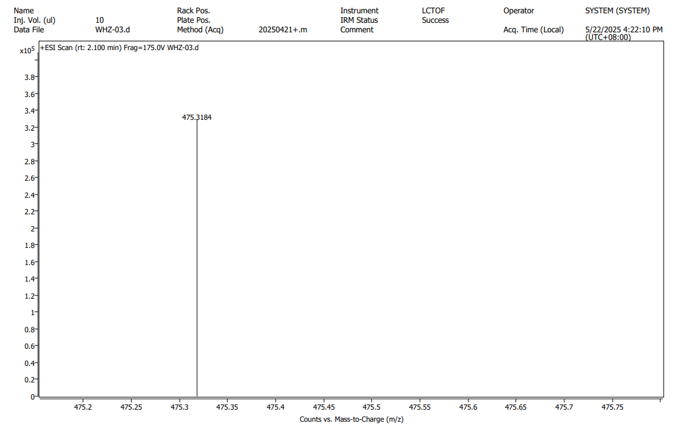
Fig. S5. The mass pectrum of DBH+Zn²⁺.

2 Spectroscopic research
Fig. S6. UV-Vis (a) and fluorescence (b) spectra of probe DBH in different H₂O/DMF ratios.（λ_{ex}=380nm，H₂O/DMF=5:5）
Fig. S7. fluorescence spectra of probe DBH at various pH values.
（λex=380nm，H₂O/DMF=5:5）

Fig. S8. Job's plot of the DBH-Zn²⁺ binding system.（λex=380nm，H₂O/DMF=5:5）
Fig. S9. (a) Fluorescence bar chart of DBH+Zn²⁺ with different cations; (b) Fluorescence bar chart of DBH+S²⁻ with different anions.（λex = 380 nm，F=500nm）
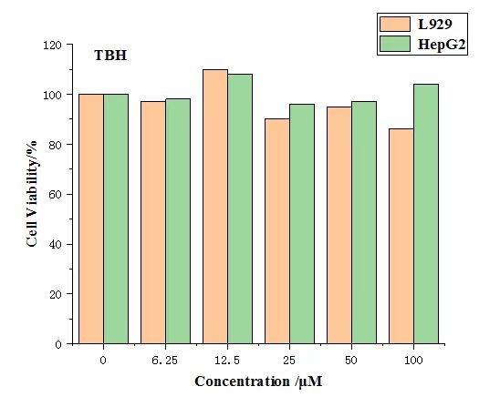
Fig. S10. Cytotoxicity of probe DBH toward normal human liver cells (L929) and human hepatocellular carcinoma cells (HepG2).

