Fig. A1 (A) Relative abundances of nematode trophic groups and (B) trophic structure under different fertilizer treatments (mean ± SE). Different uppercase letters on the bars indicate significant differences among treatments at P < 0.05 level.

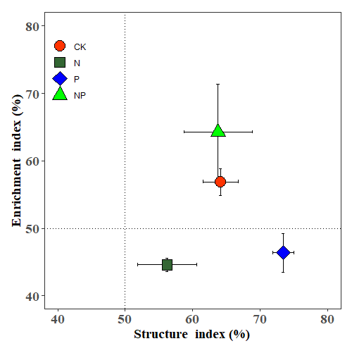
Fig. A2 Enrichment index and structure index.
Symbols represent average observations at a particular treatment ± SE

