Supplementary Information
Cation Locking Accelerates Exciton Recombination in Polar Two-Dimensional Hybrid Perovskites
Yuhong Mao,¹ Liwei Tang,² Songhao Guo,¹ Xingyu Chen,¹ Yifan Zhang,¹ Qingyang Hu,¹ Zhihua Sun,² Junhua Luo,² Wenge Yang,¹ and Xujie Lü^{1,*}
¹ Center for High Pressure Science and Technology Advanced Research (HPSTAR), Shanghai, 201203, China
² State Key Laboratory of Structural Chemistry, Fujian Institute of Research on the Structure of Matter, Chinese Academy of Sciences Institution, Fuzhou, Fujian, 350002, China
* Corresponding authors: Email: xujie.lu@hpstar.ac.cn

Supplementary Tables
Supplementary Table 1. Crystallographic information for (iBA)₂(MA)₂Pb₃Br₁₀
Crystal data
Chemical formula | [(CH₃)₂CHCH₂NH₃]₂(CH₃NH₃)₂Pb₃Br₁₀
M_{r} | 1633.10
Crystal system, space group | Tetragonal, I4/mmm
a, c (Å) | 5.9204 (3), 50.863 (4)
V (Å³) | 1782.8 (2)
Z | 2
Radiation type | Mo Ka
m (mm⁻¹) | 25.34
Data collection
R_{int} | 0.043
(sin q/l)_{max} (Å⁻¹) | 0.595
Refinement
R[F² > 2s(F²)], wR(F²), S | 0.051, 0.139, 1.13
No. of reflections | 543
No. of parameters | 45
No. of restraints | 28
H-atom treatment | H-atom parameters constrained
w = 1/[s²(F_{o}²) + (0.0708P)² + 47.6557P]
where P = (F_{o}² + 2F_{c}²)/3
Dρ_{max}, Dρ_{min} (e Å⁻³) | 2.28, -3.07

Supplementary Table 2. Crystallographic information for (iBA)₂(EA)₂Pb₃Br₁₀
Crystal data
Chemical formula | [(CH₃)₂CHCH₂NH₃]₂(CH₃CH₂NH₃)₂Pb₃Br₁₀
M_{r} | 1661.15
Crystal system, space group | Orthorhombic, Cmc2₁
a, b, c (Å) | 50.617 (2), 8.5192 (3), 8.5183 (4)
V (Å³) | 3673.2 (3)
Z | 4
Radiation type | Mo Ka
m (mm⁻¹) | 24.60
Data collection
R_{int} | 0.040
(sin q/l)_{max} (Å⁻¹) | 0.650
Refinement
R[F² > 2s(F²)], wR(F²), S | 0.065, 0.235, 1.08
No. of reflections | 4222
No. of parameters | 152
No. of restraints | 76
H-atom treatment | H-atom parameters constrained
w = 1/[s²(F_{o}²) + (0.0779P)² + 134.1122P]
where P = (F_{o}² + 2F_{c}²)/3
Dρ_{max}, Dρ_{min} (e Å⁻³) | 1.88, -1.38

Supplementary Table 3. Crystallographic information for (iBA)₂(MHy)₂Pb₃Br₁₀
Crystal data
Chemical formula | [(CH₃)₂CHCH₂NH₃]₂(CH₃NH₂NH₃)₂Pb₃Br₁₀
M_{r} | 1663.13
Crystal system, space group | Monoclinic, Pc
a, b, c (Å) | 11.7467 (1), 49.2238 (6), 11.8147 (1)
b (°) | 90.537 (1)
V (Å³) | 6831.16 (12)
Z | 4
Radiation type | Ga Ka, l = 1.3405 Å
m (mm⁻¹) | 29.35
Data collection
R_{int} | 0.043
(sin q/l)_{max} (Å⁻¹) | 0.595
Refinement
R[F² > 2s(F²)], wR(F²), S | 0.082, 0.237, 1.04
No. of reflections | 16703
No. of parameters | 1099
No. of restraints | 1035
H-atom treatment | H-atom parameters constrained
w = 1/[s²(F_{o}²) + (0.1801P)² + 86.P]
where P = (F_{o}² + 2F_{c}²)/3
Dρ_{max}, Dρ_{min} (e Å⁻³) | 5.60, -3.22

Supplementary Table 4. Crystallographic information for (EA)₄Pb₃Br₁₀¹
Crystal data
Chemical formula | (CH₃CH₂NH₃)₄Pb3Br₁₀
M_{r} | 1605
Crystal system, space group | Orthorhombic, C2cb
a, b, c (Å) | 8.4267 (12), 46.351 (5), 8.4298 (10)
V (Å³) | 3292.5 (7)
Z | 4
Radiation type | Mo Ka
m (mm⁻¹) | 27.44
Data collection
R_{int} | 0.073
(sin q/l)_{max} (Å⁻¹) | 0.685
Refinement
R[F² > 2s(F²)], wR(F²), S | 0.096, 0.185, 3.14
No. of reflections | 5228
No. of parameters | 81
No. of restraints | 6
H-atom treatment | H-atom parameters constrained
Dρ_{max}, Dρ_{min} (e Å⁻³) | 2.83, -3.84

Supplementary Table 5. Crystallographic information for (iBA)₂(EA)Pb₂Br₇²
Crystal data
Chemical formula | [(CH₃)₂CHCH₂NH₃]₂CH₃CH₂NH₃Pb₂Br₇
M_{r} | 1168.13
Crystal system, space group | Monoclinic, Cc
a, b, c (Å) | 36.800 (4), 8.4400 (5), 8.3776 (6)
b (°) | 90.029 (8)
V (Å³) | 2602.0 (4)
Z | 4
Radiation type | Mo Ka
m (mm⁻¹) | 23.67
Data collection
R_{int} | 0.052
(sin q/l)_{max} (Å⁻¹) | 0.696
Refinement
R[F² > 2s(F²)], wR(F²), S | 0.055, 0.155, 1.02
No. of reflections | 6257
No. of parameters | 208
No. of restraints | 163
H-atom treatment | H-atom parameters constrained
Dρ_{max}, Dρ_{min} (e Å⁻³) | 2.68, -1.58

Supplementary Table 6. Crystallographic information for (BA)₂(EA)₂Pb₃I₁₀³
Crystal data
Chemical formula | (CH₃CH₂CH₂NH₃)₂(CH₃CH₂NH₃)₂Pb₃I₁₀
M_{r} | 2103
Crystal system, space group | Monoclinic, Cc
a, b, c (Å) | 52.209 (6), 8.9061 (6), 8.9400 (11)
b (°) | 90.002 (9)
V (Å³) | 4156.9 (8)
Z | 4
Radiation type | Mo Ka
m (mm⁻¹) | 19.54
Data collection
R_{int} | 0.054
(sin q/l)_{max} (Å⁻¹) | 0.687
Refinement
R[F² > 2s(F²)], wR(F²), S | 0.109, 0.113, 4.78
No. of reflections | 7083
No. of parameters | 166
No. of restraints | 16
H-atom treatment | H-atom parameters constrained
Dρ_{max}, Dρ_{min} (e Å⁻³) | 7.09, -7.16

Supplementary Figures

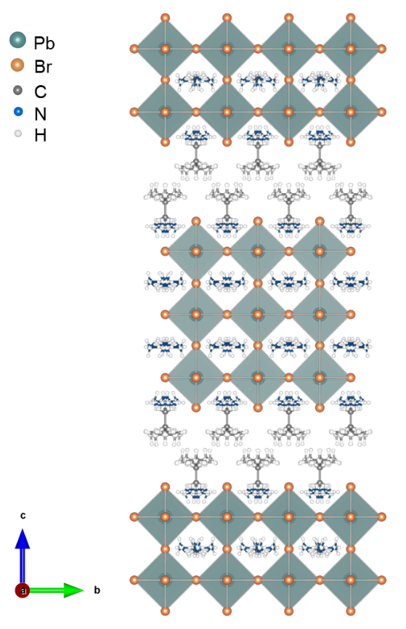
Figure S1. Extended crystal structure of (iBA)₂(MA)₂Pb₃Br₁₀.

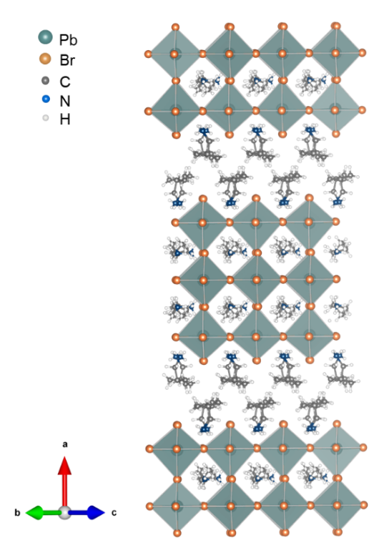
Figure S2. Extended crystal structure of (iBA)₂(EA)₂Pb₃Br₁₀.

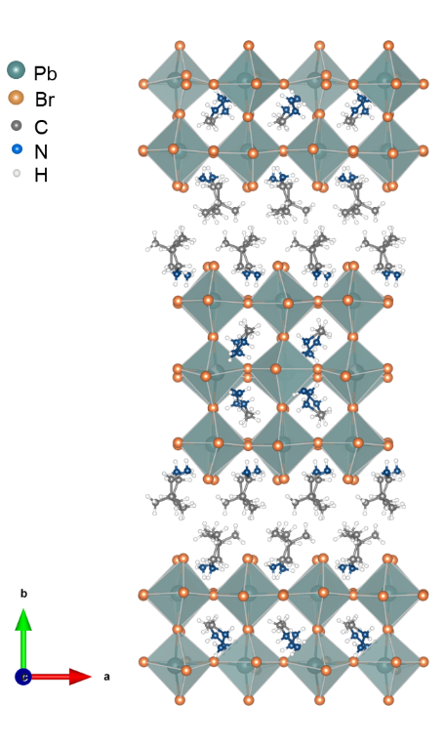
Figure S3. Extended crystal structure of (iBA)₂(MHy)₂Pb₃Br₁₀. Pb-N coordinate bonds are removed for clarity.
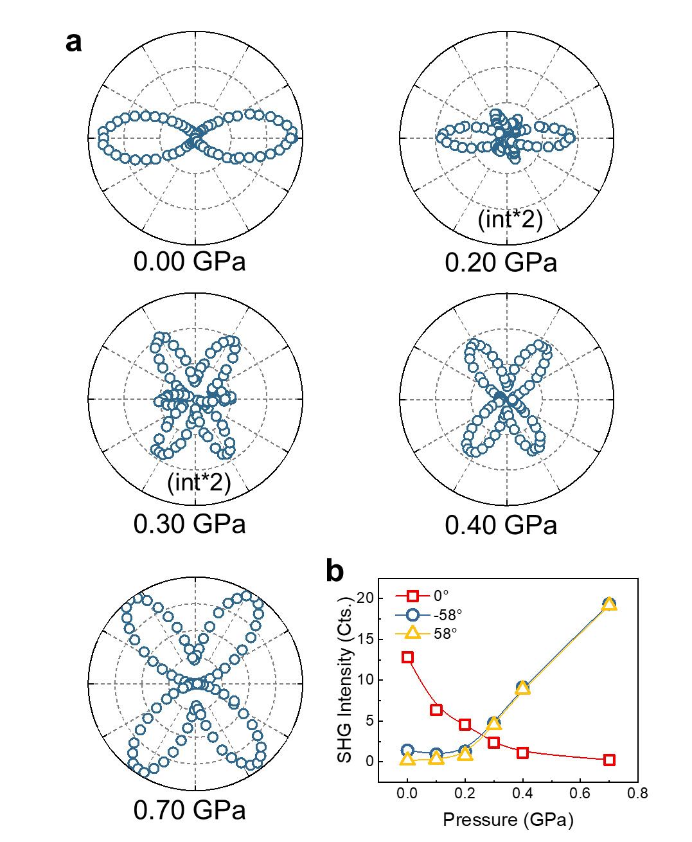
Figure S4. (a) SHG polarization polar plots of iBA-EA with the parallel configurations at different pressures. (b) Corresponding SHG intensity as a function of pressure in iBA-EA.

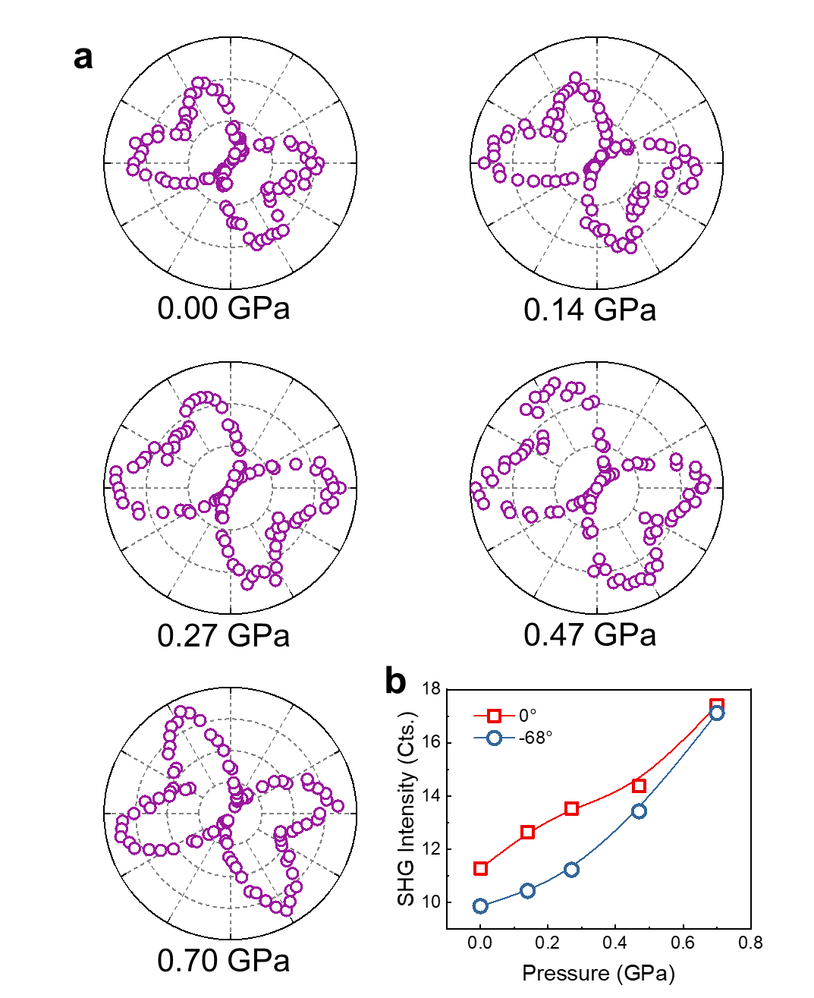
Figure S5. (a) SHG polarization polar plots of iBA-MHy with the parallel configurations at different pressures. (b) Corresponding SHG intensity as a function of pressure in iBA-MHy.

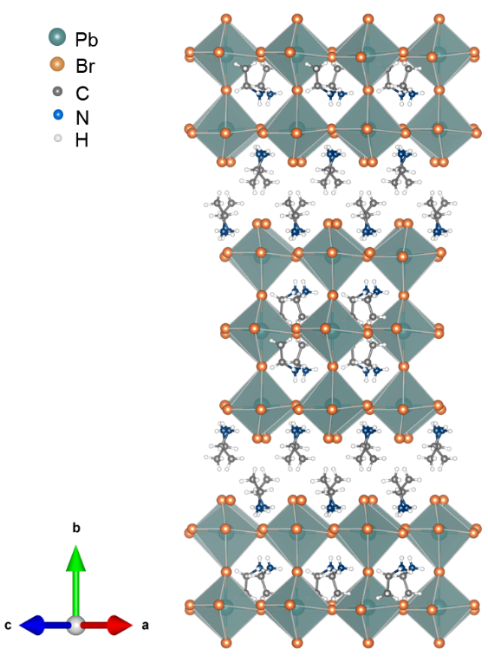
Figure S6. Extended crystal structure of (EA)₂(EA)₂Pb₃Br₁₀.

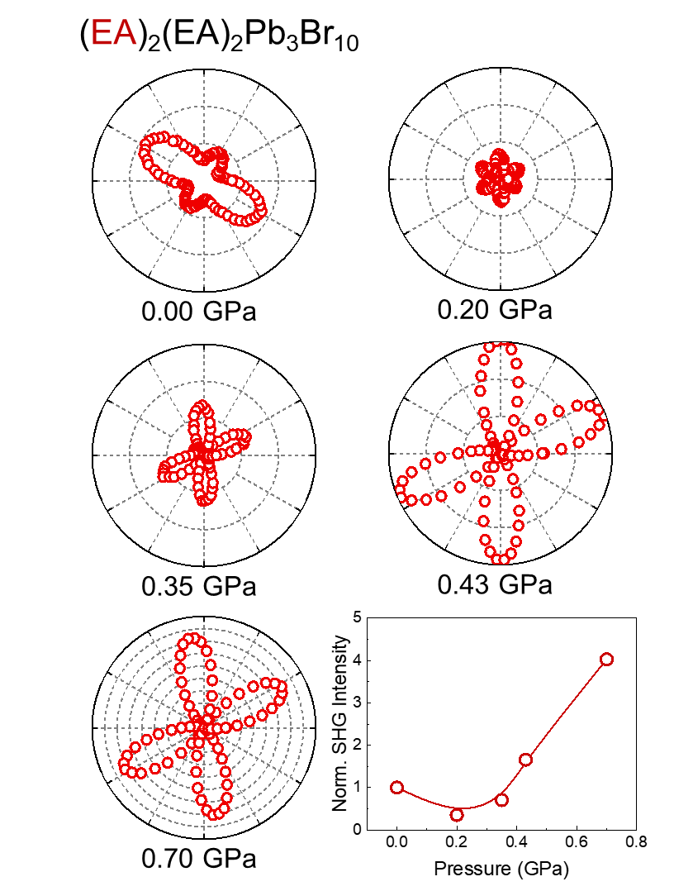
Figure S7. Parallel mode SHG polarization polar plots of (EA)₂(EA)₂Pb₃Br₁₀ and its corresponding SHG intensity as a function of pressure.

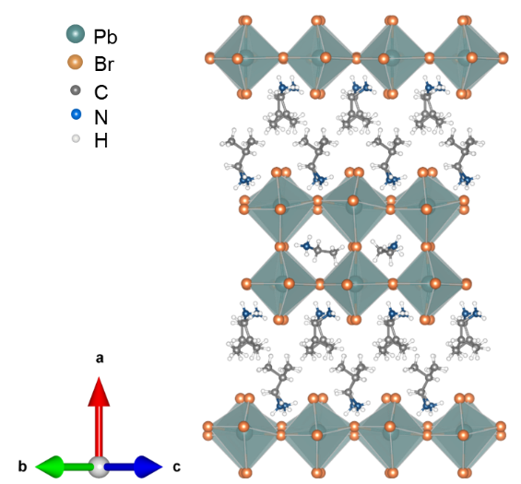
Figure S8. Extended crystal structure of (iBA)₂(EA)Pb₂Br₇.

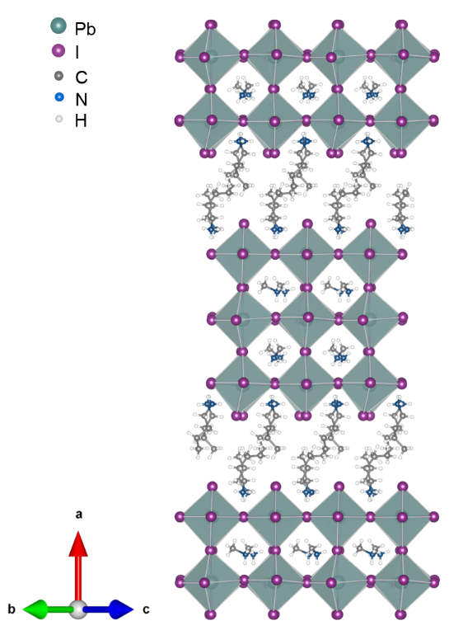
Figure S9. Extended crystal structure of (BA)₂(EA)₂Pb₃I₁₀.

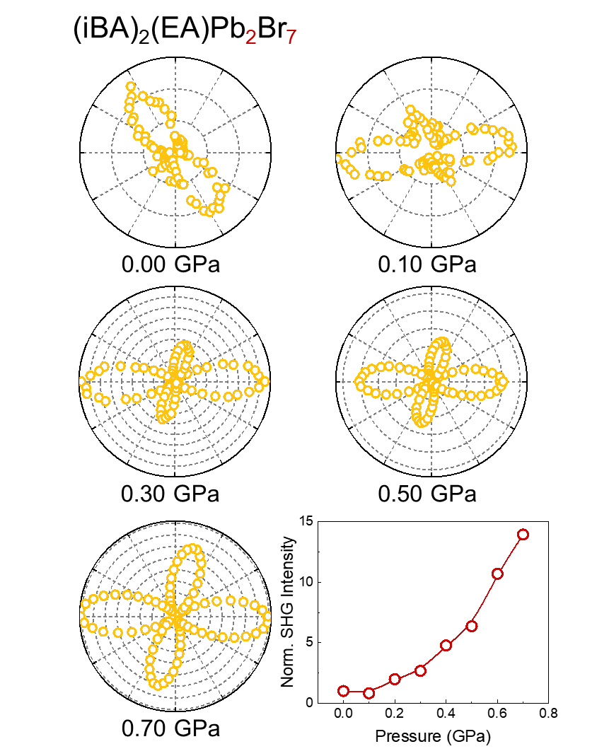
Figure S10. Parallel mode SHG polarization polar plots of (iBA)₂(EA)Pb₂Br₇ and its corresponding SHG intensity as a function of pressure.

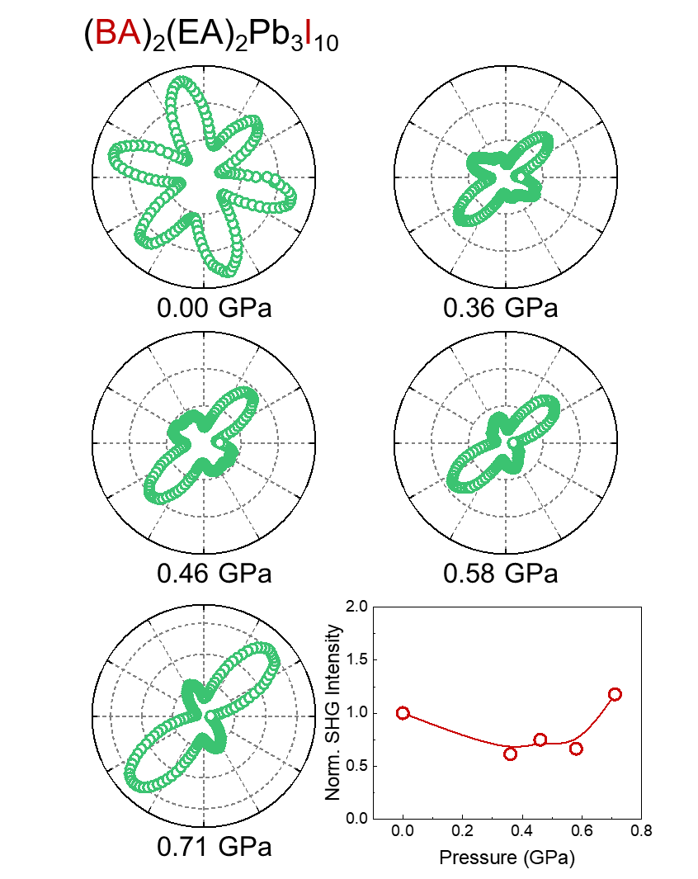
Figure S11. Parallel mode SHG polarization polar plots of (BA)₂(EA)Pb₃I₁₀ and its corresponding SHG intensity as a function of pressure.

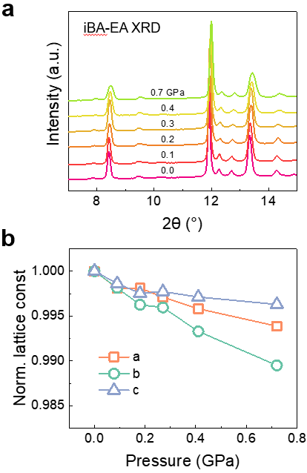
Figure S12. (a) p-XRD spectra of iBA-EA at different pressures. (b) Normalized lattice constants as a function of pressure.

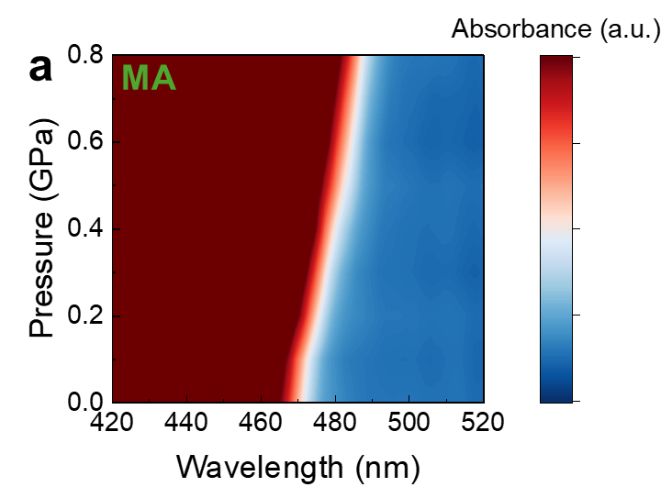
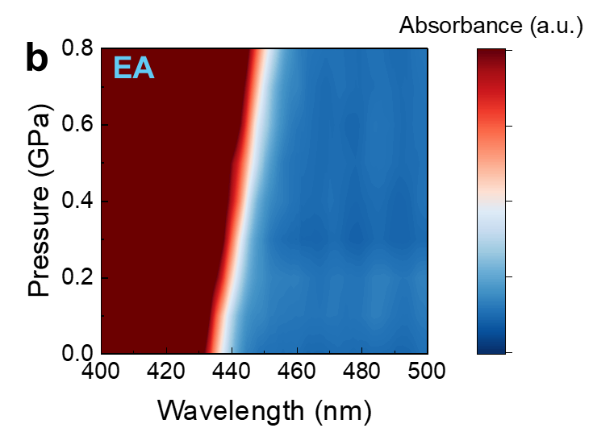
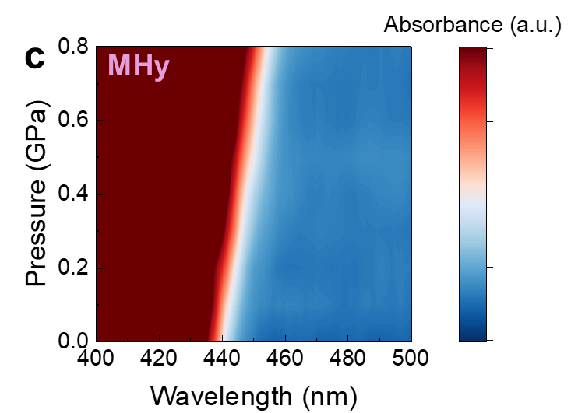
Figure S13. Absorption spectrum evolutions of (a) iBA-MA, (b) iBA-EA, and (c) iBA-MHy between 0 and 0.8 GPa.

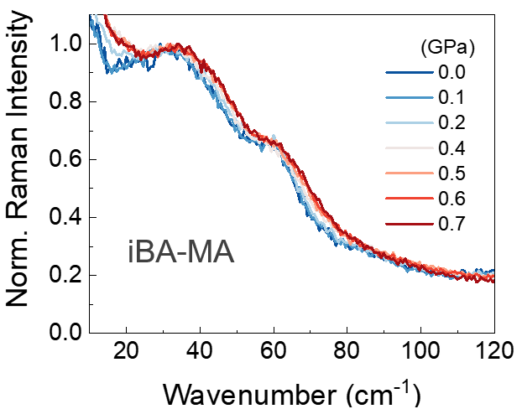
Figure S14. Inorganic lattice Raman signals of iBA-MA at selected pressures.

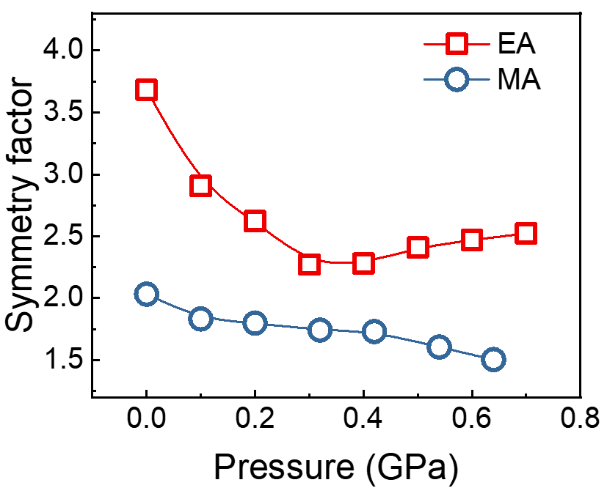
Figure S15. The PL symmetry factor of iBA-EA and iBA-MA as a function of pressure.

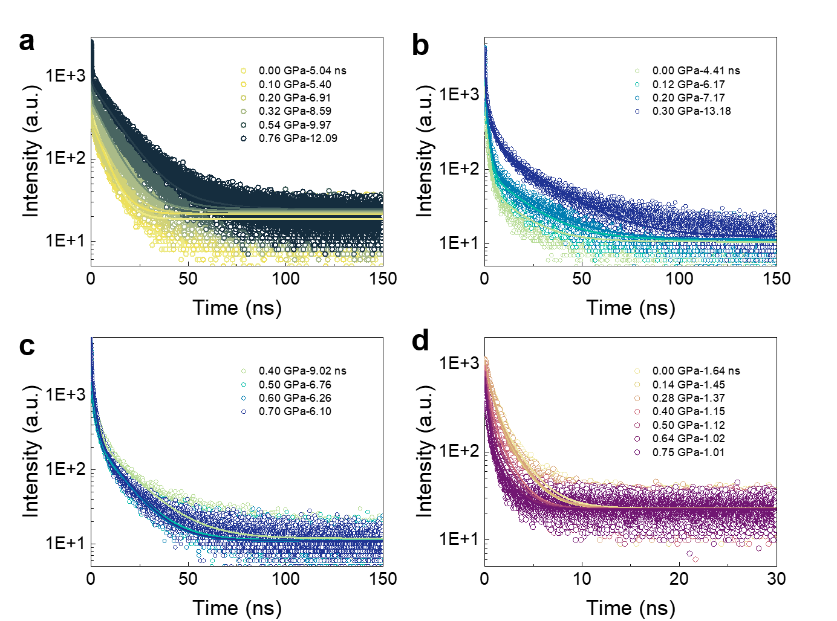
Figure S16. PL Lifetime of (a) iBA-MA, (b)(c) iBA-EA, and (d) iBA-MHy at different pressures.

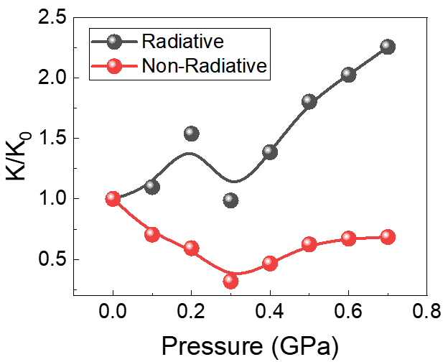
Figure S17. Normalized radiative (k_{r}/k₀, black) and non-radiative (k_{nr}/k₀, red) recombination rates of iBA-EA as a function of pressure.

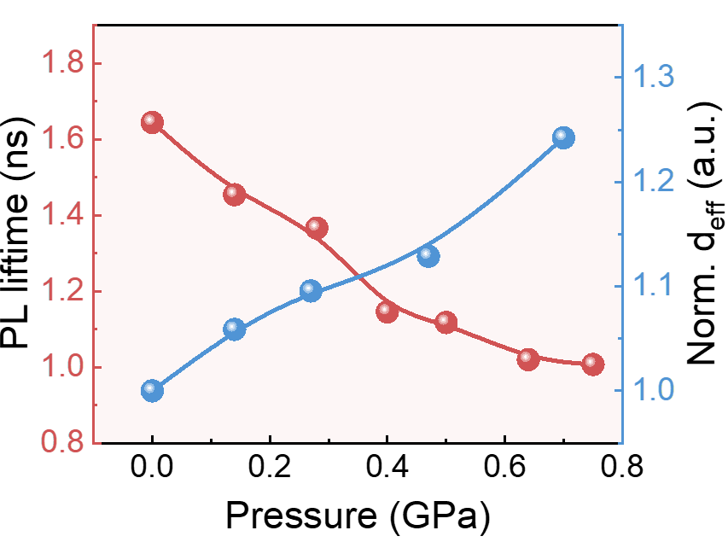
Figure S18. Comparison of the pressure-dependent evolution of PL lifetime and d_{eff} of iBA-MHy.

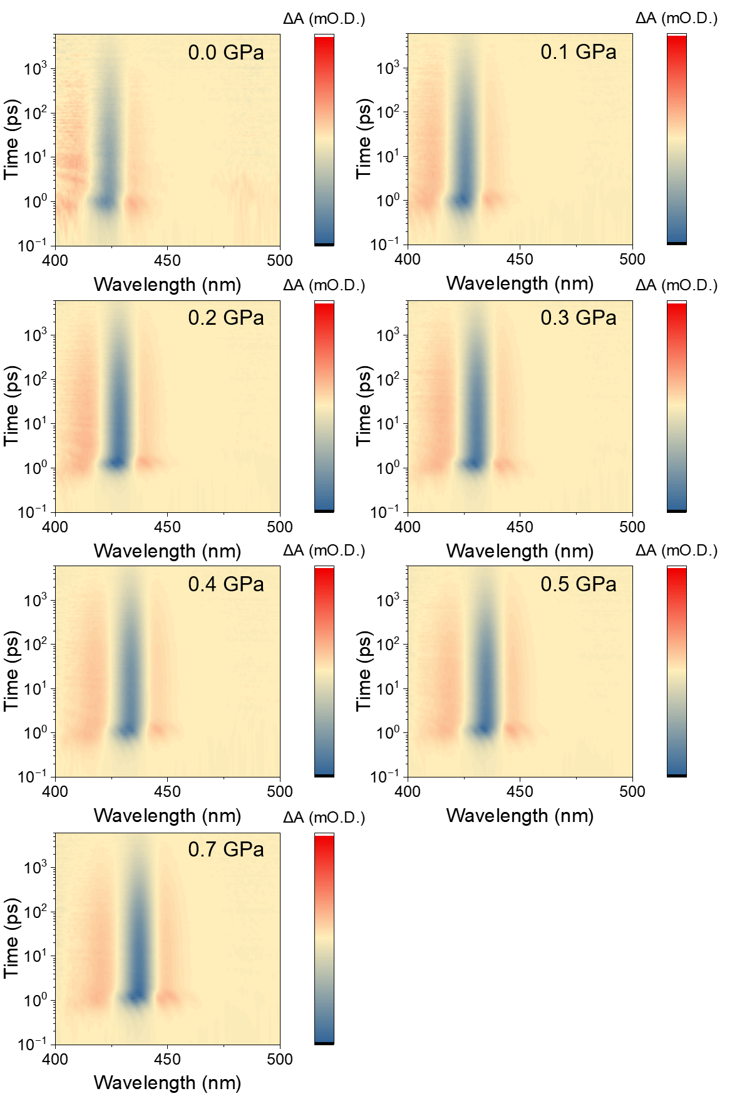
Figure S19. TA spectra of iBA-EA at selected pressures.

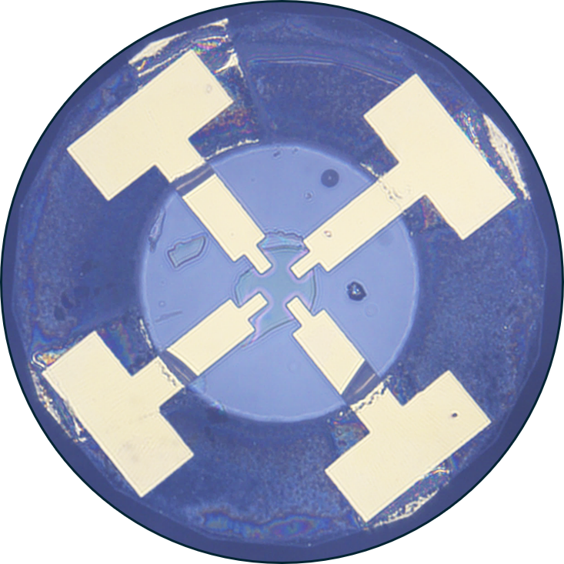
Figure S20. Photo of the iBA-EA high-pressure photoelectric response testing circuit.

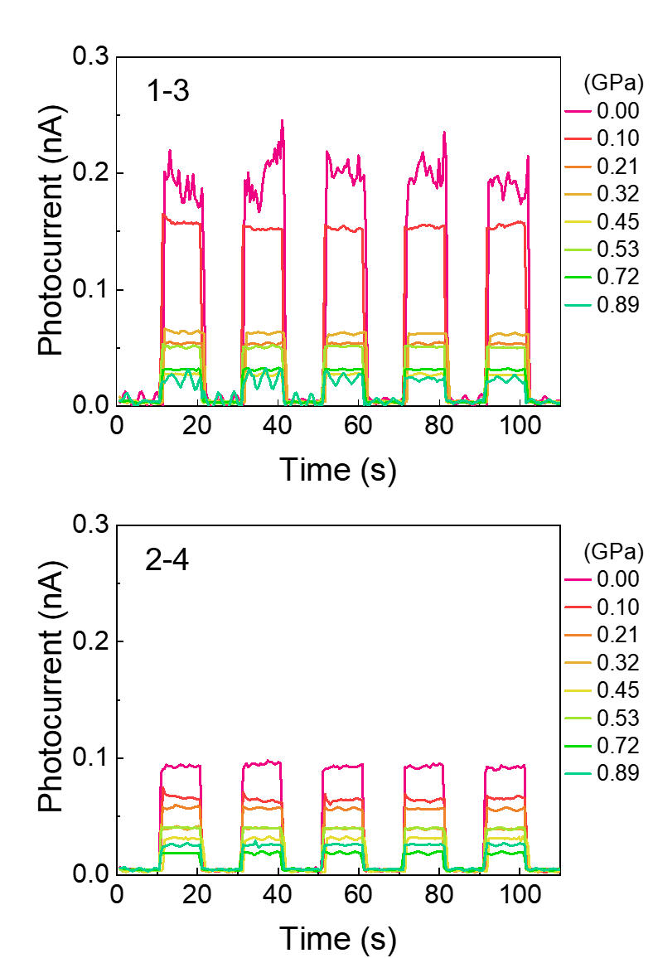
Figure S21. I-T curves of iBA-EA in 1-3 and 2-4 directions at selected pressures.

References
1. Mao, L.; Wu, Y.; Stoumpos, C. C.; Traore, B.; Katan, C.; Even, J.; Wasielewski, M. R.; Kanatzidis, M. G., Tunable White-Light Emission in Single-Cation-Templated Three-Layered 2D Perovskites (CH₃CH₂NH₃)₄Pb₃Br_{10-x}Cl_{x}. J. Am. Chem. Soc. 2017, 139 (34), 11956-11963.
2. Peng, Y.; Bie, J.; Liu, X.; Li, L.; Chen, S.; Fa, W.; Wang, S.; Sun, Z.; Luo, J., Acquiring High-T(C) Layered Metal Halide Ferroelectrics via Cage-Confined Ethylamine Rotators. Angew. Chem. Int. Ed. 2021, 60 (6), 2839-2843.
3. Fu, Y.; Jiang, X.; Li, X.; Traore, B.; Spanopoulos, I.; Katan, C.; Even, J.; Kanatzidis, M. G.; Harel, E., Cation Engineering in Two-Dimensional Ruddlesden–Popper Lead Iodide Perovskites with Mixed Large A-Site Cations in the Cages. J. Am. Chem. Soc. 2020, 142 (8), 4008-4021.

