Part One: Abuse Liability of Vuse Solo Relative to Combustible Cigarettes and Nicotine Gum Supplementary Material
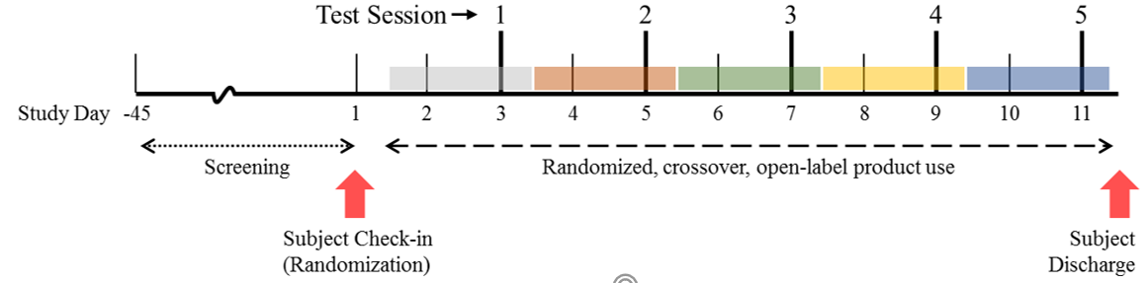

Supplementary Figure S1. Study Schematic

Parameter | All Enrolled Subjects (n=40)
Age (years) | 41.2 (±11.01)
Weight (kg) | 84.1 (±17.44)
Height (cm) | 172.9 (±8.74)
BMI (kg/m²) | 28.07 (±5.040)
Sex
Male | 28 (70%)
Female | 12 (30%)
Ethnicity
Hispanic/Latino | 2 (5%)
Not Hispanic/Latino | 38 (95%)
Race
White | 38 (95%)
Black/African American | 1 (3%)
Native Hawaiian/Other Pacific Islander | 0 (0%)
Asian | 0 (0%)
American Indian/Alaska Native | 1 (3%)
Multiple | 0 (0%)
Smoking
Number of years smoked | 19.7 (±12.7)
Number of cigarettes smoked per day | 18.1 (±4.26)
Level of dependence on nicotine (FTND) | 5.5 (±1.54)
Data are mean (±SD) or number (%). Abbreviations: BMI = body-mass index, FTND = Fagerström Test for Nicotine Dependence
Supplementary Table S1. Demographic and baseline characteristics

