Supplementary Information
Catalytic Etherification of Furfuryl Alcohol to Isopropyl Furfuryl Ether over MIL-68(V) and MOF-Derived V₂O₃@C
Ubed SF Arrozi^{1*§}, Aryan B. Saputra^{1§,} M. Rafi Pratama¹, Istifhamy Irnanda¹, Surjani Wonorahardjo¹, Yessi Permana², Witri W. Lestari³, Wirawan Ciptonugroho⁴, Yudha P. Budiman⁵, Khoa D. Nguyen⁶, Hadi Nur¹, Sheela Chandren⁷, Lee H. Voon⁸
¹Department of Chemistry, Faculty of Mathematics and Natural Sciences, State University of Malang, Jl. Semarang 5, Malang 65145, East Java, Indonesia
²Inorganic and Physical Chemistry Research Division, Faculty of Mathematics and Natural Sciences, Institut Teknologi Bandung, Jl. Ganesha 10, Bandung 40132, Indonesia
³Department of Chemistry, Faculty of Mathematics and Natural Sciences, Universitas Sebelas Maret, Jl. Ir. Sutami No. 36, Kentingan-Jebres Surakarta, Central Java, Indonesia, 57126
⁴Department of Chemistry Education, Faculty of Teacher Training and Education, Universitas Sebelas Maret, Jl. Ir. Sutami No. 36, Kentingan-Jebres Surakarta, Central Java, Indonesia, 57126
⁵Department of Chemistry, Faculty of Mathematics and Natural Sciences, Universitas Padjadjaran, 45363 Sumedang, Indonesia
⁶Department of Chemical Engineering, Ho Chi Minh City University of Technology (HCMUT), VNU-HCM, 268 Ly Thuong Kiet street, Dien Hong ward, Ho Chi Minh City, Vietnam
⁷Department of Chemistry, Faculty of Science, Universiti Teknologi Malaysia, 81310 UTM Johor Bahru, Johor, Malaysia
⁸Nanotechnology & Catalysis Research Centre (NANOCAT), Block A, Level 3, Advanced Studies Complex, Universiti Malaya, 50603 Kuala Lumpur, Malaysia
Corresponding author: ubedsonai.fmipa@um.ac.id
§Authors contribute equally

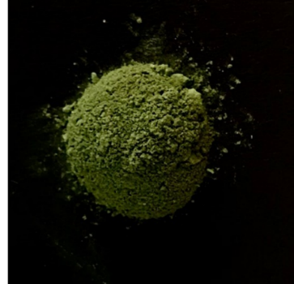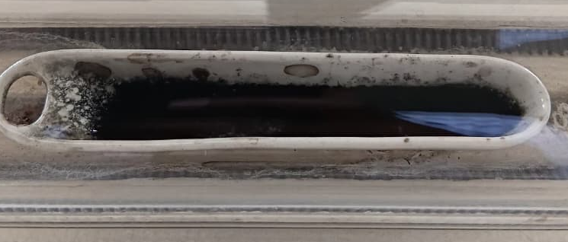
Figure S1. Physical appearance of MIL-68(V) (left) and the corresponding V₂O₃@C.
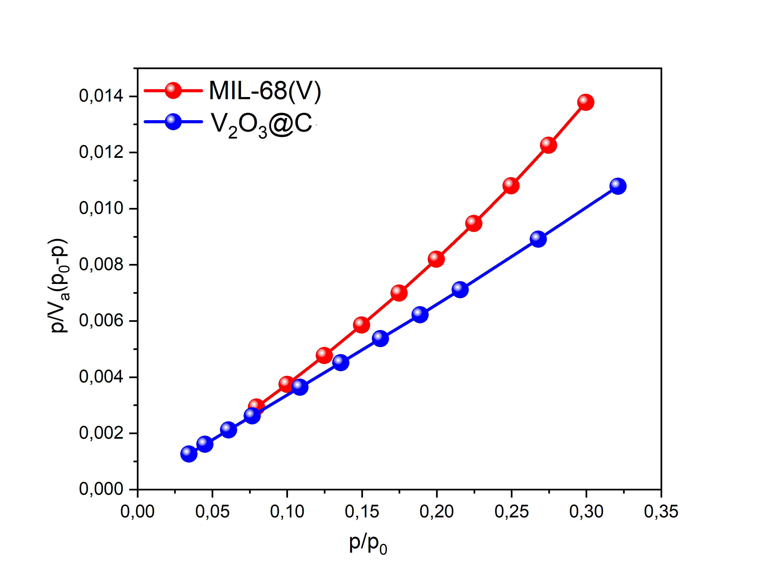
Figure S2. BET plot of MIL-68(V) and V₂O₃@C

Table S1. BET surface area and pore volume of the vanadium MOFs and V₂O₃@C
Samples | BET surface area [m²g⁻¹]
MIL-68(V) | 91
V₂O₃@C | 131

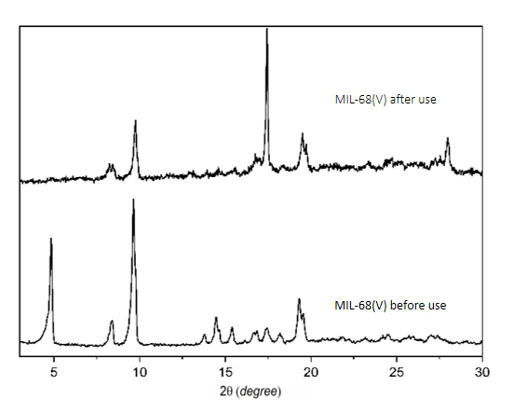
Figure S3. PXRD plot of MIL-68(V) after reusability test

