Supporting Information for

Transport of Polymer-Coated Metal-Organic Framework Nanoparticles in Porous Media

Satish K. Nune,^{a*} Quin R. S Miller,^{b} H. Todd Schaef,^{b} Tengyue Jian,^{b} Miao Song,^{b} Dongsheng Li,^{b} and B. Peter McGrail ª

ªEnergy & Environment Directorate, Pacific Northwest National Laboratory, Richland, WA 99354, USA
^{b}Physical and Computational Science Directorate, Pacific Northwest National Laboratory, Richland, WA 99354, USA

*Corresponding Author Email: satish.nune@pnnl.gov

Characterization Methods

Scanning Electron Microscopy
Aqueous uncoated and polymer coated nanoparticles were sonicated for a few minutes and then ~200 µl of the solution was drop cast on a Si wafer and dried in air. Scanning electron microscopy was performed with a JEOL 7600 FEG SEM at low 3-5 kV accelerating voltages in both secondary and backscatter modes.

Zeta Potential and Dynamic Light Scattering
The zeta potential (ζ-potential) values of the MIL-101(Cr) nanoparticles were measured by using Brookhaven NanoZeta potential (ZetaPALS) at room temperature (~25 °C). The final ζ-potential values for all polymer-coated nanoparticles were obtained by averaging three measurements. The pH of the freshly prepared uncoated nanoparticles was measured by Horiba compact pH meter. Dynamic light scattering (DLS) measurements performed on a Brookhaven Instruments Corporation Zeta Phase Analysis Light Scattering analyzer were used to determine the hydrodynamic diameters of MOF nanoparticles.

Ultraviolet-Visible Spectrometry
Ultraviolet-visible spectrometry (UV-Vis) measurements were made on recovered effluent from the flow-through sand column experiments. UV-vis was performed on a Ultrospec 2100 pro using 1 cm path length quartz cells. The UV–vis absorbance values were measured at wavelengths from 350 nm to 700 nm and water was used as the blank sample. To measure the nanoparticle retention profile, the concentration of the nanoparticles coming out of the column was measured using UV-Vis spectroscopy. The absorbance of the samples was measured over a wavelength range of 300–800 nm and the results presented are the average of at least two measurements. Colloidal nanoparticles (~ 0.5 wt% in water) have absorbances at ~560-580 nm. The unique on ultraviolet-visible (UV-Vis) spectra can be utilized to calculate nanoparticle concentrations. Concentrations of colloidal MOF nanoparticles were determined with the Beer-Lambert law that uses unique absorption peaks of nanoparticles in ultraviolet-visible (UV-Vis) spectra:
A = εbc (Eq. 1)
where A is absorbance, ε is the molar extinction coefficient with unit of M⁻¹ cm⁻¹, b is the path length of the sample (cm), c is the concentration of nanoparticles in solution (M).

In order to make calibration curves, five different known concentrations of each nanoparticle were prepared to measure the UV-Vis absorbance. For each concentration of nanoparticle, the maximum absorbance was determined. Using these samples with known concentrations and measured absorbances, calibration curves were plotted to determine the linear absorbance-concentration relationships for each.

SUPPLEMENTARY TABLES

Nanofluid Sample Name | Polymer Coating | Molecular Weight of Polymer | Hydrodynamic Diameter (nm)† | Zeta Potential Range (mV) | Amount of Nanoparticle Retained in Accusand Column Experiments (%)‡ | Nanofluid pH
NP | n/a, uncoated MIL-101(Cr) | n/a | 116 (4) ¹³ | +32 to +35 ¹⁴ | 11 | 5.97
NP-PVP | poly(vinylpyrrolidinone) | 40000 | 153 (17) | +2 to +5 | 27 | 6.20
NP-PD1 | poly(diallyldimethylammonium  chloride), 1 wt% polydadmac | 200,000-350,000 | 158 (11) | +26 to +30 | 32 | 4.73
NP-PSS-70K | poly(sodium 4-styrenesulfonate | 70,000 | 258 (28) | -21 to -31 | 9 | 6.60
NP-PSS-200K | poly(sodium 4-styrenesulfonate | 200,000 | 630 (32) | -25 to -31 | 35 | 6.89
NP-PEI | polyethylenimine | 10000 | 139 (26) | +8 | 51 | 7.20
Table S1. List of polymer-coated MOF nanoparticles with DLS, and zeta potential results.

Nanofluid Sample Name | Polymer Coating | NaCl Concentration (M) | Initial Nanofluid Concentration (wt%) | Amount of Nanoparticle Retained in Accusand Column Experiments (%)‡
NP | n/a, uncoated MIL-101(Cr) | 0 | 0.2596 | 8.6
NP | n/a, uncoated MIL-101(Cr) | 1 | 0.2596 | 29.2
NP-PSS-70K | poly(sodium 4-styrenesulfonate | 0 | 0.3688 | 3.2
NP-PSS-70K | poly(sodium 4-styrenesulfonate | 1 | 0.4253 | 8.4
NP-PSS-70K | poly(sodium 4-styrenesulfonate | 2 | 0.2970 | 9.2
NP-PSS-70K | poly(sodium 4-styrenesulfonate | 5 | 0.2596 | 13.0
Abbreviations: n/a, not applicable
‡ Estimated uncertainty is ±2%

Table S2. Results for MOF nanofluid transport as a function of NaCl concentration and coated vs. PSS-coated.

SUPPLEMENTARY FIGURES
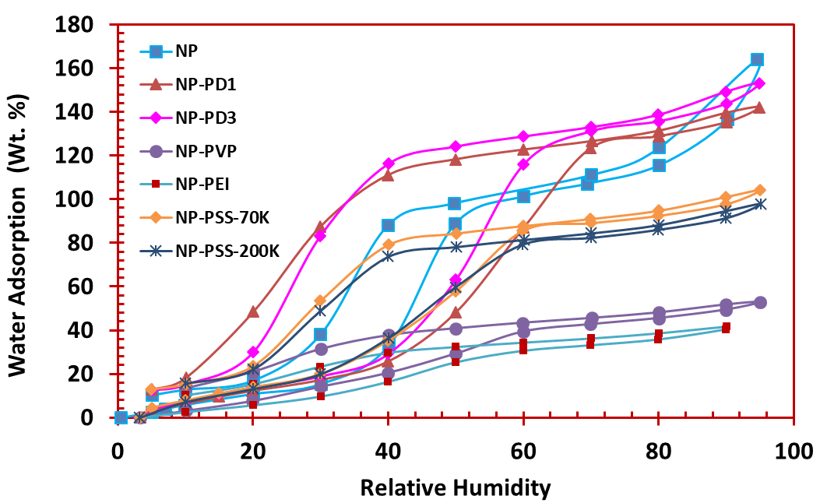
Fig. S1: Water adsorption isotherms at 25 °C for uncoated NP and polymer-coated nanoparticles (Table S1).

