Supplementary information:
Head-to-Head Preclinical Comparison of a Triazine-Based SSTR2 Homodimer and SSTR2/FAP Heterodimer in Neuroendocrine Tumors
Le Li^{1,2†}, Hanyue Ma^{1,2†}, Dylan Blijleven³, Amber Piet^{1,2}, Corrina de Ridder^{1,2}, Debra Stuurman^{1,2}, Priciana Paraïso^{1,2}, Yann Seimbille^{1,2,*}
- Erasmus MC, University Medical Center Rotterdam, Department of Radiology and Nuclear Medicine, Rotterdam, The Netherlands
- Erasmus MC Cancer Institute, Rotterdam, The Netherlands
- Rotterdam University of Applied Sciences, Rotterdam, The Netherlands
† These authors contributed equally to this work.
* Correspondence: y.seimbille@erasmusmc.nl; Tel: +31 10-703-8961
Table of Contents
Synthetic method | 2
Figure S1. LC-MS spectrum of 3. | 5
Figure S2. LC-MS spectrum of 4. | 5
Figure S3. LC-MS spectrum of 6. | 6
Figure S4. LC-MS spectrum of 7. | 6
Figure S5. LC-MS spectrum of 8. | 7
Figure S6. LC-MS spectrum of 10. | 7
Figure S7. LC-MS spectrum of 11. | 8
Figure S8. LC-MS spectrum of 12. | 8
Figure S9. LC-MS spectrum of 13. | 9
Figure S10. LC-MS spectrum of 14. | 9
Figure S11. iTLC spectrum and radio-HPLC chromatograms of [¹⁷⁷Lu]Lu-8 directly after labeling (T0), 1, 4, and 24 h post-incubation at 37˚C in PBS and murine serum. | 10
Figure S12. iTLC spectrum and radio-HPLC chromatograms of [¹⁷⁷Lu]Lu-14 directly after labeling (T0), 1, 4, and 24 h post-incubation at 37˚C in PBS and murine serum. | 10
Table S1. Cell uptake of [¹⁷⁷Lu]Lu-8 and [¹⁷⁷Lu]Lu-14 (n=3) using U2OS.SSTR2 cells and HT-1080.huFAP cell at different time points. | 11
Table S2. Ex vivo biodistribution of [¹⁷⁷Lu]Lu-8 at 1, 4, and 24 h post-injection. | 12
Table S3. Ex vivo biodistribution of [¹⁷⁷Lu]Lu-14 at 1, 4, and 24 h post-injection. | 12
Figure S13. In vitro autoradiography of HT-1080.huFAP tumor sections. Representative H&E-stained sections and corresponding autoradiography are shown for [¹¹¹In]In-FAPI-46 under non-blocked and blocked conditions. | 13

Synthetic method
Solid-phase synthesis and oxidative cyclization of the SSTR2-binding peptide scaffold (3)
The fully protected linear peptide 1 was synthesized using standard Fmoc solid-phase peptide synthesis (SPPS) protocols on 2-chlorotrityl chloride resin (0.17 g, loading capacity: 0.60 mmol/g). Fmoc-L-Thr(tBu)-OH (39 mg, 0.153 mmol, 1.5 equiv.) was initially loaded onto the resin in the presence of DIPEA for 90 min at room temperature. The resin was subsequently capped using dichloromethane/methanol/DIPEA (80:15:5, v/v/v) for 15 min. Fmoc deprotection was carried out using 20% piperidine in DMF for 15 min. Amino acid couplings were performed using HATU (3.8 equiv.) and DIPEA (7.8 equiv.) in DMF for 45 min. Coupling efficiency and Fmoc deprotection were monitored by the Kaiser test (1), and incomplete reactions were repeated when necessary. Sequential coupling of Fmoc-L-Cys(Acm)-OH, Fmoc-L-Thr(tBu)-OH, Fmoc-L-Lys(Alloc)-OH, Fmoc-D-Trp(Boc)-OH, Fmoc-L-Tyr(tBu)-OH, Fmoc-L-Cys(Acm)-OH, Fmoc-D-Phe-OH, and Fmoc-Amcha-OH afforded the fully protected linear peptide 1. After completion of chain elongation, the resin-bound peptide was treated with thallium(III) trifluoroacetate (TTFA, 2 equiv.) in DMF at room temperature for 3 h to remove the Acm protecting groups and promote intramolecular disulfide cyclization, affording cyclic intermediate 2. Successful cyclization was confirmed by analytical RP-HPLC analysis of a cleaved test sample. Subsequently, the Fmoc protecting group was removed using 20% piperidine in DMF, and the resin was washed thoroughly with DMF (5 x 1 mL) and dichloromethane (3 x 1 mL). Final cleavage and deprotection were achieved using TFA/H₂O/TIPS (95:2.5:2.5, v/v/v) for 3 h at room temperature. The crude peptide was precipitated with ice-cold diethyl ether, collected by centrifugation, and purified by prep-HPLC to afford compound 3 as a white solid (63.9 mg, 50%). ESI-MS: m/z calc’ for C₆₁H₈₁N₁₁O₁₅S₂ 1272.50; found 1273.30 [M + H]⁺; 636.90 [M + 2H]²⁺.
Conjugation of the GABOB linker to the SSTR2 peptide (4)
Boc-4-amino-3-hydroxybutanoic acid (Boc-GABOB-OH; 11.7 mg, 0.054 mmol, 1.5 equiv.) was added to a solution of compound 3 (45 mg, 0.036 mmol, 1.0 equiv.) in DMF (2 mL). HBTU (27.3 mg, 0.072 mmol, 2.0 equiv.) and DIPEA (72 μL, 0.36 mmol, 10 equiv.) were added, and the reaction mixture was stirred at room temperature for 1 h. The reaction mixture was diluted with EtOAc (20 mL), washed with water and brine, dried over MgSO₄, and concentrated in vacuo. The residue was treated with TFA/DCM (1:1, v/v, 2 mL) at room temperature for 30 min to remove the Boc protecting group. The solvents were removed under an air stream and the crude product was purified by prep-HPLC to afford compound 4 as a white solid (22.8 mg, 46%). ESI-MS: m/z calc’ for C₆₅H₈₈N₁₂O₁₇S₂ 1373.61 ; found 1374.50 [M + H]⁺; 687.40 [M + 2H]²⁺.
Dimerization of the SSTR2 peptide on the triazine-based platform (6)
Compound 5 was prepared according to an established procedure developed in our laboratory (unpublished data). 4 (10 mg, 7.3 µmol, 2.2 equiv.) and 5 (2.1 mg, 3.3 µmol, 1.0 equiv.) were dissolved in DMF (1 mL). HBTU (2.8 mg, 7.3 µmol, 2.2 equiv.) and DIPEA (6.6 µL, 0.036 mmol, 10 equiv.) were added, and the reaction mixture was stirred at room temperature for 1 h. The reaction mixture was diluted with EtOAc (20 mL), washed with water and brine, dried over MgSO₄, and concentrated in vacuo. The residue was treated with TFA/DCM (1:1, v/v, 2 mL) at room temperature for 30 min. The solvents were removed and the crude product was purified by prep-HPLC to afford compound 6 as a white solid (3 mg, 28%). ESI-MS: m/z calc’ for C₁₅₃H₂₁₅N₃₁O₄₀S₄ 3254.46 ; found 1629.20[M + 2H]²⁺; 1086.30 [M + 3H]³⁺; 815.00 [M + 4H]⁴⁺.
DOTA-GA conjugation to the SSTR2 homodimeric platform (7)
DOTA-GA anhydride (0.5 mg, 1.24 µmol, 1.2 equiv.) was dissolved in 1 mL of DMF and added to compound 6 (3 mg, 0.92 µmol, 1 equiv.). DIPEA (1.8 µL, 7.0 µmol, 10 equiv.) was added, and the reaction mixture was stirred at room temperature for 1 h. The reaction mixture was diluted with EtOAc (20 mL), washed with water and brine, dried over MgSO₄, and concentrated in vacuo. The crude product was purified by prep-HPLC to afford compound 7 as a white solid (2.1 mg, 81%). ESI-MS: m/z calc’ for C₁₇₂H₂₄₅N₃₅O₄₉S₄ 3712.66; found 1858.30 [M + 2H]²⁺; 1239.10 [M + 3H]³⁺.
Alloc deprotection to afford the SSTR2-targeting homodimer (8)
Compound 7 (2.1 mg, 0.56 µmol, 1 equiv.) was dissolved in DCM (1 mL), and Pd(PPh₃)₄ (0.14 mg, 0.13 µmol, 0.23 equiv.) and PhSiH₃ (0.7 µL, 5.6 µmol, 10 equiv.) were added. The reaction mixture was stirred at room temperature for 3 h to remove the Alloc protecting groups. After completion of the reaction, the palladium catalyst was removed by filtration. The solvents were removed and the crude product was purified by prep-HPLC to afford compound 8 as a white solid (1 mg, 50%). ESI-MS: m/z calc’ for C₁₆₄H₂₃₇N₃₅O₄₅S₄ 3547.14; found 1774.40 [M + 2H]²⁺; 1183.20 [M + 3H]³⁺; 887.60 [M + 4H]⁴⁺; 710.31 [M + 5H]⁵⁺.
Conjugation of the FAP-targeting moiety to the triazine platform (10)
Compound 5 (12.1 mg, 18.7 µmol, 1.2 equiv.) was dissolved in DMF (1 mL), and compound 9 (8.7 mg, 15.6 µmol, 1.0 equiv.), which was synthesized according to previously reported procedure (unpublished data), was added. HBTU (3.9 mg, 10.3 µmol, 0.66 equiv.) and DIPEA (11 μL, 0.062 mmol, 4 equiv.) were added, and the reaction mixture was stirred at room temperature for 1 h. The reaction mixture was diluted with EtOAc, washed with water and brine, dried over MgSO₄, and concentrated in vacuo. The crude product was purified by prep-HPLC to afford compound 10 as a white solid (4.8 mg, 26%). ESI-MS: m/z calc’ for C₅₆H₈₃F₂N₁₃O₁₃ 1183.62; found 1184.50 [M + H]⁺ ; 592.90 [M + 2H]²⁺.
Assembly of the SSTR2 peptide onto the FAP-substituted triazine platform (11)
Compound 10 (4.8 mg, 4.0 µmol, 1.0 equiv.) and 4 (6.6 mg, 4.8 µmol, 1.2 equiv.) were dissolved in DMF (1 mL). HBTU (1.8 mg, 4.8 µmol, 1.2 equiv.) and DIPEA (7 μL, 0.04 mmol, 10 equiv.) were added, and the reaction mixture was stirred at room temperature until completion. The reaction mixture was diluted with EtOAc (20 mL), washed with water and brine, dried over MgSO₄, and concentrated in vacuo. The crude product was purified by prep-HPLC to afford compound 11 as a white solid (5.1 mg, 50%). ESI-MS: m/z calc’ for C₁₂₁H₁₆₉F₂N₂₅O₂₉S₂ 2538.19; found 1270.70 [M + 2H]²⁺; 847.50 [M + 3H]³⁺.
Boc deprotection of the heterodimer precursor (12)
Compound 11 (5.1 mg, 2.0 µmol) was treated with TFA/DCM (1:1, v/v, 2 mL) at room temperature for 30 min to remove the Boc protecting group. The solvents were removed under an air stream, and the crude product was purified by prep-HPLC to afford compound 12 as a white solid (3.7 mg, 74%). ESI-MS: m/z calc’ for C₁₁₆H₁₆₁F₂N₂₅O₂₇S₂ 2438.14; found 1220.70 [M + 2H]²⁺; 814.00 [M + 3H]³⁺.
DOTA-GA conjugation to the SSTR2-FAP heterodimer precursor (13)
DOTA-GA anhydride (0.72 mg, 1.8 µmol, 1.2 equiv.) was dissolved in DMF (1 mL) and added to a solution of compound 12 (3.7 mg, 1.5 µmol, 1.0 equiv.) in DMF. DIPEA (3 μL, 0.015 mmol, 10 equiv.) was added, and the reaction mixture was stirred at room temperature for 1 h. The reaction mixture was diluted with EtOAc (20 mL), washed with water and brine, dried over MgSO₄, and concentrated in vacuo. The crude product was purified by prep-HPLC to afford compound 13 as a white solid (2.8 mg, 64%). ESI-MS: m/z calc’ for C₁₃₅H₁₉₁F₂N₂₉O₃₆S₂ 2896.34; found 1449.70[M + 2H]²⁺; 966.80 [M + 3H]³⁺.
Final Alloc deprotection to afford the SSTR2/FAP-targeting heterodimer (14)
Compound 13 (2.8 mg, 1.0 µmol, 1.0 equiv.) was dissolved in DCM (1 mL). Pd(PPh₃)₄ (0.26 mg, 0.22 µmol, 0.23 equiv.) and PhSiH₃ (1.1 µL, 9.7 µmol, 10 equiv.) were added. The reaction mixture was stirred at room temperature for 3 h to remove the Alloc protecting groups. After completion of the reaction, the palladium catalyst was removed by filtration. The solvents were removed in vacuo, and the crude product was purified by prep-HPLC to afford compound 14 as a white solid (1 mg, 36%). ESI-MS: m/z calc’ for C₁₃₁H₁₈₉F₂N₂₉O₃₄S₂ 2814.34; found 1407.80 [M + 2H]²⁺; 938.90[M + 3H]³⁺; 704.40[M + 4H]⁴⁺; 563.70[M + 5H]⁵⁺.
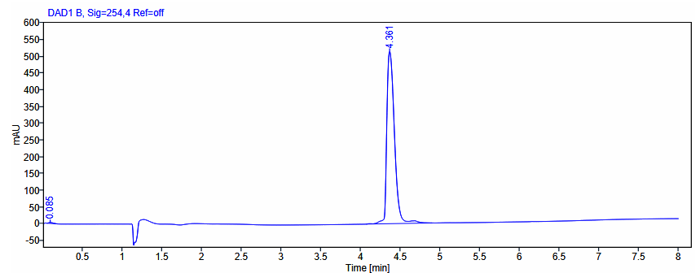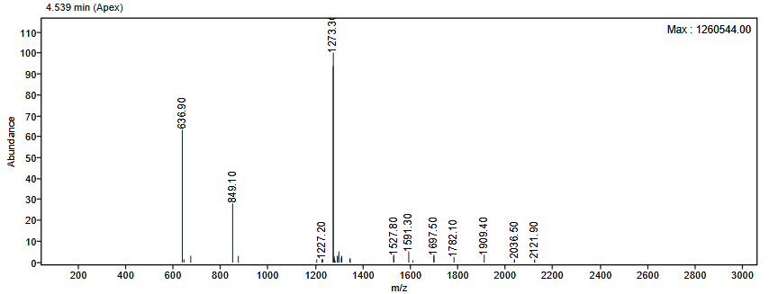
Figure S1. LC chromatogram and ESI-MS spectrum of 3.

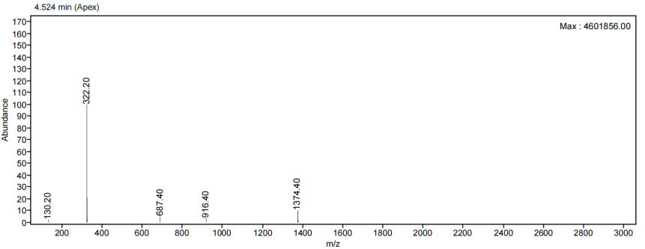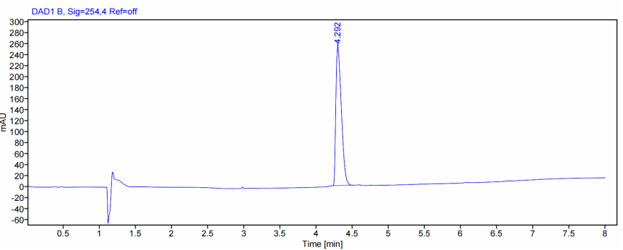
Figure S2. LC chromatogram and ESI-MS spectrum of 4.

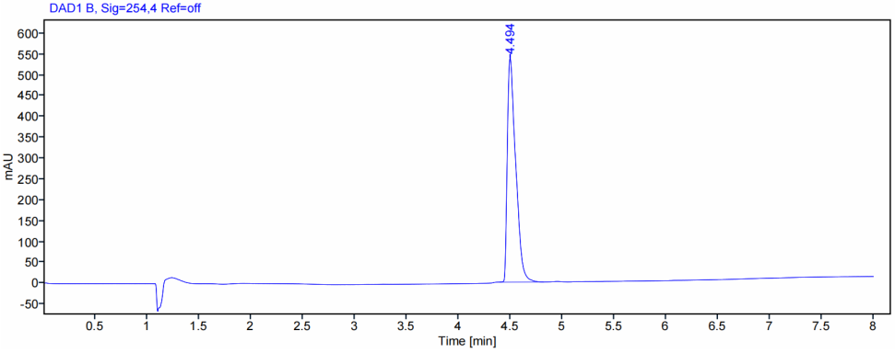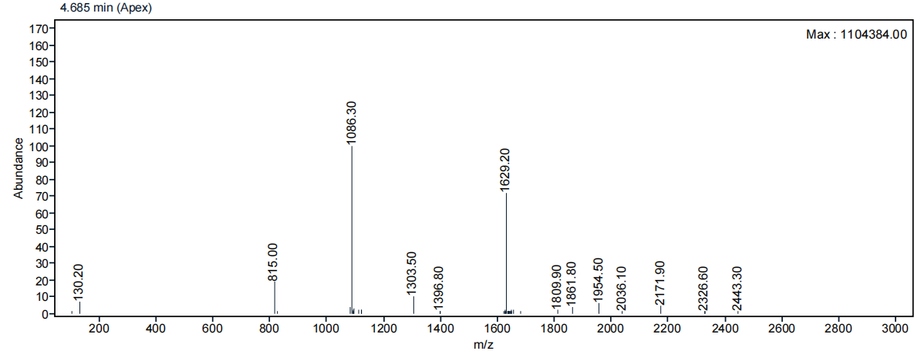
Figure S3. LC chromatogram and ESI-MS spectrum of 6.

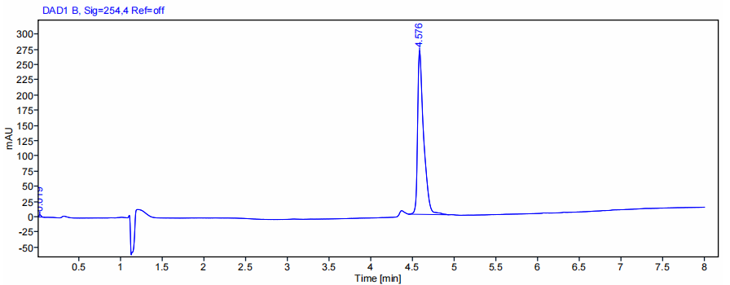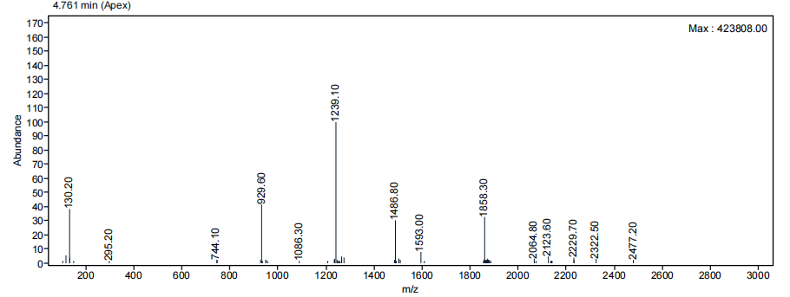
Figure S4. LC chromatogram and ESI-MS spectrum of 7.

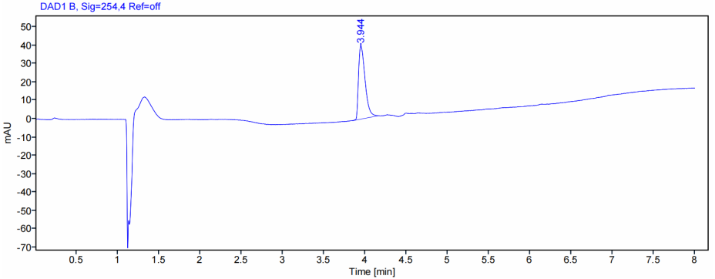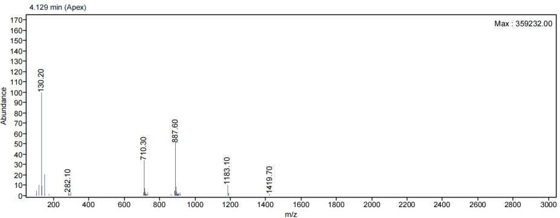
Figure S5. LC chromatogram and ESI-MS spectrum of 8.

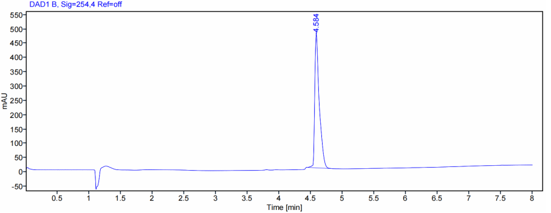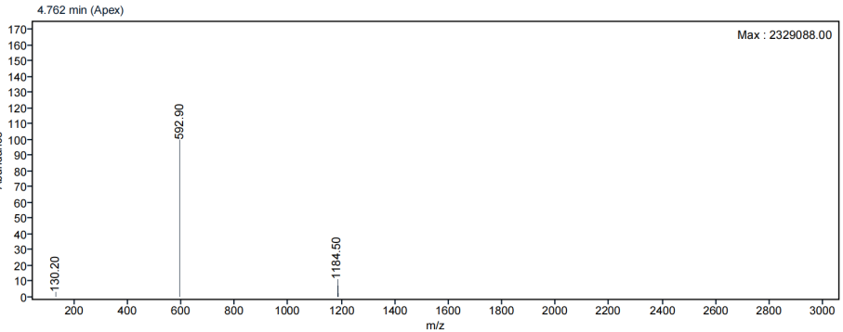
Figure S6. LC chromatogram and ESI-MS spectrum of 10.
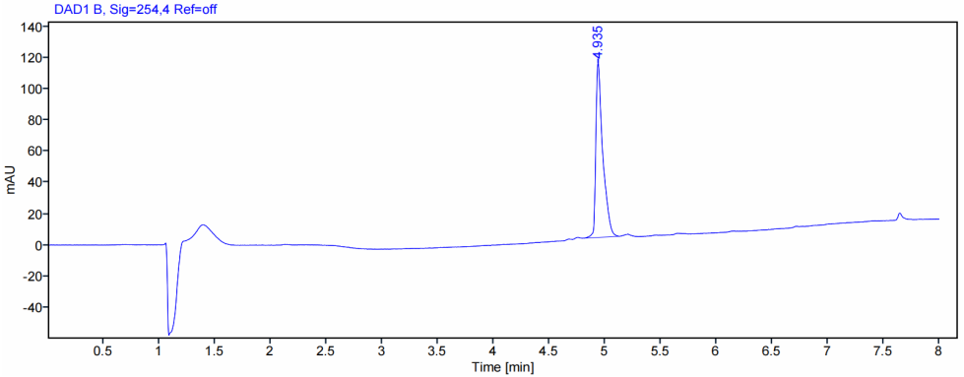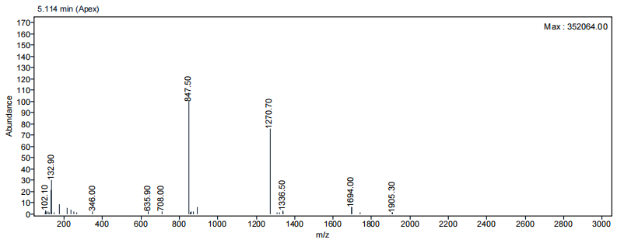
Figure S7. LC chromatogram and ESI-MS spectrum of 11.

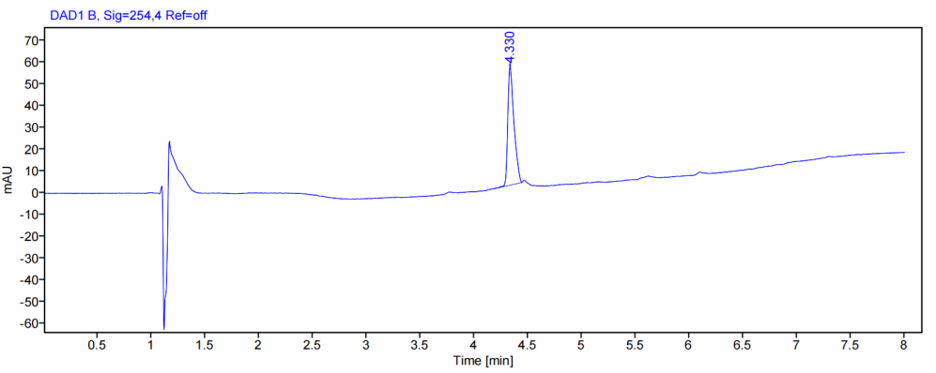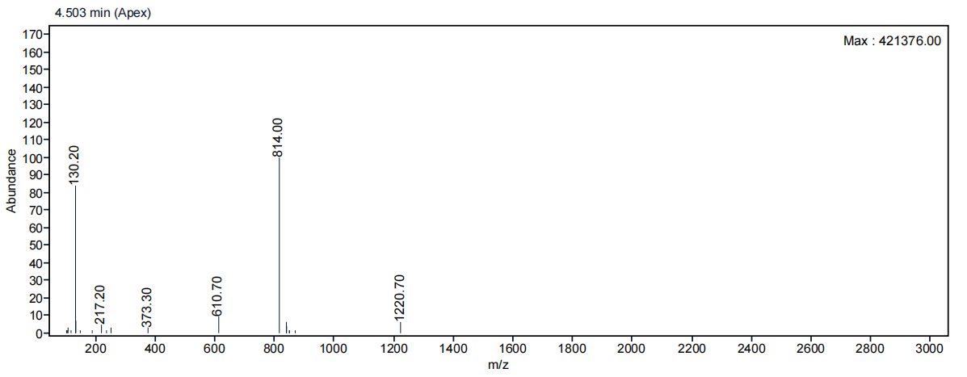
Figure S8. LC chromatogram and ESI-MS spectrum of 12.
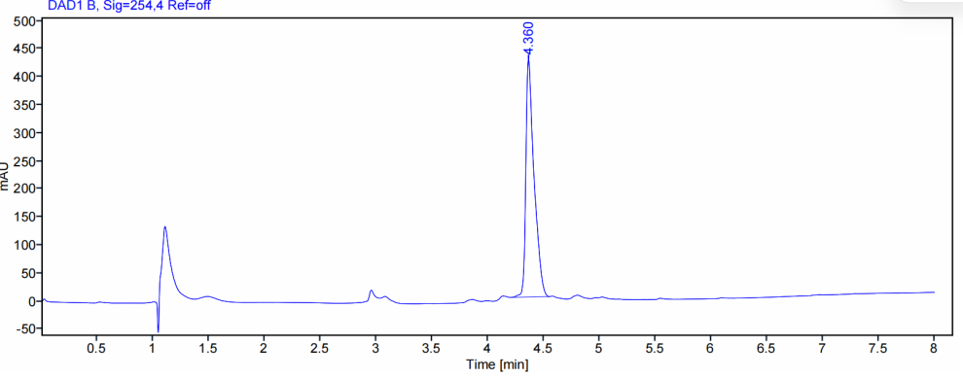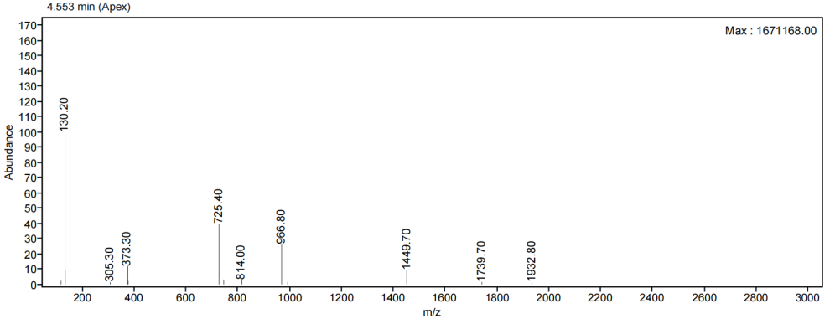
Figure S9. LC chromatogram and ESI-MS spectrum of 13.

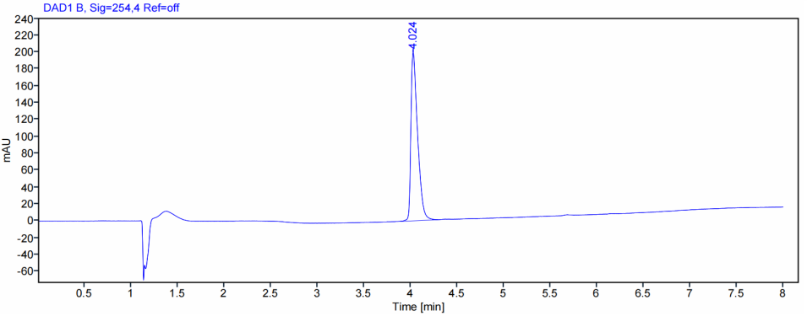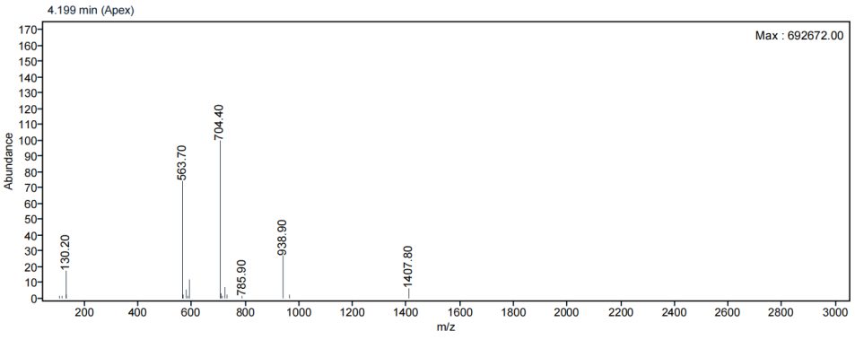
Figure S10. LC chromatogram and ESI-MS spectrum of 14.

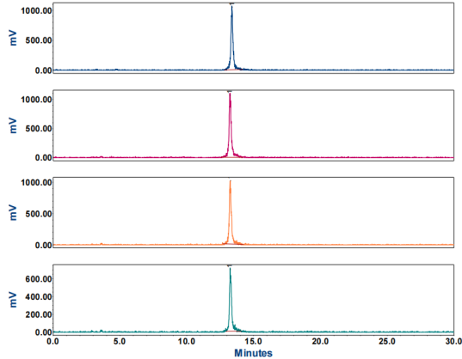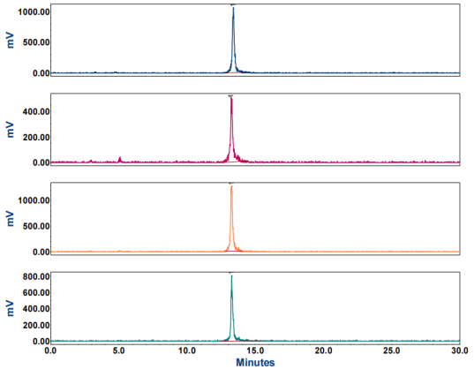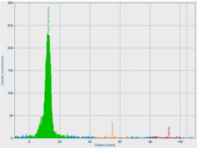
PBS
Murine Serum
0 h
1 h
4 h
24 h
Figure S11. iTLC chromatogram and stability in PBS and murine serum of [¹⁷⁷Lu]Lu-8.

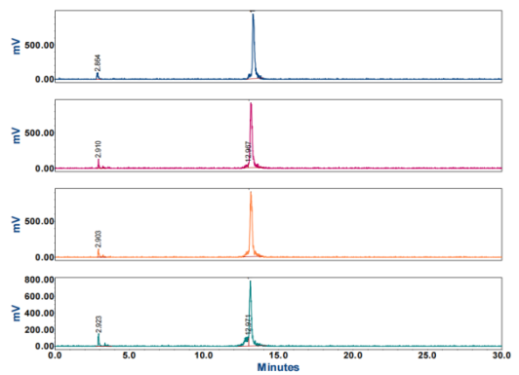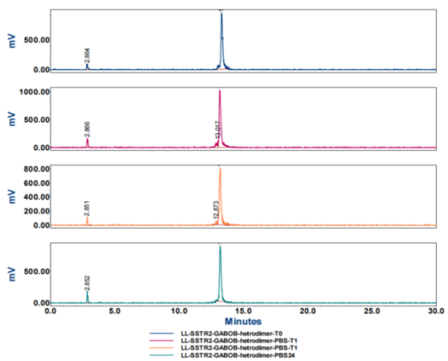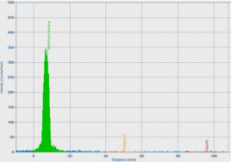
0 h
1 h
4 h
24 h
PBS
Murine Serum
Figure S12. iTLC chromatogram and stability in PBS and murine serum of [¹⁷⁷Lu]Lu-14.

Compounds | % Added dose
Compounds | U2OS.SSTR2 cell |  |  |  | HT-1080.huFAP cell
Compounds | 0.5 h | 1 h | 2 h | Block | 0.5 h | 1 h | 2 h | Block
[¹⁷⁷Lu]Lu-DOTA-TATE | 25.2 ± 6.5 | 40.2 ± 4.4 | 61.4 ± 6.4 | 0.24 ± 0.1 | - | - | - | -
[¹⁷⁷Lu]Lu-8 | 22.7 ± 4.1 | 35.5 ± 3.5 | 49.2 ± 3.2 | 0.47 ± 0.2 | - | - | - | -
[¹⁷⁷Lu]Lu-14 | 15.4 ± 5.1 | 29.4 ± 3.8 | 41.6 ± 3.3 | 0.84 ± 0.6 | 16.4 ± 1.7 | 27.7 ± 3.1 | 37.0 ± 6.4 | 0.13 ± 0.1
[¹⁷⁷Lu]Lu-FAPI-46 | - | - | - | - | 13.8 ± 3.4 | 15.5 ± 3.8 | 17.6 ± 4.3 | 0.23 ± 0.2
Table S1. Cell uptake of [¹⁷⁷Lu]Lu-8 and [¹⁷⁷Lu]Lu-14 (n=3) using U2OS.SSTR2 cells and HT-1080.huFAP cell at different time points. Uptake of all compounds was blocked with a 1000-fold molar excess of DOTA-TATE or FAPI-46.
Table S2. Ex vivo biodistribution analysis of [¹⁷⁷Lu]Lu-8 in NCI-H69 xenograft tumor-bearing mice at 1, 4, 24 h p.i. (n = 4 mice/compound); Uptake in tissues is expressed as the percentage of the injected dose per gram of tissue (% ID/g).
Tissues | 1 h | 4 h | 4 h-block | 24 h
Blood | 1.64 ± 0.51 | 0.26 ± 0.06 | 0.26 ± 0.04 | 0.06 ± 0.01
Tumor | 5.49 ± 0.71 | 4.96 ± 0.51 | 0.59 ± 0.03 | 3.02 ± 0.12
Heart | 1.47 ± 0.32 | 0.27 ± 0.03 | 0.22 ± 0.02 | 0.07 ± 0.01
Lungs | 4.54 ± 0.47 | 2.00 ± 0.13 | 0.64 ± 0.11 | 0.60 ± 0.10
Liver | 3.27 ± 0.67 | 1.01 ± 0.04 | 0.87 ± 0.13 | 0.40 ± 0.03
Spleen | 1.19 ± 0.40 | 0.50 ± 0.07 | 0.37 ± 0.04 | 0.24 ± 0.04
Stomach | 5.77 ± 1.49 | 2.52 ± 0.46 | 0.25 ± 0.04 | 1.09 ± 0.18
Intestines | 2.44 ± 0.41 | 2.32 ± 0.09 | 1.09 ± 0.19 | 0.31± 0.07
Pancreas | 6.60 ± 1.46 | 2.74 ± 0.57 | 0.30 ± 0.02 | 0.60 ± 0.11
Kidneys | 107.30 ± 9.74 | 116.03 ± 4.56 | 125.63 ± 9.24 | 41.56 ± 1.74
Muscle | 0.62 ± 0.40 | 0.09 ± 0.01 | 0.10 ± 0.01 | 0.08 ± 0.09
Skin | 1.98 ± 0.27 | 0.72 ± 0.04 | 0.60 ± 0.09 | 0.32 ± 0.06
Bones | 1.00 ± 0.40 | 0.38 ± 0.04 | 0.27 ± 0.03 | 0.19 ± 0.04

Table S3. Ex vivo biodistribution analysis of [¹⁷⁷Lu]Lu-14 in NCI-H69 xenograft tumor-bearing mice at 1, 4, 24 h p.i. (n = 4 mice/compound); Uptake in tissues is expressed as the percentage of the injected dose per gram of tissue (% ID/g).
Tissues | 1 h | 4 h | 4 h-block | 24 h
Blood | 5.01 ± 0.61 | 2.08 ± 0.14 | 2.50 ± 0.23 | 0.12 ± 0.03
Tumor | 5.66 ± 0.97 | 5.07 ± 0.27 | 3.23 ± 0.70 | 2.83 ± 0.16
Heart | 1.85 ± 0.44 | 0.94 ± 0.18 | 1.15 ± 0.20 | 0.09 ± 0.01
Lungs | 4.01 ± 0.36 | 2.28 ± 0.14 | 1.73 ± 0.30 | 0.54 ± 0.076
Liver | 2.38 ± 0.47 | 1.48 ± 0..09 | 1.66 ± 0.13 | 0.49 ± 0.06
Spleen | 1.27 ± 0.23 | 0.78 ± 0.05 | 0.89 ± 0.18 | 0.29 ± 0.08
Stomach | 2.94 ± 0.51 | 1.77 ± 0.38 | 0.97 ± 0.37 | 0.61 ± 0.20
Intestines | 1.54 ± 0.15 | 1.35 ± 0.23 | 0.95 ± 0.08 | 0.17 ± 0.02
Pancreas | 4.16 ± 0.53 | 2.21 ± 0.24 | 2.02 ± 0.21 | 0.40 ± 0.07
Kidneys | 22.32 ± 2.41 | 19.54 ± 1.60 | 17.98 ± 1.37 | 3.38 ± 0.29
Muscle | 1.95 ± 0.31 | 1.22 ± 0.27 | 1.57± 0.42 | 0.12 ± 0.01
Skin | 7.05 ± 0.73 | 4.10 ± 0.35 | 5.10 ± 0.42 | 0.61± 0.07
Bones | 6.31 ± 1.08 | 3.43 ± 0.36 | 3.51 ± 0.75 | 0.55 ± 0.11
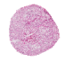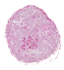
[¹¹¹In]In-FAPI-46

Block Non-Block

H&E staining Autoradiography

Figure S13. In vitro autoradiography of HT-1080.huFAP tumor sections. Representative H&E-stained sections and corresponding autoradiography are shown for [¹¹¹In]In-FAPI-46 under non-blocked and blocked conditions.
References
1. Kaiser E, Colescott RL, Bossinger CD, Cook PI. Color test for detection of free terminal amino groups in the solid-phase synthesis of peptides. Anal Biochem. 1970;34(2):595-8.

