A multi-layer computational framework for structural prioritization of transcriptome-derived proteins
Ângela Benevides^{1#}, João A. Teodoro^{1#}, Tales A. Costa-Silva¹ and Danilo T. Amaral^{1*}
#Both authors contributed equally to this work.
¹Centro de Ciências Naturais e Humanas, Universidade Federal do ABC (UFABC), Santo André, São Paulo, Brasil.
*Corresponding author, Avenida dos Estados, 5001, bloco A, 504-3 room. ZIP CODE 09210-580, Santo André, Brazil. email: danilo.trabuco@ufabc.edu.br

Figure S1. Structural alignment between predicted (green) and reference (blue) models of the prioritized proteins, illustrating the degree of conformational agreement between AlphaFold 3 and Modeller predictions.

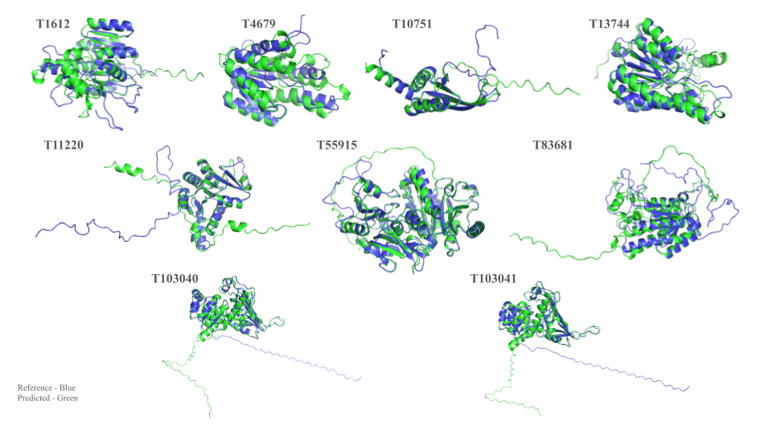

Figure S2. Structural superposition of predicted docking poses (HADDOCK) and experimentally resolved cytokine-receptor complexes used in the redocking benchmark. Yellow represents the best-scoring docking cluster; green and blue represent chain #1 and chain #2.
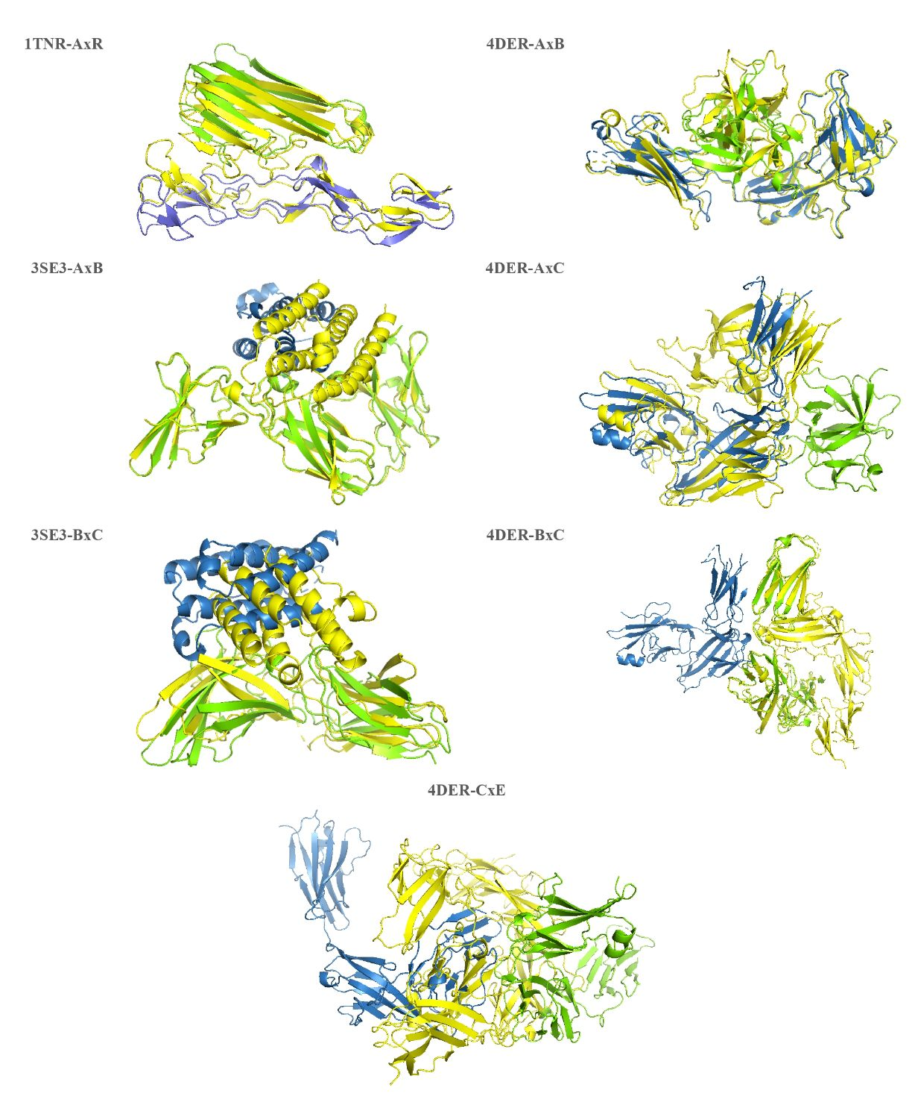

Table S1 - Structural validation of the prioritized proteins using AlphaFold 3.
Protein | Mean pLDDT | Min pLDDT | Max pLDDT | pTM | AF3-model
ST1612 | 95.35 | 38.15 | 98.99 | 0.940 | 0
ST4679 | 73.26 | 21.38 | 97.59 | 0.750 | 0
ST10751 | 84.95 | 25.92 | 98.51 | 0.740 | 0
ST11220 | 87.29 | 26.59 | 98.87 | 0.840 | 2
ST13744 | 95.22 | 39.34 | 98.98 | 0.940 | 0
ST55915 | 93.28 | 17.58 | 98.96 | 0.930 | 0
ST83681 | 81.19 | 14.44 | 98.99 | 0.790 | 1
ST103040 | 90.58 | 22.96 | 98.89 | 0.880 | 0
ST103041 | 90.43 | 22.68 | 98.89 | 0.870 | 1

Table S2. Highlighting the strongest protein–protein interactions and their physicochemical properties.
Protein x Target | H-bonds | AA (H-bonds) | Distance (H-A) | Salt Bridge | AA (Salt Bridge) | Distance (Salt Bridge)
ST83681 x 1RH2 | 38 | Ala, Arg, Asn, Asp. Gln, Glu, Gly, His, Ile, Leu, Lys, Phe, Ser, Thr and Tyr | 1.70 - 3.64 | 8 | Arg, Asp, Glu, His and Lys | 3.60 - 5.46
ST83681 x 1IOB | 25 | Arg, Asn, Glu, Lys, Ser and Tyr | 1.59 - 3.21 | 7 | Glu and Lys | 3.34 - 5.36
ST11220 x 1EXT | 24 | Arg, Asn, Asp, Gln, Glu, Leu, Lys, Ser and Thr | 1.64 - 3.64 | 6 | ASP, GLU and LYS | 4.02 - 5.20
ST55915 x 1EXT | 23 | Arg, Asn, Cys, Gln, Glu, His, Lys and Ser | 1.70 - 3.68 | 5 | GLU and LYS | 2.68 - 4.01
ST103040 x 1IOB | 21 | Ala, Asn, Asp, Gln, Glu, Leu, Lys, Ser, Thr and Tyr | 1.57 - 3.07 | 6 | ASP, GLU and LYS | 2.39 - 5.43
ST103041 x 1EXT | 21 | Ala, Asn, Glu, Gln, His, Ile, Lys, Pro, Ser and Tyr | 1.70 - 3.60 | 5 | ASP, GLU and LYS | 3.05 - 3.93

Table S3. Percentage frequency of amino acids identified by ConSurf as key residues, along with their residue codes.
Code | Amino Acids | Frequency (%)
Gly | Glycine | 11.58%
Glu | Glutamic acid | 10.53%
Lys | Lysine | 10.53%
Arg | Arginine | 9.82%
Asn | Asparagine | 9.12%
Asp | Aspartic acid | 8.42%
Pro | Proline | 8.42%
Thr | Threonine | 7.72%
Gln | Glutamine | 7.02%
Ser | Serine | 5.61%
Ala | Alanine | 3.16%
His | Histidine | 3.16%
Tyr | Tyrosine | 1.75%
Met | Methionine | 1.40%
Leu | Leucine | 1.05%
Trp | Tryptophan | 0.70%

Table S4. MM/GBSA binding free energy decomposition for protein–protein interactions, including van der Waals (VDW), electrostatic (ELE), Generalized Born (GB), surface area (SA), and total binding energy contributions.
Protein-Protein | VDW | ELE | GB | SA | Total
T103040_1EXT | -211.1 | -354.25 | 481.11 | -27.02 | -111.26
T103040_1IOB | -153.38 | -147.62 | 213.6 | -21.05 | -108.46
T103040_1RH2 | -158.63 | -177.04 | 257.04 | -20.39 | -99.01
T103041_1EXT | -161.23 | -480.47 | 586.38 | -20.74 | -76.06
T103041_1IOB | -145.3 | -312.02 | 368.09 | -22.44 | -111.67
T103041_1RH2 | -156.23 | -139.06 | 247.1 | -20.42 | -68.61
T10751_1EXT | -126.25 | -332.7 | 382.35 | -17.72 | -94.32
T10751_1IOB | -153.93 | -261.76 | 350.4 | -20.1 | -85.39
T10751_1RH2 | -133.86 | 271.44 | -177.43 | -17.82 | -57.66
T11220_1EXT | -155.09 | -233.66 | 329.74 | -22.02 | -81.03
T11220_1IOB | -155.09 | -233.66 | 329.74 | -22.02 | -81.03
T11220_1RH2 | -151.75 | -408.37 | 471.98 | -22.09 | -110.23
T13744_1EXT | -129.38 | -406.34 | 459.83 | -18.1 | -93.98
T13744_1IOB | -128.33 | -530.95 | 586.66 | -18.74 | -91.35
T13744_1RH2 | -102.47 | -434.9 | 493.29 | -14.41 | -58.48
T1612_1EXT | -65.09 | -225.85 | 261.4 | -9.5 | -39.04
T1612_1IOB | -160.98 | -275.64 | 348.28 | -22.13 | -110.47
T1612_1RH2 | -154.87 | -660.68 | 720.58 | -25.15 | -120.12
T4679_1EXT | -142.86 | -30.54 | 119.36 | -18.69 | -72.74
T4679_1IOB | -125.32 | -435.94 | 478.43 | -17.68 | -100.51
T4679_1RH2 | -134.89 | -72.42 | 169.26 | -18.88 | -56.93
T55915_1EXT | -171.34 | -570.96 | 661.6 | -24.13 | -104.83
T55915_1IOB | -130.87 | 30.36 | 55.23 | -15.91 | -61.19
T55915_1RH2 | -134.81 | 61.52 | 21.85 | -16.35 | -67.8
T83681_1IOB | -156.66 | -389.41 | 463.63 | -22.84 | -105.28
T83681_1RH2 | -164.54 | -293.58 | 366.7 | -23.48 | -114.89

