Supplementary materials
Supplementary Methods S1
In this study, for each patient, voxel-wise feature maps were generated for T2WI, T2-FLAIR, T1CE, ADC, and CBF images. A total of 33 distinct radiomics feature maps were generated per imaging sequence, corresponding to the features listed below. All features and their calculations adhere to the Imaging Biomarker Standardization Initiative (IBSI) definitions.
First-order: original_firstorder_Mean, original_firstorder_Std, original_firstorder_Skewness, original_firstorder_Kurtosis, original_firstorder_Entropy
GLCM: original_glcm_Contrast, original_glcm_Correlation, original_glcm_Dissimilarity, original_glcm_Autocorrelation, original_glcm_ClusterShade, original_glcm_ClusterProminence, original_glcm_Imc1, original_glcm_Imc2, original_glcm_MaximumProbability
GLRLM: original_glrlm_ShortRunEmphasis, original_glrlm_LongRunEmphasis, original_glrlm_GreyLevelNonUniformity, original_glrlm_RunLengthNonUniformity, original_glrlm_RunPercentage, original_glrlm_LowGreyLevelRunEmphasis, original_glrlm_HighGreyLevelRunEmphasis
GLSZM: original_glszm_SmallAreaEmphasis, original_glszm_LargeAreaEmphasis, original_glszm_ZonePercentage, original_glszm_GreyLevelNonUniformity, original_glszm_SizeZoneNonUniformity, original_glszm_LowGreyLevelZoneEmphasis, original_glszm_HighGreyLevelZoneEmphasis
NGTDM: original_ngtdm_Coarseness, original_ngtdm_Contrast, original_ngtdm_Busyness, original_ngtdm_Complexity, original_ngtdm_Strength

Supplementary Methods S2
To determine the optimal number of habitats (K) for Gaussian Mixture Model (GMM)–based soft habitat construction, the Bayesian Information Criterion (BIC) was employed as the model selection criterion.
For each imaging sequence, GMMs with diagonal covariance structure were fitted on voxel-wise radiomics features extracted from the tumor and peritumoral edema regions within the training set. Candidate models were evaluated across a predefined range of cluster numbers (K = 2–8). For each K, the BIC value was calculated based on the maximum log-likelihood of the fitted model and the corresponding number of model parameters.
Given the patient-based design of the study, BIC values were computed separately for each patient within the training set. For each imaging sequence, the distribution of optimal K values across patients was summarized. The K value that most frequently minimized BIC (i.e., the modal optimal K) across training patients was selected as the final habitat number for that sequence. This strategy ensures model stability while preserving inter-patient heterogeneity, without enforcing semantic alignment of habitat labels across subjects.
As shown in Supplementary Table S2, K = 3 yielded the lowest BIC in the majority of training patients across sequences, indicating the best trade-off between model fit and complexity. K = 3 was the most frequent optimal value for most sequence–ROI combinations, although several combinations favored K = 4.

Supplementary Methods S3
1. habitat entropy mean
Definition
It refers to the average value of the entropy of the habitat probability distribution of all voxels within the Region of Interest (ROI), which is used to characterize the uncertainty and mixing degree of the overall habitat distribution of the tumor.
Formula
$$H_{i}=-\sum_{k=1}^{K}{p_{ik}}log⁡(p_{ik})$$
$$habitat entropy mean=\frac{1}{N}\sum_{i=1}^{N}{H_{i}}$$
Explanation
$i=1,…,N$ denotes the index of voxels within the region of interest (ROI), where $N$ is the total number of voxels.
$k=1,…K$ denotes the index of latent habitat categories (habitat clusters), with a total of $K$ habitats.
$p_{ik}$​ represents the probability that the $i$-th voxel belongs to the $k$-th habitat, satisfying
$$\sum_{k=1}^{K}{p_{ik}}=1$$
$H_{i}$ denotes the entropy of the $i$-th voxel, which quantifies the uncertainty of habitat assignment at the voxel level.

2. habitat dominance ratio
Definition
It is defined as the voxel proportion of the dominant habitat (i.e., the habitat with the largest proportion) within the Region of Interest (ROI), which is used to assess whether the tumor is dominated by a single habitat.
Formula
$$habitat dominance ratio=\max_{k}{\frac{1}{N}}(\sum_{i}{p_{ik})}$$
Explanation
$i=1,…,N$ denotes the index of voxels within the region of interest (ROI), where $N$ is the total number of voxels.
$k=1,…K$ denotes the index of latent habitat categories (habitat clusters), with a total of $K$ habitats.
$p_{ik}$​ represents the probability that the $i$-th voxel belongs to the $k$-th habitat.

3. habitat num effective
Definition
It is calculated based on the entropy index of habitat proportions, and is used to represent the effective number of habitats actually involved in the tumor when the distribution imbalance is taken into account.
Formula
First, compute the mean habitat entropy within the ROI:
$$\overline{H}=\frac{1}{N}\sum_{i=1}^{N}{H_{i}}$$
where
$$H_{i}=-\sum_{k=1}^{K}{p_{ik}\log_{e}⁡(p_{ik})}$$
Then, the effective number of habitats is defined as:
$$Habitat num effective=e^{\overline{H}}$$
Explanation
$i=1,…,N$ denotes the index of voxels within the region of interest (ROI), where $N$ is the total number of voxels.
$k=1,…K$ denotes the index of latent habitat categories (habitat clusters), with a total of $K$ habitats.
$p_{ik}$​ represents the probability that the $i$-th voxel belongs to the $k$-th habitat.
$H_{i}$ denotes voxel-level entropy.
$\overline{H}$ denotes the mean entropy across all voxels.

4. Moran’s I
Definition
Moran’s I quantifies the global spatial autocorrelation of habitat-related measurements within the Region of Interest (ROI). It reflects the degree to which similar habitat values are spatially clustered or dispersed.
Formula
$$I=\frac{N}{W}∙\frac{\sum_{i=1}^{N}{\sum_{j=1}^{N}{w_{ij}(x_{i}-\overline{x}})(x_{j}-\overline{x})}}{\sum_{i=1}^{N}{{(x_{i}-\overline{x})}^{2}}}$$
Explanation
$i=1,…,N$ denotes the index of voxels within the region of interest (ROI), where $N$ is the total number of voxels.
$\overline{x}$ is the mean value of $x_{i}$ within the ROI.
$w_{ij}$ is the spatial weight between voxel $i$ and voxel 𝑗, defined as:
$$w_{ij}=\left\{\begin{aligned}1, &if voxels i and j are spatial neighbors \\ 0, &otherwise\end{aligned}\right.$$
$W=\sum_{i=1}^{N}{\sum_{j=1}^{N}{w_{ij}}}$ denotes the total spatial weight.
A positive Moran’s I indicates spatial clustering, whereas values close to zero suggest random spatial distribution.

5. Fragmentation index
Definition
The fragmentation index quantifies the structural complexity of habitat distribution by measuring the degree to which a habitat is divided into multiple disconnected spatial components.
Formula
Let the ROI contain $M$ connected components of a given habitat. If $v_{m}$ denotes the voxel count of the $m$-th connected component and $V$ denotes the total voxel count of that habitat:
$$FI=1-\sum_{m=1}^{M}{{(\frac{v_{m}}{V})}^{2}}$$
Explanation
$m$=1,…,$M$ denotes the index of connected components.
$v_{m}$ represents the number of voxels in the $m$-th component.
$V=\sum_{m=1}^{M}{v_{m}}$ denotes the total voxel count of the habitat within the ROI.
The fragmentation index ranges from 0 to 1. Values close to 0 indicate a dominant contiguous region. Values approaching 1 indicate highly fragmented habitat patterns.

6. Gini coefficient
Definition
The Gini coefficient measures the inequality of habitat volume distribution across different habitat categories within the ROI. It quantifies whether the tumor is dominated by a single habitat or composed of multiple habitats with similar proportions.
Formula
Let $p_{k}$ denote the volume proportion of the $k$-th habitat:
$$p_{k}=\frac{V_{k}}{V}, k=1,…,K$$
where $V_{k}$ is the voxel count of habitat $k$ and $V$ is the total voxel count within the ROI.
The Gini coefficient is defined as:
$$G=\frac{\sum_{k=1}^{K}{\sum_{l=1}^{K}{\left|p_{k}-p_{l}\right|}}}{2K\sum_{k=1}^{K}{p_{k}}}$$
Since $\sum_{k=1}^{K}{p_{k}}=1$, it simplifies to:
$$G=\frac{1}{2K}\sum_{k=1}^{K}{\sum_{l=1}^{K}{\left|p_{k}-p_{l}\right|}}$$
Explanation
$k, l=1,…,K$ denote habitat category indices.
$V_{k}$ represents the voxel count of habitat $k$.
$p_{k}$ represents the relative volume fraction of habitat$k$.
A Gini coefficient close to 0 indicates uniform habitat distribution, whereas values approaching 1 indicate strong dominance of a specific habitat.

7. ΔEntropy
Δ habitat entropy quantifies the difference in habitat distribution uncertainty between the tumor core and the peritumoral edema region. It reflects the ecological gradient of habitat heterogeneity across the tumor–edema interface.
Formula
First, the mean habitat entropy is calculated independently within the tumor and edema regions according to Equation (1):
$${\overline{H}}_{T}=mean habitat entropy in the tumor region$$
$${\overline{H}}_{E}=mean habitat entropy in the edema region$$
Then the differential entropy is defined as
$$Δentropy={\overline{H}}_{T}-{\overline{H}}_{E}$$
Explanation
${\overline{H}}_{T}$​ denotes the mean habitat entropy computed within the tumor region based on Equation (1).
${\overline{H}}_{E}$​ denotes the mean habitat entropy computed within the edema region based on Equation (1).

8. Δ Moran’s I
Definition
Δ Moran’s I measures the difference in spatial autocorrelation of habitat patterns between the tumor core and the peritumoral edema region. It quantifies the ecological gradient of spatial organization across the tumor–edema interface.
Formula
First, Moran’s I is calculated independently within the tumor and edema regions using Equation (4):
$$I_{T}=Moran's I calculated in the tumor region$$
$$I_{E}=Moran's I calculated in the edema region$$
The differential Moran’s I is then defined as:
$$ΔMoran's I=I_{T}-I_{E}$$
Explanation
$I_{T}$ denotes Moran’s I computed within the tumor region according to Equation (4).
$I_{E}$​ denotes Moran’s I computed within the edema region according to Equation (4).

9. Δ Fragmentation index
Definition
Δ Fragmentation index quantifies the difference in spatial structural complexity of habitat patterns between the tumor core and the peritumoral edema region. It reflects the ecological gradient of habitat fragmentation across the tumor–edema interface.
Formula
First, the fragmentation index is calculated independently within the tumor and edema regions according to Equation (5):
$${FI}_{T}=fragmentation index calculated in the tumor region$$
$$FI_{E}=fragmentation index calculated in the edema region$$
The differential fragmentation index is then defined as:
$$ΔFragmentation index={FI}_{T}-FI_{E}$$
Explanation
${FI}_{T}$ denotes the fragmentation index computed within the tumor region according to Equation (5).
$FI_{E}$​ denotes the fragmentation index computed within the edema region according to Equation (5).

Supplementary Methods S4
To mitigate scanner-induced systematic variation in habitat metrics, empirical Bayes–based ComBat harmonization was performed. Batch correction was applied exclusively at the patient-level habitat metrics and not at the voxel-level feature maps to avoid violations of independence assumptions due to spatial autocorrelation. The batch variable was defined as scanner model. The training cohort included two different scanner models: Siemens MAGNETOM Avanto 1.5T (n = 121) and GE SIGNA Pioneer 3.0T (n = 53). The external validation cohort was acquired from a third scanner model at another center (n = 95). To achieve cross-batch alignment, the scanner with the largest sample size in the training cohort was designated as the reference batch, and all batches were mapped to this unified training reference distribution. No IDH status or outcome variables were included during ComBat harmonization; batch parameters were estimated solely based on the distribution of habitat metrics. For the external validation cohort, batch parameters were likewise estimated using its feature distribution and mapped to the training reference distribution without utilizing IDH labels or outcome information. The harmonized habitat metrics were subsequently used for robustness assessment, feature selection, and IDH status prediction modeling. To evaluate the effectiveness of harmonization, differences in habitat metric distributions across scanners before and after ComBat correction were compared (Supplementary Figure S2&S3).
For each habitat metric, ComBat assumes that the observed value follows the model:
$$X_{ij}=α_{j}+γ_{b\left(i\right),j}+δ_{b\left(i\right),j}∙ϵ_{ij}$$
where:
$X_{ij}$ denotes the observed value of the $j$-th habitat metric for the $i$-th patient;
$α_{j}$ represents the overall mean of feature $j$;
$γ_{b\left(i\right),j}$ and $δ_{b\left(i\right),j}$​ denote the additive (location effect) and multiplicative (scale effect) batch effects of batch $b\left(i\right)$ on feature $j$, respectively;
$ϵ_{ij}$ represents the random error term.

Supplementary Methods S5
Among the 95 patients in the external validation cohort, 61 had adequate follow-up and complete clinical information required for the exploratory survival analysis. The remaining 34 patients were excluded because survival status or the date of last contact could not be reliably ascertained (n = 13), MGMT promoter methylation status was unavailable (n = 7), preoperative Karnofsky Performance Status was not documented (n = 6), extent of resection could not be reliably determined because postoperative MRI or operative records were unavailable (n = 5), or adjuvant treatment records were incomplete (n = 3). Each patient was assigned a single primary reason for exclusion according to a prespecified hierarchical rule, even when more than one item was missing.

Supplementary Methods S6
The imaging-only habitat signature used in the exploratory survival analysis was constructed exclusively from the 13 imaging predictors retained by Elastic Net for the combined clinical–imaging IDH model. Age, sex, tumor location, and all other clinical variables were excluded.
For patient $i$ each retained imaging predictor $x_{ij}$ was standardized using the mean $μ_{j}$ and standard deviation $σ_{j}$ estimated in the training cohort:
$$z_{ij}=\frac{x_{ij}-μ_{j}}{σ_{j}}$$
The imaging-only habitat signature was calculated as:
$$S_{i}=\left[β_{0}\right]+\sum_{j=1}^{13}{β_{j}}z_{ij}$$
Where $β_{j}$ denotes the training-derived coefficient for imaging predictor $j$. All feature definitions, scaling parameters, and coefficients were frozen after model development and applied unchanged to the external-validation cohort. The complete feature list and coefficients are provided in Supplementary Table S6.

Supplementary Table S1. Summary of Multicenter MRI Scanning Sequence Parameters
Parameters | T2WI | T2-FLAIR | T1CE | DWI | ASL
MR scanner A (Center A, Siemens MAGNETOM Avanto 1.5T)
TR (ms) | 4400 | 8000 | 2300 | 3500 | 4861
TE (ms) | 107 | 90 | 8 | 89 | 10.9
Flip angle (°) | 120 | 150 | 120 | NA | NA
Slice thickness (mm) | 5 | 5 | 5 | 5 | 5
Slice gap (mm) | 1.5 | 1.5 | 1.5 | 1.5 | 1.5
Matrix | 256×256 | 256×256 | 320×320 | 192×192 | 384×384
FOV (mm²) | 230×230 | 230×230 | 230×230 | 230×230 | 230×230
b-value (s/mm²) | NA | NA | NA | 1000 | NA
MR scanner B (Center A, GE SIGNA Pioneer 3.0T)
TR (ms) | 4618 | 8000 | 3000 | 3739 | 4854
TE (ms) | 120 | 90 | 24 | 80 | 10.7
Flip angle (°) | 111 | 160 | 111 | NA | NA
Slice thickness (mm) | 5 | 5 | 5 | 5 | 5
Slice gap (mm) | 1.5 | 1.5 | 1.5 | 1.5 | 1.5
Matrix | 320×320 | 320×320 | 320×320 | 128×128 | 512×512
FOV (mm²) | 240×240 | 240×240 | 240×240 | 240×240 | 240×240
b-value (s/mm²) | NA | NA | NA | 1000 | NA
MR scanner C (Center B, Philips Achieva 1.5T)
TR (ms) | 4000 | 8000 | 2800 | 4000 | 4000
TE (ms) | 120 | 100 | 20 | 80 | 12
Flip angle (°) | 110 | 140 | 120 | NA | NA
Slice thickness (mm) | 5 | 5 | 5 | 5 | 5
Slice gap (mm) | 1.5 | 1.5 | 1.5 | 1.5 | 1.5
Matrix | 320×320 | 384×320 | 320×320 | 192×192 | 384×384
FOV (mm²) | 240×240 | 240×240 | 240×240 | 240×240 | 240×240
b-value | NA | NA | NA | 1000 | NA
PLD | NA | NA | NA | NA | 2000
Note: T2WI: T2-weighted imaging; T2-FLAIR: T2-weighted fluid-attenuated inversion recovery; T1CE: T1-weighted imaging with contrast enhancement; DWI: diffusion-weighted imaging; ASL: arterial spin labeling; MR: magnetic resonance; TR: repetition time; TE: echo time; FOV: field of view; PLD: Post-labeling delay

Supplementary Table S2. Patient-level BIC results for selecting the optimal habitat number (K) across MRI modalities in the training set
ROI | Modality | K = 2 | K = 3 | K = 4 | K = 5 | K = 6 | K = 7 | K = 8 | Most frequent optimal K
Tumor | T2 | 17 (9.8%) | 92 (52.9%) | 34 (19.5%) | 15 (8.6%) | 8 (4.6%) | 5 (2.9%) | 3 (1.7%) | 3
Tumor | FLAIR | 19 (10.9%) | 88 (50.6%) | 36 (20.7%) | 16 (9.2%) | 8 (4.6%) | 5 (2.9%) | 2 (1.1%) | 3
Tumor | T1CE | 16 (9.2%) | 94 (54.0%) | 31 (17.8%) | 15 (8.6%) | 9 (5.2%) | 6 (3.4%) | 3 (1.7%) | 3
Tumor | ADC | 23 (13.2%) | 40 (23.0%) | 78 (44.8%) | 16 (9.2%) | 9 (5.2%) | 5 (2.9%) | 3 (1.7%) | 4
Tumor | CBF | 18 (10.3%) | 87 (50.0%) | 36 (20.7%) | 17 (9.8%) | 8 (4.6%) | 5 (2.9%) | 3 (1.7%) | 3
Edema | T2 | 24 (13.8%) | 80 (46.0%) | 39 (22.4%) | 16 (9.2%) | 8 (4.6%) | 5 (2.9%) | 2 (1.1%) | 3
Edema | FLAIR | 22 (12.6%) | 41 (23.6%) | 77 (44.3%) | 17 (9.8%) | 9 (5.2%) | 5 (2.9%) | 3 (1.7%) | 4
Edema | T1CE | 20 (11.5%) | 84 (48.3%) | 37 (21.3%) | 16 (9.2%) | 9 (5.2%) | 5 (2.9%) | 3 (1.7%) | 3
Edema | ADC | 26 (14.9%) | 42 (24.1%) | 74 (42.5%) | 17 (9.8%) | 8 (4.6%) | 5 (2.9%) | 2 (1.1%) | 4
Edema | CBF | 23 (13.2%) | 79 (45.4%) | 40 (23.0%) | 16 (9.2%) | 9 (5.2%) | 5 (2.9%) | 2 (1.1%) | 3

Supplementary Table S3. Comparison of candidate classifiers using the training-selected Clin+TEΔ-ALL feature set
Classifier | Training AUC (mean CV) | External AUC
SVC | 0.851 | 0.846
Random Forest | 0.876 | 0.859
XGBoost | 0.861 | 0.862
Logistic Regression | 0.947 | 0.955
MLP | 0.875 | 0.821
Decision Tree | 0.791 | 0.773
Note: All candidate classifiers were trained using the same Clin+TEΔ-ALL feature set selected in the training cohort, comprising 13 imaging predictors, age, and tumor location. Hyperparameters were optimized using nested stratified five-fold cross-validation within the training cohort. Classifier selection was based exclusively on the mean cross-validated area under the receiver operating characteristic curve (AUC) in the training cohort; the external-validation cohort (n = 95) was not used for classifier selection or hyperparameter tuning. External-validation AUCs are presented only for post-selection evaluation. The training cohort comprised 174 patients. AUC, area under the receiver operating characteristic curve; Clin, clinical variables; CV, cross-validation; MLP, multilayer perceptron; SVC, support vector classifier; TEΔ-ALL, tumor-region, edema-region, and tumor–edema difference habitat metrics derived from all MRI modalities.

Supplementary Table S4. Summary of performance results for each model
Model | Training AUC (mean CV, 95% CI) | External AUC (95% CI) | Acc, % | Sen, % | Spe, % | Pre, % | F1
Clinical | 0.747 (0.684-0.810) | 0.660 (0.568-0.758) | 69.5 | 80.6 | 34.8 | 79.5 | 0.800
Clin+TEΔ-ALL | 0.947 (0.914-0.977) | 0.955 (0.905-0.989) | 90.5 | 91.7 | 87.0 | 95.7 | 0.936
TEΔ-ALL | 0.930 (0.891-0.966) | 0.921 (0.863-0.968) | 85.3 | 86.1 | 82.6 | 93.9 | 0.899
TE-ALL | 0.857 (0.805-0.908) | 0.855 (0.779-0.926) | 77.9 | 76.4 | 82.6 | 93.2 | 0.840
T-ALL | 0.842 (0.787-0.897) | 0.796 (0.716-0.874) | 74.7 | 73.6 | 78.3 | 91.4 | 0.815
E-ALL | 0.738 (0.672-0.805) | 0.686 (0.589-0.779) | 73.7 | 79.2 | 56.5 | 85.1 | 0.820
TEΔ-FUNC | 0.874 (0.822-0.920) | 0.853 (0.779-0.916) | 78.9 | 77.8 | 82.6 | 93.3 | 0.848
TEΔ-STRUCT | 0.799 (0.736-0.856) | 0.773 (0.684-0.853) | 78.9 | 84.7 | 60.9 | 87.1 | 0.859
TE-FUNC | 0.836 (0.782-0.891) | 0.831 (0.747-0.905) | 69.5 | 62.5 | 91.3 | 95.7 | 0.756
TE-STRUCT | 0.678 (0.609-0.747) | 0.679 (0.579-0.768) | 71.6 | 73.6 | 65.2 | 86.9 | 0.797
Note: AUC, area under the receiver operating characteristic curve; CI, confidence interval; Acc, accuracy; Sen, sensitivity; Spe, specificity; Pre, precision; T, tumor-region features; E, edema-region features; TE, combined tumor- and edema-region features; Δ, tumor–edema differential features; TEΔ, combined tumor-region, edema-region, and tumor–edema differential features; ALL, all MRI modalities, including contrast-enhanced T1-weighted imaging (T1CE), T2-weighted imaging (T2WI), T2-weighted fluid-attenuated inversion recovery (T2-FLAIR), apparent diffusion coefficient (ADC), and cerebral blood flow (CBF); STRUCT, structural MRI modalities, including T1CE, T2WI, and T2-FLAIR; FUNC, functional MRI modalities, including ADC and CBF; Clin, clinical model; Clin+, addition of the retained clinical predictors.

Supplementary Table S5. Baseline characteristics of patients included and not included in the survival analysis
Variable | Included in survival analysis, n=61 | Not included, n=34 | P
Age | 57.5 ± 12.6 | 48.9 ± 29.8 | 0.053
gender |  |  | 0.256
Female | 27 (44.3%) | 11 (32.4%)
Male | 34 (55.7%) | 23 (67.6%)
IDH status |  |  | 0.908
Mutant | 15 (24.6%) | 8 (23.5%)
Wild-type | 46 (75.4%) | 26 (76.5%)
Location |  |  | 0.054
Frontal lobe | 14 (23.0%) | 3 (8.8%)
Temporal | 11 (18.0%) | 2 (5.9%)
Parietal/Occipital | 5 (8.2%) | 1 (2.9%)
Other | 9 (14.8%) | 9 (26.5%)
Multilobar (≥2 lobes) | 22 (36.1%) | 19 (55.9%)
WHO CNS5 integrated diagnosis |  |  | 0.938
Astrocytoma, IDH-mutant, CNS WHO grade 2 | 4 (6.6%) | 2 (5.9%)
Astrocytoma, IDH-mutant, CNS WHO grade 3 | 5 (8.2%) | 2 (5.9%)
Astrocytoma, IDH-mutant, CNS WHO grade 4 | 3 (4.9%) | 3 (8.8%)
Glioblastoma, IDH-wildtype, CNS WHO grade 4 | 46 (75.4%) | 26 (76.5%)
Oligodendroglioma, IDH-mutant and 1p/19q-codeleted, CNS WHO grade 2 | 2 (3.3%) | 1 (2.9%)
Oligodendroglioma, IDH-mutant and 1p/19q-codeleted, CNS WHO grade 3 | 1 (1.6%) | 0 (0.000%)
Note: CNS, central nervous system; IDH, isocitrate dehydrogenase; WHO, World Health Organization; WHO CNS5 integrated diagnosis, 2021 World Health Organization Classification of Tumors of the Central Nervous System, fifth edition; 1p/19q-codeleted, combined deletion of chromosome arms 1p and 19q.

Supplementary Table S6. Definition of the imaging-only habitat signature used in the exploratory survival analysis
Predictor | β | exp(β)
Intercept | 1.145 | —
CBF_Tumor_habitat_entropy_mean | 0.842 | 2.321
ADC_Tumor_habitat_entropy_mean | 0.731 | 2.077
CBF_Tumor_fragmentation_index | 0.668 | 1.950
ADC_Tumor_Moran's_I | 0.521 | 1.684
ADC_Tumor_Gini_coefficient | 0.487 | 1.627
CBF_Edema_habitat_entropy_mean | 0.329 | 1.390
ADC_Delta_Moran's_I | 0.311 | 1.365
CBF_Tumor_Gini_coefficient | 0.274 | 1.315
ADC_Edema_habitat_entropy_mean | 0.218 | 1.244
ADC_Tumor_fragmentation_index | 0.197 | 1.218
CBF_Delta_entropy | 0.153 | 1.165
ADC_Delta_entropy | 0.129 | 1.138
CBF_Tumor_Moran's_I | −0.116 | 0.890
Note: The imaging-only habitat signature was calculated as the intercept plus the sum of the 13 imaging predictors weighted by their corresponding logistic regression coefficients: Habitat signature = $1.145 + Σ(βᵢ × Xᵢ)$. All continuous predictors were standardized using the means and standard deviations derived from the training cohort, and the same scaling parameters, intercept, and coefficients were applied unchanged to the external-validation cohort. β denotes the coefficient estimated from the independently refitted imaging-only logistic regression model, and exp(β) represents the corresponding exponentiated coefficient; these values should not be interpreted as hazard ratios from the survival analysis. Positive coefficients indicate higher signature values with increasing predictor values, whereas negative coefficients indicate inverse associations. Delta denotes the difference between the corresponding tumor and peritumoral edema metrics. ADC, apparent diffusion coefficient; CBF, cerebral blood flow.

Supplementary Table S7. Univariate analysis of predictors of OS
Variable | Univariable analysis
 | Hazard ratio (95% CI) | P
Habitat signature (per 1 SD increase) | 4.979 (2.903, 8.540) | <0.001
Age (per 10 years increase) | 2.501 (1.821, 3.436) | <0.001
Gender
Female | Ref
Male | 1.462 (0.760, 2.813) | 0.255
Location
Frontal | Ref
Temporal | 1.698 (0.688, 4.191) | 0.251
Parietal/Occipital | 2.125 (0.836, 5.398) | 0.113
Other | 1.394 (0.428, 4.539) | 0.581
Multilobar (≥2 lobes) | 1.120 (0.374, 3.353) | 0.839
CNS WHO grade
Grade 2 | Ref
Grade 3 | inf. (0.000, Inf) | 0.997
Grade 4 | inf. (0.000, Inf) | >0.996
MGMT
Unmethylated | Ref
Methylated | 0.393 (0.179, 0.863) | 0.020
KPS (per 10 points increase) | 0.316 (0.194, 0.516) | <0.001
EOR
Biopsy only | Ref
Subtotal resection | 0.212 (0.093, 0.483) | <0.001
Gross total resection | 0.188 (0.077, 0.456) | <0.001
Treatment
NonStd or Incomplete | Ref
Standard | 0.385 (0.199, 0.746) | 0.005
Note: CI, confidence interval; CNS, central nervous system; EOR, extent of resection; HR, hazard ratio; IDH, isocitrate dehydrogenase; KPS, Karnofsky Performance Status; MGMT, O6-methylguanine-DNA methyltransferase; OS, overall survival; Ref, reference category; SD: standard deviation; WHO, World Health Organization.

Supplementary Table S8. Primary and sensitivity multivariable Cox models for overall survival
Variable | Model 1 HR (95% CI) | P | Model 2 HR (95% CI) | P | Model 3 HR (95% CI) | P
Habitat signature (per 1 SD increase) | 4.225 (2.355-7.580) | <0.001 | 4.189 (2.316-7.575) | <0.001 | 4.213 (2.337-7.594) | <0.001
Age (per 10 years increase) | 4.291 (2.630-7.001) | <0.001 | 3.916 (2.373-6.461) | <0.001 | 4.289 (2.619-7.023) | <0.001
KPS (per 10 points increase) | 0.296 (0.166-0.527) | <0.001 | 0.333 (0.180-0.614) | 0.001 | 0.292 (0.162-0.524) | <0.001
MGMT
Unmethylated | Ref |  | Ref |  | Ref
Methylated | 0.411 (0.171-0.985) | 0.046 | 0.392 (0.159-0.968) | 0.045 | 0.456 (0.185-1.122) | 0.087
EOR
Biopsy only | Ref |  | Ref |  | Ref
Subtotal resection | 0.126 (0.043-0.370) | <0.001 | 0.131 (0.043-0.396) | <0.001 | 0.151 (0.048-0.471) | 0.001
Gross total resection | 0.044 (0.011-0.174) | <0.001 | 0.053 (0.013-0.213) | <0.001 | 0.057 (0.013-0.244) | <0.001
CNS WHO grade
Grade 2 | - | - | Ref
Grade 3 | - | - | 7042327.472 (0.000-Inf) | 0.998 | - | -
Grade 4 | - | - | Inf (0.000-Inf) | 0.997 | - | -
Treatment
NonStd or Incomplete | - | - | - | - | Ref
Standard | - | - | - | - | 0.618 (0.270-1.414) | 0.254
Note: Model 1 was the primary multivariable Cox model and included the imaging-only habitat signature, age, KPS, MGMT promoter methylation status, and EOR. Model 2 was a sensitivity model additionally adjusted for CNS WHO grade. Model 3 was a sensitivity model additionally adjusted for standard treatment. IDH status and WHO CNS5 integrated diagnosis were not entered into the Cox models because IDH status is embedded in the integrated diagnosis and the habitat signature was developed for IDH prediction. The CNS WHO grade-adjusted model was exploratory. Estimates for CNS WHO grade was unstable because of sparse events and quasi-complete separation in some grade categories; therefore, grade-specific HRs should not be interpreted. Abbreviations: CI, confidence interval; CNS, central nervous system; EOR, extent of resection; HR, hazard ratio; IDH, isocitrate dehydrogenase; KPS, Karnofsky Performance Status; MGMT, O6-methylguanine-DNA methyltransferase; OS, overall survival; Ref, reference category; SD: standard deviation; WHO, World Health Organization.

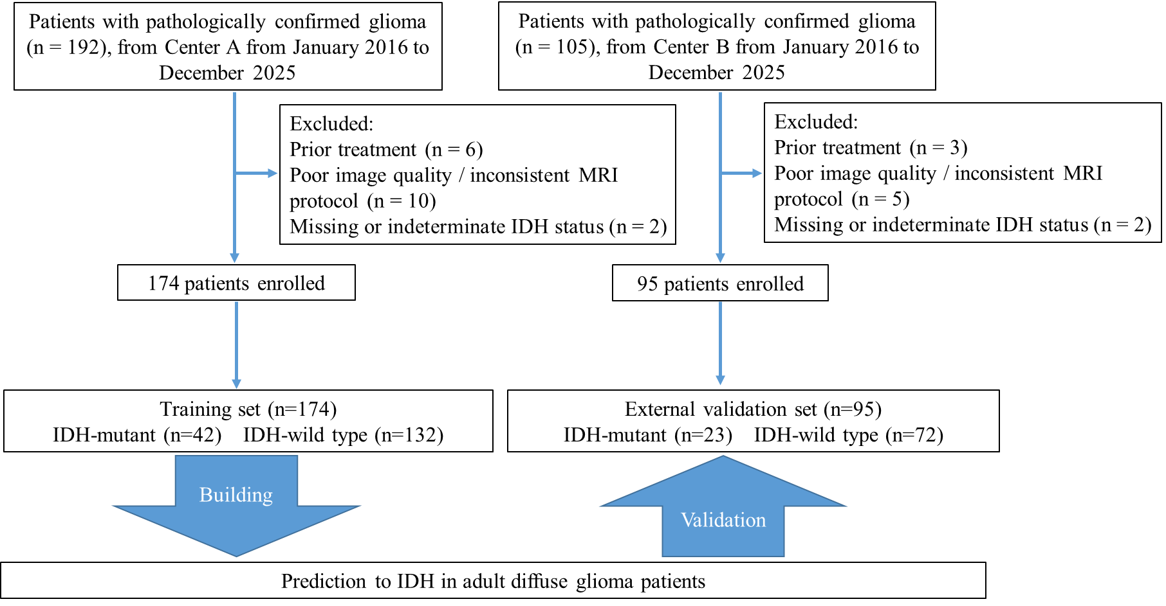
Supplementary Figure S1. The inclusion and exclusion flowchart of this study

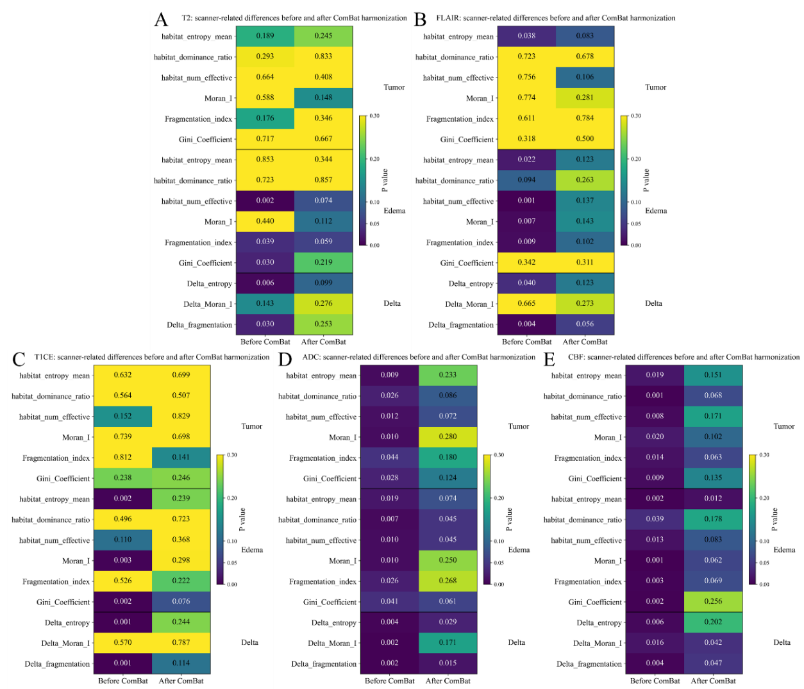
Supplementary Figure S2. Scanner-related differences of habitat metrics before and after ComBat harmonization across MRI sequences

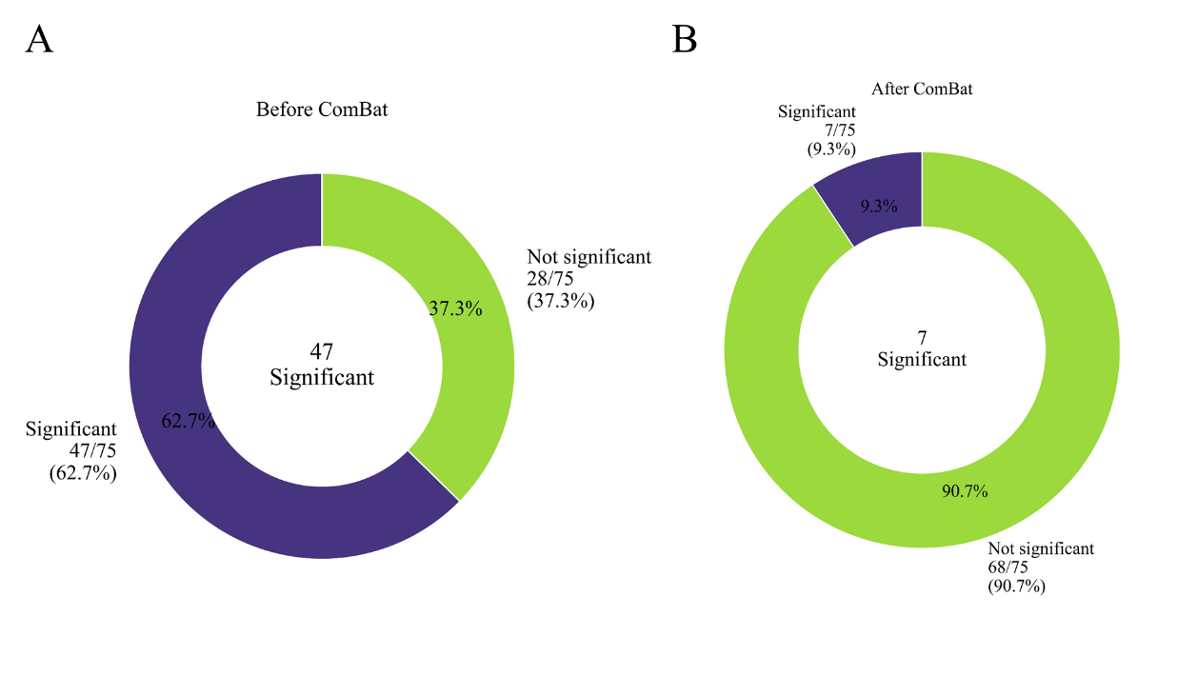
Supplementary Figure S3. Proportion of habitat metrics with significant scanner-related differences before and after ComBat harmonization

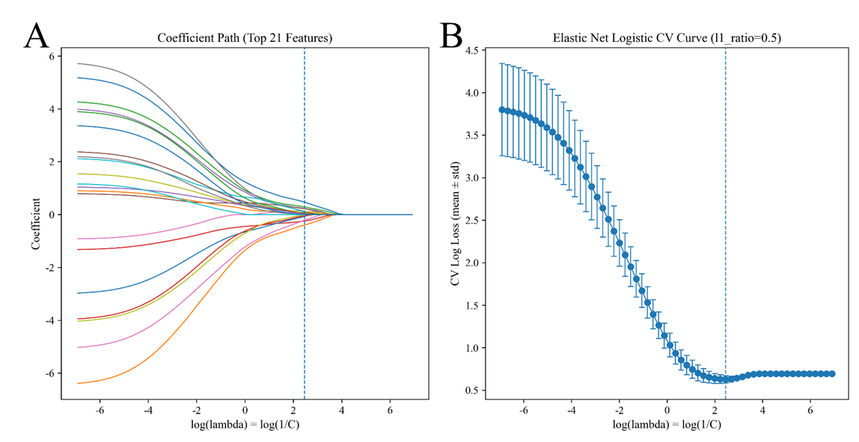
Supplementary Figure S4. Elastic Net regularization path and cross-validation performance. (A) Coefficient path of the Elastic Net logistic regression model. Each curve represents the regression coefficient of an individual feature as a function of the regularization parameter (log λ = log(1/C)). The vertical dashed line indicates the optimal regularization parameter selected by five-fold cross-validation (λ_min = 9.251; corresponding C = 0.1081), at which 15 non-zero features were retained. (B) Cross-validation curve showing the mean cross-validated log loss (± standard deviation) across different values of log λ. The optimal λ_min was defined as the value yielding the minimum mean cross-validation error.

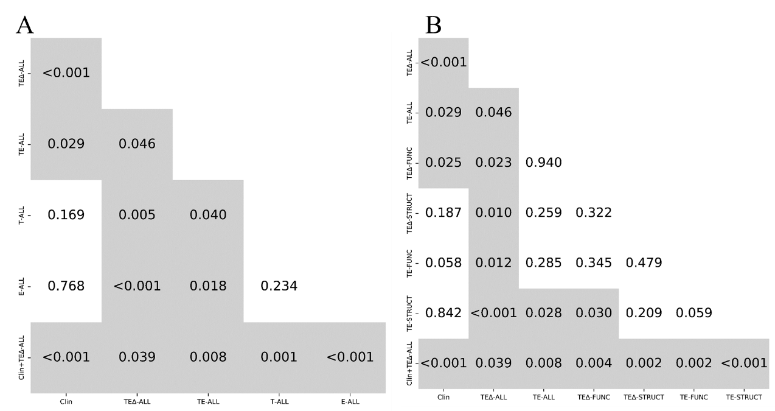
Supplementary Figure S5. Pairwise comparison of model performance using the DeLong test

