Five decades of crocodilian ecotoxicology: a global scientometric analysis of environmental biomonitoring research
Environmental Science and Pollution Research
Rayssa Lima dos Santos¹*
¹Graduate Program in Development and Environment (PRODEMA), Center for Exact and Natural Sciences (CCEN), Federal University of Paraíba (UFPB), João Pessoa, Paraíba, Brazil
*Corresponding author: rayssa.limas@ufpe.br

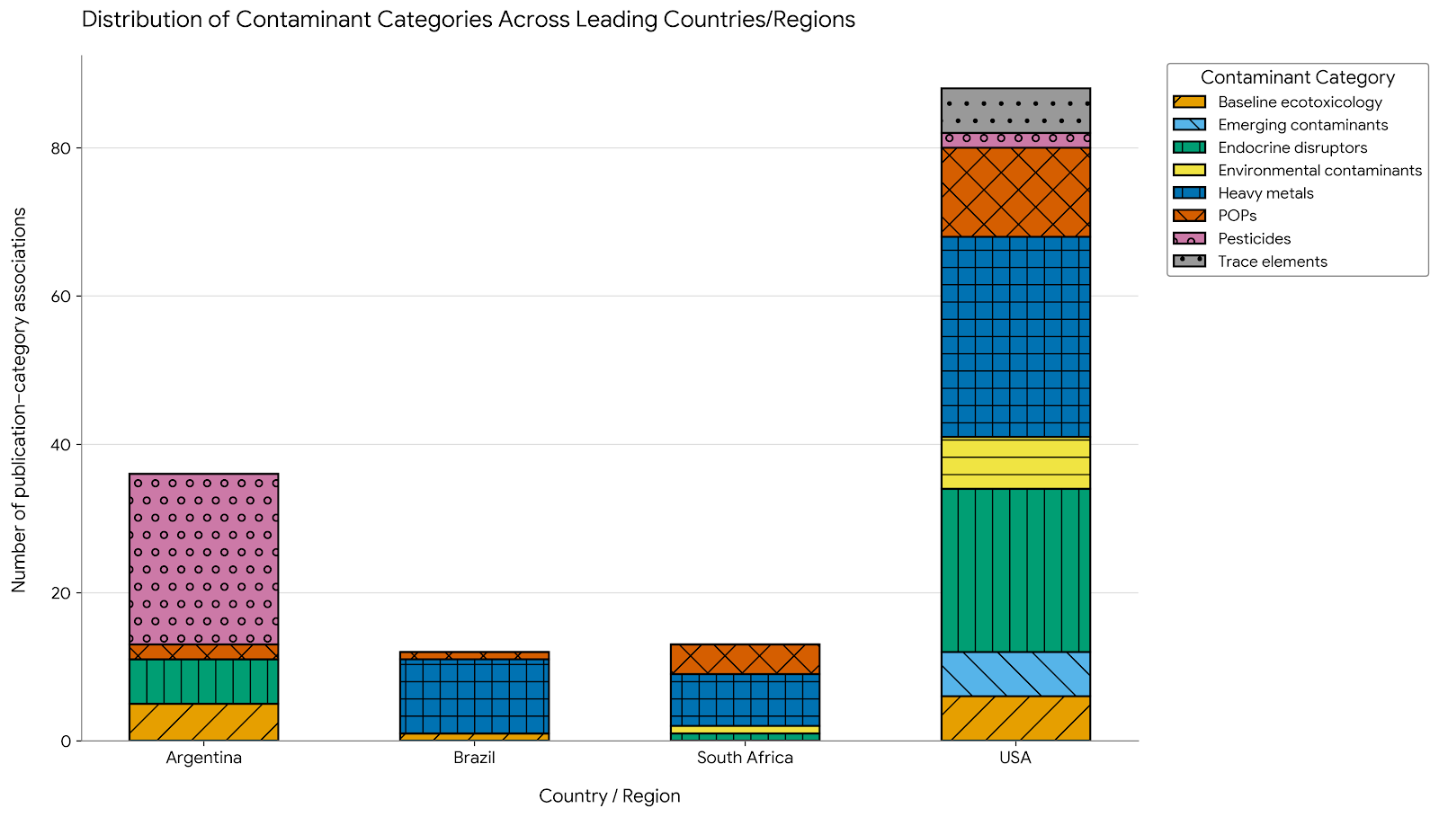Online Resource 1 Cross-tabulation of contaminant categories among the four principal research countries represented in the curated dataset. Bar segments indicate the number of unique publication–category associations recorded for each country. Publications addressing more than one contaminant category contributed once to each corresponding association; therefore, stacked totals represent publication–category associations rather than mutually exclusive publication counts.

