Extended Data Figure 1
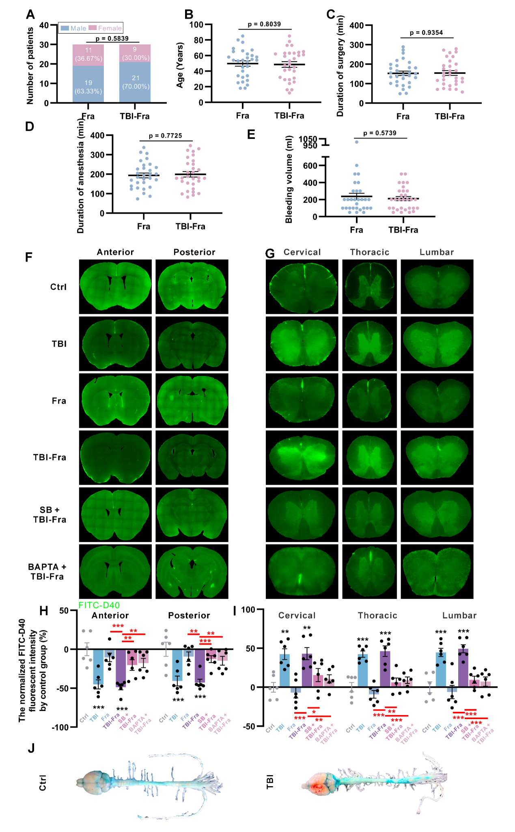

Extended Data Fig. 1. Biological and surgery-related information in patients with excessive femoral callus, and TBI promoted the transportation through PAS pathway in mice (related to Figure 1).
(A) Sex distribution of patients with femoral fracture alone and femoral fracture combined with TBI (n = 30); (B) Age distribution of patients with femoral fracture alone and femoral fracture combined with TBI. The data are shown as the mean ± SEM (n = 30); (C) Surgical duration in patients with femoral fracture alone and femoral fracture combined with TBI. The data are shown as the mean ± SEM (n = 30); (D) Anesthesia duration in patients with femoral fracture alone and femoral fracture combined with TBI. The data are shown as the mean ± SEM (n = 30); (E) Intraoperative blood loss in patients with femoral fracture alone and femoral fracture combined with TBI. The data are shown as the mean ± SEM (n = 30); (F) Distribution of FITC-D40 in anterior (0.62 relative to bregma) and posterior (-1.34 relative to bregma) sections of the cerebrum; (G) Distribution of FITC-D40 in the cervical (C3), thoracic (T5), and lumbar (L3) spinal cord; (H) Normalized relative changes in the FITC-D40 distribution in anterior and posterior sections of the cerebrum. The data are shown as the mean ± SEM (n = 6); (I) Normalized relative changes in FITC-D40 distribution in the cervical, thoracic, and lumbar spinal cord. The data are shown as the mean ± SEM (n = 6); (J) Optical images of the mouse brain, spinal cord, and sciatic nerve after CIM injections of blue dye (cadaverine); *p < 0.05, **p < 0.01 and ***p < 0.001.

Extended Data Figure 2
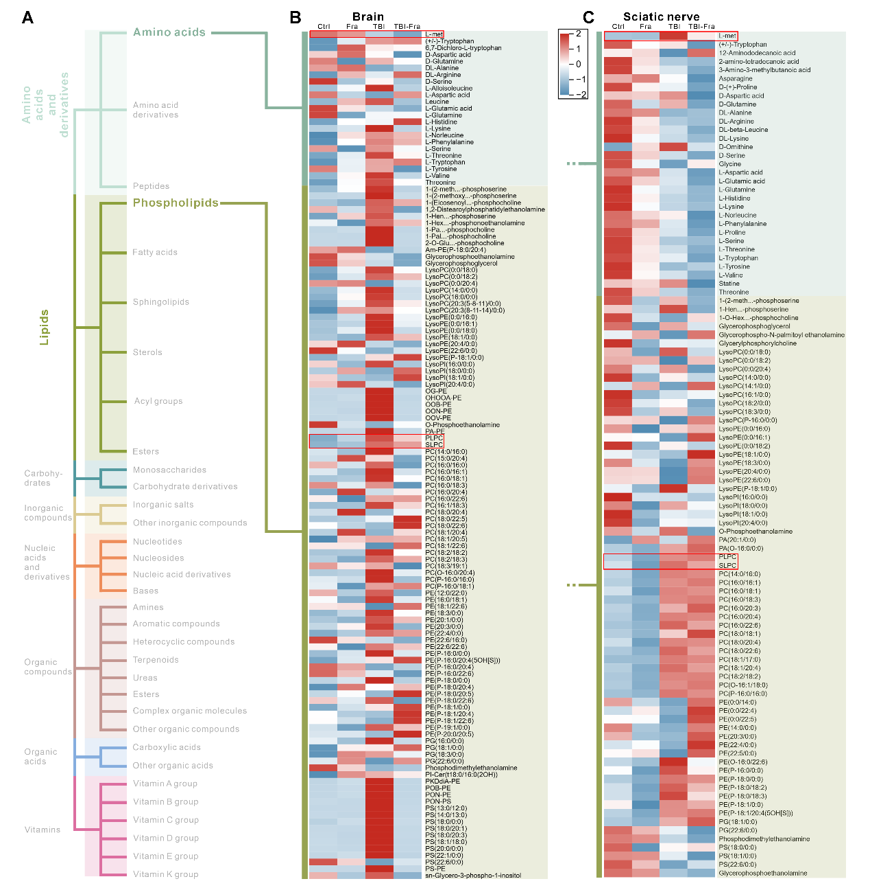

Extended Data Fig. 2. Comprehensive assessment of amino acid- and phospholipid-class metabolites in the brain and sciatic nerve tissues (related to Figure 2).
- Classification of metabolites; (B) Heatmap showing the levels of amino acid- and phospholipid-class metabolites in the injured-side brain tissue (n = 6); (C) Heatmap showing the levels of amino acid- and phospholipid-class metabolites in sciatic nerve tissue (n = 6).

Extended Data Figure 3
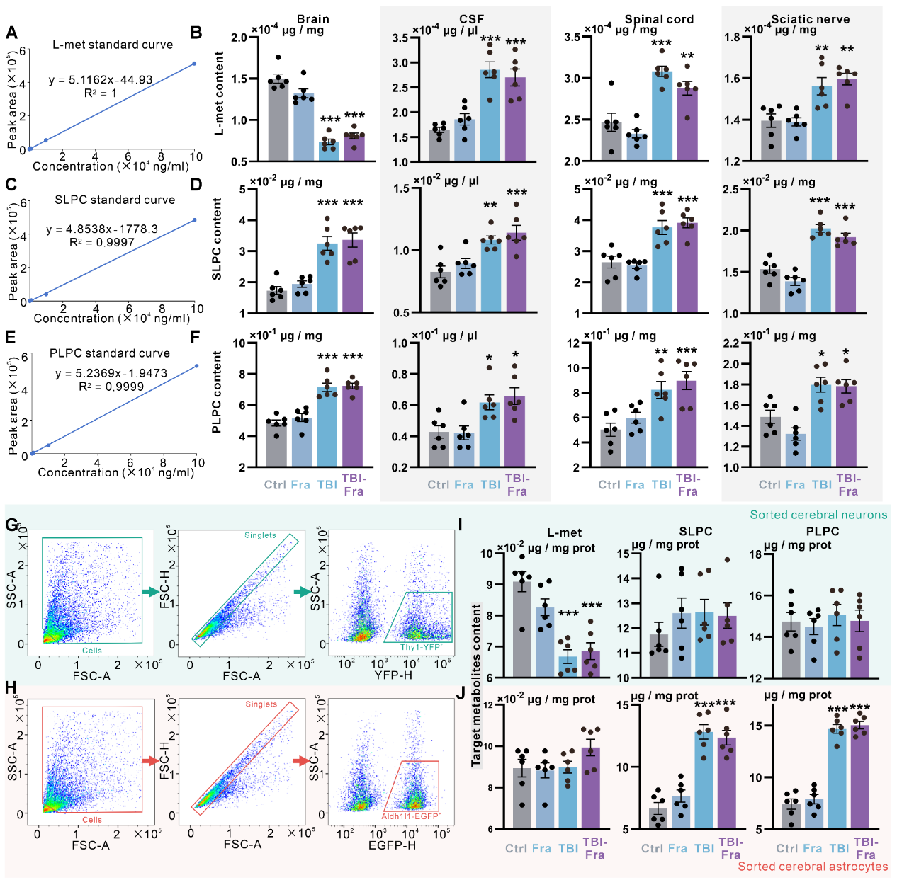
Extended Data Fig. 3. Quantification of L-met, SLPC, and PLPC in PAS transportation-related tissues and in the sorted neural cells (related to Figure 3).
(A) Standard curve for L-met quantification; (B) Absolute levels of L-met in PAS-associated tissues of the mice. The data are shown as the mean ± SEM (n = 6); (C) Standard curve for SLPC quantification; (D) Absolute levels of SLPC in PAS-associated tissues of the mice. The data are shown as the mean ± SEM (n = 6); (E) Standard curve for PLPC quantification; (F) Absolute PLPC levels in PAS-associated tissues of the mice. The data are shown as the mean ± SEM (n = 6); (G) Complete flow cytometry gating strategy for sorting brain neurons from Thy1-YFP transgenic mice; (H) Complete flow cytometry gating strategy for sorting brain astrocytes from Aldh1l1-EGFP transgenic mice; (I) Absolute levels of L-met, SLPC, and PLPC in sorted cerebral neurons of the mice. The data are shown as the mean ± SEM (n = 6); (J) Absolute levels of L-met, SLPC, and PLPC in sorted cerebral astrocytes of the mice. The data are shown as the mean ± SEM (n = 6); *p < 0.05, **p < 0.01 and ***p < 0.001.

Extended Data Figure 4
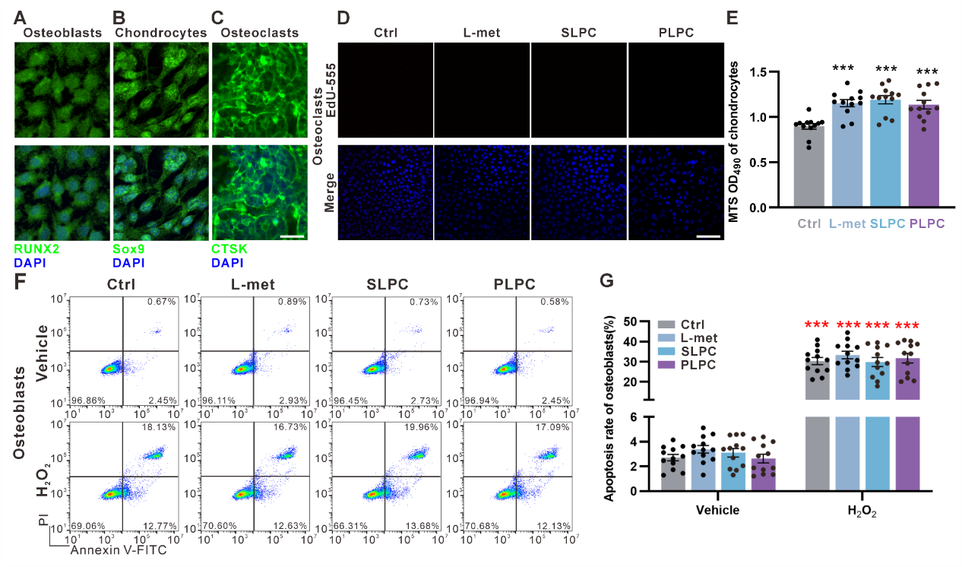
Extended Data Fig. 4. Osteoclast proliferation and osteoblast apoptosis (related to Figure 4).
- Representative IF images showing primary cultured osteoblasts labeled with the osteoblast marker RUNX2 (green). Nuclei stained with DAPI (blue). Scale bar, 25 μm; (B) Representative IF images showing primary cultured chondrocytes labeled with the chondrocyte marker Sox9 (green). Nuclei stained with DAPI (blue). Scale bar, 25 μm; (C) Representative IF images showing primary cultured osteoclasts labeled with the osteoclast marker CTSK (green). Nuclei stained with DAPI (blue). Scale bar, 25 μm; (D) Representative images of EdU-555 staining in osteoclasts. Scale bar, 100 μm; (E) Osteoclast viability assessed by MTS assays (n = 12); (F) Representative images of Annexin V-FITC/PI staining showing the effects of L-met, SLPC, and PLPC on osteoblast apoptosis with control vehicle or H₂O₂ pretreatment; (G) Effects of L-met, SLPC, and PLPC on osteoblast apoptosis rates (%) with control vehicle or H₂O₂ pretreatment. The data are shown as the mean ± SEM (n = 12); *p < 0.05, **p < 0.01 and ***p < 0.001.

Extended Data Figure 5

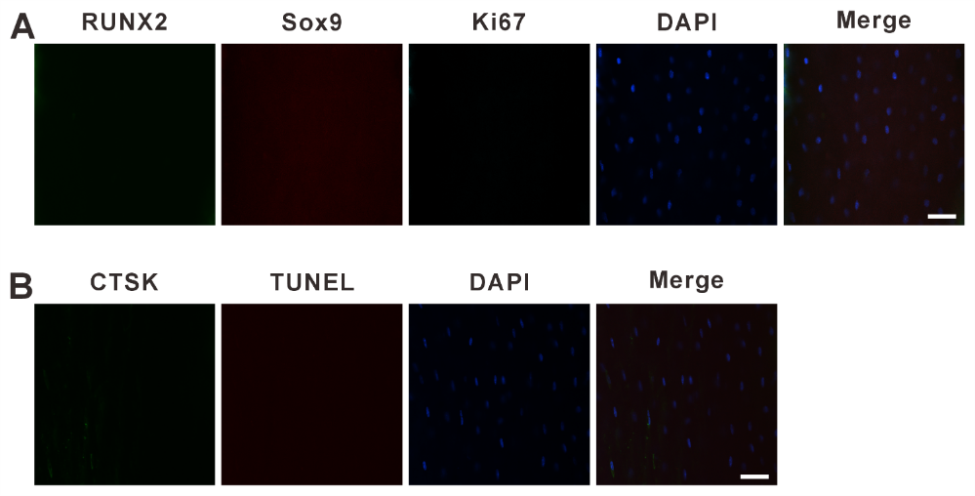

Extended Data Fig. 5. Skeletal cells in non-jured bone tissue (related to Figure 5).
(A) Representative IF images showing the osteoblast marker RUNX2 (green), the chondrocyte marker Sox9 (red), Ki-67 (cyan), and DAPI-stained nuclei (blue) in the normal cortical bone of mice. Scale bar, 25 μm; (B) Representative IF images showing the osteoclast marker cathepsin K (CTSK; green), TUNEL (red), and DAPI-stained nuclei (blue) in the normal cortical bone of mice. Scale bar, 25 μm.

