Figure S1

Figure S1. Telescope based quantification of TE expression
(A-B) Volcano plot showing DESeq2 analysis of RNA-seq data from isolated SCs comparing control (bamGal4, Blanks-GFP) and U2af38 knockdown (bamGal4 >U2af38 RNAi, Blanks-GFP) testes using Telescope. Features were colored by regulation status: upregulated (adjusted p-value < 0.05, log2 fold change > 0.2), downregulated (adjusted p-value < 0.05, log2 fold change < −0.2), or not significant. Data shown in these plots are provided in Spreadsheet 3. In B, TE aligned reads whose divergence from consensus exceeded 5% were excluded.

Figure S2
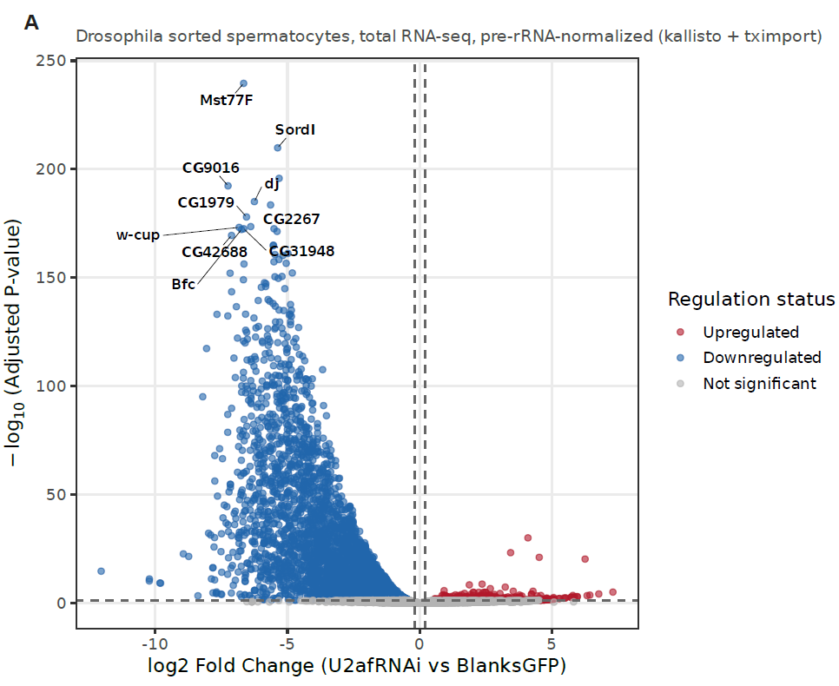

Figure S2. Gene expression changes in SCs from U2af38 knockdown testes.
Related to Figure 3L. (A) Volcano plot showing DESeq2 analysis of RNA-seq data from isolated SCs comparing control (bamGal4, Blanks-GFP) and U2af38 knockdown (bamGal4 >U2af38 RNAi, Blanks-GFP) testes using featureCounts. Features were colored by regulation status: upregulated (adjusted p-value < 0.05, log2 fold change > 0.2), downregulated (adjusted p-value < 0.05, log2 fold change < −0.2), or not significant. Only genes are shown in this volcano plot. Data shown in these plots are provided in Spreadsheet 3.

