Supplementary information
Rapid Antibiotic Susceptibility Testing by Reflectometric Interference Fourier Transform Spectroscopy on pH-responsive Hydrogel Infiltrated Porous Silicon Integrated into Microchips

Shima Abarghoe¹, Fereshteh Rahimi^{1*}, Nizami Duran^{2*}, Ali Abouei Mehrizi³, Mahsa Sedighi⁴, Mahya Mosayebzadeh³, Elif Yaprak Colak², Selin Sabanci⁵

¹ Department of Nanobiotechnology and Biomimetics, School of Life Science Engineering, College of Interdisciplinary Science and Technology, University of Tehran, Tehran, Iran, 1439957131.
² Department of Microbiology, Faculty of Medicine, Mustafa Kemal Hatay University,
Antakya-Hatay, Turkey, 31060.
³ Department of Medical Technology and Tissue Engineering, School of Life Science Engineering, College of Interdisciplinary Science and Technology, University of Tehran, Tehran, Iran, 1439957131.
⁴ Converging Technologies Research Center, Shahid Beheshti University, Tehran, Iran, 19839-69411.
⁵Department of Histology and Embryology, Faculty of Medicine, Mustafa Kemal Hatay University,
Antakya-Hatay, Turkey, 31060.

*Corresponding Authors:
Fereshteh Rahimi: orcid.org/0000-0003-0020-644X; Email: rahimi.f@ut.ac.ir, Phone: +982186093154
﻿Nizami Duran: orcid.org/0000-0002-2766-3491; E-mail: nduran@mku.edu.tr; Phone: +905334675534

Experimental materials, chemicals and microbial strains
In this study, boron-doped p⁺-type silicon wafers (thickness 525 ± 25 µm, 0.001-0.009 Ω.cm resistivity, <100>-oriented) were obtained from Latech Scientific Supply, Singapore. Hydrofluoric acid (HF, 48%), absolute ethanol, methanol and potassium hydroxide (KOH) for the fabrication of PSi were purchased from Merck (Germany). Materials used for surface modification and gelatin layer deposition on PSi, including H₂O₂ (35%, v/v), (3‑aminopropyl) triethoxysilane (APTES) and glutaraldehyde (GA) were obtained from Merck (Germany), and gelatin )Type A, molecular weight 50–100 kDa) from porcine skin was purchased from Sigma-Aldrich (Germany). Additional buffer solutions, including phosphate-buffered saline (PBS; 1 mM phosphate buffer, 154 mM NaCl, pH 7.4) and 4-(2-hydroxyethyl)-1-piperazineethanesulfonic acid (HEPES), were prepared according to standard laboratory protocols using deionized water and filtered before use. The bacterial strain E. coli (PTCC 1269) was obtained from the Persian Type Culture Collection and maintained according to the supplier's recommendations. Fresh subcultures were prepared prior to each experimental series to preserve bacterial viability and ensure phenotypic consistency throughout the study. All bacterial culture media were purchased from Quelab, while polydimethylsiloxane (PDMS) was obtained from the Sylgard® 184 Silicone Elastomer Kit (Dow Corning, USA).
Functional Validation of the CGG μchip
For validation of the CGG μchip, five identical PSiO₂ samples were first placed in the five microchannels of the nanosensor μchip. Before introducing any liquid, the effective optical thickness (EOT) of each sample was measured in air under dry conditions to provide a common reference. Following this, two comparative experiments were performed.
In the first experiment, ethanol solutions with concentrations of 25%, 50%, 75%, and 100% (v/v) were manually prepared by mixing ethanol with deionized (DI) water. The four ethanol solutions, together with pure DI water, were individually introduced into the five microchannels at a flow rate of 50 µL min⁻¹. The flow was maintained for 10 min, during which reflectance spectra were recorded every 30 s. The corresponding EOT values were subsequently extracted from the Fourier transform of the reflectance spectra using IGOR software.
In the second experiment, the same procedure was repeated using the CGG μchip. The outlets of the CGG μchip were connected to the inlets of the nanosensor μchip. Pure DI water and pure ethanol were introduced into the two inlets of the CGG μchip, generating five outlet streams with different ethanol concentrations. These streams were then delivered to the five microchannels of the nanosensor μchip. As in the first experiment, reflectance spectra were acquired every 30 s for 10 min, and the corresponding EOT values were obtained from the Fourier transform of the reflectance spectra.

Fig. S1a presents the EOT changes of the five channels relative to their corresponding dry-state values for both experiments. As can be seen, excellent agreement was obtained between the manually prepared solutions and the concentrations generated by the CGG μchip, demonstrating that the on-chip concentration gradient generator produces concentration profiles equivalent to those obtained by conventional manual mixing.

Furthermore, the measured ΔEOT values were plotted as a function of the refractive index of the corresponding solutions and fitted using a linear regression model to determine the refractive-index sensitivity of the sensing structures (Fig. S1b). The sensitivities obtained from the manually prepared solutions and the on-chip concentration gradient generated by the CGG μchip were 5244 ± 232 nm RIU⁻¹ and 5311 ± 304 nm RIU⁻¹, respectively. The excellent agreement between these values demonstrates that the CGG μchip generates concentration gradients with an accuracy comparable to that of conventional manual solution preparation. Both values are also in good agreement with the refractive-index sensitivity of 5872 ± 357 nm RIU⁻¹ previously reported for the same PSiO₂ structures in our earlier work [1]. These results further confirm that integration of the CGG μchip does not alter the intrinsic optical response of the PSiO₂ sensors.
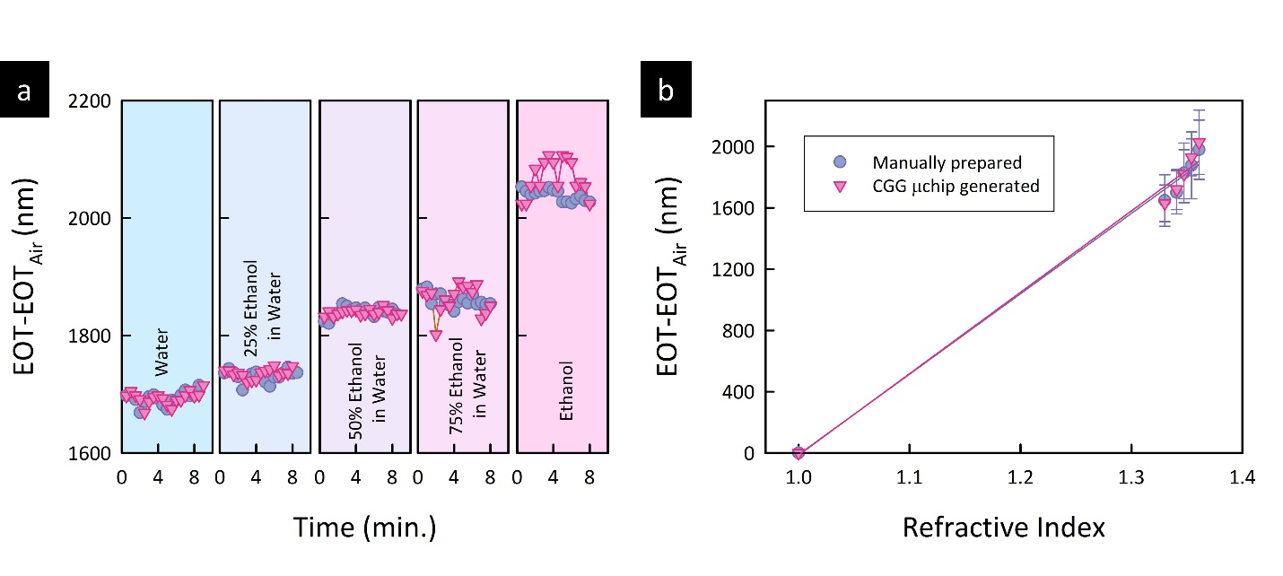
Figure S1. Validation of the CGG μchip. (a) Comparison of the ΔEOT responses of the five PSiO₂ sensors obtained using manually prepared ethanol solutions and on-chip concentration gradient generation. (b) ΔEOT versus refractive index with linear fits used to determine the refractive-index sensitivity.

FTIR
ATR-FTIR spectroscopy was used to evaluate and confirm the interaction between gelatin and the APTES-modified PSi surface and to monitor the changes in surface functional groups. Fig. S2 shows ATR-FTIR analysis after surface functionalization of PSiO₂ with APTES and gelatin deposition. Previous studies have reported FTIR spectra related to the synthesis of PSi and after oxidation ¹. After surface modification with APTES, the spectrum indicates a sharp peak at 2936 cm⁻¹ related to the symmetric stretching mode of C–H and another peak at 1483 cm⁻¹ assigned to NH₂ vibrations. Finally, after gelatin deposition on the APTES-modified PSi surface, where GA was used as a cross-linker, a broad band at 3293 cm⁻¹ is observed and assigned to the stretching vibrations of N–H/O–H groups, characteristic of the amide functionalities of gelatin. A band at 1632 cm⁻¹ appears, which can be attributed to the Amide I (C=O stretching) vibration of gelatin and may also include a contribution from C=N stretching of imine (Schiff base) bonds formed by the reaction of GA with amino groups of gelatin and APTES. The presence of this band suggests that gelatin has been cross-linked by GA and covalently attached to the APTES-modified PSi surface. In addition, the band corresponding to Amide II is observed at 1526 cm⁻¹, arising from N–H bending and C–N stretching vibrations. The peak at 1229 cm⁻¹, characteristic of the Amide III band is also detected and confirms the proteinaceous structure of gelatin. These
observations are consistent with the results of previous studies ^{1,2}.

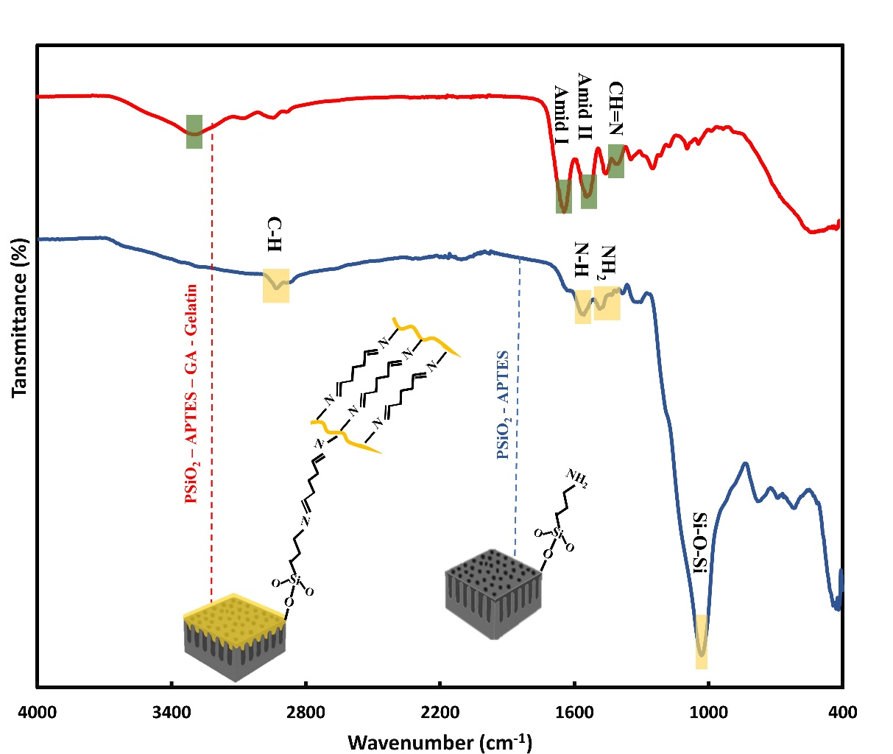
Fig. S2. ATR-FTIR characterization of the sensor surface. Comparison between APTES-functionalized PSi (blue) and gelatin-immobilized PSi (red) surfaces. The labels indicate the characteristic vibrational modes of APTES (N-H, C-H, Si-O-Si) and the newly formed amide and imine bonds (Amide I, II, and CH=N) following gelatin deposition and GA-mediated crosslinking. The schematic insets represent the molecular assembly at each modification stage.

References
1 Mohammadi, S. et al. Design, fabrication, and characterization of microfluidic-based interferometric porous silicon aptasensors for multiplexed sepsis biomarkers detection. Sens. Actuators Rep. 10, 100382 (2025).
2 Ji, F., Zhou, W., Zhang, Z. & Zhang, B. Effects of Relative Molecular Weight Distribution and Isoelectric Point on the Swelling Behavior of Gelatin Films. Front Chem 10 (2022).

