Supplementary Information
Supplementary Table 1. Fields downloaded from the clinicaltrials.gov database
Feature Name | Feature Description
NCT Number | A unique identifier for every entry in the clinicaltrials.gov database. Follows the format NCT{unique number}.
Study Title | Official title of the clinical trial.
Study Status | The current status of the trial as listed in the database. One of:  - Not Yet Recruiting: the study has not started recruiting participants.  - Recruiting: the study is currently recruiting participants.  - Enrolling by Invitation: the study is selecting its participants from a population, or group of people, decided on by the researchers in advance.  - Active, not recruiting: the study is ongoing but potential participants are not being recruited or enrolled.  - Suspended: the study has stopped early but may start again.  - Terminated: the study has stopped early and will not start again. Participants are no longer being examined or treated.  - Withdrawn: the study stopped early, before enrolling its first participant.  - Completed: the study has ended normally.  - Unknown: the status is not known and has not been verified within the last two years.
Brief Summary | A short description of the study.
Conditions | The disease, disorder, syndrome, illness, or injury being studied.
Interventions | A process or action that is the focus of a clinical study. Interventions include drugs, medical devices, procedures, vaccines, and other products that are either investigational or already available. Interventions can also include noninvasive approaches, such as education or modifying diet and exercise.
Phases | The stage of the clinical trial. One of:  - Early Phase 1: exploratory trials conducted before Phase 1 trials to investigate how or whether a drug affects the body.  - Phase 1: usually conducted with healthy volunteers to describe the safety of the drug.  - Phase 2: gathers preliminary data on whether a drug works in people who have a certain condition/disease (that is, the drug's effectiveness).  - Phase 1, Phase 2: completes the requirements for phase 1 and phase 2 trials  - Phase 3: gathers more information about a drug's safety and effectiveness by studying different populations and different dosages and by using the drug in combination with other drugs.  - Phase 2, Phase 3: completes the requirements for phase 2 and phase 3 trials  - Phase 4: clinical trials occurring after FDA has approved a drug for marketing.
Enrollment | The number of participants in a clinical study. The "estimated" enrollment is the target number of participants that the researchers need for the study.
Start Date | The actual date that the first participant was enrolled in a clinical study. The “estimated” start date is the date that the researchers think will be the study start date.
Completion Date | The date on which the last participant in a clinical study was examined or received an intervention/treatment to collect final data for the primary outcome measures, secondary outcome measures, and adverse events (that is, the last participant's last visit). The "estimated" study completion date is the date that the researchers think will be the study completion date.

Supplementary Table 2. Fields that human volunteers and LLM agents annotated. The available categories for categorical features are listed.
Feature Name | Feature Description
Delivery Mode | The method of administering the interventional drug that is being tested in the clinical study. One of:  - Injection/Infusion: administration of the drug via a syringe, needle, IV line, catheter.  - Oral: administration of the drug via the participant’s mouth.  - Topical: application of the drug directly on the skin or mucous membranes.  - Other: unknown delivery mode or not one of injection/infusion, oral, or topical.
Sequence | The sequence of the peptide drug that is being tested in the clinical study.
Outcome | The outcome of the clinical trial. One of:  - Active: the study was ongoing at the time of annotation.  - Positive: the study completed and met its clinical endpoints/safety criteria.  - Terminated: the study stopped early and will not start again. Participants are no longer being examined or treated.  - Withdrawn: the study stopped early, before enrolling its first participant.  - Failed: the study completed as normal but did not meet its clinical endpoints/safety criteria.  - Unknown: the outcome of the trial is not known.
Reason for Failure | The reported reason why a study was annotated as either ‘Terminated’, ‘Withdrawn’, or ‘Completed – failed trial’. One of:  - Recruitment issues: the study was unable to recruit enough participants.  - Business reasons: the study was interrupted by commercial concerns.  - Ineffective for purpose: the interventional drug was not effective for its intended purpose in the study population.  - Toxic/unsafe: the interventional drug demonstrated adverse effects in the study population.  - Due to COVID-19 pandemic: the study ended due to disruptions caused by the COVID-19 pandemic.  - Unknown: the reason for the study ending is unclear or not made public.

Supplementary Table 3. The distribution of trials annotated by and the educational backgrounds of the human volunteers.
Annotator | Highest Level of Education Attained | Number of Annotated Trials
A1 | Bachelor’s degree | 854
A2 | High school diploma | 309
A3 | High school diploma | 228
A4 | Post-doctoral degree | 200
A5 | Bachelor’s degree | 30
A6 | Bachelor’s degree | 20
A7 | High school diploma | 31
A8 | Bachelor’s degree | 36

Supplementary Table 4. The APIs queried by the locally installed LLMs to inform their annotation process. The weights were passed to the LLMs to reflect the source’s reliability and relevance.
Source | Weight | Data Retrieved
ClinicalTrials.gov API V2 | 0.95 | Protocol, status, interventions, arms, conditions, outcomes, intervention names
OpenFDA | 0.85 | Drug labels, adverse events, approval status
PubMed | 0.90 | Abstracts, MeSH terms, publication metadata
PMC | 0.85 | Full-text articles, figures, supplementary materials
PMC BioC | 0.80 | Structured full-text in BioC XML format
UniProt | 0.95 | Protein sequences, function annotations, subcellular localization
DRAMP | 0.80 | Antimicrobial peptide-specific annotations, MIC data, structural class
DuckDuckGo | 0.40 | General web results, news articles
Google Scholar | 0.70 | Academic citations, related articles
DBAASP API | 0.85 | MIC values, hemolytic activity, antimicrobial spectrum, structure-activity data
ChEMBL API | 0.85 | Bioactivity assays, clinical development phase, mechanism of action, target data
RCSB PDB API | 0.90 | Structural classification, molecular weight, chain length, experimental method, binding data
EBI Proteins API | 0.85 | Amino acid sequences, post-translational modifications, variants, functional annotations, GO terms
APD (HTML scraping) | 0.80 | AMP classifications, activity annotations, peptide sequences, source organism
dbAMP 3.0 (HTML scraping) | 0.80 | AMP sequences, functional annotations, antimicrobial activity, target organisms
WHO ICTRP (HTML parsing) | 0.85 | Trial registrations from 17+ international registries, status, interventions, conditions
IUPHAR Guide to Pharmacology (REST API) | 0.85 | Mechanism of action, drug targets, ligand classification, receptor-ligand interactions
IntAct (REST API) | 0.75 | Molecular interactions, interaction types, detection methods, UniProt cross-references
CARD (AJAX endpoints) | 0.80 | Resistance mechanisms, ARO terms, resistance gene annotations, drug class classifications
PDBe (Solr search + REST API) | 0.80 | Structure quality metrics (resolution, R-factor), experimental method details, deposition metadata
Supplementary Table 5. User-inputted prompts to generated LLM-based peptide clinical trial annotations via Claude Opus 4.8 v2.1.177. The Python scripts and README files used for the annotation tasks can be found at https://github.com/BirolLab/LLM-Clinical-Trial-Annotator
Task | Prompt
Selecting interventional peptide drug trials | given the file, 'ctg-studies_06_12_2026.csv', containing information about clinical trials, select for interventional clinical trials (of any phase) that actually test peptide-based pharmaceutical agents. Ensure that your decisions are evidence based. Consult external sources where necessary. Save the peptide-based clinical trials (all of the columns in the original file) in a new CSV file titled: ctg-studies_peptide_trials_06_12_2026.csv
Delivery mode annotation | Based on the instructions in the README file and running the python files in this subdirectory, annotate all of the clinical trials with ClinicalTrials.gov NCT ID in ctg-studies_peptide_trials_06_12_2026.csv with the delivery mode of the drug. Use a variety of resources from the web to make the annotation decision, including but not limited to the ClinicalTrials.gov API, FDA databases, peer-reviewed literature, pharmaceutical company websites, and more. If unsure of the delivery mode of the drug, write Other. Save your progress in batches as you go in case I unexpectedly lose connection.
Sequence annotation | Based on the instructions in the README file and running the python files in this subdirectory, annotate all of the clinical trials with ClinicalTrials.gov NCT ID in ctg-studies_peptide_trials_06_12_2026.csv with the sequence of the drug. Use a variety of resources from the web to make the annotation decision, including but not limited to the ClinicalTrials.gov API, FDA databases, peer-reviewed literature, pharmaceutical company websites, and more. If unsure of the sequence of the drug, leave blank. Save your progress in batches as you go in case I unexpectedly lose connection.
Outcome annotation | Based on the instructions in the README file and the python files in this subdirectory, annotate all of the clinical trials with ClinicalTrials.gov NCT ID in ctg-studies_peptide_trials_06_12_2026.csv with the outcome of the trial. Use a variety of resources from the web to make the annotation decision, including but not limited to the ClinicalTrials.gov API, FDA databases, peer-reviewed literature, pharmaceutical company websites, and more. If unsure of the outcome of the trial, mark as unknown. Save your progress in batches as you go in case I unexpectedly lose connection.
Reason for Failure annotation | Based on the instructions in the README file and the annotate_peptides.py file, annotate all of the clinical trials with ClinicalTrials.gov NCT ID in ctg-studies_peptide_trials_06_12_2026_OUTCOME_final.csv with the reason for failure of the trial if the trial was suspended, withdrawn, terminated, or completed but reported failed results. Use a variety of resources from the web to make the annotation decision, including but not limited to the ClinicalTrials.gov API, FDA databases, peer-reviewed literature, pharmaceutical company websites, and more. If unsure of the sequence of the drug, leave blank. Save your progress in batches as you go in case I unexpectedly lose connection.
Annotation validation | Given the instructions in the 4 README files in this subdirectory and an annotated peptide clinical trial CSV file (ctg-studies_peptide_trials_06_12_2026_MASTER_annotated.csv), validate the values in the 'Delivery Mode', 'Outcome', 'Reason for Failure' and 'Sequence' columns. Look for mistakes and make corrections where possible. Update the reasoning/evidence columns as necessary. Do not hallucinate, all annotations must be evidence-based. Save the validated trials in a file called validated_peptide_trials_06_14_2026.csv

Supplementary Table 6: Disk storage size (GB) and context length of locally installed LLMs to annotate clinical trials on a personal machine.
Model | Disk Storage Size (GB) | Context Length
Llama 3.1:8b | 4.9 GB | 131,072
Gemma 3:12b | 8.1 GB | 131,072
Qwen3:8b | 5.2 GB | 40,960
Qwen 3:14b | 9.3 GB | 40,960

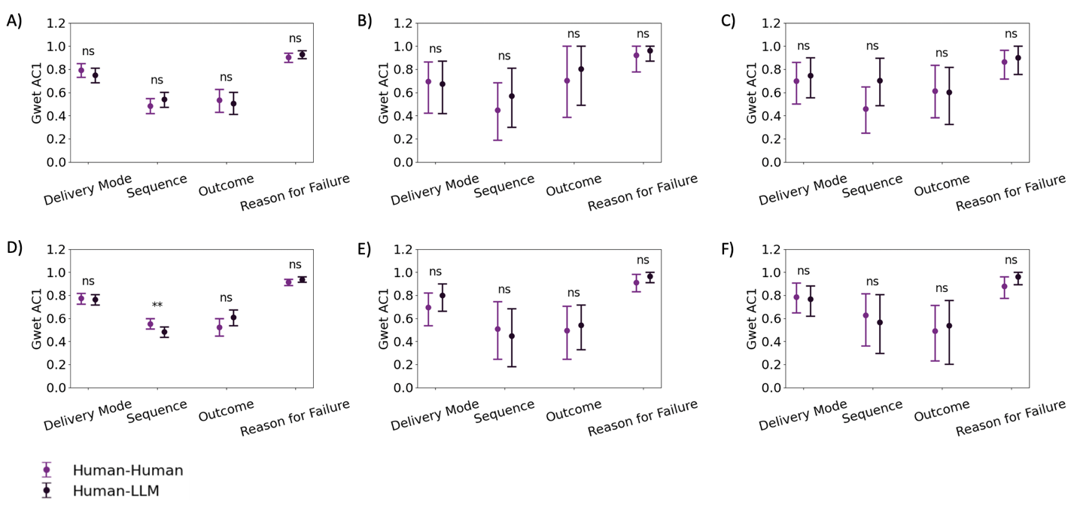

Supplementary Figure 1. Inter-rater agreement (AC1) scores for each annotated feature comparing human annotations with annotations generated by Claude and a locally installed LLM. Panels A–C show agreement between human and Claude annotations for the training (n = 234), validation (n = 27), and test (n = 32) datasets, respectively. Panels D–F show agreement between human and locally installed LLM annotations for the training (n = 453), validation (n = 58), and test (n = 28) datasets, respectively. AC1 scores are only calculated for overlapping trials in both datasets.

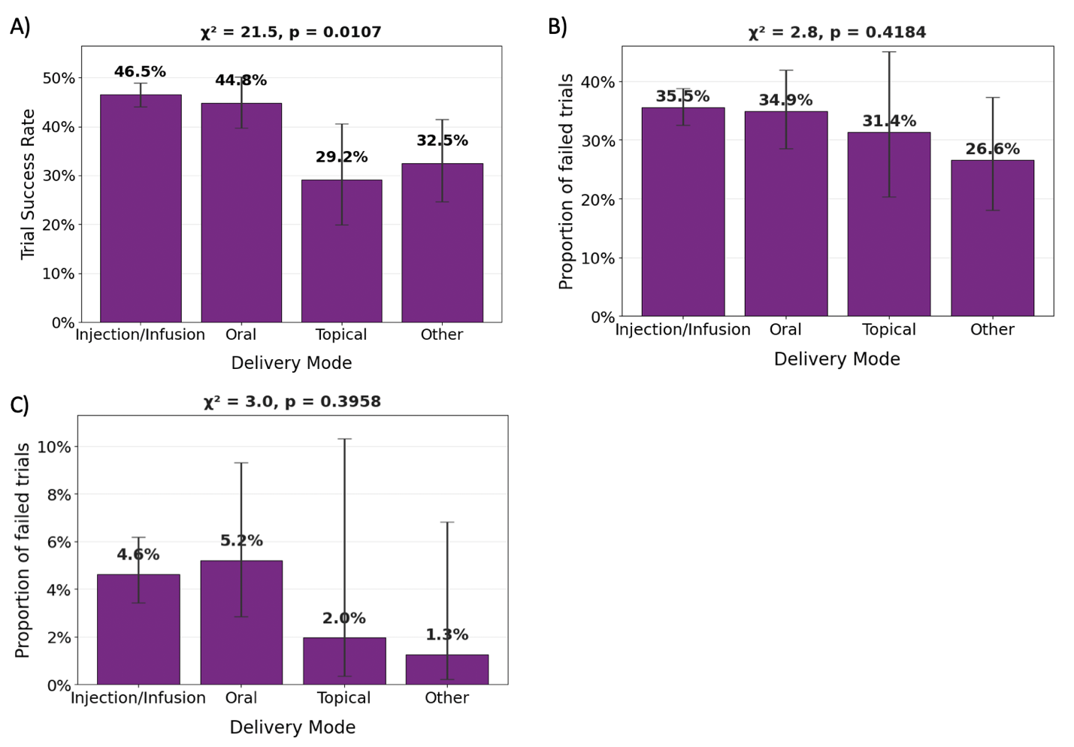
Supplementary Figure 2. A) The proportion of successful peptide clinical trials and the proportion of failed clinical trials for trials that failed due to B) ineffectiveness and C) safety concerns across different delivery modalities. Chi-squared tests were conducted for each analysis with chi-square values and p-values being reported. 95% confidence intervals are also shown on each bar.

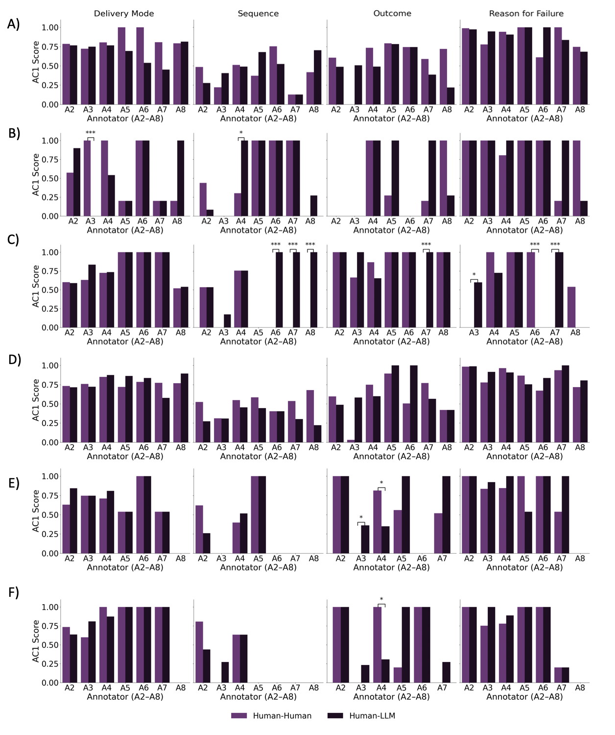
Supplementary Figure 3. Inter-rater agreement (AC1) scores for each annotated feature comparing each individual human annotator with annotations generated by Claude and a locally installed LLM. Panels A–C show agreement between human and Claude annotations for the training (n = 234), validation (n = 27), and test (n = 32) datasets, respectively. Panels D–F show agreement between human and locally installed LLM annotations for the training (n = 453), validation (n = 58), and test (n = 28) datasets, respectively.
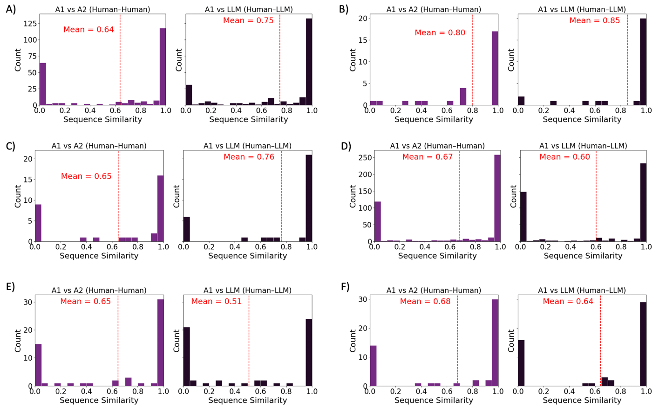
Supplementary Figure 4. Distribution of sequence similarity scores between human-annotated peptide sequences and LLM-generated sequence annotations. Panels A–C show sequence similarity distributions for Claude-generated annotations in the training (A; n = 234), validation (B; n = 27), and test (C; n = 32) datasets, respectively. Panels D–F show sequence similarity distributions for annotations generated by a locally installed LLM in the training (D; n = 453), validation (E; n = 58), and test (F; n = 28) datasets, respectively.

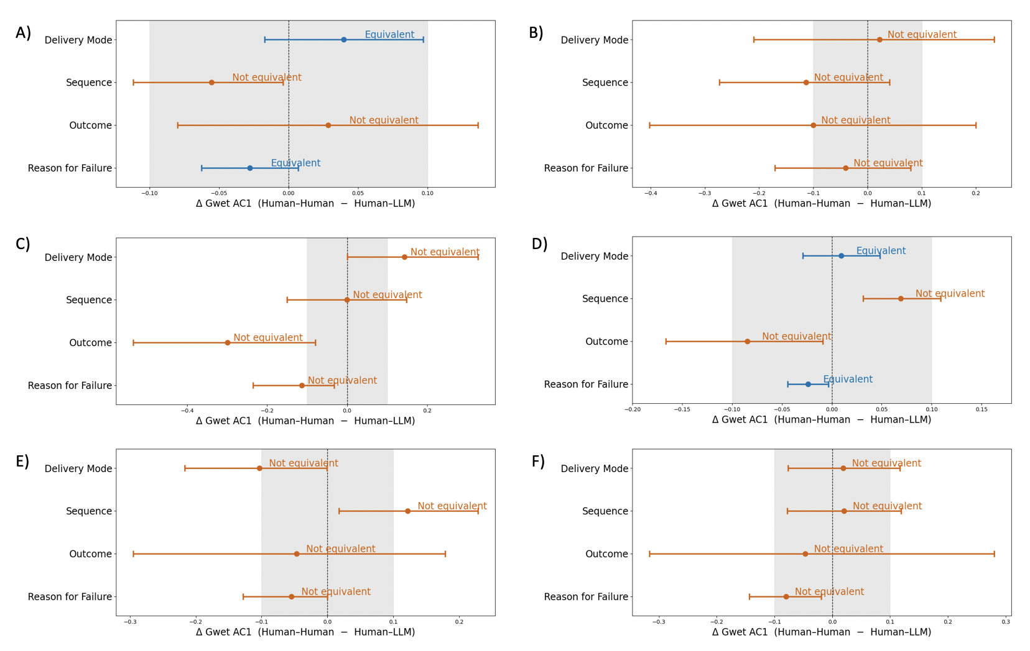Supplementary Figure 5. Two one-sided tests (TOST) for equivalence comparing inter-rater agreement (AC1) between human–human and human–LLM annotations for each annotated feature. Panels A–C show the equivalence analysis for the training (n = 234), validation (n = 27), and test (n = 32) datasets, respectively, for the comparison between human and Claude annotations. Panels D–F show the corresponding equivalence analysis for the training (n = 453), validation (n = 58), and test (n = 28) datasets, respectively, for the comparison between human and locally installed LLM annotations. Points represent the difference in AC1 (human–human − human–LLM), and horizontal error bars denote the 90% bootstrap confidence intervals. The shaded region indicates the prespecified equivalence margin (Δ = ±0.1 AC1 units).

Supplementary Text 1. The standard-operating-procedure used to guide volunteers through the manual annotation process.

This SOP was originally developed for manual annotation of AMP-related trials and later generalized to peptide-based therapeutics as described in the main text.

SOP # jAMP1.2_short ver.
jAMPoree
Last revised: 02 July 2025

REVISION HISTORY
Revision Date Author Position
1.1 02-July-2025 Emily Zhang MSc student, Birol Lab
1.2 04-July-2025 Emily Zhang MSc student, Birol Lab

DOCUMENT APPROVAL
Approval by: Whom document was approved by (Laboratory Safety Officer, Principal Investigator, Supervisor)

_______________________________________ _______________________
Approval Signature Date approved

*If a copy of this standard operating procedure is printed, it is the users’ responsibility to verify that the copy is the most current version of the document

PURPOSE
This SOP outlines the standardized process for manually annotating peptide-based drug clinical trials on clinicaltrials.gov. With the annotations of the clinical trials, we hope to publish a literature review documenting the current landscape of AMPs in clinical use and to create a machine learning model that predicts clinical trial outcomes. The model will use sequence information, delivery mode, etc., to predict whether an AMP trial will be successful (thus the AMP is both safe and effective), or whether it will fail (and why it failed). As such, it’s important that we’re detailed and consistent when annotating trials with their respective sequences and outcomes.

DESCRIPTION
This procedure applies to all team members responsible for:
- Researching and extracting data from websites like clinicaltrials.gov, PDFs, databases, and other sources.
- Inputting data into the project’s central data repository (Google Sheets/insert link)
- Inputting prompts to LLMs and interpreting and documenting responses to verify data accuracy.

PROCEDURE
- Open the spreadsheet and review your assigned rows/trials to ensure that you are annotating the correct trials. Read and understand all the required fields.
- Find the drug in the interventions column (column F) and cross-reference it with the clinicaltrials.gov site for that study to ensure you are gathering data for the correct drug.
- Verify that this drug (denoted F) is a peptide. Can look for:
  - The long summary on clinicatrials.gov. Sometimes they refer to the drug as a peptide.
  - Peer-reviewed papers referencing it as a peptide.
  - Other websites you deem reputable (biotech newspapers, for example)
  - If it’s not a peptide, mark column V (peptide?) as FALSE and leave columns K-U blank. Else mark column V (peptide?) as TRUE.
- Determine the classification of the drug. These are ‘AMP (infection)’, ‘AMP (other)’, and ‘Other’:
  - AMP (infection): AMPs used to treat infectious diseases. For the purpose of this activity, we’ll define AMPs as peptides that are antimicrobial in nature (including immunomodulatory AMPs).
  - AMP (other): AMPs (as per the prior definition) being used to treat a non-infectious disease, such as obesity.
  - Other: any other peptide-based drug
    - To determine whether or not a drug is an AMP, you can search for it by name in http://dramp.cpu-bioinfor.org/ or https://dbaasp.org/search. If nothing appears, it may not be an AMP. To confirm, you can try to find the mode of action of the drug and if it is not antimicrobial, we can classify it as ‘Other’.
    - Infectious disease refers to an illness caused by pathogenic microorganisms such as bacteria, viruses, fungi, parasites, etc
- After classifying the drug, document it by writing one of ‘AMP (infection)’, ‘AMP (other)’, or ‘Other’ under the ‘Classification’ column (K). Paste all of the links you used to make your decision in the ‘Evidence link(s)’ column (L). For all evidence links, if you are on Google Chrome, you can highlight the exact phrase you used, right click, and select “Copy Link to Highlight” to provide more specific sources.
- Determine the delivery mode of the drug. This can almost always be found directly on the clinicaltrials.gov website (I am just unable to download it for some reason). It is usually listed under the ‘Study Plan’ tab within the ‘Arms and Interventions’ table. Just locate the drug of interest and it’ll usually say how it’s administered. Document the delivery mode in column M by selecting an item from the drop down tab
  - Keep this section fairly brief. No need to include information about dosage, number of treatments, etc
  - If you select ‘Other’ specify the delivery mode in the comments column (W)
- Determine the peptide sequence of the drug.
  - You can search through databases like http://dramp.cpu-bioinfor.org/ or https://dbaasp.org/search if it is an AMP
  - If it is part of a known protein sequence, you can look through databases like https://www.uniprot.org/ and select the residues that are being used in the study (eg: if the drug name has the format DNase (12-40), you can find the sequence for DNase and select residues 12-40).
  - Databases like https://go.drugbank.com/ also have peptide sequences of many drugs.
  - Sequences will also be published in scholarly articles about that drug.
  - https://violinet.org/ may have vaccine sequences under detailed gene information
  - Ensure that the sequence is in single letter amino acid format if possible. If it is in three letter format, you can run it through https://www.bioinformatics.org/sms2/three_to_one.html to convert it.
  - Document the peptide sequence in column N. Some of the sequences I have automatically grabbed with a Python script from DRAMP but it may not be the correct sequence. Check to see if the sequence is correct - the DRAMP name for that peptide is listed in column O - you can cross-reference this with your peptide of interest. The DRAMP sequence is mostly likely incorrect but in the few instances where it is correct, it’ll save you some time. You do not need to fill in column P if the peptide is correct.
    - If the DRAMP sequence is incorrect, delete the data columns N and O and start again at 7a
  - Document the links to the databases/websites you used to get the peptide sequence in column P.
  - Note: occasionally the sequences are in the study description, which makes your life a lot easier but this is fairly rare so I wouldn’t count on it.
- Look for publications detailing study results.
  - Search the name of the study and look for scholarly articles. Oftentimes, study names and publication names will match.
  - If nothing comes up, you can search the PI’s name (found under collaborators and investigators tab in clinicaltrials.gov) and some relevant keywords (eg: drug name, condition, clinical trial ID)
  - If you can’t find anything, just write ‘Unknown’
  - If you can find a scholarly article, put either its PMID or DOI in column Q. If there’s no PMID or DOI, can include the link to the article.
  - Determine the outcome of the clinical trial.
  - If the trial is associated with a scholarly article, you can read its abstract, conclusion, or discussion to determine the outcome of the trial. It will often state if it was effective, safe, toxic, ineffective, etc.
  - (Phase 1 & 2 drugs) To see if a drug moved on to the next clinical trial phase, you can try searching for the drug + sponsor/PI with the correct phase search filter selected in clinicaltrials.gov - cross reference dates just to double check.
  - If a drug has moved on to the next phase, we can assume it’s a positive outcome. Select ‘Positive’ in column R and paste the subsequent trial ID in column ‘T’
  - If you can’t find a subsequent trial nor a paper describing results, you can search the trial name/ID and look for news reports from biotech sites. Often companies will announce positive results.
  - If there’s a positive results with no subsequent trial, you can just select ‘Positive’ in column R
  - For Phase 1: positive results usually means that the drug is SAFE
  - For Phase 2: positive results means that the drug is effective (and safe) in the study cohort
  - NOTE: we are concerned with peptides that meet these criteria and we don’t necessarily care about how it compares to existing drugs on the market.
  - (Phase 3 drugs) Here, you’re checking that the drug is on the market or pending approval with some regulatory body. Search the drug name + company name and see if it is being sold. Oftentimes, biotech news sites will also report if a drug has been FDA approved or if a study has been terminated for example. If it has been approved, select ‘Positive’ in column R
  - If it is not on the market yet, you can look through the scholarly article describing results (if made available) to determine that the drug is safe and effective in the larger cohort. This can also be marked as ‘Positive’ in column R
  - If you think a clinical trial has ‘Failed, document why (if possible).
  - Similarly, you want to be looking at papers, biotech websites, etc. and select the appropriate reason in column S.
  - Often if the status is ‘Withdrawn’ or ‘Terminated’ on clinicaltrials.gov, the reason will be made available. Select the correct status in column ‘R’ and the appropriate reason in column.
    - 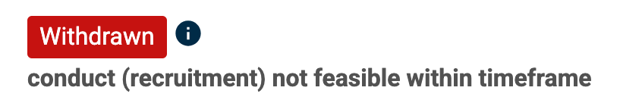(this would go under ‘Recruitment issues)
  - Paste all of the links to the sites you used to make your decision in column U
- If the drug is a cancer vaccine, write that in column W (comments)
- If you have any other comments, write them in column W

