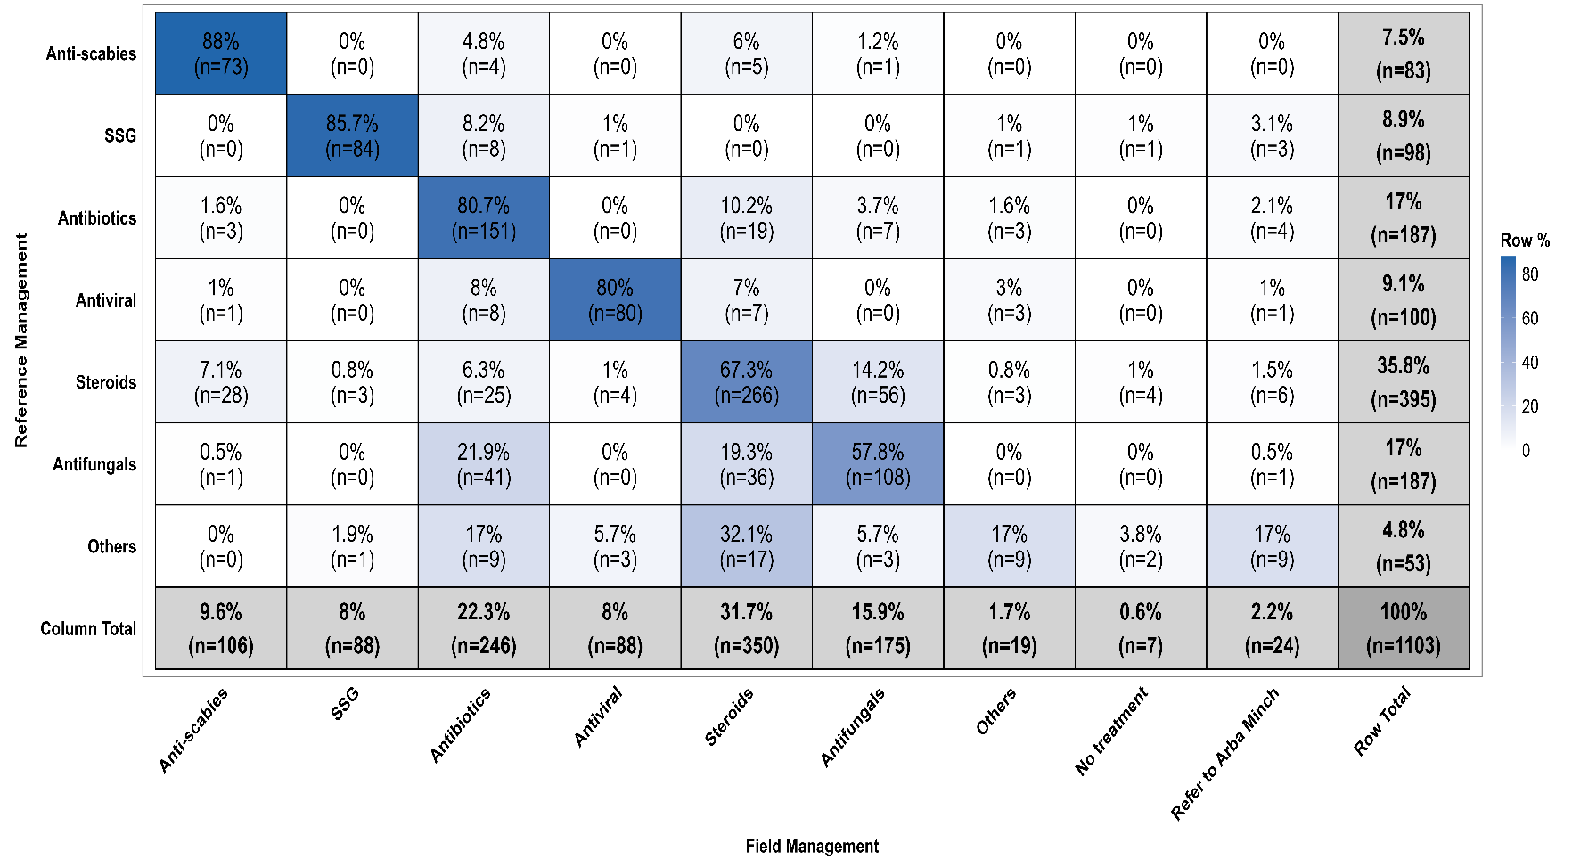
Additional file Figure S4. Row-normalized management concordance matrix heatmap with cell colors representing the row-wise proportions among the overall study populations: The matrix displays management concordance and discordance between reference management (rows) and primary hospital management (columns). Values within cells indicate percentages (%) and corresponding counts (n), with each row summing to 100%. Colors indicate the row-wise percentage of cases, showing for each reference management the proportion correctly managed (diagonal) versus discrepancies (off-diagonal) between primary hospitals' physicians' practice and reference recommendations. SSG = sodium stibogluconate.

