Additional file S1: Pre and post-training tests for clinical professionals, August 2023, Arba Minch, Southern Ethiopia.

Code ___________________________

Choose the best possible answer from the given options

- What is the most commonly recognized reservoir for cutaneous leishmaniasis (CL) in Ethiopia
- Cows
- Hyraxes
- Goat
- Rats
- I do not know
- Choose the wrong statement about L. aethiopica
- It results in long-standing CL
- It causes MCL and DCL
- It is the culprit agent in more than 90% of Ethiopian cases
- Mostly causes adult infection
- I don’t know
- The vector for CL is:
- Mosquitoes
- Sand flies
- Black flies
- Prolonged contacts
- I do not know
- Which of the following geographic areas does CL mostly occur?
- Highlands greater than 1500m above sea level
- Lowlands less than 1000m below sea level
- Highlands greater than 2700m above sea level
- Both in the highlands and lowlands
- I do not know
- What is most likely of a CL diagnosis
- Itchy lesion on the anterior chest
- Painful and pus-discharging lesion
- Chronic crusted face lesion
- Painless hypopigmented patch
- I don’t know
- These are the options of treatment for CL except:
- Topical Treatment
- Systemic treatment
- There are no modern treatments available for CL
- Heat therapy
- I don’t know
- One of the following is not a common site for scabies
- Wrist
- Face
- Palms
- Waist
- I don’t know
- What is the typical presentation of superficial fungal infection on the body?
- Annular lesion
- Peripherally active but centrally clearing lesion
- Scaly centrifugally spreading papular lesion
- All
- I don’t know
- How many types of impetigo are there?
- Three
- Two
- Five
- Four
- I don’t know

- What is the best mode of treatment delivery for Tinea capitis
- Antifungal cream
- Antifungal shampoo
- Oral antifungal drug
- Antifungal topical application
- I don’t know
- The pathognomonic sign of scabies is:
- Burrow
- Circle of Hebra
- Severe itching
- Finger web involvement
- I do not know
- Which one of the following is true about non-bullous impetigo?
- Mainly affects neonates
- Is usually associated with fever
- Can be treated with topical antibiotics
- Is a less common form of impetigo
- I do not know
- When we draw an imaginary line following the common body sites of involvement of scabies results in:
- A serpiginous line
- A circle
- A burrow
- A zigzag
- I do not know
- One of the following is not a factor in developing bacterial infection?
- The portal of entry
- The host immunity
- The pathogenic properties of the organism
- None
- I do not know
What is the most likely clinical diagnosis of each of the images listed below from 15 to 20?
- Cutaneous leishmaniasis:
- Tinea Capitis:
- Impetigo:
- Scabies:
- Tinea corporis:
- Psoriasis/eczema:
B. 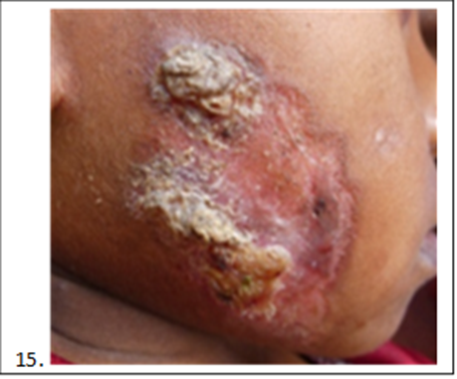

A.

D.
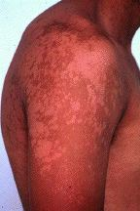
C.

F. 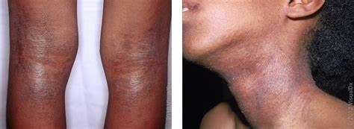

E.

Answers:
- B | 11. A
- D | - C
- B | - B
- A | - D
- C | - B
- C | - A
- B | - C
- D | - E
- B | - D
- C | - F

