Additional file S1: Pre and post-training tests for Laboratory professionals, August 2023, Arba Minch, Southern Ethiopia.

ID or Code of trainer: ………………………………………

Directions: Please, if you do not know the answer to the questions below, do not guess and just choose I do not know. Indicating this will have no further consequences for you.
- Which of the following tests are not applied for skin disease?
- Skin scraping
- Blood smear
- 10% KOH wet mount
- Cerebrospinal fluid (CSF)
- I do not know
- Who is responsible for doing the diagnosis of cutaneous leishmaniasis?
- Clinician
- Laboratory professionals
- Clinician with lab confirmation
- Other (specify)
- I do not know
- Which tool is used to collect a sample from a cutaneous leishmaniasis (CL) patient?
- Scalpel/surgical blade
- Syringes
- Blood lancets
- All can be used
- I do not know
- Which sample type is commonly used to diagnose CL microscopically?
- Skin tissue sample
- Blood sample
- Buffy coat sample
- Serum or plasma
- I do not know

- Where in the CL skin lesion should samples be collected most commonly?
- Reddish part around the lesion
- Border of the lesion
- Center of the lesion
- A and B are correct
- I do not know
- Which reagent is commonly used to fix cutaneous leishmaniasis samples on the microscopy slide?
- Methanol
- Ethanol
- 70 % denatured alcohol
- Acid alcohol
- I do not know
- Which staining method is commonly used to visualize Leishmania parasites microscopically?
- Gram’s stain
- Acid fast stain
- Giemsa stain
- KOH stain
- I do not know
- Which microscopic objective is used to visualize the Leishmania parasites?
- 100x with immersion oil
- 10X dry objective
- 40x wet and dry mount
- I do not know
- What is the typical laboratory finding for the microscopic diagnosis of Cutaneous leishmaniasis from a skin lesion?
- Trophozoite stages of Leishmania
- Promastigote stages of Leishmania
- Amastigote stages of Leishmania
- Tropomastigote stages of Leishmania
- I do not know

- How many fields should be read to indicate a slide is negative for CL?
- 200 fields
- 100 fields
- 10 fields
- 1000 fields
- I do not know
- Which sample can be collected for the diagnosis of bacterial skin infections
- Wound swab
- Pus
- Wound exudate
- All of the above
- I do not know
- Which method is used for sample staining for the diagnosis of bacterial infections?
- 10 - 20% KOH stain
- Gram’s stain
- Acid fast stain
- Giemsa stain
- I do not know
- How do Gram-positive and Gram-negative bacteria look in a Gram stain?
- Gram-positive is purple, and Gram-negative is blue
- Gram-positive is red, and Gram-negative is purple
- Gram-positive is purple, and Gram-negative is red
- Gram-positive is red, and Gram-negative is blue
- I do not know
- Which sample type should be collected for the laboratory diagnosis of superficial and cutaneous fungal infections?
- Skin, nail, hair scrapings, and swabs
- Cerebrospinal fluid (CSF)
- Blood, urine, and urogenital specimen
- Tissue biopsies from visceral organs
- I do not know

- Which reagent is used to visualize the fungus (yeasts) under the microscope?
- Acid-fast stain
- 10 - 20% KOH stain
- Giemsa stain
- Gram’s stain
- I do not know
- What sample type is used for leprosy diagnosis?
- Sputum
- Skin or nerve scraping
- Blood
- Aspiration
- I do not know
- Which staining method is used for leprosy diagnosis?
- 10 - 20% KOH stain
- Acid fast stain
- Giemsa stain
- Gram’s stain
- I do not know
- In which colour does Mycobacterium leprae appear microscopically?
- Purple
- Blue
- Pink
- Violet
- I do not know
- Which sample is collected for the diagnosis of Lymphatic filariasis (images on the right side)?
- Blood
- Skin scraping
- Pus
- Exudate
- I do not know

- Which staining method is used to stain samples taken from lymphatic filariasis patients?
- 10 - 20% KOH stain
- Acid-fast stain
- Giemsa stain
- Gram’s stain
- I do not know
- What are the typical laboratory findings for the microscopic diagnosis of lymphatic filariasis?
- Eggs of microfilaria seen
- Adult stages of microfilaria seen
- Larval stages of microfilaria seen
- Microfilaria seen
- I do not know
What are the most likely laboratory findings of each of the images listed below from A to H?
23
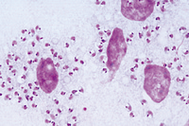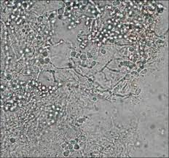
22

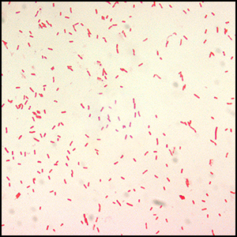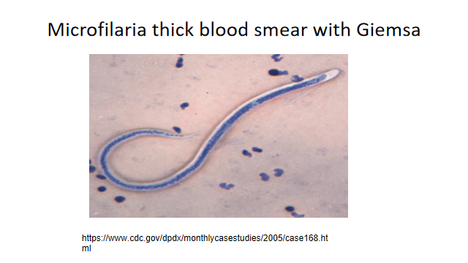
25
24

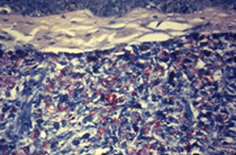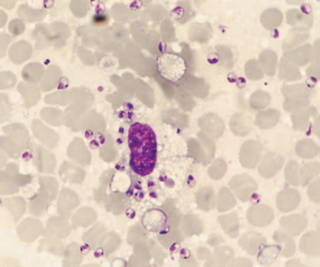
27
26

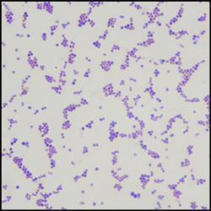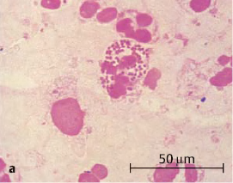
29
28

Answers:
1. D | 11. D | 21. C
2. C | 12. B | 22. Amastigote stages of Leishmania seen
3. D | 13. C | 23. Yeast cells or fungal elements seen
4. A | 14. A | 24. Gram-negative bacteria seen
5. D | 15. B | 25. Microfilaria seen
6. A | 16. B | 26. Acid fast bacilli seen
7. C | 17. B | 27. Amastigote stages of Leishmania seen
8. A | 18. C | 28. Gram-positive bacteria seen
9. C | 19. A | 29. Intracellular Gram-negative bacteria seen
10. D | 20. C

