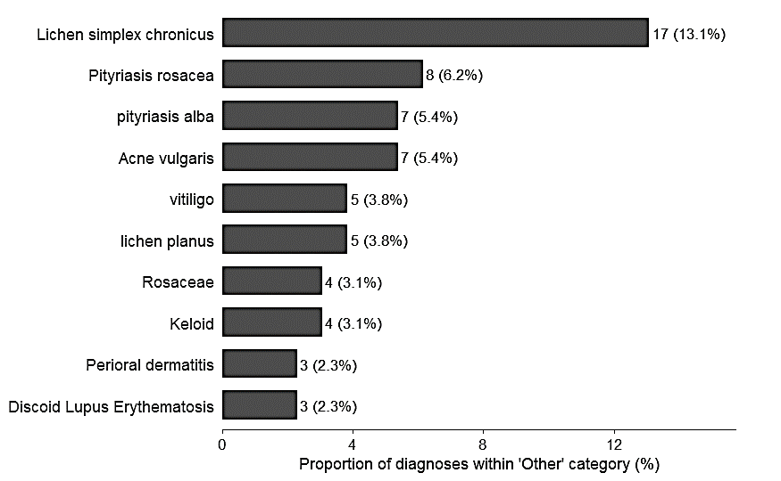
Additional file Figure S2. Distribution of the top 10 specific diagnoses within the “other” category. Bar chart showing the ten most frequent specific diagnoses initially classified under the broad “other” category based on consensus diagnosis. Values represent the proportion (%) of each diagnosis within the “other” category, with corresponding absolute counts displayed alongside bars.

