Supplementary Information (Online Resource 1)
Article title: Adjuvant fractionated stereotactic radiotherapy to the resection cavity versus observation after complete resection of brain metastases (C-O-MET): a single-center, randomized, phase 2 trial
Journal: Journal of Neuro-Oncology
Authors: Danny Jazmati, Juliane Hörner-Rieber, Ben Abler, Michael Sabel, Marion Rapp, Wilfried Budach, Marcel Kamp, Bernd Turowski, Alexandra Ljimani, Joudi Khal, Livia Schmidt, Michael Rudoy, Gerrit Fischedick, David Wasilewski, Gerald Antoch, Katharina Faust, Jan Haussmann
Corresponding author: Livia Schmidt, Department of Radiation Oncology, Medical Faculty and University Hospital Düsseldorf, Heinrich Heine University Düsseldorf, Moorenstraße 5, 40225 Düsseldorf, Germany. E-mail: Livia.Schmidt@med.uni-duesseldorf.de

Table S1 Change from baseline to last available follow-up in health-related quality of life and neurocognitive endpoints, by randomized group
Endpoint | n Obs | Mean change Obs (SD) | n fSRT | Mean change fSRT (SD) | Difference (Obs − fSRT) | P value
Functional / clinical status
KPS (Karnofsky) | 16 | 0.00 (13.17) | 12 | -9.83 (25.73) | 9.83 | 0.400
RPA Score | 16 | 0.19 (0.66) | 11 | 0.45 (0.69) | -0.27 | 0.447
mRS Score | 17 | 0.35 (1.06) | 11 | 0.18 (0.87) | 0.17 | 0.742
NIHSS Sum | 16 | -0.19 (1.28) | 13 | -0.08 (0.95) | -0.11 | 0.821
EORTC QLQ-C30 (function)
Global Health Status | 18 | 18.52 (43.12) | 12 | 4.17 (34.91) | 14.35 | 0.374
Physical Function | 18 | 3.70 (31.87) | 12 | -14.44 (41.57) | 18.15 | 0.051
Role Function | 18 | 3.70 (57.89) | 12 | 8.33 (49.49) | -4.63 | 0.983
Emotional Function | 18 | 8.33 (46.62) | 12 | -3.47 (44.16) | 11.81 | 0.567
Cognitive Function | 18 | 4.63 (40.75) | 12 | 12.50 (38.35) | -7.87 | 0.307
Social Function | 18 | 11.11 (49.84) | 12 | -1.39 (32.92) | 12.50 | 0.266
EORTC QLQ-C30 (symptoms)
Fatigue | 18 | -3.09 (49.37) | 12 | 17.59 (40.05) | -20.68 | 0.188
Nausea/Vomiting | 18 | -7.41 (28.71) | 11 | 4.55 (47.19) | -11.95 | 0.338
Pain | 18 | 13.89 (32.96) | 12 | -1.39 (41.11) | 15.28 | 0.215
Dyspnoea | 18 | 7.41 (40.51) | 12 | 11.11 (53.81) | -3.70 | 0.794
Sleep Disorder | 18 | -7.41 (55.49) | 12 | -5.56 (46.78) | -1.85 | 0.745
Appetite Loss | 18 | 9.26 (55.78) | 12 | 19.44 (30.01) | -10.19 | 0.427
Constipation/Diarrhoea | 18 | -16.67 (48.84) | 12 | -27.78 (46.78) | 11.11 | 0.309
Financial Impact | 18 | 3.70 (45.57) | 10 | 3.33 (29.19) | 0.37 | 0.797
EORTC QLQ-BN20
Future Uncertainty | 18 | 0.46 (48.21) | 12 | 6.25 (42.66) | -5.79 | 0.719
Visual Disorder | 18 | -8.02 (33.62) | 12 | -0.93 (25.27) | -7.10 | 0.836
Motor Dysfunction | 18 | 4.94 (35.59) | 12 | 8.33 (34.21) | -3.40 | 0.783
Communication Deficit | 18 | 3.70 (17.04) | 12 | 7.41 (34.27) | -3.70 | 0.806
Headache | 17 | 1.96 (39.91) | 12 | -33.33 (34.82) | 35.29 | 0.021
Seizures | 18 | -1.85 (7.86) | 12 | 0.00 (0.00) | -1.85 | 0.454
Drowsiness | 18 | 0.00 (42.78) | 12 | 22.22 (35.77) | -22.22 | 0.169
Itchy Skin | 17 | 7.84 (44.92) | 12 | 5.56 (19.25) | 2.29 | 0.433
Hair Loss | 18 | 25.93 (37.15) | 12 | 13.89 (33.21) | 12.04 | 0.261
Weakness of Legs | 18 | 35.19 (38.73) | 12 | 5.56 (48.89) | 29.63 | 0.093
Bladder Control | 18 | -11.11 (22.87) | 12 | 2.78 (22.29) | -13.89 | 0.151
Neurocognition
MMSE | 15 | 1.13 (2.56) | 11 | 1.09 (2.74) | 0.04 | 0.937
COWA Sum | 15 | 7.67 (11.45) | 9 | 2.56 (8.69) | 5.11 | 0.339
TMT A | 13 | 6.85 (58.25) | 10 | -7.70 (32.34) | 14.55 | 0.336
TMT B | 13 | -1.46 (91.90) | 10 | 8.30 (79.97) | -9.76 | 0.494
HVLT-R I Sum (immediate recall) | 14 | 6.29 (8.68) | 10 | 3.00 (7.64) | 3.29 | 0.332
HVLT-R II Recall (delayed) | 13 | 3.69 (3.95) | 8 | 2.62 (2.33) | 1.07 | 0.827
HVLT-R II Recognition | 14 | 3.14 (9.09) | 6 | 2.00 (9.12) | 1.14 | 0.679
Obs observation, fSRT fractionated stereotactic radiotherapy, SD standard deviation, KPS Karnofsky performance status, RPA recursive partitioning analysis, mRS modified Rankin Scale, NIHSS National Institutes of Health Stroke Scale, EORTC European Organisation for Research and Treatment of Cancer, MMSE Mini-Mental State Examination, COWA Controlled Oral Word Association, TMT Trail Making Test, HVLT-R Hopkins Verbal Learning Test–Revised. Values are mean change (last available follow-up minus baseline) among patients with data available for the respective endpoint. Two-sided Mann-Whitney U test. The sign of the change is interpreted per endpoint: for functional scales a positive change indicates improvement, for symptom scales a positive change indicates more symptoms. Of 36 endpoints, only the QLQ-BN20 headache subscale differed significantly between groups, favoring fSRT; no adjustment for multiple comparisons was applied, and approximately two significant results would be expected by chance alone, so this finding is supportive rather than confirmatory.

Table S2 Longitudinal course of health-related quality of life and neurocognitive endpoints over the entire follow-up (linear mixed-effects models)
Endpoint | Patients (n) | P (time) | P (arm) | P (arm × time) | Δ slope fSRT − Obs per month
Functional / clinical status
KPS (Karnofsky) | 51 | 0.901 | 0.064 | 0.712 | -0.15
EORTC QLQ-C30
Global Health Status | 51 | 0.147 | 0.717 | 0.634 | -0.40
Physical Function | 51 | 0.978 | 0.431 | 0.068 | -1.27
Emotional Function | 51 | 0.151 | 0.579 | 0.035 | -1.93
Cognitive Function | 51 | 0.333 | 0.140 | 0.484 | -0.65
Social Function | 51 | 0.243 | 0.303 | 0.113 | -1.69
Fatigue | 51 | 0.749 | 0.415 | 0.479 | -0.78
Pain | 51 | 0.008 | 0.534 | 0.239 | -1.21
EORTC QLQ-BN20
Headache | 51 | 0.917 | 0.149 | 0.256 | -1.16
Motor Dysfunction | 51 | 0.712 | 0.161 | 0.894 | 0.11
Communication Deficit | 51 | 0.083 | 0.039 | 0.683 | -0.25
Visual Disorder | 51 | 0.029 | 0.383 | 0.783 | 0.21
Neurocognition
COWA Sum | 48 | 0.052 | 0.216 | 0.543 | -0.21
NIHSS Sum | 49 | 0.136 | 0.004 | 0.647 | -0.01
Obs observation, fSRT fractionated stereotactic radiotherapy. Estimates are the group difference in trajectory over time. Only emotional function reached nominal significance for the interaction (P = 0.035, numerically favoring observation); this signal was fragile and did not persist when sparsely populated late visits or the six patients with floor scores of zero were excluded (P = 0.09–0.89), and is most plausibly a statistical artefact driven by isolated patients at late time points. Significant time effects for pain and visual disorder reflect change in both groups rather than a treatment effect, and significant arm effects for communication deficit and the NIHSS sum reflect a baseline level difference rather than divergence over time. Fourteen scores were tested with three tests each without adjustment for multiple comparisons; all longitudinal analyses are exploratory and hypothesis-generating.

Table S3 Treatment-related adverse events (CTCAE version 5.0), highest grade per patient over the entire follow-up
Category | Observation (n = 25) | Radiotherapy (n = 28) | Total | P value
Any adverse event | 11 | 16 | 27 | 0.414
Grade 1 (mild) as max | 0 | 2 | 2 | 0.492
Grade 2 (moderate) as max | 6 | 9 | 15 | 0.556
Grade 3 (severe) as max | 5 | 5 | 10 | 1.000
Grade ≥2 | 11 | 14 | 25 | 0.785
Grade ≥3 | 5 | 5 | 10 | 1.000
CTCAE Common Terminology Criteria for Adverse Events. Each patient contributes once, at their maximum grade recorded over the entire follow-up. Treatment-related toxicity only; events reflecting disease progression or study outcomes (death, progressive disease, local recurrence, leptomeningeal disease, intracranial haemorrhage, resumption of chemotherapy, inpatient work-up) were excluded. Fisher exact test per category. No grade 4 or 5 events occurred. Numbers are small and should be interpreted cautiously.

Table S4 Oncological endpoints by randomized group and by radiotherapy actually received
Endpoint | Observation / no fSRT | Radiotherapy / fSRT received | Total events | P value
A) Per-protocol (by randomized arm)
Local recurrence | 12 / 25 | 5 / 28 | 17 | 0.037
Intracranial recurrence (any) | 15 / 25 | 13 / 28 | 28 | 0.412
Distant intracranial recurrence | 12 / 25 | 11 / 28 | 23 | 0.586
Leptomeningeal disease | 5 / 25 | 9 / 28 | 14 | 0.365
Overall survival (deaths) | 18 / 25 | 19 / 28 | 37 | 0.774
Neurological death (approx.) | 11 / 25 | 10 / 28 | 21 | 0.584
B) As-treated (by radiotherapy actually received)
Local recurrence | 15 / 31 | 2 / 22 | 17 | 0.003
Intracranial recurrence (any) | 18 / 31 | 10 / 22 | 28 | 0.413
Distant intracranial recurrence | 13 / 31 | 10 / 22 | 23 | 1.000
Leptomeningeal disease | 6 / 31 | 8 / 22 | 14 | 0.213
Overall survival (deaths) | 23 / 31 | 14 / 22 | 37 | 0.545
Neurological death (approx.) | 13 / 31 | 8 / 22 | 21 | 0.779
fSRT fractionated stereotactic radiotherapy. Data are numbers of patients with the event. Neurological death is approximated as death in a patient with documented intracranial progression; no adjudicated cause-of-death field was available.

Table S5 Univariable and multivariable analysis of factors associated with local recurrence
Factor | OR (univariable) | 95% CI | P value | OR (multivariable) | 95% CI | P value
Randomized treatment (fSRT) | 0.236 | 0.068–0.818 | 0.023 | 0.226 | 0.060–0.855 | 0.028
Gender | 2.229 | 0.708–7.012 | 0.171 | – | – | –
Location | 0.993 | 0.954–1.034 | 0.734 | – | – | –
Primary tumor | 0.852 | 0.444–1.636 | 0.630 | – | – | –
KPS at baseline | 1.043 | 0.964–1.128 | 0.292 | – | – | –
RPA | 1.319 | 0.290–5.993 | 0.720 | – | – | –
Extracranial disease at baseline | 0.727 | 0.219–2.412 | 0.603 | – | – | –
Growth pattern (limited, infiltrative) | 1.024 | 1.001–1.048 | 0.042 | 1.024 | 1.001–1.048 | 0.048
Dural/vascular contact | 1.006 | 0.655–1.544 | 0.979 | – | – | –
Resection (en bloc, piecemeal) | 1.004 | 0.990–1.019 | 0.565 | – | – | –
Resection (subtotal, total, supramarginal) | 1.004 | 0.992–1.016 | 0.524 | – | – | –
5-ALA resection | 1.012 | 0.996–1.029 | 0.142 | – | – | –
Cavity 5-ALA positive | 1.010 | 0.998–1.022 | 0.115 | – | – | –
OR odds ratio, CI confidence interval, fSRT fractionated stereotactic radiotherapy, KPS Karnofsky performance status, RPA recursive partitioning analysis, 5-ALA 5-aminolevulinic acid. A dash indicates that the variable was not retained in the multivariable model.

Fig. S1 Local recurrence: exploratory subgroup analysis by stratification factors
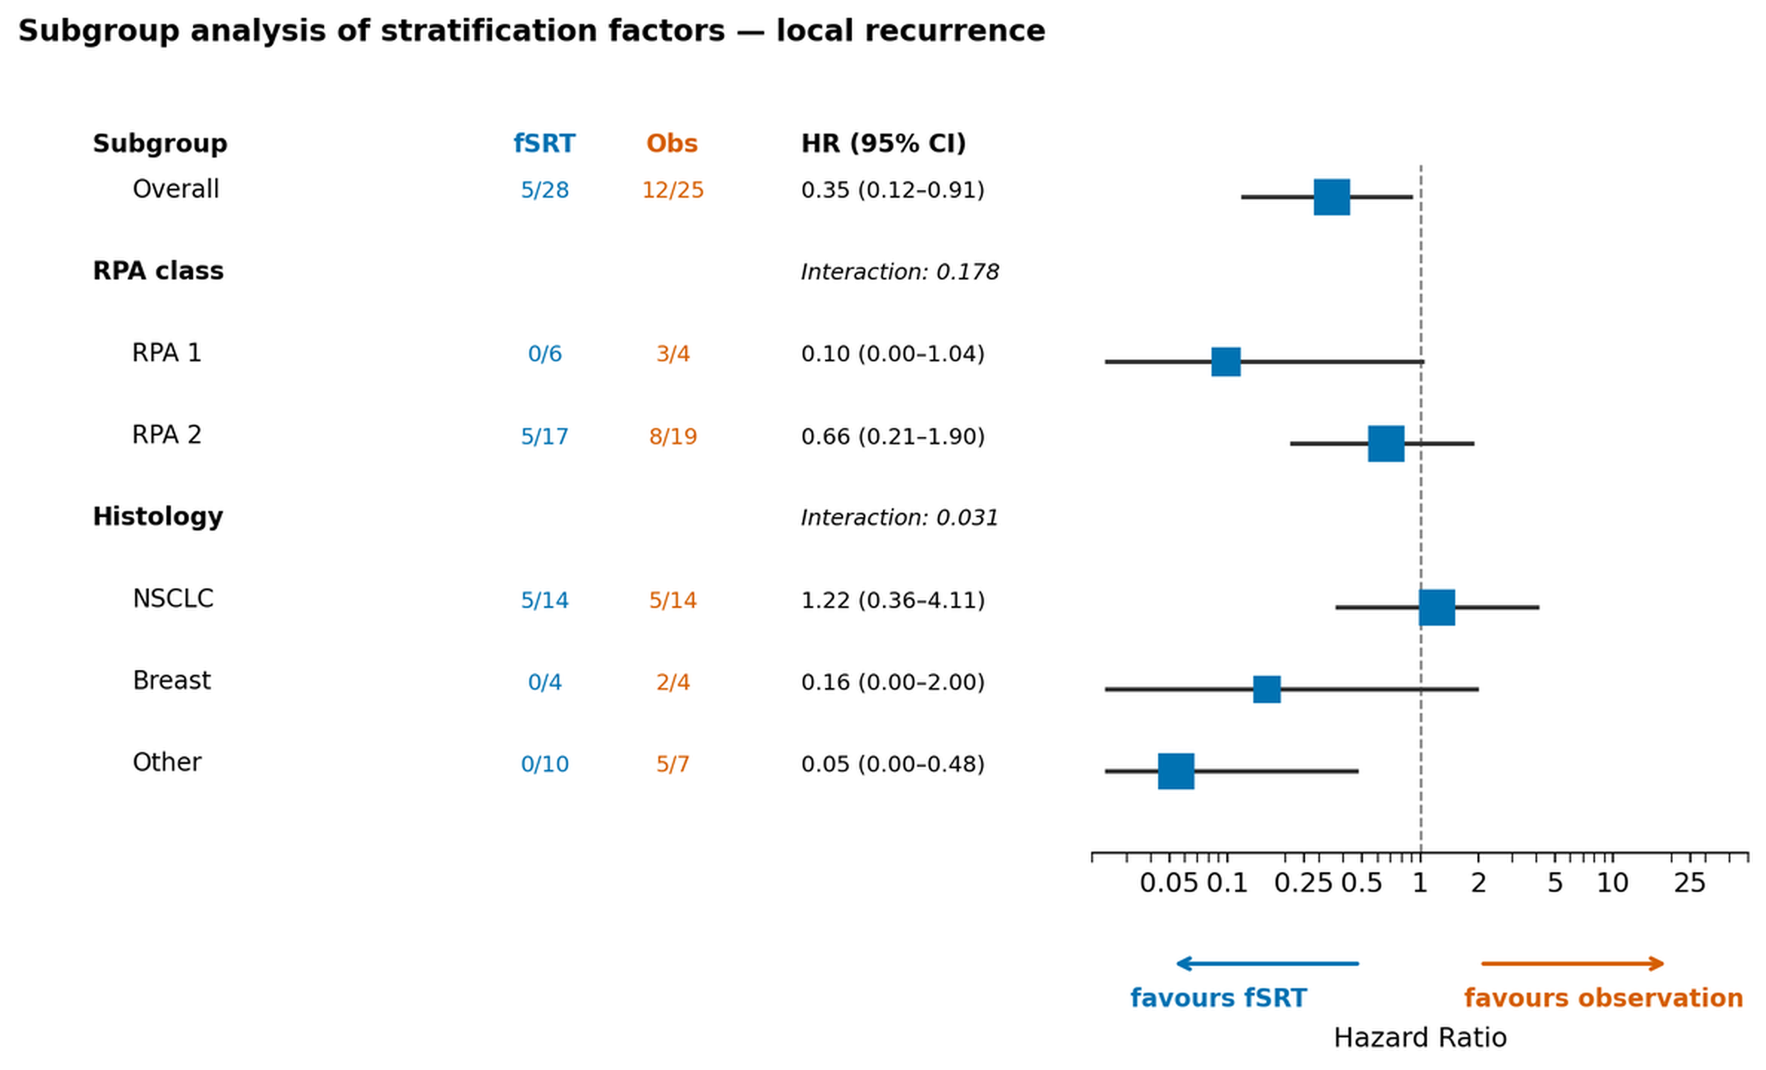
Hazard ratios for local recurrence with 95% confidence intervals in subgroups defined by the randomization strata (recursive partitioning analysis class and histology). Numbers before each estimate are events/patients per group. Recursive partitioning analysis class was not available for all patients, so subgroup totals do not sum to the full intention-to-treat population.

