Supplementary Figures
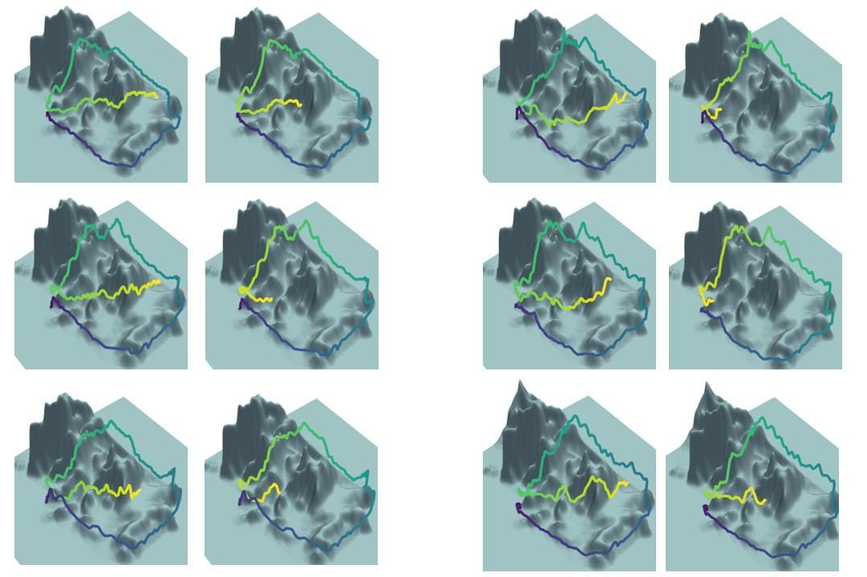
Supplementary Figure 1. Aligned trajectories for the remaining non-crash flights. Each panel shows the aligned flight path of one non-crash subject (colored line) over the terrain surface, using the same color convention as in Figure 1 (darker colors earlier in the flight, bright yellow later). Trajectories have been aligned to the reference crash flight in the low-dimensional context space (altitude, longitude, cumulative 2-D distance, and elapsed time), illustrating that non-crash paths can be matched to similar crash-proximal conditions across all six remaining subjects.

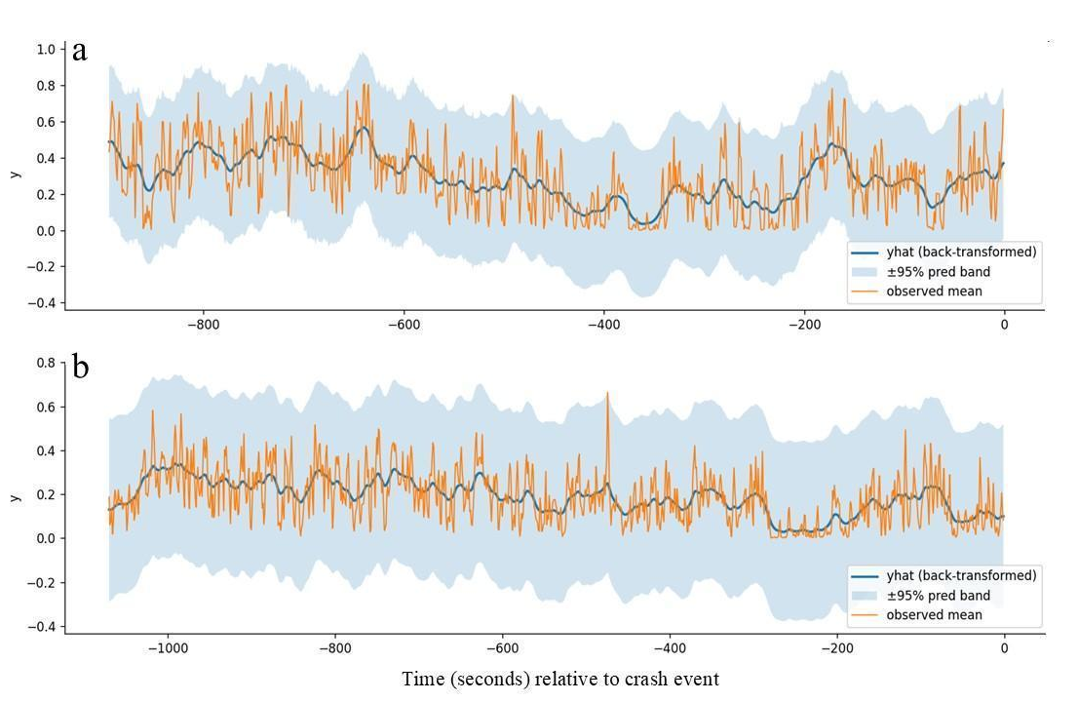
Supplementary Figure 2. Empirical survival and Kalman-smoothed latent survival trajectories for crash (a) and non-crash (b) flights. Shaded regions indicate 95% predictive intervals from the local-level state-space model. The close agreement between empirical and modeled curves demonstrates that the model captures the temporal structure of crash risk without over-smoothing.

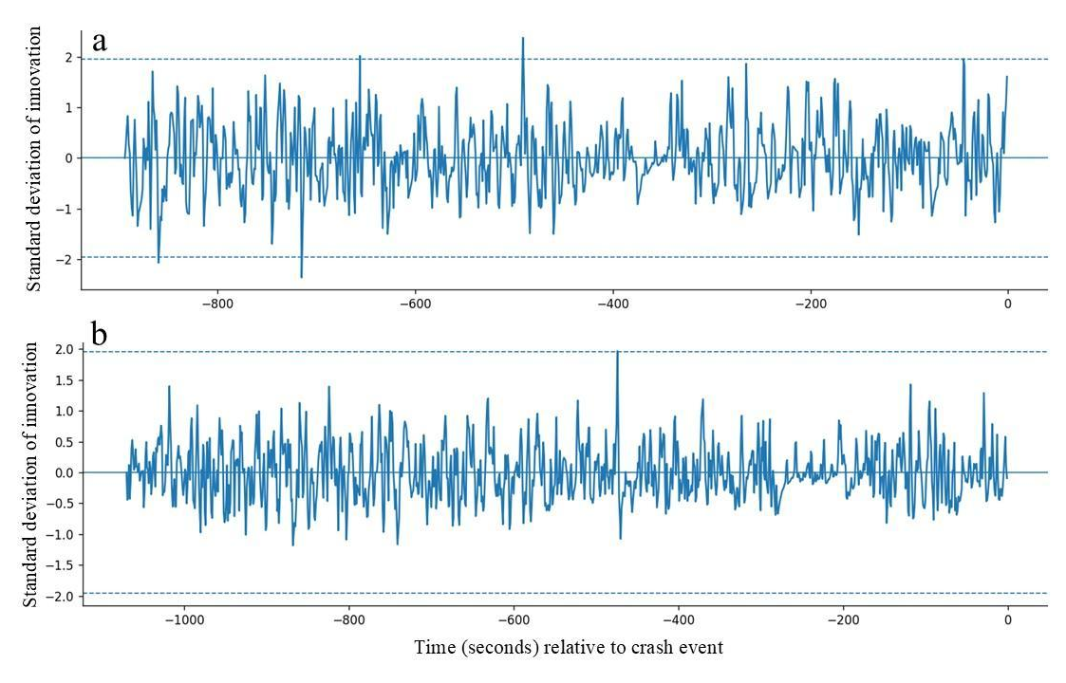
Supplementary Figure 3: Predictive-interval coverage over time for state-space hazard estimates. Proportion of observed hazard estimates falling within 95% predictive intervals is plotted as a function of time to endpoint for crash (a) and non-crash (b) groups. Coverage values close to the nominal 0.95 level confirm that the model is well-calibrated

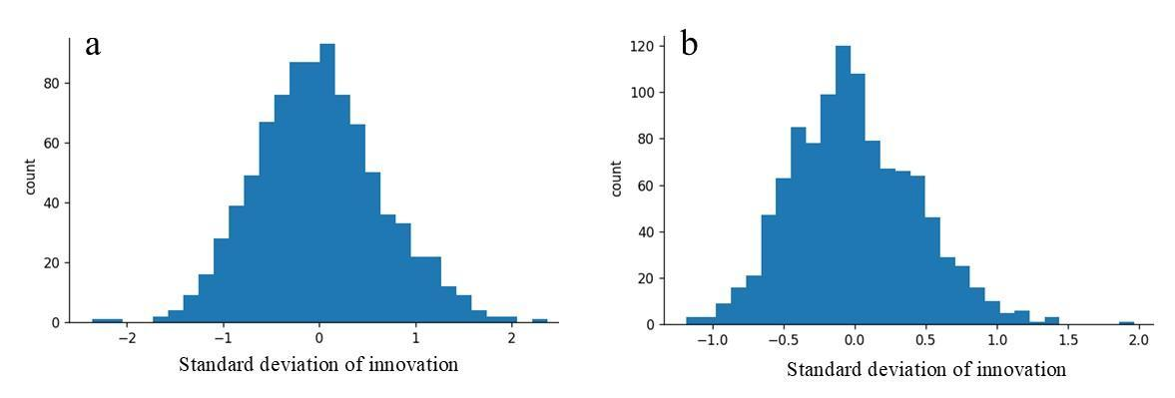
Supplementary Figure 4. Innovation diagnostics for the local-level state-space model. One-step-ahead prediction errors (innovations) for crash (a) and non-crash (b) groups show
approximately zero-mean, homoscedastic, and near-normal distributions, supporting the adequacy of the selected process- and observation-noise parameters.

Supplementary Table

Event Order | Event | Tasks | Estimated Time Point
1 | Takeoff | Patron begins asking questions | 1:00 min
2 | En route | ACT requests weather report | 3:00 min
3 | Giants Stadium reporting point | Hydraulic #2 pump fail | 5:00 min
4 | En route | Radio frequency change | 5:00 min
5 | En route | Rain begins | 8:00 min
6 | En route | Increase turbulence to 5 | 8:00 min
7 | En route | Left pedal drive malfunction | 9:00 min
8 | En route | Radio frequency change | 9:30 min
9 | Golden Gate reporting point | Transponder code change | 9:30 min
10 | En route | Pedal drive persists | 14:00 min
11 | En route | Visibility to 1 mile | 16:00 min
12 | En route | Increase turbulence to 7 | 17:00 min
13 | En route | #2 Engine fail | 18:00 min
14 | 49er stadium reporting point | Radio frequency change | 19:00 min
15 | Polo fields reporting point |  | 20:00 min
16 | Landing at Polo fields |  | 22.00 min
Supplementary table 1: Flight tasks.

