Extended Data Fig.1| High fat high sucrose (HFHS) diet-induced mouse model and insulin secretions in islets with aldolase knockdown
a, Body weights of mice fed with Chow Diet (CD) and HFHS diet at 6, 12, 20, and 25 weeks (n=5-9). b, Fasting blood glucose levels in mice with Chow Diet (CD) and HFHS diets at 6, 12, 20, and 25 weeks (n=5-9). c-e Relative gene expressions of aldob (c), aldoa (d) and aldoc (e) in islets from mice with Chow Diet (CD) and high fat high sucrose (HFHS) diet for 6,12, 25 weeks. Each gene expression is normalized to the average of its expressions in CD group.f-g, ALDOB expressions and quantifications in human primary islets treated with siNC and siAldolase. Each protein expression is normalized to the average of its expressions in siNC group. h-i, ALDOB expression and quantifications in human endoderm cell-induced islets treated with siNC and siAldolase. Each protein expression is normalized to the average of its expressions in siNC group.j-k, ALDOB expression and quantifications in rat endoderm cell-induced islets treated with siNC and siAldolase of. Each protein expression is normalized to the average of its expressions in siNC group.Results are presented as mean ± SEM. Statistical analysis was performed using two-sided unpaired t-test.
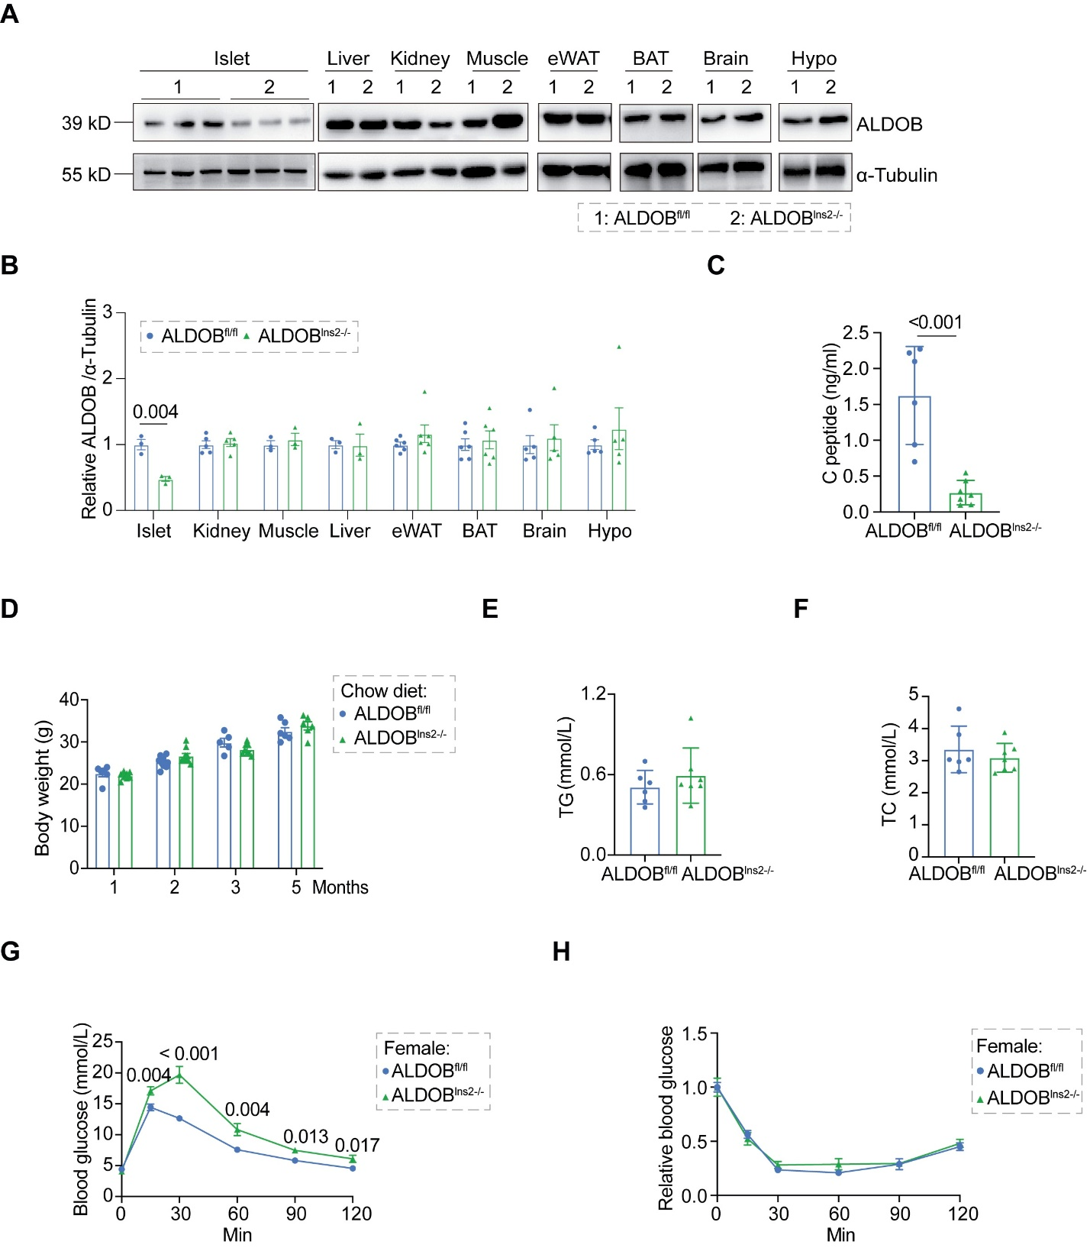

Extended Data Fig.2| β cell-specific ALDOB knockout mice fed with Chow Diet
a-b, Representative image (A) and quantification (B) of ALDOB expressions in different tissues from ALDOB^{fl/fl} and ALDOB^{Ins2-/-} mice. c,Levels of serum C peptide in ALDOB^{fl/fl} and ALDOB^{Ins2-/-} mice. Fasting blood glucose levels in mice under chow diet (CD) and HFHS diet at 6, 12, 20, and 25 weeks (n=5-9). d-f, Body weights (d), serum levels of triglycerides (TG, e), and total cholesterol (TC, f) in ALDOB^{fl/fl} and ALDOB^{Ins2-/-} mice. g-h, Glucose tolerance test (GTT, G) and insulin tolerance test (ITT, H) in ALDOB^{fl/fl} and ALDOB^{Ins2-/-} female mice.Results are presented as mean ± SEM. Statistical analysis was performed using two-sided unpaired t-test.

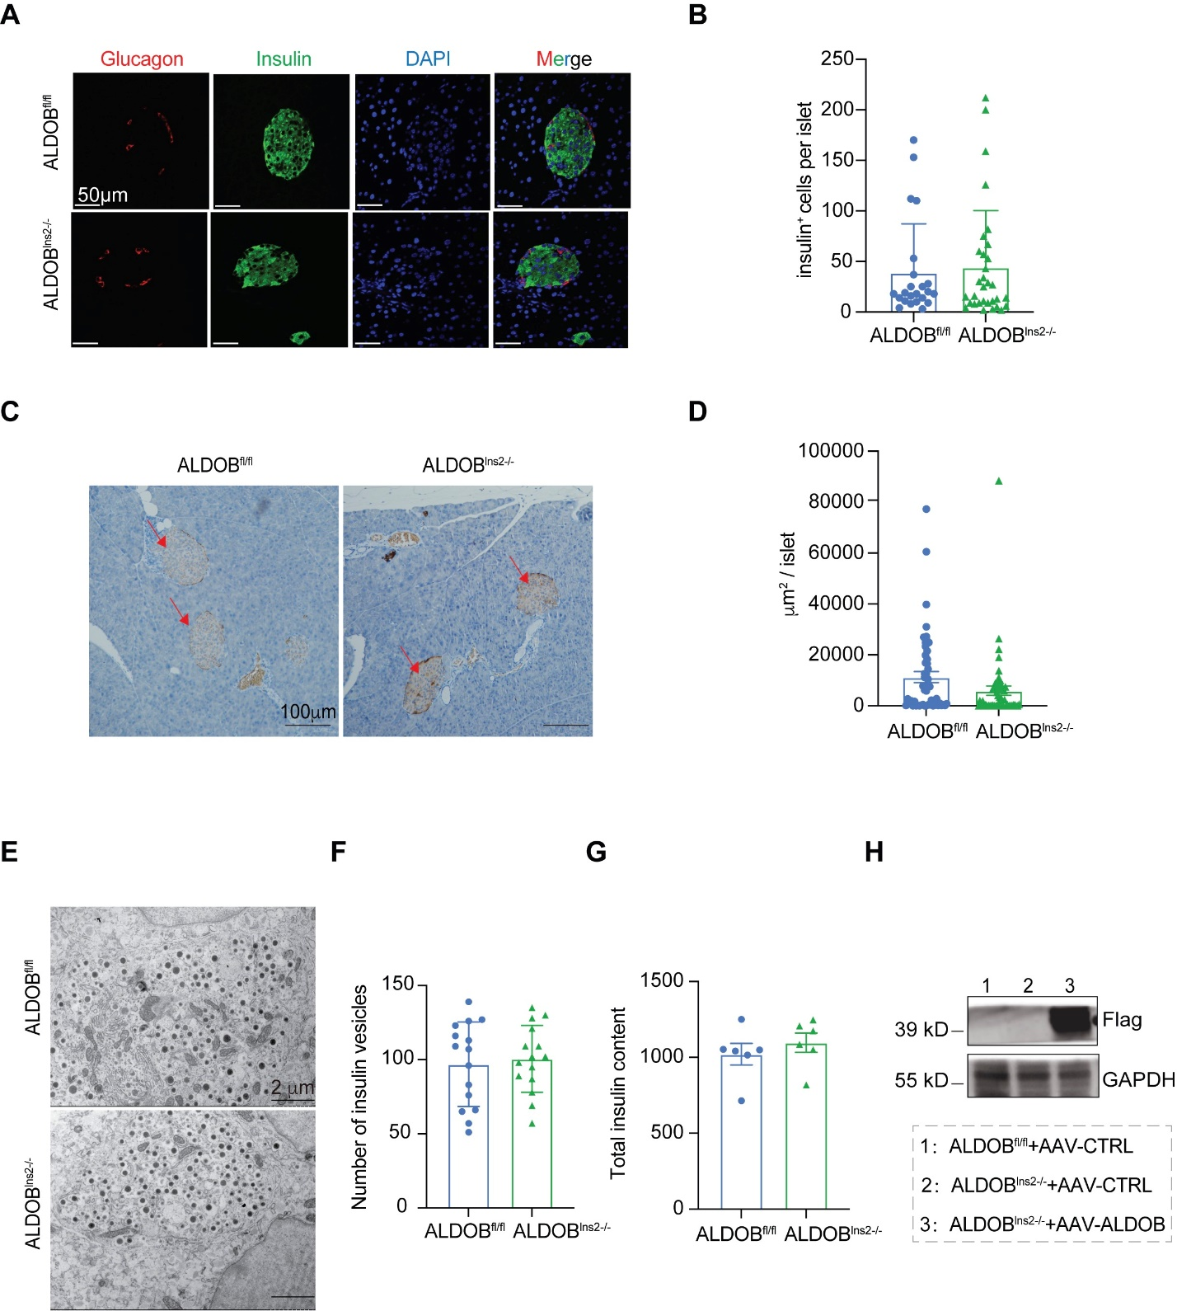
Extended Data Fig.3| Morphology of primary islets from ALDOB^{fl/fl} and ALDOB^{Ins2-/-} mice with Chow Diet
a-b, Representative images (A) and quantifications (green, B) of immunofluorescence analysis of nuclear staining (DAPI, blue), insulin (green) and glucagon (red) expression in islets of ALDOB^{fl/fl} and ALDOB^{Ins2-/-} mice. Scale bar, 50 μm. c-d, Representative immunohistochemical images (C) and quantifications (islet size, D) of pancreas from ALDOB^{fl/fl} and ALDOB^{Ins2-/-} mice, stained with insulin antibody (brown). Scale bar, 100 μm. e-f, Transmission electron microscopy analysis of representative insulin vesicles (E) and quantification of the number of insulin vesicles (F) in primary islet cell clusters from ALDOB^{fl/fl} and ALDOB^{Ins2-/-} mice. Scale bar, 2μm. g, Total insulin content in islets from ALDOB^{fl/fl} and ALDOB^{Ins2-/-} mice. h, Flag-ALDOB expressions in primary islets of ALDOB^{fl/fl} mice with control AAV injection, ALDOB^{Ins2-/-} mice with control AAV injection and ALDOB^{Ins2-/-} with overexpressed ALDOB AAV injection mice.
For all data, values are presented as mean ± SEM. Statistical analysis was performed using two-sided unpaired t-test.

Extended Data Fig.4| Knocking out ALDOB in β cells induces mouse T2D phenotypes with HFHS feeding
a, Relative gene expressions of aldoa, aldob and aldoc in primary islets from control (ALDOB^{fl/fl}) and β cell-specific ALDOB knockout (ALDOB^{Ins2-/-}) mice with HFHS feeding. Each gene is normalized to the average of its expressions in ALDOB^{fl/fl} group. b-c, Body weight (b) and insulin tolerance test (ITT, c) in ALDOB^{fl/fl} and ALDOB^{Ins2-/-} mice fed with HFHS diet for 19 weeks (n=9-10). d, Representative image of lipid accumulation stained by Oil Red O in livers of ALDOB^{fl/fl} and ALDOB^{Ins2-/-} mice fed with HFHS diet for 19 weeks. e-f, Protein expressions in insulin receptor signaling pathways (e) and quantifications (f) in liver tissues of ALDOB^{fl/fl} and ALDOB^{Ins2-/-} mice fed with HFHS diet for 19 weeks. Each protein is normalized to the average of its expressions in ALDOB^{fl/fl} group. g-h, Representative Masson staining image (g) and lesion area quantification (h) of kidneys from ALDOB^{fl/fl} and ALDOB^{Ins2-/-} mice fed with HFHS diet for 19 weeks. i-j, Representative image (i) and quantification (j) of ALDOB expressions in primary islets of ALDOB^{fl/fl} mice with AAV-GFP injection (CTRL) and ALDOB^{fl/fl} mice with AAV-Cre injection (Cre). k-l, Body weight (k) and glucose tolerance test (GTT, l) in ALDOB^{fl/fl} mice with AAV-GFP injection (CTRL) and ALDOB^{fl/fl} mice with AAV-Cre injection (Cre) fed with HFHS diet (n=6). m-n, Representative image of islet morphology (m) and quantification (n) of area of slets from ALDOB^{fl/fl} mice with AAV-GFP injection (CTRL) and ALDOB^{fl/fl} mice with AAV-Cre injection (Cre) fed with HFHS diet.Results are presented as mean ± SEM. Statistical analysis was performed using two-sided unpaired t-test.

Extended Data Fig.5| ALDOA not ALDOB-mediated glycolysis plays a major role in insulin secretion in β cells
a-b, Representative image (a) and quantification (b) of aldolase expression in primary islets of ALDOA^{fl/fl} mice injected with control AAV (CTRL) and Cre AAV (Cre (A)). AAV is driven by insulin promoter (AAV-Ins2). c-e, Body weight (c), glucose tolerance test (GTT, d, n=6) and GSIS (e) in ALDOA^{fl/fl} mice injected with control AAV (CTRL) and Cre AAV (Cre(A)). f, ¹³C-labeled metabolites from ¹³C-glucose in primary islets of ALDOA^{fl/fl} mice injected with control AAV (CTRL) and Cre AAV (Cre(A)). Primary islets were treated with labeled ¹³C- glucose for 2 hours under 16.7mM glucose stimulation. g, Intracellular ATP content in primary islets of ALDOA^{fl/fl} mice injected with control AAV (CTRL) and Cre AAV (Cre(A)) after 30 minutes 16.7mM glucose stimulation. h, Glucose uptake detected by 2-NBDG in primary islets of 6 hour starved ALDOA^{fl/fl} mice injected with control AAV (CTRL) and Cre AAV (Cre(A)). i, ¹³C-labeled metabolites from ¹³C-glucose in primary islets of ALDOB^{fl/fl} and ALDOB^{Ins2-/-} mice. Primary islets were treated with labeled ¹³C- glucose for 2 hours under 16.7mM glucose stimulation. j-k, Glucose tolerance test (GTT, j) and insulin tolerance test (ITT, k) in 12-week-old male ALDOB-R304A flox/flox mice injected with control AAV (CTRL) and Cre AAV (Cre(304)) (n=6). l, GSIS in primary islets of 12-week-old male ALDOB-R304A flox/flox mice injected with control AAV (CTRL) and Cre AAV (Cre(304)). For all data, values are presented as mean ± SEM. Statistical analysis was performed using two-sided unpaired t-test.

Extended Data Fig.6| Knocking down aldolase decreased cAMP pathway in lns1 cells
a, Relative intracellular cAMP content in siNC and siAldolase Ins1 cells after 1 hour 16.7 mM glucose stimulation. b-c, Protein levels (b) and quantifications (c) of phosphorylated PKA substrate, Epac1 and Epac2 in siNC and siAldolase Ins1 cells. d, Representative calcium images in primary islets of ALDOB^{fl/fl} and ALDOB^{Ins2-/-} mice under 2.8 mM and 16.7mM glucose stimulation (n=22). For all data, values are presented as mean ± SEM. Statistical analysis was performed using two-sided unpaired t-test.

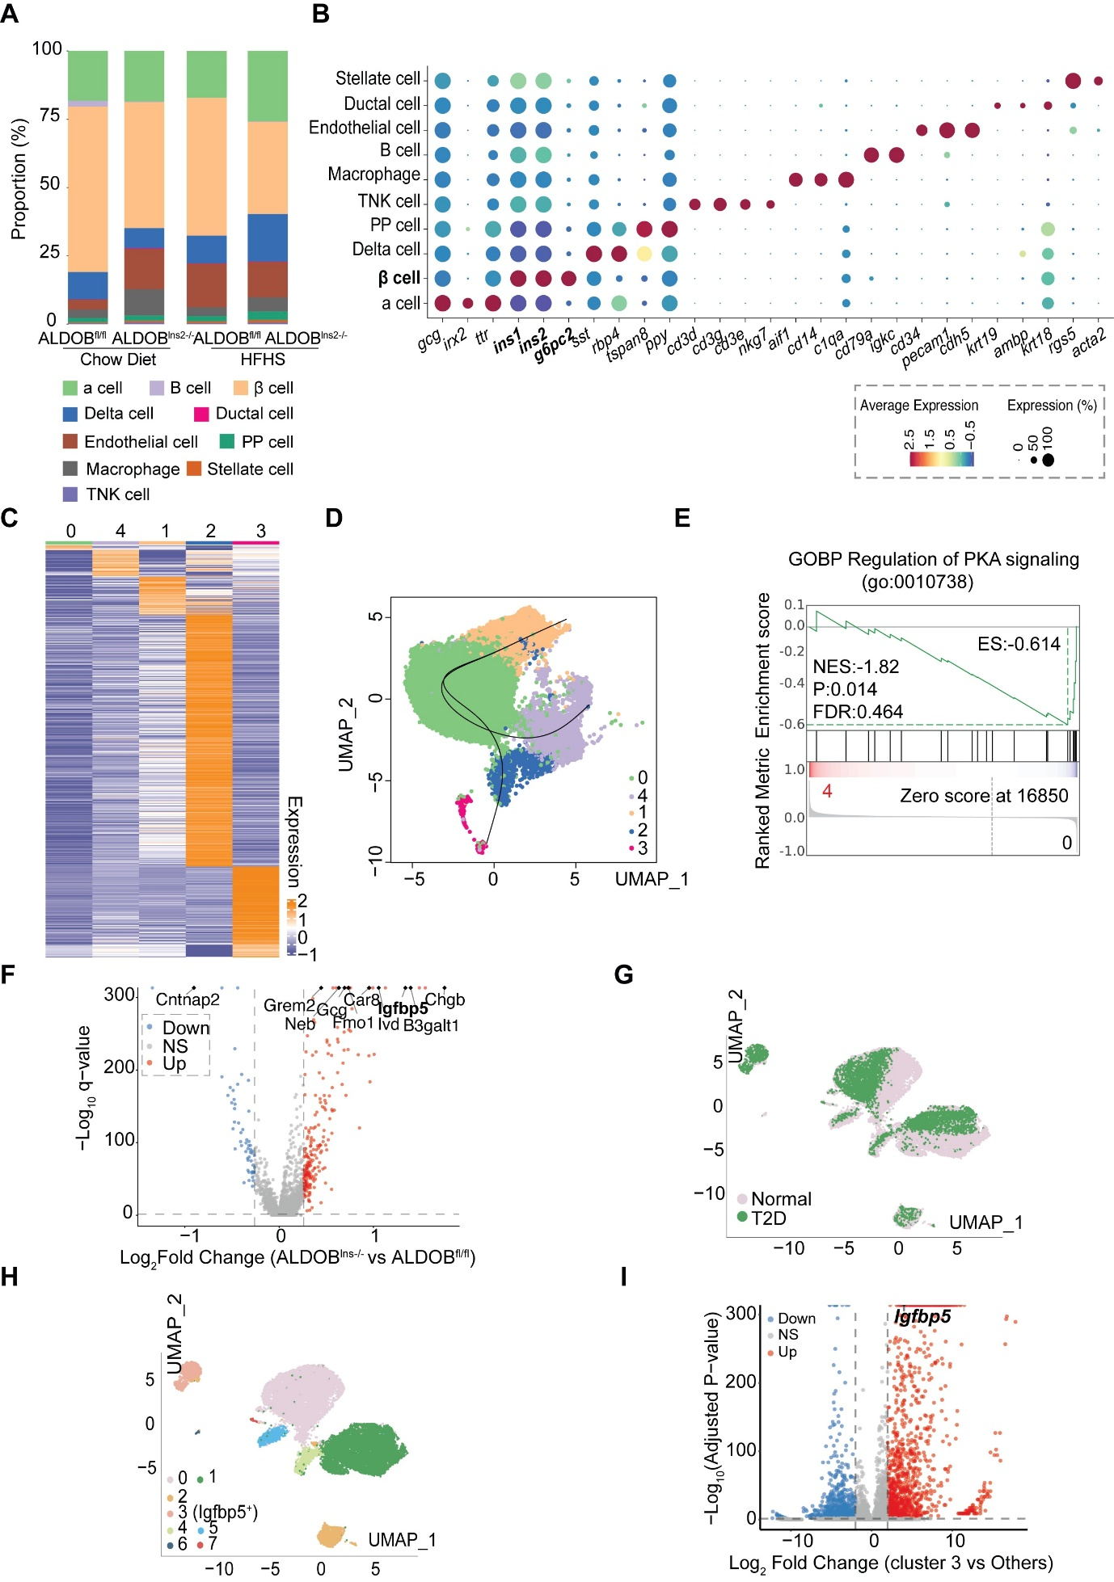

Extended Data Fig.7| Single cell sequencing of primary islets of ALDOB^{fl/fl} and ALDOB^{Ins2-/-} mice fed with Chow Diet or HFHS diet
a, Different cell type clustering of single-cell transcriptomes from pancreatic islets of ALDOB^{fl/fl} and ALDOB^{Ins2-/-} mice (n=3). b, Bubble chart of specific gene annotations for different cell types in figure S9A. c, Heat maps of differential gene expression in β cell sub-clusters. d, Slingshot simulation of β-cell differentiation trajectory. e, GSEA based on GOBP gene sets showed that regulation of PKA signaling (GO:0010738) was negatively enriched in Cluster 4 vs Cluster 0 (NES = -1.82, p = 0.014, FDR = 0.464), suggesting reduced PKA signaling activity in Cluster 4. f, Volcano plot analysis of differentially expressed genes in β-cells of ALDOB^{fl/fl} and ALDOB^{Ins2-/-} mice. g, Unsupervised clustering of single-cell transcriptome visualized with UMAP analysis. Data represent islet β cells from healthy and T2D people. h, Projection of β cells (n= 25894) from healthy and T2D people using UMAP analysis. β cell groups are defined according to k-nearest neighbours (kNN)-based clusters. i, Volcano plot analysis of differential expressed genes between β-cell subpopulations Cluster 3 (Igfbp5+) and other clusters in Extended Data Fig.9g.

Extended Data Fig.8| Manipulating IGFBP5 in lns1 cells and mice
a, Extracellular IGFBP5 content secreted by primary islets of ALDOB^{fl/fl} and ALDOB^{Ins2-/-} mice. b-c, IGFBP5 protein levels (b) and quantification (c) in control (overNC) and IGFBP5 overexpressed (overIGFBP5) Ins1 cells. IGFBP5 expression is normalized to the average of its expressions in overNC group. d-e, IGFBP5 protein levels (d) and quantification (e) in control (siNC) and IGFBP5 knocking down (siIGFBP5) Ins1 cells. IGFBP5 expression is normalized to the average of its expressions in siNC group. f-g, Representative image (f) and quantification (g) of IGFBP5 protein level in primary islets of ALDOB^{fl/fl} and ALDOB^{Ins2-/-} mice with shNC and shIGFBP5 AAV injection accordingly. For all data, values are presented as mean ± SEM. Statistical analysis was performed using two-sided unpaired t-test (a, c, e) and two-way ANOVA (g).

Extended Data Fig.9| ALDOB binds to C domain of IGFBP5 to inhibit the nuclear translocation of IGFBP5 in lns1 cells
a-b, Representative image (a) and quantification (b) of subcellular fractionation of IGFBP5 expression in lns1 cells. The quantification of IGFBP5 in cytoplasm is normalized to the same cell number of IGFBP5 in nuclear. c, Immunofluorescence analysis of IGFBP5 subcellular localization in Ins1 cells. Scale bars, 5 μm. d-e, Subcellular fractionation of IGFBP5 expression (d) and its quantification (e) in siNC and siAldolase lns1 cells. The quantification of IGFBP5 in cytoplasm is normalized to the same cell number of IGFBP5 in nuclear. f, Diagram of IGFBP5 different domains and mutations. g-h, Representative image (g) and quantification (h) of Subcellular fractionation of Myc expression in lns1 cells transfected with different IGFBP5 mutations. The quantification of Myc expression in cytoplasm is normalized to the same cell number of Myc expression in nuclear. i, Molecular dynamics simulations to predict the binding sites of ALDOB and IGFBP5. j-k, Co-immunoprecipitation of Flag-tagged ALDOB and Myc -agged IGFBP5 in 293T cells. l-m,Immunoprecipitation of Flag-tagged ALDOB and Myc-tagged various mutant IGFBP5 plasmids, followed by enrichment using Flag antibody. For all data, values are presented as mean ± SEM. Statistical analysis was performed using two-sided unpaired t-test (b, e, k) and one-way ANOVA (h, m).

Extended Data Fig.10| IGFBP5 increases the transcription of GNAI2 in lns1 cells
a, Heatmaps of IGFBP5 ChIP-seq peaks near the TSS in lns1 cells. b, ChIP-seq distribution for IGFBP5 at representative gene Gnai2 loci. c, Correlation analysis between mRNA levels of igfbp5 and gnai2 in pancreas from GEPIA database. d, Relative Gnai2 mRNA level in siNC and siIGFBP5 lns1 cells. Gnai2 gene expression is normalized to the average of its expressions in siNC group. e-f, Representative image (E) and quantification (F) of IGFBP5 and GNAI2 expression in control (overNC) and IGFBP5 overexpressed (overIGFBP5) lns1 cells. Each protein expression is normalized to the average of its expressions in overNC group. g-h, Representative image (G) and quantification (H) of GNAI2 expression in control (overNC) and GNAI2 overexpressed (overGNAI2) lns1 cells. GNAI2 protein expression is normalized to the average of its expressions in overNC group. i, Relative intracellular cAMP content in control (overNC) and GNAI2 overexpressed (overGNAI2) Ins1 cells after 1 hour 16.7 mM glucose stimulation. cAMP content is normalized to the average of cAMP content in overNC group.For all data, values are presented as mean ± SEM. Statistical analysis was performed using two-sided unpaired t-test.

Extended Data Fig.11| ALDOB KO inhibits GSIS through promoting IGFBP5-mediated gnai2 transcription
a, Representative immunoblots of GNAI2 expression in primary islets from ALDOB^{fl/fl} and ALDOB^{Ins2-/-} mice. Quantification of GNAI2 and ALDOB in Figure 6G. b, Relative gnai2 expression in different β cell sub-clusters of single cell sequencing data in Figure 4. c, ChIP-qPCR results of IGFBP5 enriched 1126-1400 bp upstream of GNAI2 TSS in siNC and siAldolase Ins1 cells. d-e, Representative immunoblots (d) and quantifications (e) of ALDOB and GNAI2 protein levels in control (siNC) and siGNAI2 (siG) islets from ALDOB^{fl/fl} and ALDOB^{Ins2-/-} mice. siG-1 and siG-2 represent two different siRNA sequencing. f, Insulin secretion of primary islets of control and siGNAI2 islets from ALDOB^{fl/fl} and ALDOB^{Ins2-/-} mice. g-h, Representative immunoblots (g) and quantifications (h) of GNAI2 expression in primary islets from ALDOB^{fl/fl} mice, ALDOB^{Ins2-/-} mice and ALDOB^{Ins2-/-} mice injected with shGNAI2-AAV. i, Insulin tolerance test (ITT) in ALDOB^{fl/fl} mice, ALDOB^{Ins2-/-} mice and ALDOB^{Ins2-/-} mice injected with shGNAI2-AAV (n=5). For all data, values are presented as mean ± SEM. Statistical analysis was performed using one-way ANOVA (c) and two-way ANOVA (e,f, h-i).

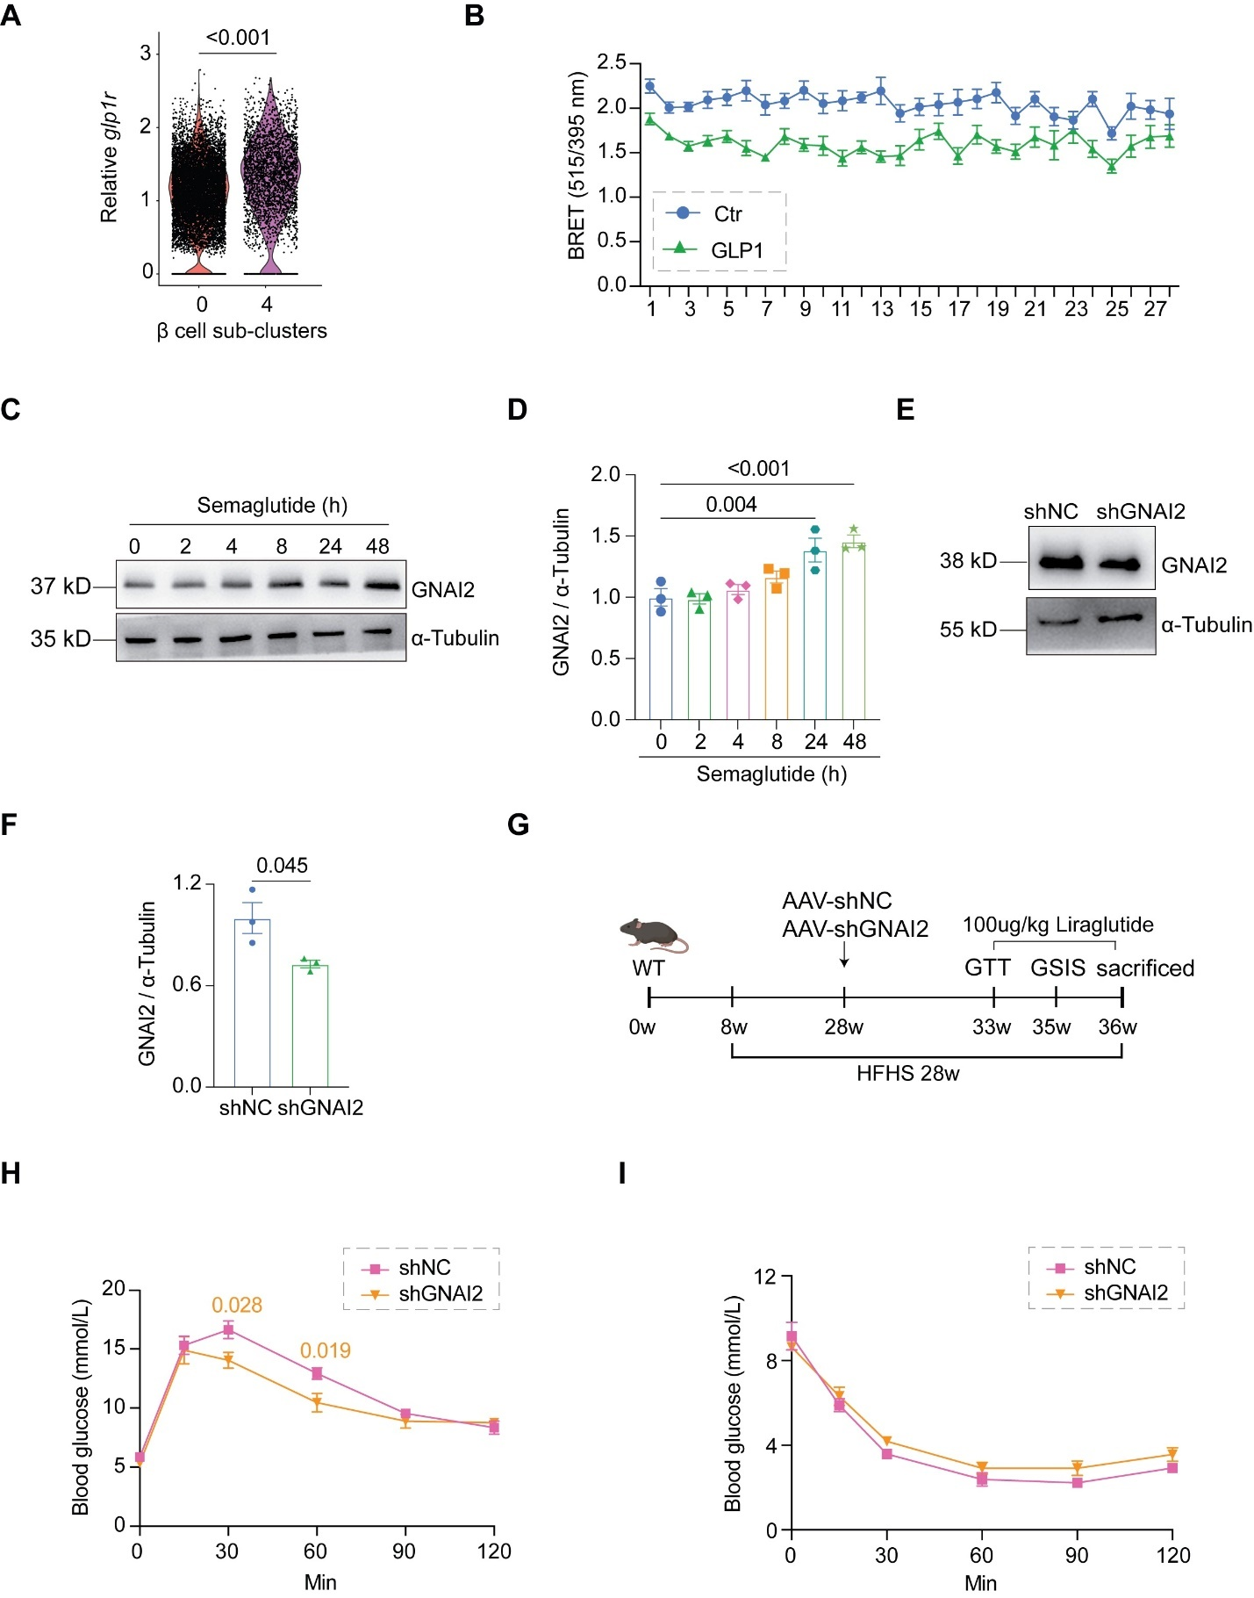

Extended Data Fig.12| GNAI2 Inhibition improves the efficacy of GLP-1R agonists
a, Relative glp1r expression level in different β cell clusters of single cell sequencing data in Figure 4. b, Trupath assay to measure the activity of GLP-1R and GNAI2 by overexpressing GLP1R, GNAI2 and their G protein β and γ subunits in 293T cells (n=12). c-d, Representative immunoblots (c) and quantifications (d) of GNAI2 expression in Ins1 cell treated with 10 nM semaglutide for 0, 2, 4, 8, 24, 48 hours. e-f, Representative immunoblots (e) and quantifications (f) of GNAI2 expression of primary islets of shNC and shGNAI2 mice. g, Diagram of knocking down GNAI2 in mice with Liraglutide treatment. h-i, Glucose tolerance test (GTT, h) and insulin tolerance test (ITT, i) of shNC and shGNAI2 mice with HFHS diet 28 weeks (n=6-7). For all data, values are presented as mean ± SEM. Statistical analysis was performed using Wilcoxon test (a), one-way ANOVA (d) and two-sided unpaired t-test (f, h,i).

