SUPPORTING INFORMATION
Inclusive DFT insight into sensing mechanism of cyclotetrapyrole towards lung irritants

Saif Ullahª, Haleema Sadiaª, Faizan Ullah^{b, *}, Tabish Jadoon^{a,b,*}

a Department of Chemistry, GPGC No.1 Abbottabad, KPK, Pakistan
b Department of Chemistry, COMSATS University Abbottabad Campus, 22060, Pakistan

Corresponding Author
Tabish Jadoon
Tel: +92-300-5615564
Email: tabishjadoon99@gmail.com
Table S1: Interaction energies (kJ/mol) of various possible orientations of cyclotetrapyrrole-phosgene (phosgene@CTPy) complexes.
S. No. | SCF energy (kJ/mol)  phosgene@CTPy complex | SCF energy (kJ/mol) of  CTPy | SCF energy (kJ/mol) of Phosgene | Interaction energy (kJ/mol)
CTPy-phosgene-1 | -4903941.033 | -2192465.947 | -2711447.313 | -27.77
CTPy-phosgene-2 | -4903937.627 | -2192465.947 | -2711447.313 | -24.36
CTPy-phosgene-3 | -4903950.243 | -2192465.947 | -2711447.313 | -36.98
CTPy-phosgene-4 | -4903950.239 | -2192465.947 | -2711447.313 | -36.97
CTPy-phosgene-5 | -4903936.491 | -2192465.947 | -2711447.313 | -23.23

Table S2: Interaction energies (kJ/mol) of various possible orientations of cyclotetrapyrrole-diphosgene ( diphosgene@CTPy) complexes.
S. No. | SCF energy (kJ/mol)  CTPy@diphosgene complex | SCF energy (kJ/mol) of  CTPy | SCF energy (kJ/mol) of diphosgene | Interaction energy (kJ/mol)
CTPy-diphosgene-1 | -7615361.838 | -2192465.947 | -5422856.132 | -39.75
CTPy-diphosgene-2 | -7615351.685 | -2192465.947 | -5422856.132 | -29.60
CTPy-diphosgene-3 | -7615353.915 | -2192465.947 | -5422856.132 | -31.83
CTPy-diphosgene-4 | -7615369.78 | -2192465.947 | -5422856.132 | -47.70

Table S3: Interaction energies (kJ/mol) of various possible orientations of cyclotetrapyrrole-chloropicrin ( chloropicrin@CTPy) complexes.
S. No. | SCF energy (kJ/mol)  chloropicrin@CTPy complex | SCF energy (kJ/mol) of  CTPy | SCF energy (kJ/mol) of chloropicrin | Interaction energy (kJ/mol)
Ctpy-chloropicrin 1 | -6451638.577 | -2192465.947 | -4259133.805 | -38.82
Ctpy-chloropicrin 2 | -6451630.006 | -2192465.947 | -4259133.805 | -30.25
Ctpy-chloropicrin 3 | -6451637.923 | -2192465.947 | -4259133.805 | -38.17
Ctpy-chloropicrin 4 | -6451629.516 | -2192465.947 | -4259133.805 | -29.76

Table S4: Interaction energies (kJ/mol) of various possible orientations of cyclotetrapyrrole-chlorine ( chlorine@CTPy)complexes.
S. No. | SCF energy (kJ/mol)  chlorine@CTPy  complex | SCF energy (kJ/mol) of  CTPy | SCF energy (kJ/mol) of Chlorine | Interaction energy (kJ/mol)
ctpy-cl2-1 | -4606578.998 | -2192465.947 | -2414075.812 | -37.24
ctpy-cl2-2 | -4606578.997 | -2192465.947 | -2414075.812 | -37.23

System | HOMO | LUMO
CTPy | 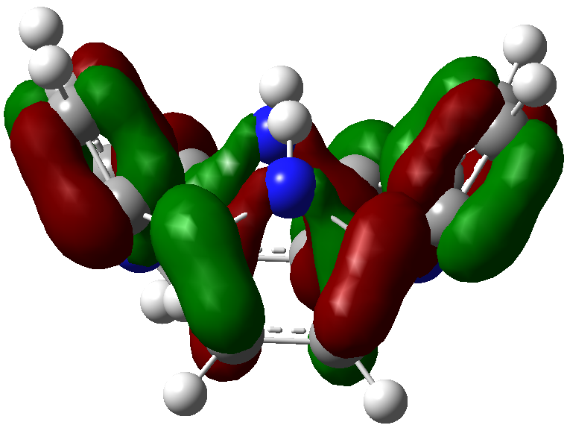 | 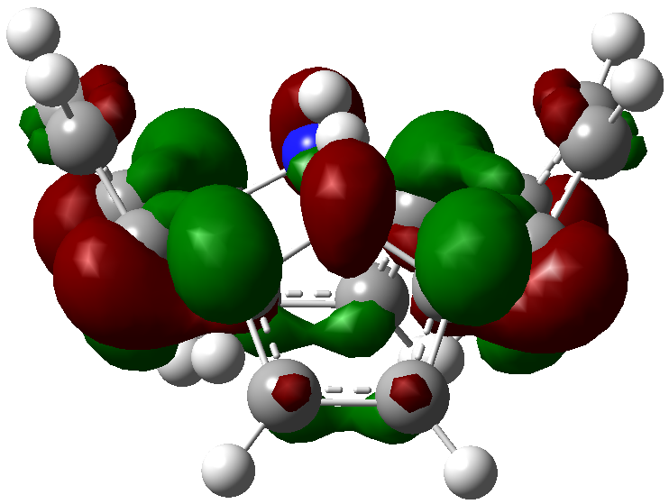
CTPy-phosgene | 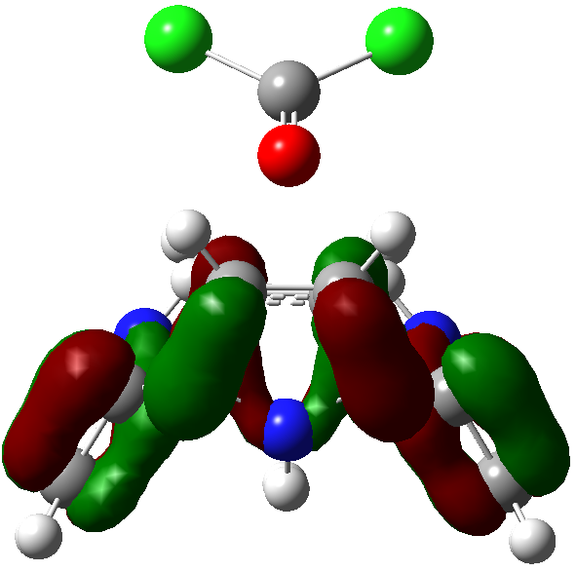 | 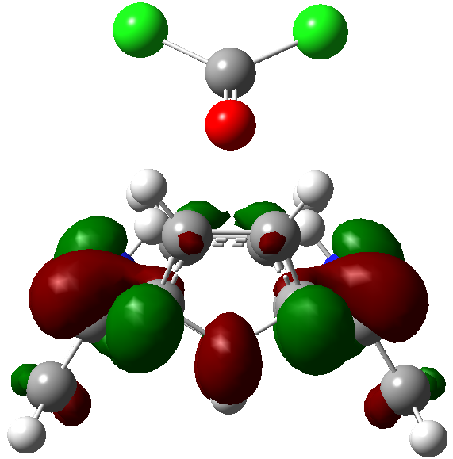
CTPy-diphosgene | 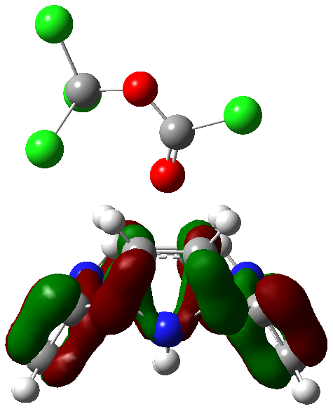 | 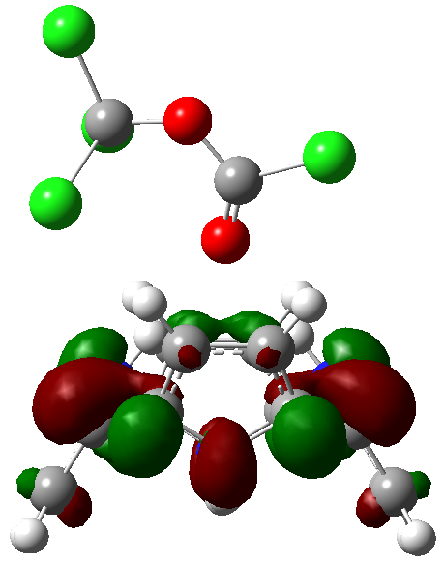
CTPy-chloropicrin | 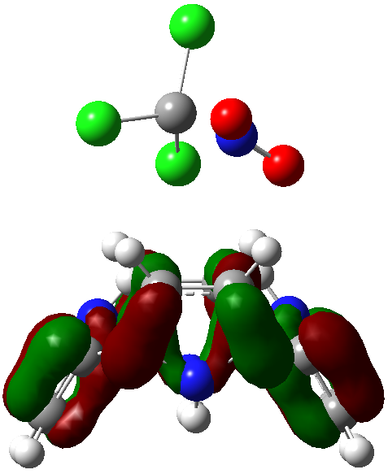 | 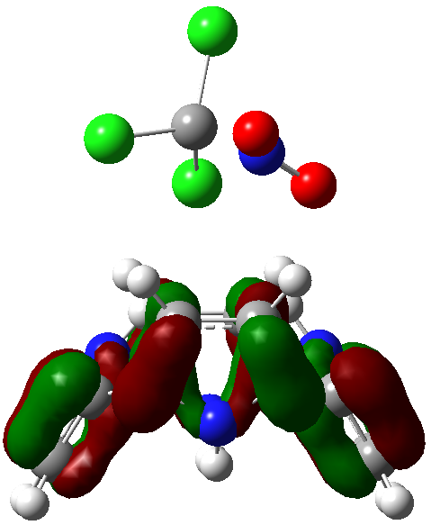
CTPy-chlorine | 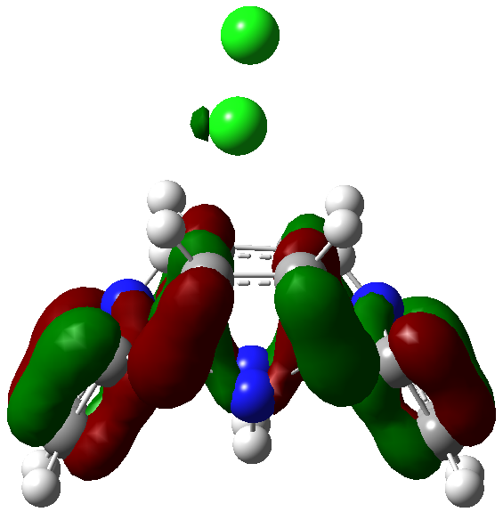 | 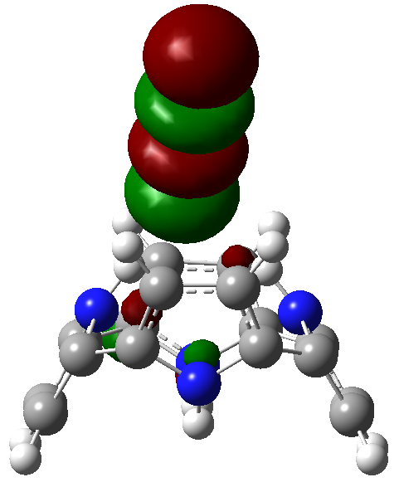

Figure S1. HOMO and LUMO visualization of the complexes.

Coordinates of CTPy-phosgene complex
Charge = 0 Multiplicity = 1
C -2.45128 -0.34525 0.11366
C -2.75515 -1.097 1.24577
C -1.91903 -2.26078 1.24595
C -1.10943 -2.21292 0.11396
N -1.52681 -1.09704 -0.59126
H -0.99801 -0.71732 -1.36274
H -3.44767 -0.80782 2.0245
H -1.86607 -3.0092 2.02487
C 0.34526 -2.45126 -0.11346
C 1.09723 -2.75528 -1.24538
C 2.26103 -1.91918 -1.24543
C 2.21294 -1.1094 -0.11358
N 1.09691 -1.52668 0.59148
H 0.71704 -0.99777 1.3628
H 0.80821 -3.4479 -2.02408
H 3.0096 -1.86635 -2.02421
C 2.45127 0.3453 0.11377
C 2.75509 1.0973 1.24573
C 1.91894 2.26106 1.24563
C 1.10939 2.21294 0.11361
N 1.52682 1.09692 -0.59136
H 0.99799 0.71699 -1.36271
H 3.44758 0.8083 2.02455
H 1.86595 3.00965 2.02438
C -0.34528 2.45126 -0.11398
C -1.09707 2.75493 -1.24613
C -2.26086 1.91882 -1.24611
C -2.21294 1.1094 -0.11399
N -1.09703 1.52689 0.59111
H -0.71728 0.99822 1.36267
H -0.8079 3.4473 -2.025
H -3.00931 1.86574 -2.02498
C -0.22846 -0.19481 -4.68084
O -0.93261 -0.88103 -4.0221
Cl -0.2256 -0.19925 -6.44422
Cl 0.93566 0.94687 -4.00898

Coordinates of CTPy-diphosgene complex
Charge = 0 Multiplicity = 1
C -2.60241 -0.08814 2.89416
C -2.90628 -0.83989 4.02628
C -2.07016 -2.00368 4.02646
C -1.26055 -1.95581 2.89446
N -1.67794 -0.83993 2.18924
H -1.14914 -0.46021 1.41777
H -3.5988 -0.55071 4.80501
H -2.0172 -2.75209 4.80538
C 0.19413 -2.19415 2.66705
C 0.94611 -2.49818 1.53513
C 2.10991 -1.66207 1.53507
C 2.06181 -0.8523 2.66693
N 0.94578 -1.26957 3.37198
H 0.56591 -0.74066 4.14331
H 0.65708 -3.19079 0.75643
H 2.85848 -1.60924 0.7563
C 2.30015 0.6024 2.89428
C 2.60396 1.35441 4.02624
C 1.76781 2.51817 4.02614
C 0.95826 2.47005 2.89412
N 1.37569 1.35403 2.18915
H 0.84686 0.97409 1.4178
H 3.29645 1.06541 4.80506
H 1.71483 3.26676 4.80489
C -0.4964 2.70837 2.66652
C -1.24819 3.01203 1.53438
C -2.41198 2.17593 1.5344
C -2.36407 1.36651 2.66652
N -1.24816 1.784 3.37162
H -0.86841 1.25533 4.14318
H -0.95903 3.70441 0.75551
H -3.16044 2.12285 0.75553
C -0.02529 0.23155 -2.82137
Cl -1.56194 0.2829 -1.97334
O 1.03975 0.1593 -2.30028
O -0.30189 0.28941 -4.15973
C 0.73574 0.26761 -5.11357
Cl 1.82193 1.684 -4.92513
Cl 1.67091 -1.26187 -5.02236
Cl -0.1223 0.363 -6.679

Coordinates of CTPy-chloropicrin complex
Charge = 0 Multiplicity = 1
C 1.04156 0.34714 2.48959
C -0.18786 0.99933 2.55511
C -0.11554 2.17382 1.73637
C 1.15405 2.22738 1.16837
N 1.85078 1.16804 1.72404
H 2.74851 0.86893 1.3735
H -1.06389 0.64184 3.07793
H -0.92701 2.85718 1.52957
C 1.67009 2.51384 -0.20288
C 2.92155 2.9143 -0.66676
C 3.25766 2.10238 -1.79654
C 2.20883 1.21162 -2.01838
N 1.23371 1.55315 -1.09708
H 0.4007 1.00323 -0.9441
H 3.5573 3.65286 -0.19775
H 4.19529 2.11319 -2.3355
C 2.19331 -0.25918 -2.27619
C 1.29871 -1.15113 -2.86168
C 1.23988 -2.32696 -2.03958
C 2.0989 -2.14384 -0.95842
N 2.72498 -0.9331 -1.19232
H 3.28467 -0.46974 -0.49202
H 0.70241 -0.95666 -3.74271
H 0.59056 -3.17902 -2.18864
C 2.0026 -2.38885 0.51204
C 2.95446 -2.60041 1.50696
C 2.6109 -1.7846 2.63403
C 1.45214 -1.07816 2.31979
N 1.06434 -1.54147 1.0758
H 0.36356 -1.07064 0.52363
H 3.83898 -3.21512 1.40969
H 3.18817 -1.67364 3.54181
C -2.96951 -0.32264 -0.24515
Cl -1.61016 -0.95623 -1.19509
Cl -4.49996 -0.42294 -1.14575
Cl -3.07127 -1.10847 1.33237
N -2.73357 1.25947 -0.00968
O -1.97855 1.81712 -0.7822
O -3.36737 1.7542 0.90011
Coordinates of CTPy-chlorine complex
Charge = 0 Multiplicity = 1
C -2.53125 -0.13456 -2.34728
C -2.83512 -0.88631 -1.21516
C -1.999 -2.05009 -1.21498
C -1.18939 -2.00223 -2.34697
N -1.60677 -0.88635 -3.05219
H -1.07797 -0.50662 -3.82367
H -3.52764 -0.59712 -0.43643
H -1.94604 -2.7985 -0.43606
C 0.2653 -2.24056 -2.57439
C 1.01727 -2.54459 -3.70631
C 2.18107 -1.70849 -3.70636
C 2.13297 -0.89871 -2.57451
N 1.01695 -1.31598 -1.86946
H 0.63707 -0.78707 -1.09813
H 0.72824 -3.23721 -4.48501
H 2.92964 -1.65566 -4.48514
C 2.37131 0.55599 -2.34716
C 2.67512 1.30799 -1.2152
C 1.83898 2.47175 -1.2153
C 1.02942 2.42363 -2.34732
N 1.44685 1.30762 -3.05229
H 0.91803 0.92768 -3.82364
H 3.36762 1.01899 -0.43638
H 1.78599 3.22034 -0.43655
C -0.42524 2.66195 -2.57491
C -1.17703 2.96562 -3.70706
C -2.34082 2.12951 -3.70704
C -2.29291 1.32009 -2.57492
N -1.177 1.73758 -1.86982
H -0.79725 1.20892 -1.09826
H -0.88787 3.658 -4.48593
H -3.08928 2.07643 -4.48591
Cl 0.91881 0.79504 2.07599
Cl -0.75324 -0.38186 2.07298

