Supplementary material
Tables
Table S1: Functional electrical stimulation force model – Ding et al. (2007)
Symbol | Unit | Definition
$$cn$$ | $$-$$ | Representation of the ${Ca}^{2+}$-troponin complex
$$f^{m}$$ | $$N$$ | Muscle force
$$a$$ | $$N/s$$ | Force scaling factor related to pulse width
$$km$$ | $$-$$ | Sensitivity between strongly bound cross-bridges and $cn$
$$τ_{1}$$ | $$s$$ | Time constant force decline due to strongly bound cross-bridges absence
$$τ_{2}$$ | $$s$$ | Time constant force decline due to the extra friction between actin and myosin
$$τ_{c}$$ | $$s$$ | Time constant controlling the rise and decay of $cn$
$$t$$ | $$s$$ | Time since the start
$$t_{i}$$ | $$s$$ | Time at which the $i$-th stimulation is delivered
$$r_{j}$$ | $$-$$ | Factor accounting for ${Ca}^{2+}$ nonlinear summation of closely spaced stimulation
$$r_{0}$$ | $$-$$ | Term characterizing $cn$ enhancement from following stimuli
$$a^{'}$$ | $$N/s$$ | Muscle force factor
$$pw$$ | $$s$$ | Stimulation pulse width
$${pw}_{0}$$ | $$s$$ | Minimum pulse width leading to force production
$${pw}_{t}$$ | $$s$$ | Time constant controlling the a$-pw$ relationship

Table S2: Functional electrical stimulation fatigue model – Ding et al. (2003)
Symbol | Unit | Definition
$$a_{rest}^{'}$$ | $$N/s$$ | Rested muscle scaling factor $a^{'}$
$${km}_{rest}$$ | $$-$$ | Rested sensitivity $km$
$${τ1}_{rest}$$ | $$s$$ | Rested time constant $τ1$
$$α_{a^{'}}$$ | $$s^{-2}$$ | Fatigue coefficient for $a^{'}$
$$α_{km}$$ | $$s^{-1}N^{-1}$$ | Fatigue coefficient for $km$
$$α_{τ1}$$ | $$N^{-1}$$ | Fatigue coefficient for $τ1$
$$τ_{fat}$$ | $$s$$ | Time constant controlling the recovery of $a^{'}$, $km$ and $τ1$

Table S3: Scaling method and FES models values
Parameters | Method | Values
PCSA ($cm^{2}$) | Values from [1] and [2] | $$rf=10.88$$
PCSA ($cm^{2}$) | Values from [1] and [2] | $$da=2.54$$  $$dp=2.73$$  $$bic=7.33$$  $$tri=15.56$$
Fiber type I/II proportion | Values from [3] and [4] | $$rf=35/65$$
Fiber type I/II proportion | Values from [3] and [4] | $$da=47/53$$  $$dp=56/44$$  $$bic=38/62$$  $$tri=44/56$$
$a_{rest}^{'}$ ($N/s$) | $${a^{'}}_{rest}^{m}=\frac{{a^{'}}_{rest}^{rf}*{PCSA}^{m}}{{PCSA}^{rf}}$$ | $$rf=4920$$
$a_{rest}^{'}$ ($N/s$) |  | $$da=1148.6$$  $$dp=1234.5$$  $$bic=3314.7$$  $$tri=7036.3$$
$f_{max}^{m}$ ($N$) | Maximum produced force for a  1 second 33 Hz pulse train with $a_{rest}^{',m}$ | $$rf=287$$
$f_{max}^{m}$ ($N$) |  | $$da=48$$  $$dp=51$$  $$bic=149$$  $$tri=617$$
$α_{a^{'}}$ ($N^{-2}$) | $$α_{{a^{'}}^{m}}=\frac{α_{{a^{'}}^{rf}}*{fp}^{m}}{{fp}^{rf}}*\frac{{a^{'}}_{rest}^{rf}}{{a^{'}}_{rest}^{m}}$$ | $$rf=-4.0*{10}^{-2}$$
$α_{a^{'}}$ ($N^{-2}$) |  | $$da=-1.4*{10}^{-1}$$  $$dp=-1.1*{10}^{-1}$$  $$bic=-5.6*{10}^{-2}$$  $$tri=-3.4*{10}^{-2}$$
$τ_{fat}$ ($s$) | $$τ_{fat}^{m}=\frac{τ_{fat}^{rf}*{fp}^{m}}{{fp}^{rf}}*\frac{{a^{'}}_{rest}^{rf}}{{a^{'}}_{rest}^{m}}$$ | $$rf=127$$
$τ_{fat}$ ($s$) |  | $$da=445.5$$  $$dp=342.7$$  $$bic=179.6$$  $$tri=109.1$$
$rf$: rectus femoris; $d_{a}$: anterior deltoid; $dp$: posterior deltoid; $bic$: biceps; $tri$: triceps; fp: fiber type proportion

[1] Peterson SL, Rayan GM. Shoulder and Upper Arm Muscle Architecture. J Hand Surg Am 2011;36:881–9. https://doi.org/10.1016/j.jhsa.2011.01.008.
[2] KUMAZAKI T, TAKAHASHI T, NAKANO T, SAKAI T. Action and Contribution of the Iliopsoas and Rectus Femoris as Hip Flexor Agonists Examined with Anatomical Analysis. Juntendo Medical Journal 2022;68:JMJ22-0009-OA. https://doi.org/10.14789/jmj.JMJ22-0009-OA.
[3] Srinivasan RC, Lungren MP, Langenderfer JE, Hughes RE. Fiber type composition and maximum shortening velocity of muscles crossing the human shoulder. Clinical Anatomy 2007;20:144–9. https://doi.org/10.1002/ca.20349.
[4] Kusumoto Y, Goto H, Chiba K, Oonishi S, Tsuchiya J. Characteristics of muscle contraction of the rectus femoris using tensiomyography by sex in healthy college students: a cross-sectional study. PeerJ 2023;11:e14732. https://doi.org/10.7717/peerj.14732.

Table S4: States and controls boundaries (min in red, max in blue) for the optimal control program.
 |  | OCP
 |  | Node
States |  | 0 | 1…N-1 | N
$cn$ (-) | Anterior deltoid, Posterior deltoid, Biceps, Triceps | 0  10
$f^{m}$ (N) | Anterior deltoid | 0  48
$f^{m}$ (N) | Posterior deltoid | 0  51
$f^{m}$ (N) | Biceps | 0  149
$f^{m}$ (N) | Triceps | 0  262
$a^{'}$ (N/s) | Anterior deltoid | 0  1148.6
$a^{'}$ (N/s) | Posterior deltoid | 0  1234.5
$a^{'}$ (N/s) | Biceps | 0  3314.7
$a^{'}$ (N/s) | Triceps | 0  4915.5
$τ1$ (s) | Anterior deltoid, Posterior deltoid, Biceps, Triceps | 0.060601  1
$km$ (-) | Anterior deltoid, Posterior deltoid, Biceps, Triceps | 0.137  1
$q$ (°) | Shoulder | 0  85.94
$q$ (°) | Elbow | 28.65  143.24
$q$ (°) | Hand/pedal | 0  0 | 0  363 | 357  363
$\dot{q}$ (°/s) | Shoulder | -573  573
$\dot{q}$ (°/s) | Elbow | -573  573
$\dot{q}$ (°/s) | Hand/pedal | 187.93  531.70
Controls |  | 0 | 1…N-2 | N-1
$pw$ (µs) | Anterior deltoid, Posterior deltoid, Biceps, Triceps | 131  600

Table 5: Cost function formulation
Index | Objective function | Description
 | Pulse width
$$ɸ_{pw}^{1}$$ | $$\int_{0}^{T}{\left(\frac{1}{n^{m}}\sum_{m=1}^{n^{m}}{{pw}^{m}\left(t\right)}\right) }dt$$ | Minimize the average pulse width activation
$$ɸ_{pw}^{2}$$ | $$\int_{0}^{T}{{\left(\frac{1}{n^{m}}\sum_{m=1}^{n^{m}}{{\left({pw}^{m}\left(t\right)\right)}^{2}}\right)}^{\frac{1}{2}} }dt$$ | Minimize the quadratic average pulse width activation
$$ɸ_{pw}^{3}$$ | $$\int_{0}^{T}{{\left(\frac{1}{n^{m}}\sum_{m=1}^{n^{m}}{{\left({pw}^{m}\left(t\right)\right)}^{3}}\right)}^{\frac{1}{3}} }dt$$ | Minimize the cubic average pulse width activation
$$ɸ_{pw}^{∞}$$ | $$\int_{0}^{T}{\max_{m=1, ... ,n^{m}}{{pw}^{m}\left(t\right) }}dt$$ | Minimize the peak pulse width activation
 | Force
$$ɸ_{f^{m}}^{1}$$ | $$\int_{0}^{T}{\left(\frac{1}{n^{m}}\sum_{m=1}^{n^{m}}{f^{mm}\left(t\right)}\right) }dt$$ | Minimize the average muscle force
$$ɸ_{f^{m}}^{2}$$ | $$\int_{0}^{T}{{\left(\frac{1}{n^{m}}\sum_{m=1}^{n^{m}}{{\left(f^{mm}\left(t\right)\right)}^{2}}\right)}^{\frac{1}{2}} }dt$$ | Minimize the quadratic average muscle force
$$ɸ_{f^{m}}^{3}$$ | $$\int_{0}^{T}{{\left(\frac{1}{n^{m}}\sum_{m=1}^{n^{m}}{{\left(f^{mm}\left(t\right)\right)}^{3}}\right)}^{\frac{1}{3}} }dt$$ | Minimize the cubic average muscle force
$$ɸ_{f^{m}}^{∞}$$ | $$\int_{0}^{T}{\max_{m=1, ... , n^{m}}{f^{mm}\left(t\right) }}dt$$ | Minimize the peak muscle force
 | Stress
$$ɸ_{σ}^{1}$$ | $$\int_{0}^{T}{\left(\frac{1}{n^{m}}\sum_{m=1}^{n^{m}}{\frac{f^{mm}\left(t\right)}{{PCSA}^{m}}}\right) }dt$$ | Minimize the average muscle stress
$$ɸ_{σ}^{2}$$ | $$\int_{0}^{T}{{\left(\frac{1}{n^{m}}\sum_{m=1}^{n^{m}}{{\left(\frac{f^{mm}\left(t\right)}{{PCSA}^{m}}\right)}^{2}}\right)}^{\frac{1}{2}} }dt$$ | Minimize the quadratic average muscle stress
$$ɸ_{σ}^{3}$$ | $$\int_{0}^{T}{{\left(\frac{1}{n^{m}}\sum_{m=1}^{n^{m}}{{\left(\frac{f^{mm}\left(t\right)}{{PCSA}^{m}}\right)}^{3}}\right)}^{\frac{1}{3}} }dt$$ | Minimize the cubic average muscle stress
$$ɸ_{σ}^{∞}$$ | $$\int_{0}^{T}{\max_{m=1, ... , n^{m}}{\frac{f^{mm}\left(t\right)}{{PCSA}^{m}} }}dt$$ | Minimize the peak muscle stress

 | Fatigue
$$ɸ_{a^{'}}^{1}$$ | $$\int_{0}^{T}{\left(\frac{1}{n^{m}}\sum_{m=1}^{n^{m}}{{a^{'}}_{rest}^{m}-{a^{'}}^{m}\left(t\right)}\right) }dt$$ | Minimize the average muscle fatigue
$$ɸ_{a^{'}}^{2}$$ | $$\int_{0}^{T}{{\left(\frac{1}{n^{m}}\sum_{m=1}^{n^{m}}{{\left({a^{'}}_{rest}^{m}-{a^{'}}^{m}\left(t\right)\right)}^{2}}\right)}^{\frac{1}{2}} }dt$$ | Minimize the quadratic average muscle fatigue
$$ɸ_{a^{'}}^{3}$$ | $$\int_{0}^{T}{{\left(\frac{1}{n^{m}}\sum_{m=1}^{n^{m}}{{\left({a^{'}}_{rest}^{m}-{a^{'}}^{m}\left(t\right)\right)}^{3}}\right)}^{\frac{1}{3}} }dt$$ | Minimize the cubic average muscle fatigue
$$ɸ_{a^{'}}^{∞}$$ | $$\int_{0}^{T}{\max_{m=1, ... , n^{m}}{{a^{'}}_{rest}^{m}-{a^{'}}^{m}\left(t\right) }}dt$$ | Minimize the peak muscle fatigue
 | Power
$$ɸ_{w}^{2}$$ | $$\int_{0}^{T}{{\left(\frac{1}{n^{m}}\sum_{m=1}^{n^{m}}{{\left(f^{mm}\left(t\right)×{\dot{l}}_{CE}^{m}\right)}^{2}}\right)}^{\frac{1}{2}} }dt$$ | Minimize the quadratic average muscle power
 | Bayesian optimization / Physiological weight
$$ɸ_{pwω}^{2}$$ | $$\int_{0}^{T}{{\left(\frac{1}{n^{m}}\sum_{m=1}^{n^{m}}{ω^{m}×{\left({pw}^{m}\left(t\right)\right)}^{2}}\right)}^{\frac{1}{2}} }dt$$ | Minimize the weighted quadratic average pulse width activation
$$ɸ_{f^{m}ω}^{2}$$ | $$\int_{0}^{T}{{\left(\frac{1}{n^{m}}\sum_{m=1}^{n^{m}}{{ω^{m}×\left(f^{mm}\left(t\right)\right)}^{2}}\right)}^{\frac{1}{2}} }dt$$ | Minimize the weighted quadratic average muscle force
$$ɸ_{σω}^{2}$$ | $$\int_{0}^{T}{{\left(\frac{1}{n^{m}}\sum_{m=1}^{n^{m}}{{ω^{m}×\left(\frac{f^{mm}\left(t\right)}{{PCSA}^{m}}\right)}^{2}}\right)}^{\frac{1}{2}} }dt$$ | Minimize the weighted quadratic average muscle stress
$$ɸ_{a^{'}ω}^{2}$$ | $$\int_{0}^{T}{{\left(\frac{1}{n^{m}}\sum_{m=1}^{n^{m}}{{ω^{m}×\left({a^{'}}_{rest}^{m}-{a^{'}}^{m}\left(t\right)\right)}^{2}}\right)}^{\frac{1}{2}} }dt$$ | Minimize the weighted quadratic average muscle fatigue
$$ɸ_{wω}^{2}$$ | $$\int_{0}^{T}{{\left(\frac{1}{n^{m}}\sum_{m=1}^{n^{m}}{ω^{m}×{\left(f^{mm}\left(t\right)×{\dot{l}}_{CE}^{m}\right)}^{2}}\right)}^{\frac{1}{2}} }dt$$ | Minimize the weighted quadratic average muscle power

Table S6: Equation table for physiological and mechanical weight calculation
N° | Definition | Equation | Description
1 | Muscle-generated tangential crank torque | $$τ_{m}(θ)=r(θ) \text{(}f_{max}^{m}(θ)⋅e_{t}(θ))$$ | Tangential ($e_{t}$) produced torque ($τ$), with $r=0.1$ the arm lever for each 360° pedal angle ($θ$) per muscle ($m$) at maximum force ($f_{max}^{m}$).
2 | Positive task-supporting torque | $$τ_{m}^{+}(θ)=max⁡(τ_{m}(θ),0)$$ | Positive muscle torque $τ_{m}^{+}(θ)$ per angle.
3 | Contribution task ratio | $${contrib}^{m}=\frac{1}{360}\sum_{θ=1}^{360}{1[τ_{m}(θ)}>0 ]$$ | Based on the first-order Ding et al. (2003) fatigue dynamics model, the muscle fatigability metric ($fat^{m}$) was calculated using the slope between the 1st and 1500th cycle of the remaining capacity ratios. Muscle fatigue (${a^{'}}^{m}$) was estimated for each cycle ($k$) using a constant produced force ($ρf_{max}^{m}$) of 80% $f_{max}^{m}$, activated during contribution phases ($t_{act}^{m}$) and deactivated when not contributing to the task ($t_{rest}^{m}$). This metric represents the probability of a muscle to fatigue
 | Standardized repeated demand | $$ρ=0.8$$
 | Activation and rest time | $$t_{act}^{m}={contrib}^{m}, t_{rest}^{m}=1-{contrib}^{m}$$
 | Total cycles | $$k∈[1, 1500]$$
 | Muscle fatigue evolution during active phase | $${a^{'}}_{act, k}^{m}=\left({a^{'}}_{rest}^{m}+α_{{a^{'}}^{m}}*ρf_{max}^{m}*τ_{fat}^{m}\right)\left(1-e^{-\frac{t_{act}^{m}}{τ_{fat}^{m}}}\right)+e^{-\frac{t_{act}^{m}}{τ_{fat}^{m}}}*{a^{'}}_{ k}^{m}$$
 | Muscle fatigue evolution per cycle | $${a^{'}}_{k+1}^{m}={a^{'}}_{rest}^{m}\left(1-e^{-\frac{t_{rest}^{m}}{τ_{fat}^{m}}}\right)+e^{-\frac{t_{rest}^{m}}{τ_{fat}^{m}}}*{a^{'}}_{act, k}^{m}$$
 | Muscle fatigability metric | $$fat^{m}=\left(\frac{{a^{'}}_{1500}^{m}}{{a^{'}}_{rest}^{m}}-\frac{{a^{'}}_{1}^{m}}{{a^{'}}_{rest}^{m}} \right)÷ 1500$$
6 | Muscle redundancy | $$r(θ)=\sum_{m=1}^{4}{1_{τ_{m}^{+}(θ)>0}}$$ | The redundancy level $r(θ)$ is defined as the number of muscles producing positive torque at pedal angle $θ$. The unique contribution $u^{m}$ of muscle $m$ is computed by integrating its positive torque ($τ_{m}^{+}$) only over the angular regions where it is the sole contributing muscle, i.e. where $r(θ)=1$.
 | Unique-support contribution | $$u^{m}=∫1_{r(θ)=1} τ_{m}^{+}(θ) dθ$$
7 | Support inside the pre-risk region | $$p^{m}=\int_{Θ_{pre\text{-}risk}}{τ_{m}^{+}}(θ) dθ$$ | Measures the positive torque produced by muscle $m$ inside the pre-risk angular region (90° before the common negative torque production).
8 | Mechanical contribution metric | $${mc}^{m}=u^{m}+p^{m}$$ | Mechanical contribution metric ${mc}^{m}$ is based on unique-support contribution and muscle support inside the pre-risk region.
9 | Muscle weight | $$ω^{m}=\left\|{mc}^{m}*{fat^{m}}^{2}\right\|$$ | Defines the final muscle weight by multiplying mechanical contribution metric ${mc}^{m}$ and muscle fatigability metric $fat^{m}$, then normalizing it between 0 and 1.

Figures
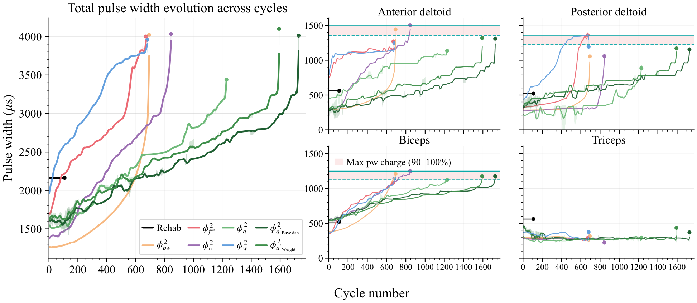
Figure S1: All (left) and muscle specific (right) pulse width charge across cycles for five quadratic cost functions and rehab (section 3), bayesiant optimization (section 4), and weight calculation (section 5). The translucent curves are the unfiltered pulse width and the full ones are filtered with a Savitzky-Golay filter (window length: 31 points, 3rd polynomial order, interpolation mode).

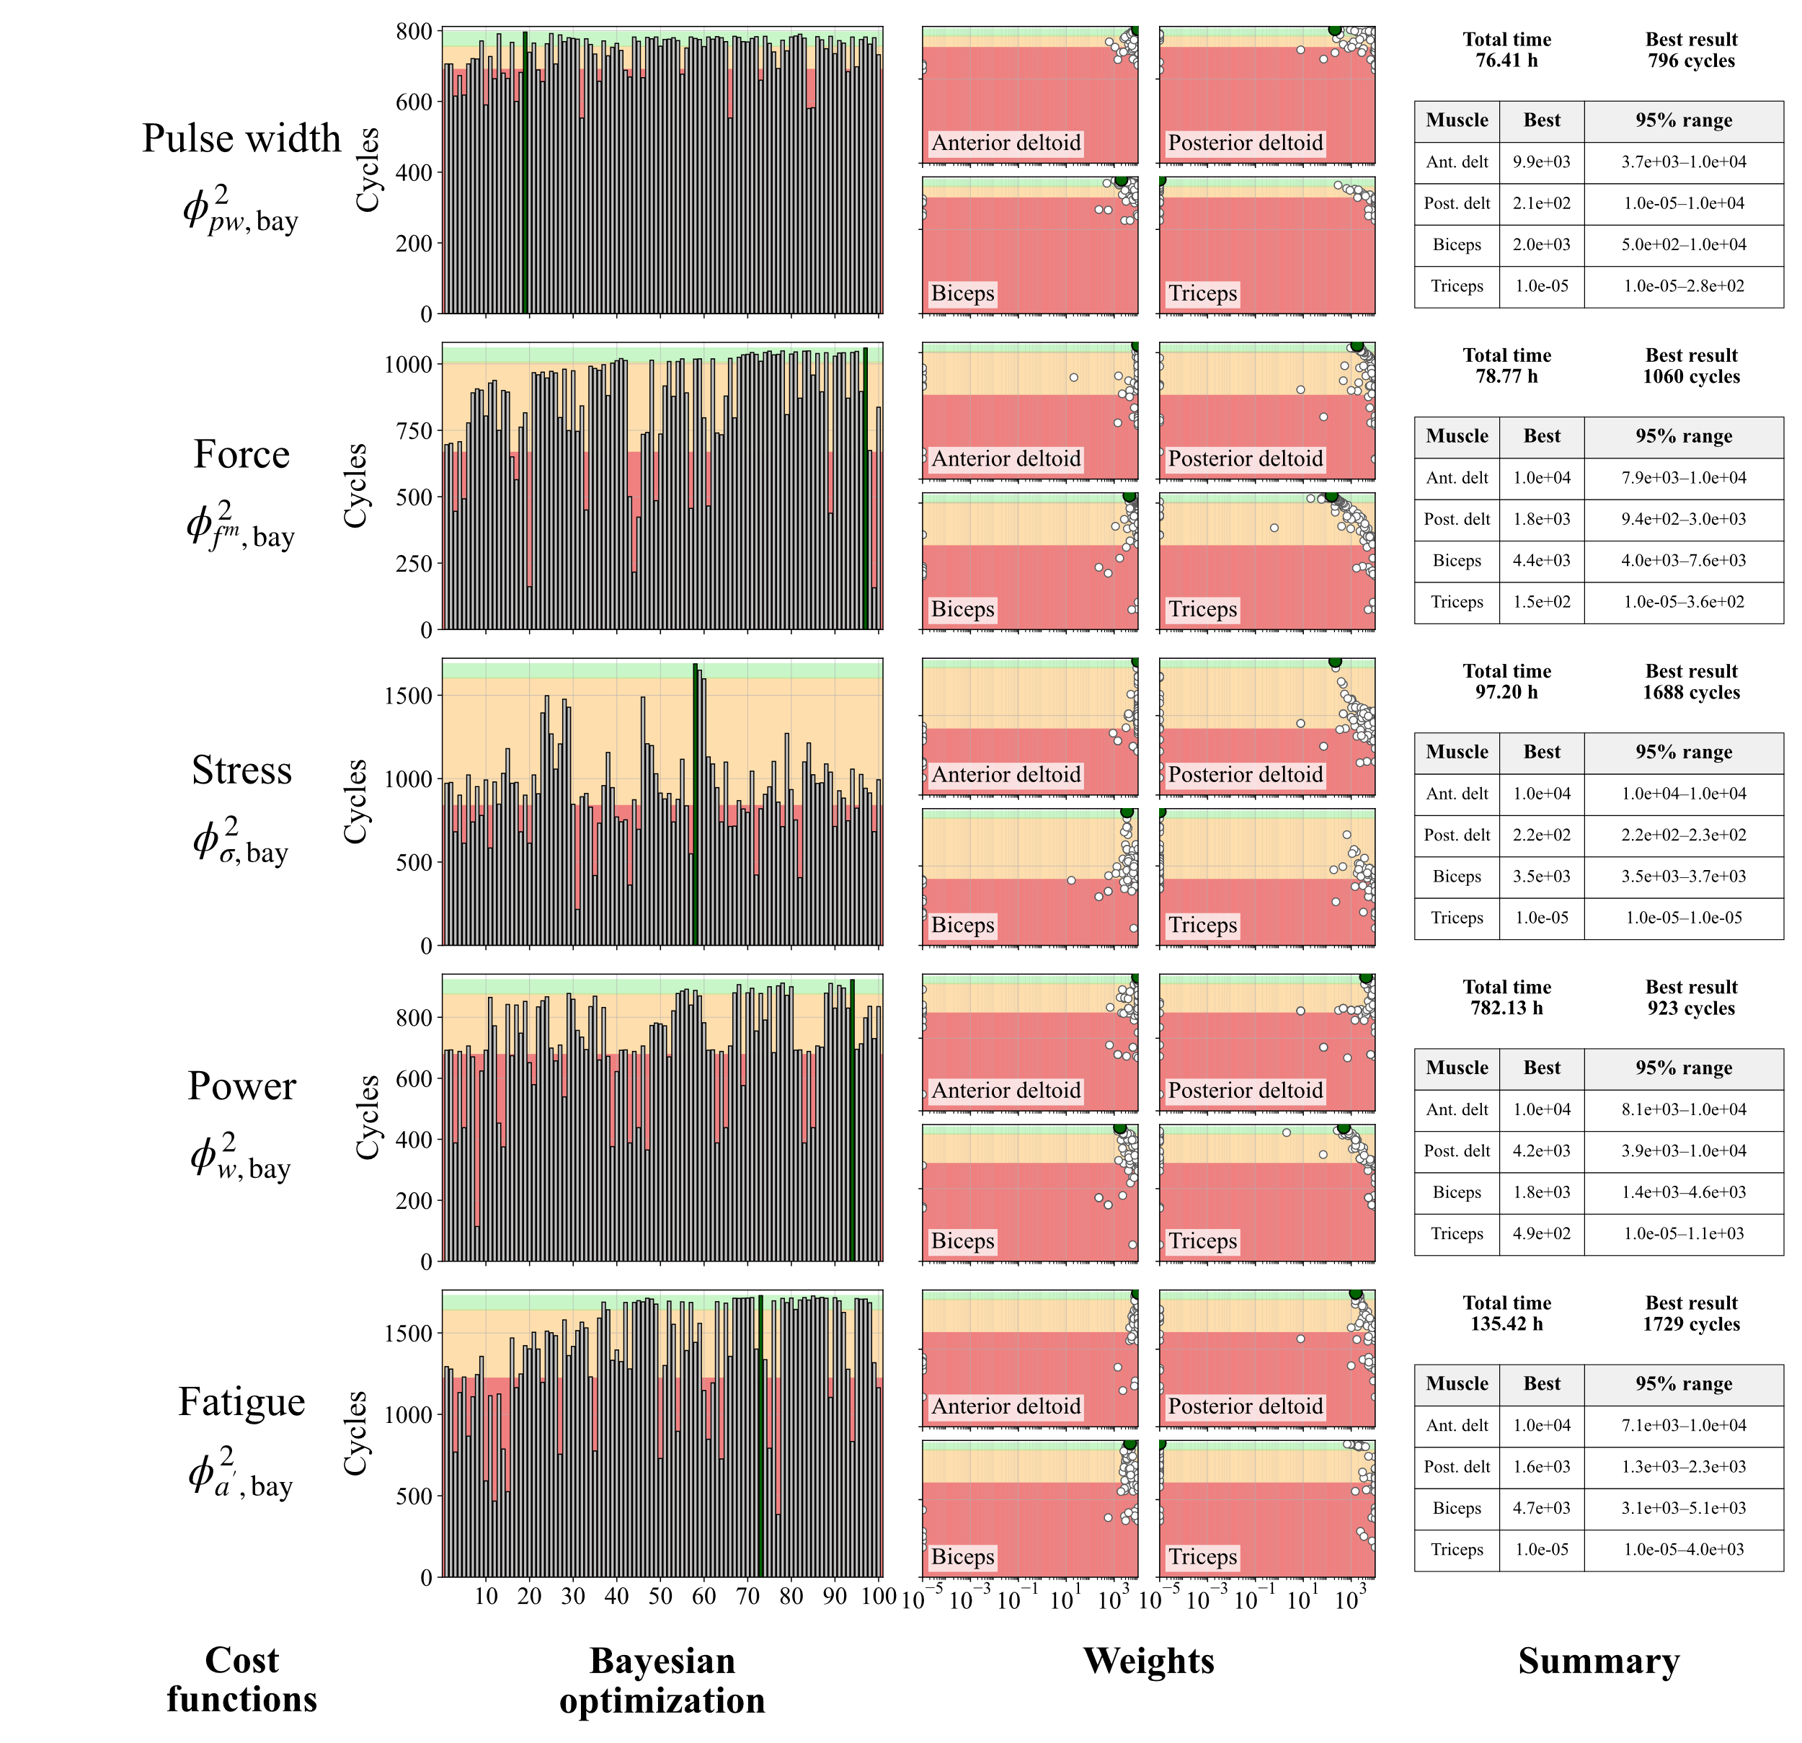
Figure S2: Bayesian optimization progress: number of completed cycles before failure with repect to iterations and corresponding weight updates. Decrease (red), increase (yellow), near optimal solutions (>95% cycle improvement in green), and best performance (dark green) compared to respective unweighted cost function.

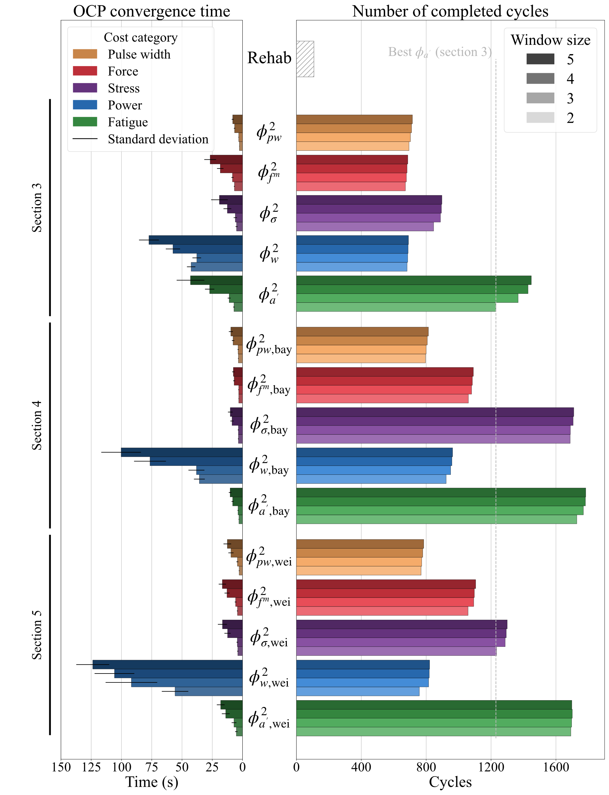
Figure S3: Mean and standard deviation times to solve an OCP on the left and number of completed cycles on the right cycles based on the quadratic cost functions (color-coded), four window size used (color gradient), and three muscle weights: uniform $ω=1$ (section 3), optimal endurance weights for the cost function obtained by Bayesian optimization (section 4), and weights calculated from physiological and mechanical properties (section 5).

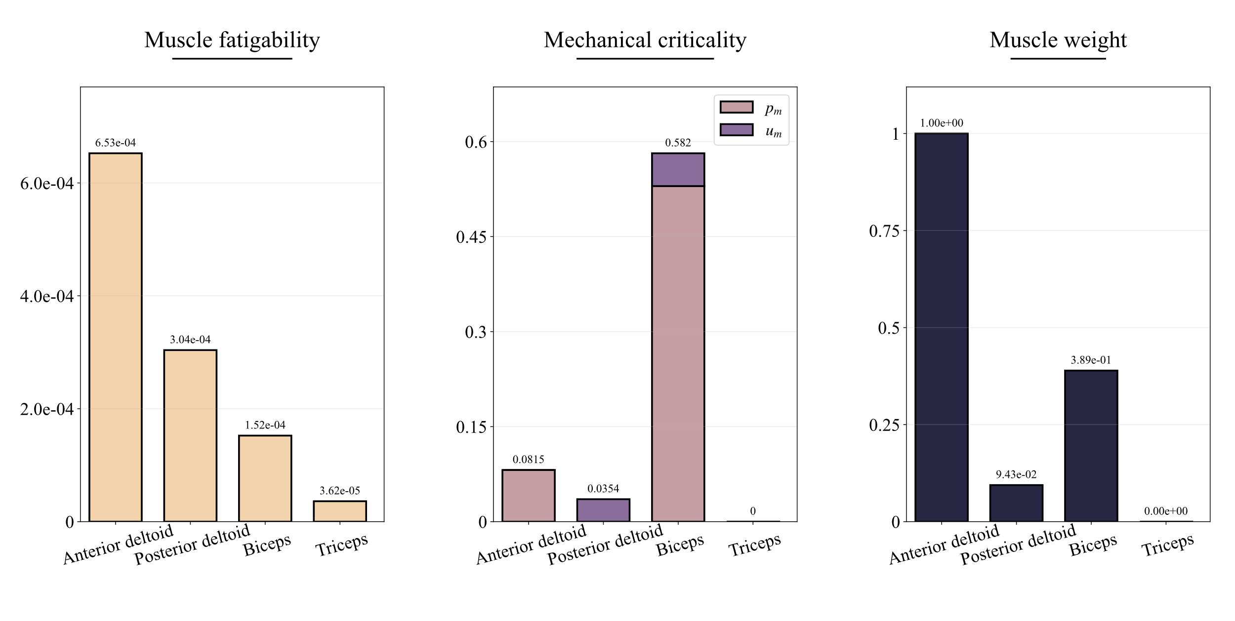
Figure S4: Muscle-specific fatigability, mechanical criticality, and normed weights for an arm cycling task.

