Supplementary Matrial 3: Diagrams
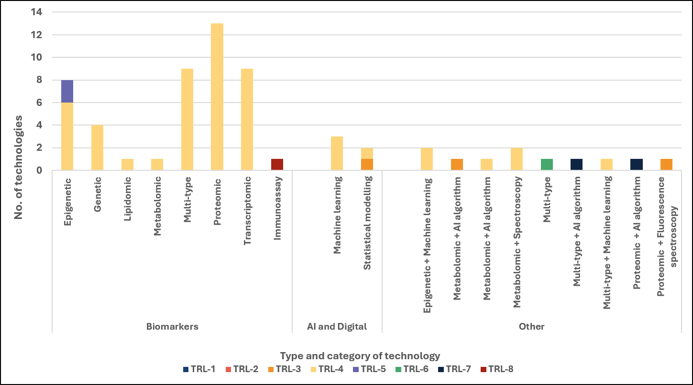
Figure S 1: Identified technologies for liver cancer by technology type, category, and TRL
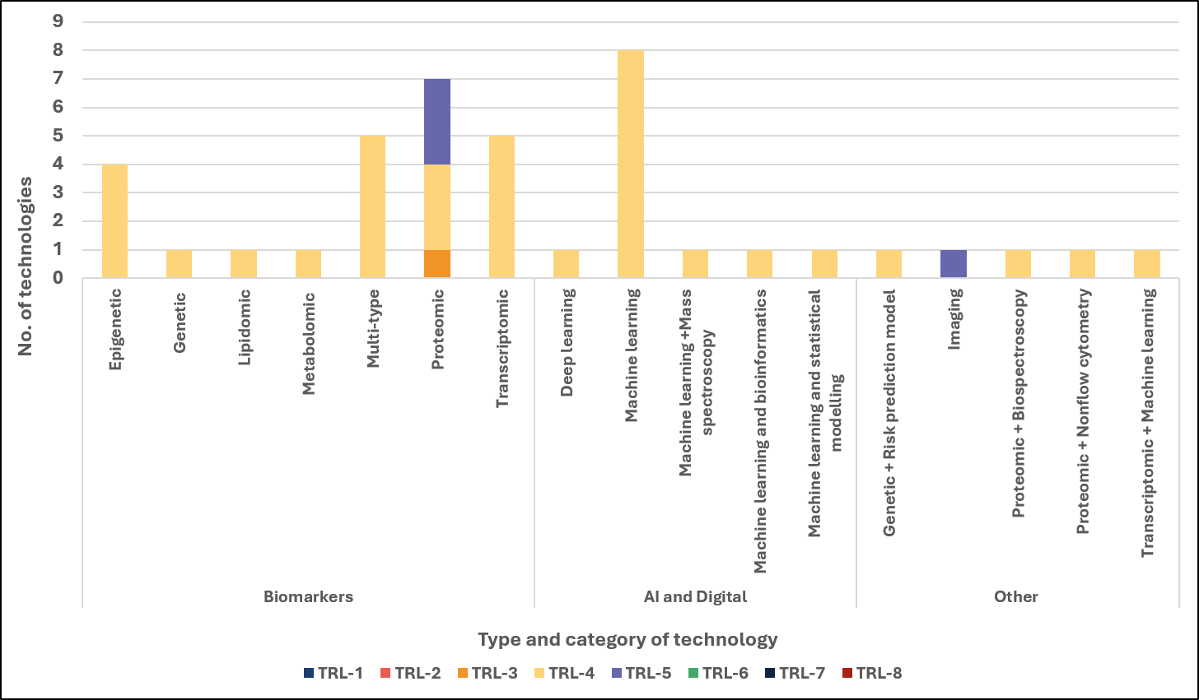
Figure S 2: Identified technologies for ovarian cancer by technology type, category, and TRL

