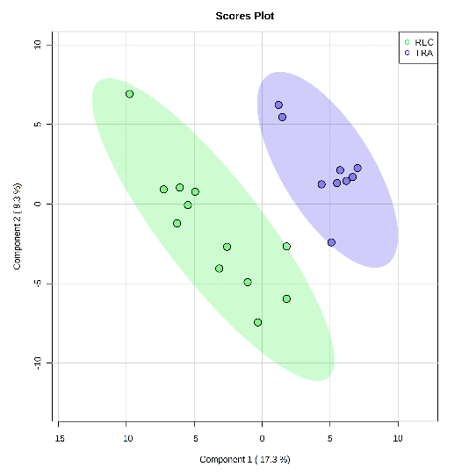
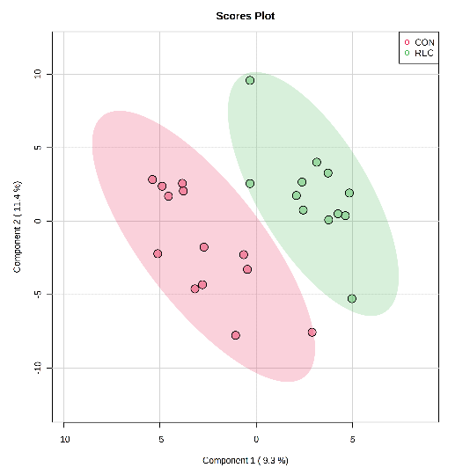
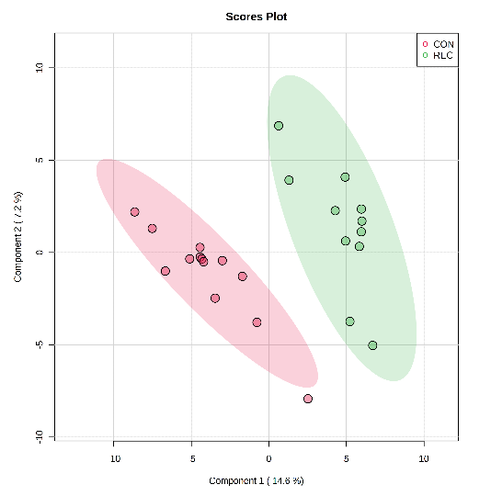
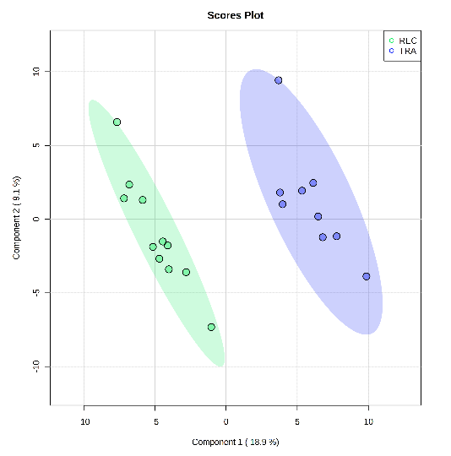
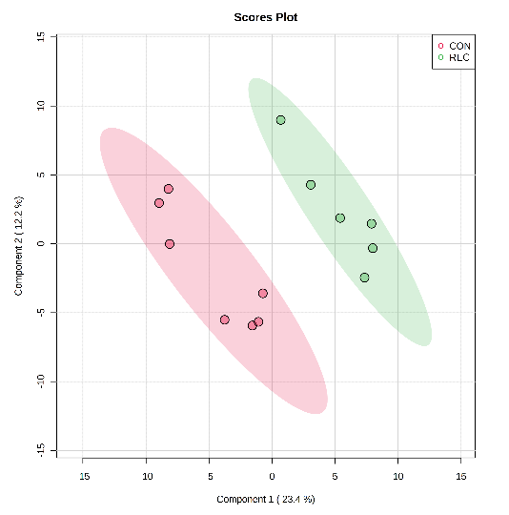
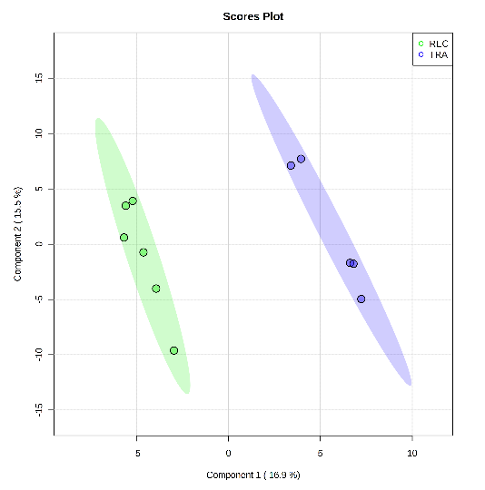
Figure S1. Partial Least Squares Discriminant Analysis (PLS-DA) 2D score plot of the metabolites in serum revealed significant differences on d 0 before E. coli challenge, d 5 and 11 post-inoculation between the TRA and REC groups (A-C) and CON and REC (D-E), respectively. ● = CON (Control); ● = TRA (Trace amounts of antibiotic); ● = REC (Label-recommended dose of antibiotic). Shaded areas in different colors represent in 95% confidence interval.
A
B
C
D
E
F
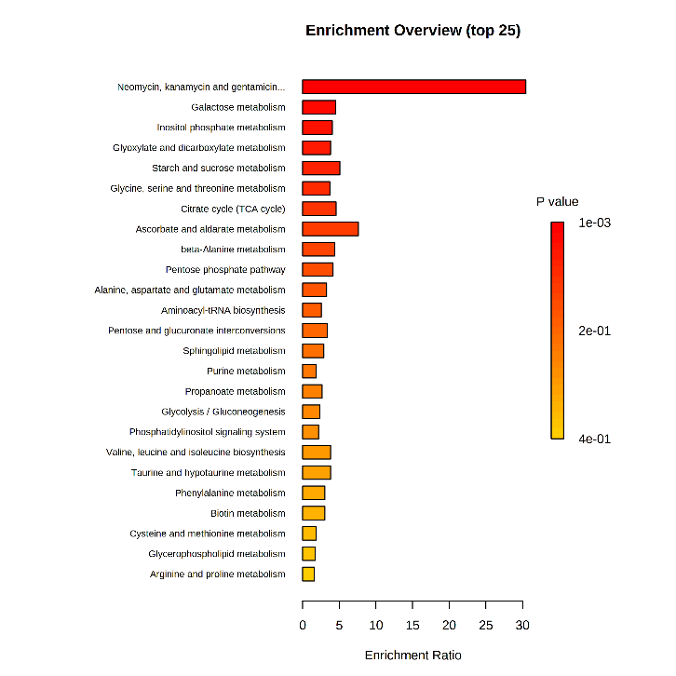
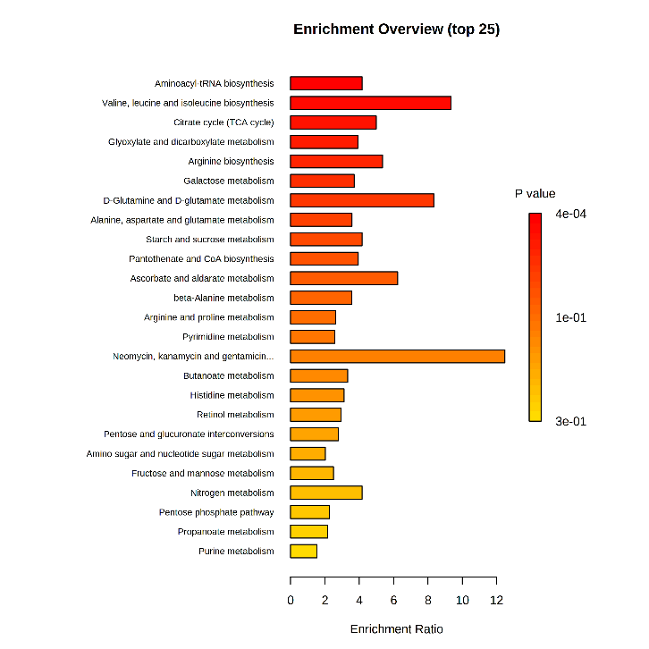
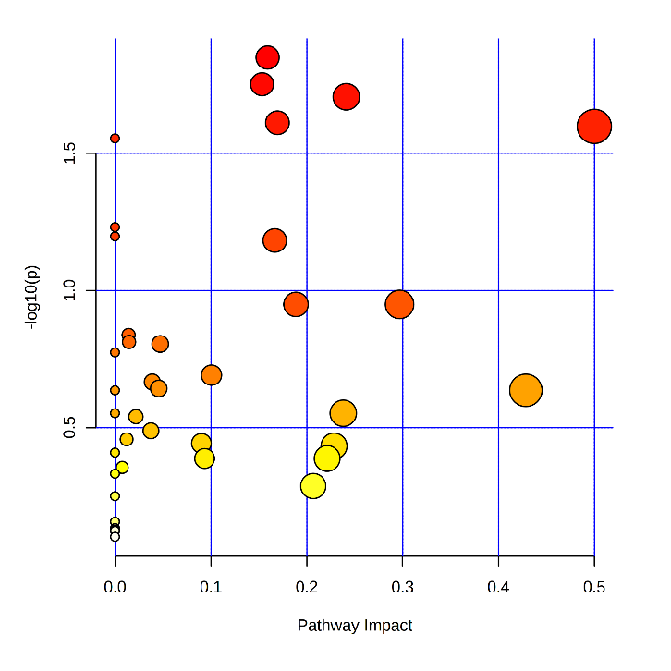
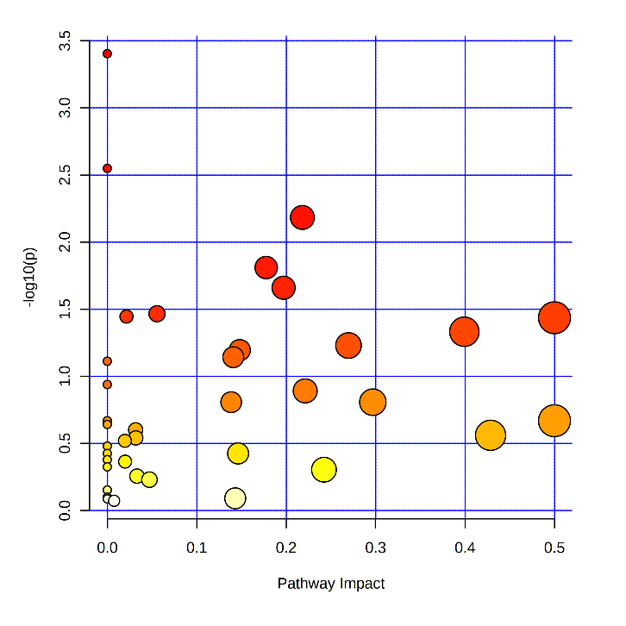
Figure S2. Significantly changed pathways in serum between the control (CON) and label-recommended dose of antibiotic (REC) groups (A), and trace amounts of antibiotic (TRA) and REC groups (B) on d 0 before E. coli challenge. The x-axis represents the pathway impact values and the y-axis represents the -log(P) values from the pathway enrichment analysis. Metabolite set enrichment analysis (C, D) shows the metabolic pathways were enriched in CON compared to REC, and TRA compared to REC on d 0 before E. coli challenge, respectively. Both pathway analysis and metabolite set enrichment analysis were performed using identified metabolites with VIP > 1.
A
Inositol phosphate metabolism
Glyoxylate and discarboxylate metabolism
Citrate cycle (TCA cycle)
Glycine, serin and threonine metabolism
Ascorbate and aldarate metabolism
B
Citrate cycle (TCA cycle)
Arginine biosynthesis
Alanine, aspartate, and glutamate metabolism
C
D

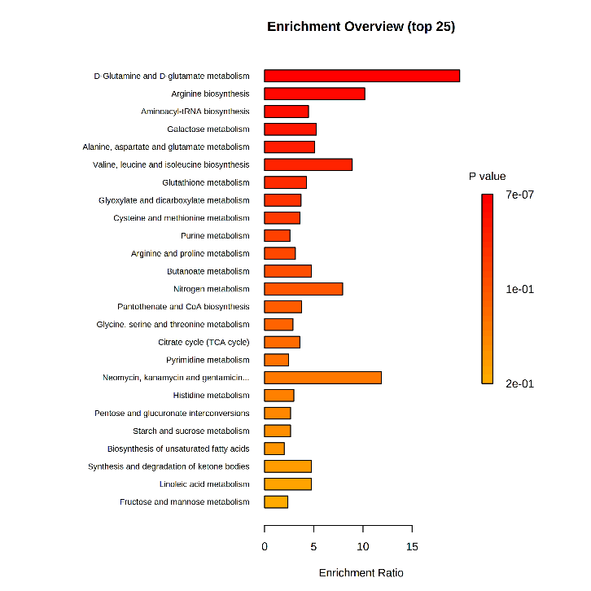
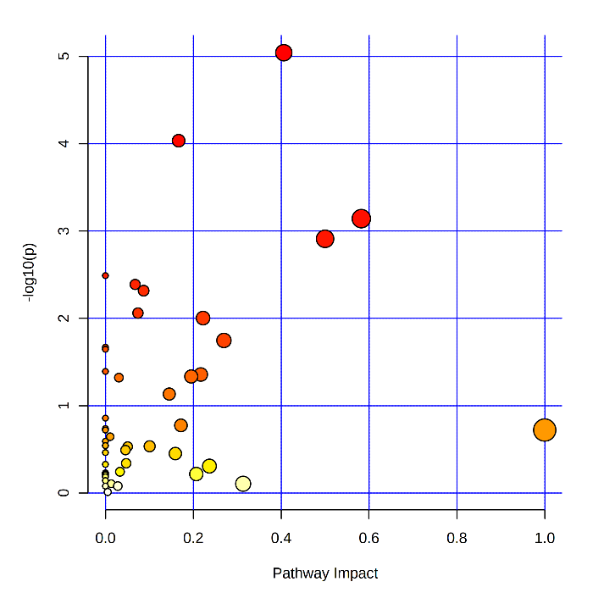
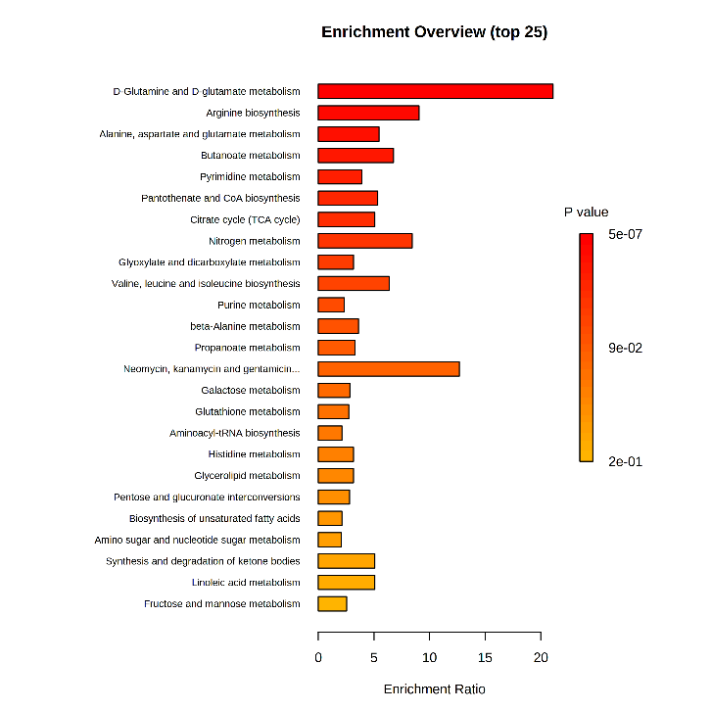
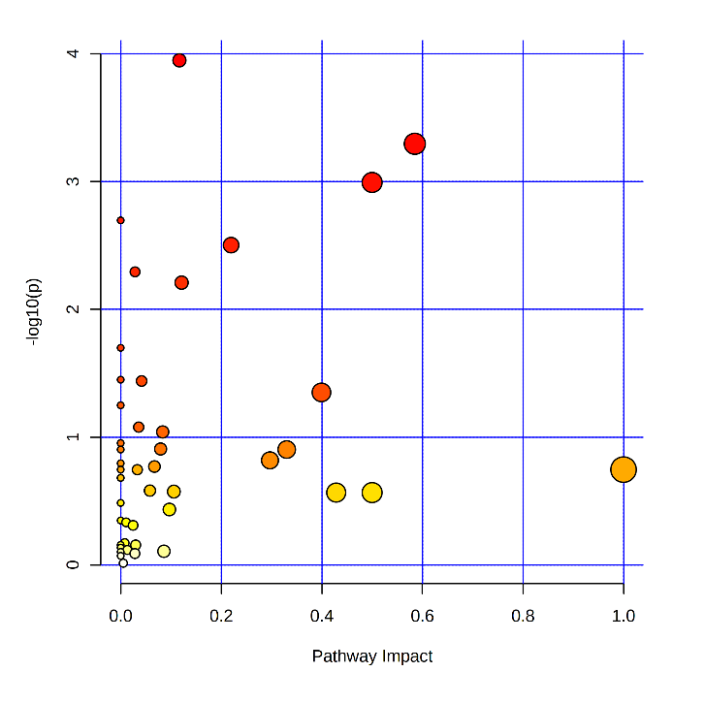
Figure S3. Significantly changed pathways in serum between the control (CON) and label-recommended dose of antibiotic (REC) groups (A), and trace amounts of antibiotic (TRA) and REC groups (B) on d 11 post-inoculation. The x-axis represents the pathway impact values and the y-axis represents the -log(P) values from the pathway enrichment analysis. Metabolite set enrichment analysis (C, D) shows the metabolic pathways were enriched in CON compared to REC, and TRA compared to REC on d 11 post-inoculation, respectively. Both pathway analysis and metabolite set enrichment analysis were performed using identified metabolites with VIP > 1.
B
C
D
A
Arginine biosynthesis
Alanine, aspartate, and glutamate metabolism
D-Glutamine and D-glutamate metabolism
Pyrimidine metabolism
Citrate cycle (TCA cycle)
Arginine biosynthesis
Aminoacyl-tRNA biosynthesis
Alanine, aspartate, and glutamate metabolism
D-Glutamine and D-glutamate metabolism

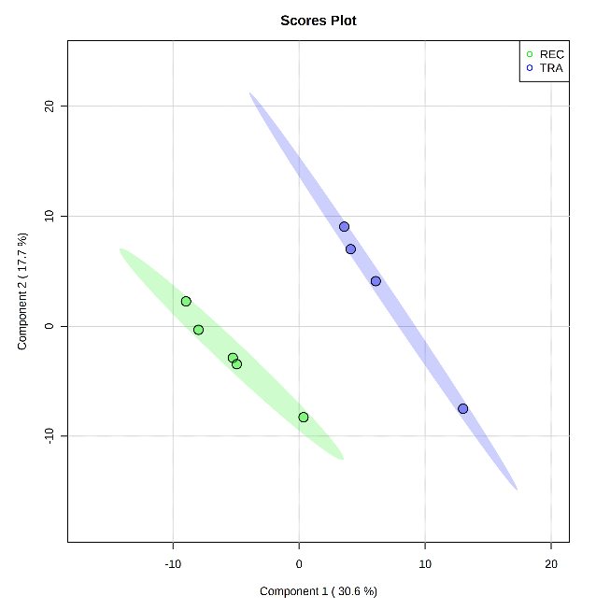
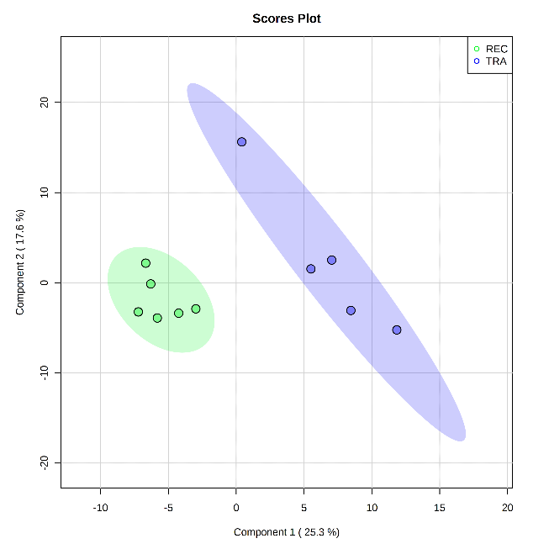
A B
Figure S4. Partial Least Squares Discriminant Analysis (PLS-DA) 2D score plot of the metabolites in colon digesta revealed significant differences between the TRA and REC groups on d 5 (A) and 11 (B) post-inoculation. ● = TRA (Trace amounts of antibiotic); ● = REC (Label-recommended dose of antibiotic). Shaded areas in different colors represent in 95% confidence interval.
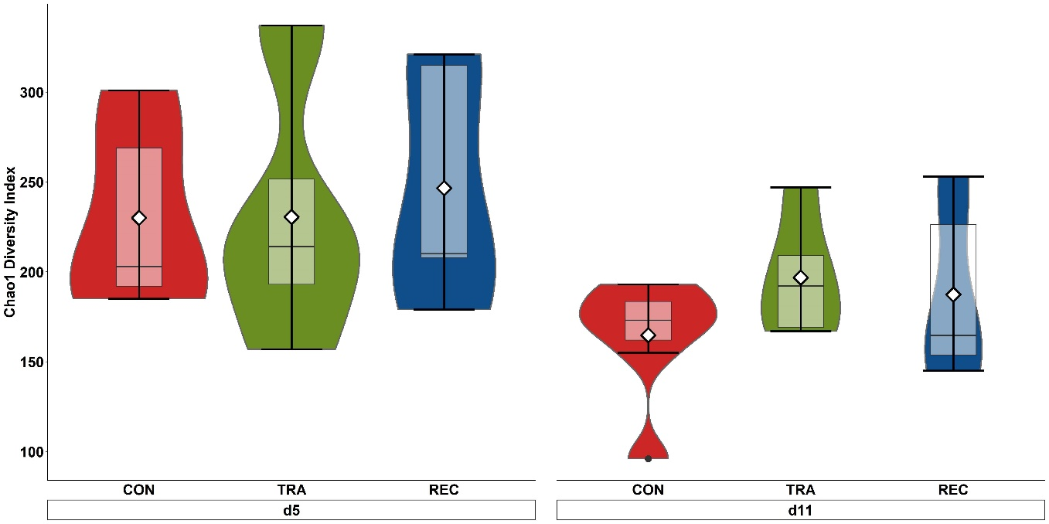
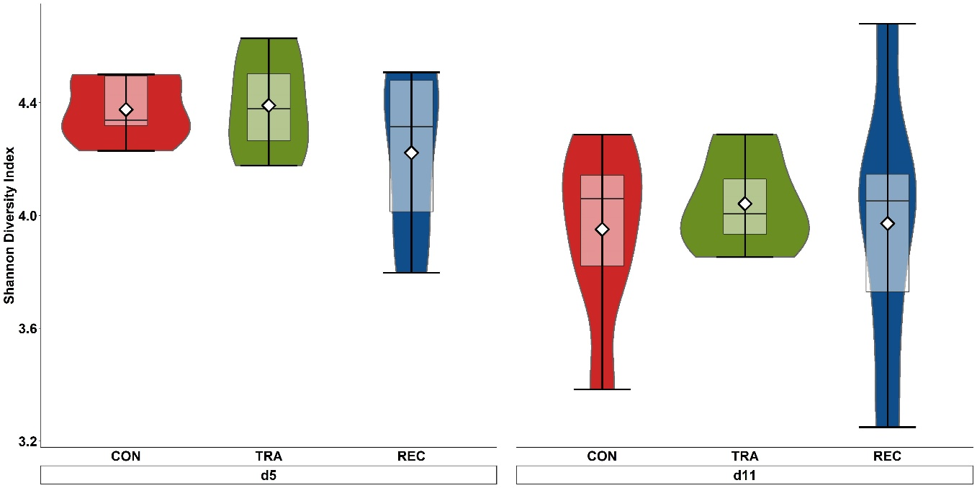
a
ab
a
b
ab
ab
a
a
ab
b
ab
b
A

B

Figure S5. Alpha diversity as indicated by Chao 1 (A) and Shannon (B) indices in colon digesta of enterotoxigenic E. coli F18 challenged pigs fed diets supplemented with different dose of antibiotic on d 5 and 11 post-inoculation. ^{a-b}Means without a common superscript are different across both time points (Diet × day, P < 0.05). Each least squares mean represents 4 to 7 observations. CON = Control; TRA = Trace amount of antibiotic; REC = Label-recommended dose of antibiotic.

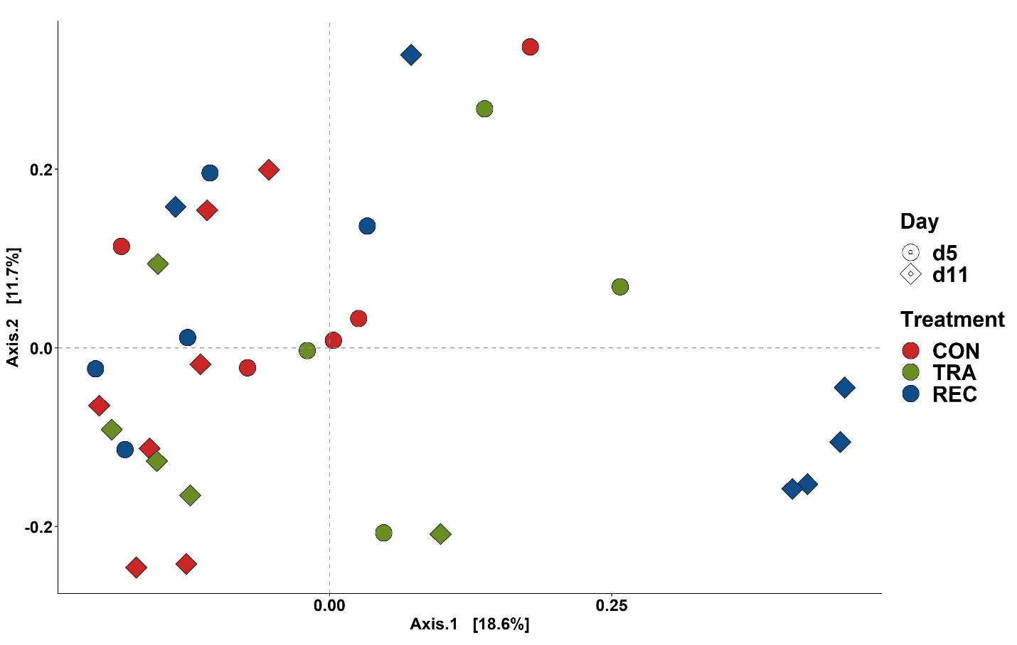
Figure S6. Beta diversity of colon digesta of enterotoxigenic E. coli F18 challenged pigs fed diets supplemented with different dose of antibiotic on d 5 and 11 post-inoculation. Data were analyzed by principal coordinate analysis (PCoA) based on the Bray-Curtis dissimilarity. Symbols indicate dietary treatments and colors indicate different sampling dates. CON = Control; TRA = Trace amount of antibiotic; REC = Label-recommended dose of antibiotic.

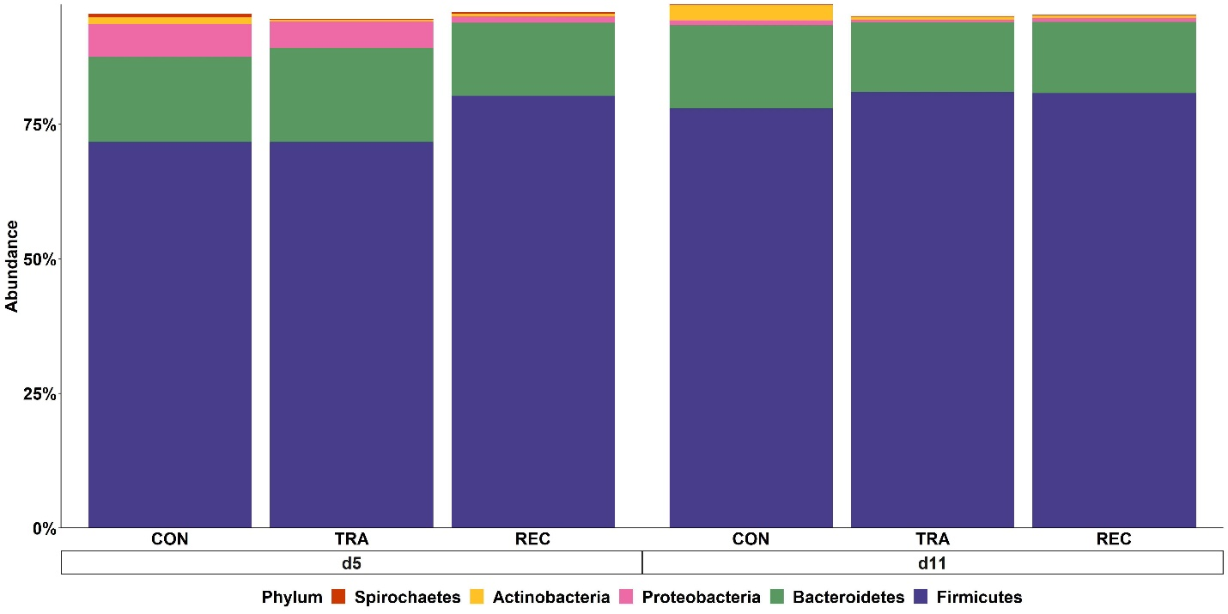
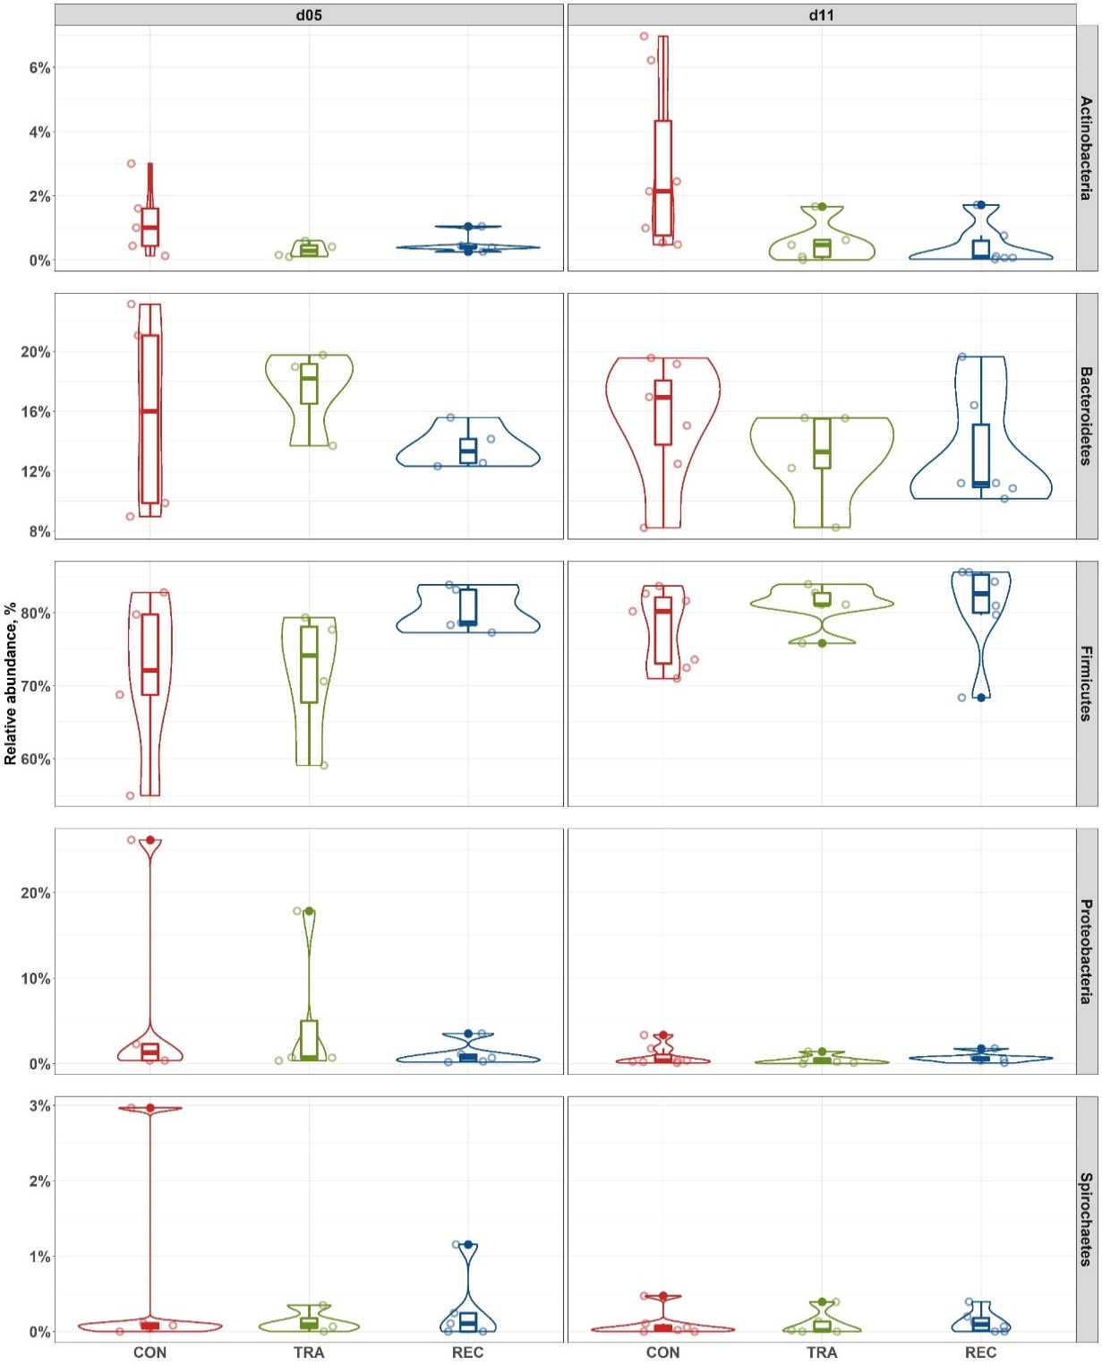
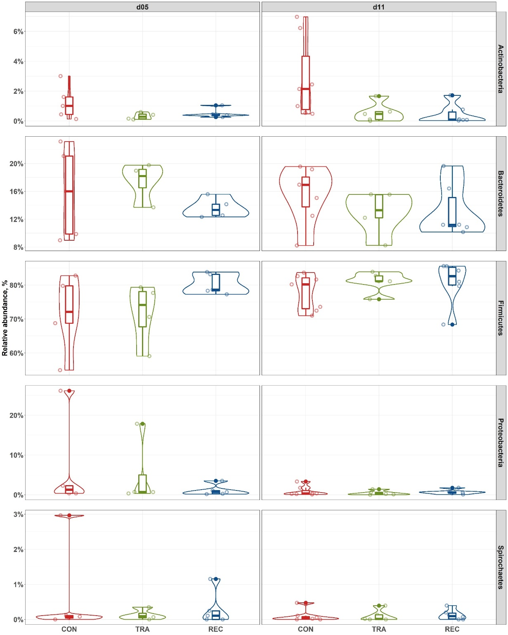
ab
b
b
a
b
b
c
bc
abc
abc
ab
a
A
B
Figure S7. Stacked bar plot showing the relative abundance of bacterial phyla in colon digesta of enterotoxigenic E. coli F18 challenged pigs fed diets supplemented with different dose of antibiotic on d 5 and 11 post-inoculation (A). Violin plot showing the relative abundance of individual bacterial phylum (B). ^{a-c}Means without a common superscript are different across both time points (Diet × day, P < 0.05). Each least squares mean represents 4 to 7 observations. CON = Control; TRA = Trace amount of antibiotic; REC = Label-recommended dose of antibiotic.

