Supplementary Information (For Online Publication Only)

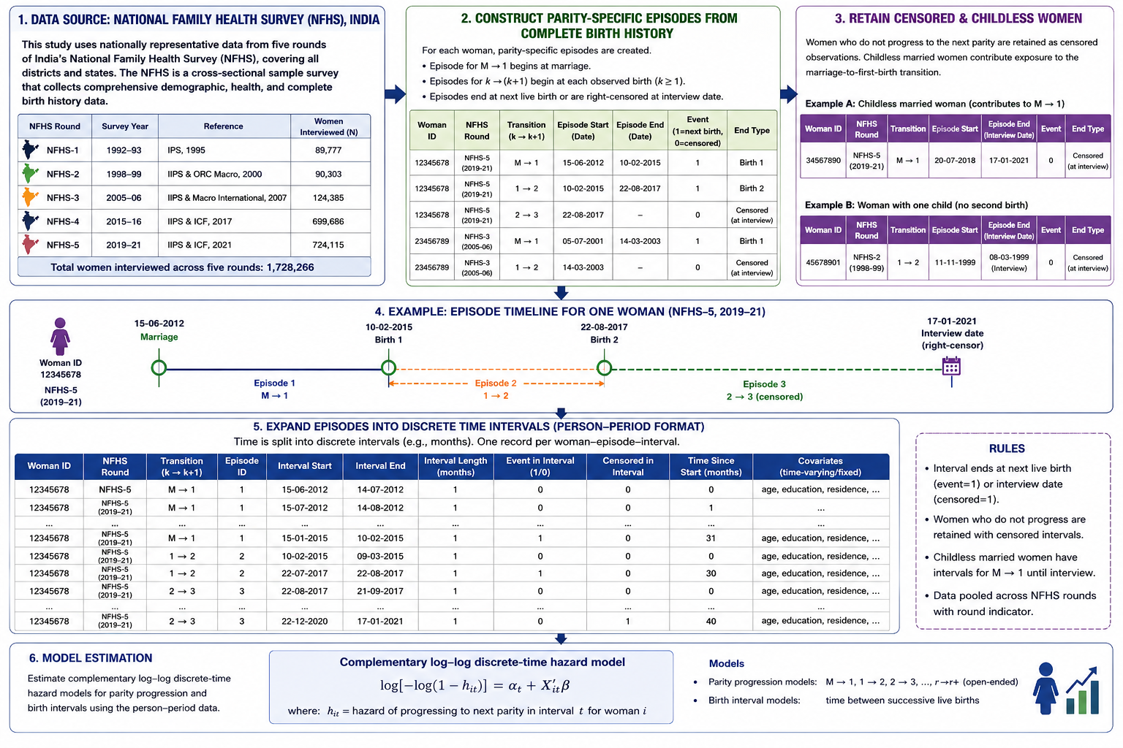
Figure S1. Construction of Woman–Person–Period Exposure Data from NFHS Complete Birth Histories for Parity Progression and Birth Interval Analysis

Figure S2. Regional trends in median second-birth interval 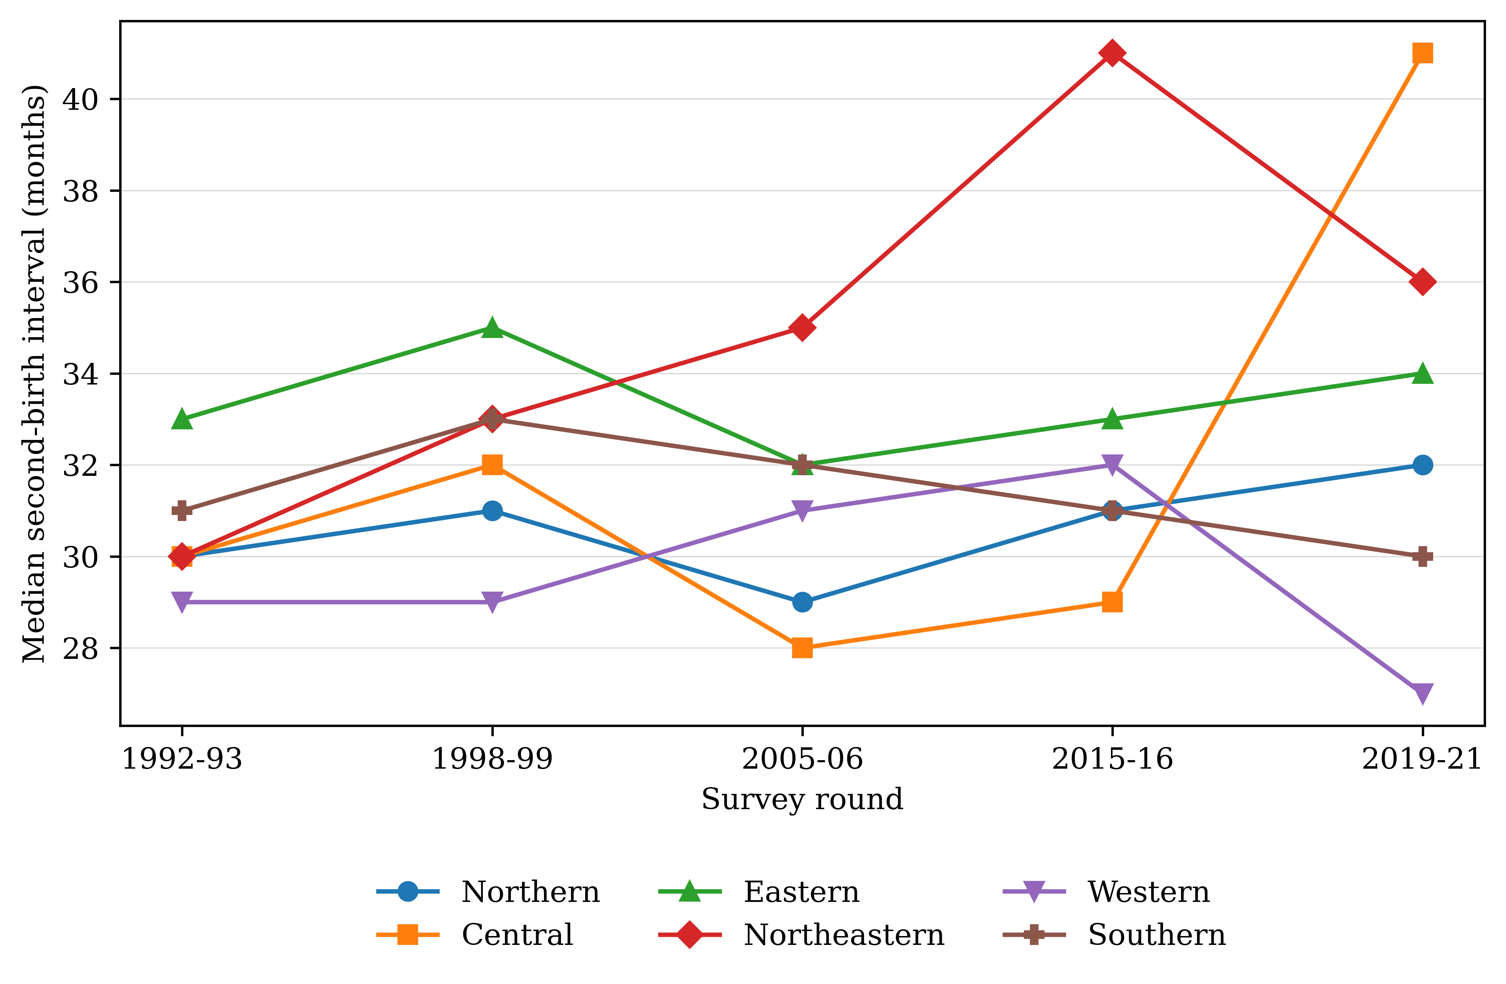

Table S-1: Percentage distribution of Birth intervals by <24 months & >24 months for 2nd order birth
 | 1992-93 |  | 1998-99 |  | 2005-06 |  | 2015-16 |  | 2019-21
States | <24 months | >24 months | <24 months | >24 months | <24 months | >24 months | <24 months | >24 months | <24 months | >24 months
North
Haryana | 31.36 | 68.64 | 25.99 | 74.01 | 29.68 | 70.32 | 33.02 | 66.98 | 31.57 | 68.43
Himachal | 31.46 | 68.54 | 28.63 | 71.37 | 32.38 | 67.62 | 23.46 | 76.54 | 20.86 | 79.14
Pradesh
Jammu & Kashmir | 24.9 | 75.1 | 18.36 | 81.64 | 26.75 | 73.25 | 21.52 | 78.48 | 19.31 | 80.69
Punjab | 30.21 | 69.79 | 31.39 | 68.61 | 34.92 | 65.08 | 27.34 | 72.66 | 24.84 | 75.16
Rajasthan | 22.27 | 77.73 | 24.54 | 75.46 | 28.85 | 71.15 | 29.72 | 70.28 | 29.45 | 70.55
Uttarakhand |  |  |  |  | 27.76 | 72.24 | 27.04 | 72.96 | 26.08 | 73.92
Central
Chhattisgarh |  |  |  |  | 23.29 | 76.71 | 24.36 | 75.64 | 20.7 | 79.3
Madhya Pradesh | 22.52 | 77.48 | 22.83 | 77.17 | 30.58 | 69.42 | 31.47 | 68.53 | 30.43 | 69.57
Uttar Pradesh | 26.01 | 73.99 | 22.91 | 77.09 | 30.21 | 69.79 | 29.45 | 70.55 | 29.89 | 70.11
East
Bihar | 21.34 | 78.66 | 18.47 | 81.53 | 28.57 | 71.43 | 31.81 | 68.19 | 36.56 | 63.44
Jharkhand |  |  |  |  | 24.08 | 75.92 | 22.48 | 77.52 | 23.31 | 76.69
Odisha | 22.76 | 77.24 | 18.98 | 81.02 | 22.72 | 77.28 | 14.74 | 85.26 | 11.37 | 88.63
West Bengal | 22.1 | 77.9 | 18.25 | 81.75 | 21.64 | 78.36 | 17.36 | 82.64 | 13.26 | 86.74
Northeast
Arunachal Pradesh | 26.96 | 73.04 | 25.74 | 74.26 | 26.69 | 73.31 | 20.24 | 79.76 | 16.22 | 83.78
Assam | 28.01 | 71.99 | 19.62 | 80.38 | 19.82 | 80.18 | 15.93 | 84.07 | 11.74 | 88.26
Manipur | 22.68 | 77.32 | 21.95 | 78.05 | 19.97 | 80.03 | 16.74 | 83.26 | 16.08 | 83.92
Meghalaya | 31.05 | 68.95 | 29.51 | 70.49 | 25.06 | 74.94 | 24.39 | 75.61 | 27.33 | 72.67
Mizoram | 31.99 | 68.01 | 28.65 | 71.35 | 31.23 | 68.77 | 21.05 | 78.95 | 21.67 | 78.33
Nagaland | 29.58 | 70.42 | 31.56 | 68.44 | 32.45 | 67.55 | 30.11 | 69.89 | 28.53 | 71.47
Tripura | 20.1 | 79.9 | 15.61 | 84.39 | 20.58 | 79.42 | 13.98 | 86.02 | 11.68 | 88.32
Sikkim |  |  | 25.04 | 74.96 | 19.66 | 80.34 | 11.93 | 88.07 | 10.65 | 89.35
West
Goa | 23.54 | 76.46 | 21.51 | 78.49 | 20.74 | 79.26 | 20.03 | 79.97 | 19.1 | 80.9
Gujarat | 27.86 | 72.14 | 30.79 | 69.21 | 28.86 | 71.14 | 24.17 | 75.83 | 25.12 | 74.88
Maharashtra | 28.39 | 71.61 | 29.08 | 70.92 | 25.06 | 74.94 | 26.47 | 73.53 | 25.12 | 74.88
South
Andhra Pradesh | 21.11 | 78.89 | 21.33 | 78.67 | 31.26 | 68.74 | 32.83 | 67.17 | 37.35 | 62.65
Karnataka | 27.07 | 72.93 | 25.32 | 74.68 | 27.9 | 72.1 | 28.08 | 71.92 | 28.59 | 71.41
Kerala | 21.85 | 78.15 | 18.62 | 81.38 | 18.82 | 81.18 | 10.98 | 89.02 | 11.71 | 88.29
Tamil Nadu | 26.22 | 73.78 | 29.74 | 70.26 | 26.06 | 73.94 | 28.16 | 71.84 | 24.29 | 75.71
Telangana |  |  |  |  |  |  | 32.44 | 67.56 | 33.06 | 66.94
Source: Authors estimation based on the National Family Health Survey, 1992-93 to 2019-21 datasets.

Table S-2: Percentage distribution of Birth intervals by <60 months & >60 months for 2nd order birth
 | 1992-93 |  |  | 1998-99 |  | 2005-06 |  | 2015-16 |  | 2019-21
States | <60 months |  | >60  months | <60  months | >60  months | <60  months | >60  months | <60  months | >60  months | <60  months | >60 months
North
Haryana | 93.42 | 6.58 |  | 91.31 | 8.69 | 91.36 | 8.64 | 90.83 | 9.17 | 86.22 | 13.78
Himachal Pradesh | 94.01 | 5.99 |  | 90.42 | 9.58 | 90.15 | 9.85 | 84.52 | 15.48 | 78.94 | 21.06
Jammu & Kashmir | 92.55 | 7.45 |  | 88.56 | 11.44 | 86.79 | 13.21 | 84.61 | 15.39 | 83.84 | 16.16
Punjab | 92.37 | 7.63 |  | 91.32 | 8.68 | 88.86 | 11.14 | 83.3 | 16.7 | 78.05 | 21.95
Rajasthan | 90.11 | 9.89 |  | 92.72 | 7.28 | 94.15 | 5.85 | 90.21 | 9.79 | 88.5 | 11.5
Central
Chhattisgarh |  |  |  |  |  | 89.35 | 10.65 | 87.81 | 12.91 | 85.77 | 14.23
Madhya Pradesh | 91.55 | 8.45 |  | 91.43 | 8.57 | 93.49 | 6.51 | 90.23 | 9.77 | 91.08 | 8.92
Uttar Pradesh | 91.64 | 8.36 |  | 92.03 | 7.97 | 91.79 | 8.21 | 89.78 | 10.22 | 87.57 | 12.43
Uttarakhand |  |  |  |  |  | 88.54 | 11.46 | 86.57 | 13.43 | 81.77 | 18.23
East
Bihar | 90.59 | 9.41 |  | 88.68 | 11.32 | 92.87 | 7.13 | 93.12 | 6.88 | 93.91 | 6.09
Jharkhand |  |  |  |  |  | 92.32 | 7.68 | 87.99 | 12.01 | 87.59 | 12.41
Odisha | 90.44 | 9.56 |  | 87.07 | 12.93 | 90.02 | 9.98 | 77.16 | 22.84 | 75.66 | 24.34
West Bengal | 90.55 | 9.45 |  | 86.19 | 13.81 | 83.48 | 16.52 | 72.6 | 22.4 | 66.36 | 33.64
Northeast
Arunachal Pradesh | 88.96 | 11.04 |  | 91.56 | 8.44 | 91.18 | 8.82 | 80.22 | 19.78 | 76.48 | 23.52
Assam | 93.04 | 6.96 |  | 88.66 | 11.34 | 83.52 | 16.48 | 74.78 | 25.22 | 69.58 | 30.42
Manipur | 89.76 | 10.24 |  | 90.05 | 9.95 | 86.56 | 13.44 | 78.81 | 21.19 | 76.78 | 23.22
Meghalaya | 95.05 | 4.95 |  | 91.15 | 8.85 | 87.37 | 12.63 | 87.83 | 12.17 | 86.66 | 13.34
Mizoram | 91.61 | 8.39 |  | 88.48 | 11.52 | 87.39 | 12.61 | 78.14 | 21.86 | 77.8 | 22.2
Nagaland | 96.47 | 3.53 |  | 93.11 | 6.89 | 92.39 | 7.61 | 87.78 | 12.22 | 90.64 | 9.36
Tripura | 88.55 | 11.45 |  | 77.91 | 22.09 | 79.02 | 20.98 | 64.02 | 35.98 | 54.6 | 45.4
Sikkim |  |  |  | 86.58 | 13.42 | 83.74 | 16.26 | 53.61 | 46.39 | 76.48 | 23.52
West
Goa | 83.7 | 16.3 |  | 80.66 | 19.34 | 79.01 | 20.99 | 74.3 | 25.7 | 72.89 | 27.11
Gujarat | 93.58 | 6.42 |  | 92.17 | 7.83 | 90.94 | 9.06 | 85.53 | 14.47 | 85.25 | 14.75
Maharashtra | 93.32 | 6.68 |  | 93.39 | 6.61 | 88.42 | 11.58 | 86.2 | 13.8 | 83.09 | 16.91
South
Andhra Pradesh | 88.86 | 11.14 |  | 88.85 | 11.15 | 88.68 | 11.32 | 89.74 | 10.26 | 89.49 | 10.51
Karnataka | 92.04 | 7.96 |  | 93.64 | 6.36 | 90.75 | 9.25 | 88.28 | 11.72 | 86.22 | 13.78
Kerala | 85.08 | 14.92 |  | 77.61 | 22.39 | 74.75 | 25.25 | 65.02 | 34.98 | 62.47 | 37.53
Tamil Nadu | 88.18 | 11.82 |  | 89.98 | 10.02 | 87.59 | 12.41 | 86.04 | 13.96 | 82.26 | 17.74
Telangana |  |  |  |  |  |  |  | 86.82 | 13.18 | 87.85 | 12.15
Source: Authors estimation based on the National Family Health Survey, 1992-93 to 2019-21 datasets.

Table S-3: Prevalence of various contraceptive method-mix in India and its states, 1992-93 to 2019-21
States | IUD |  |  |  |  | Pill
 | 1992-93 | 1998-99 | 2005-06 | 2015-16 | 2019-21 | 1992-93 | 1998-99 | 2005-06 | 2015-16 | 2019-21
All India | 4.6 | 3.4 | 3.2 | 2.9 | 2.1 | 2.9 | 4.4 | 5.5 | 7.6 | 5.1
Andhra Pradesh | 1.2 | 1.1 | 0.7 | 0.3 | 0.1 | 1 | 0.9 | 0.4 | 0.2 | 0.1
Arunachal Pradesh | 19.3 | 11.8 | 8.3 | 10.8 | 6.2 | 13.7 | 20.5 | 19.2 | 32.3 | 15.9
Assam | 2.1 | 4.3 | 2.3 | 4.2 | 2.9 | 6.4 | 14.6 | 18.2 | 42 | 28.5
Bihar | 2.3 | 2.2 | 1.8 | 2.1 | 0.8 | 4.7 | 4 | 3.8 | 3.2 | 2
Delhi | 13 | 9.7 | 7.5 | 9.9 | 6.7 | 4.8 | 6.3 | 6.7 | 5.3 | 2.7
Gujarat | 6.1 | 5.2 | 6.8 | 6.5 | 2.4 | 2.1 | 2.6 | 3.9 | 2.9 | 1.8
Goa | 5.7 | 4 | 4.8 | 3.5 | 2.2 | 1.5 | 1.9 | 3.1 | 1.3 | 1.7
Himachal Pradesh | 4.6 | 3 | 2.1 | 1.5 | 1.1 | 0.9 | 1.9 | 3.9 | 2.7 | 1.5
Haryana | 6.4 | 5.7 | 7.4 | 8.9 | 4.9 | 2.5 | 3.3 | 4.4 | 4.2 | 2.8
Jharkhand | ─ | ─ | 1.7 | 2.4 | 1.7 | ─ | ─ | 10.6 | 6.4 | 3.1
Jammu & Kashmir | 5.6 | 6 | 5.1 | 5 | 5.9 | 2.7 | 6.7 | 8.9 | 10.9 | 9
Karnataka | 6.5 | 4.7 | 4.9 | 1.6 | 2.5 | 0.9 | 1 | 1.7 | 0.9 | 2.1
Kerala | 4.3 | 2.5 | 3.4 | 3.1 | 1.5 | 0.7 | 0.7 | 0.7 | 0.4 | 0.3
Meghalaya | 10.6 | 16.3 | 6.2 | 8.7 | 4.7 | 11.6 | 22.1 | 20.2 | 47.9 | 8.9
Maharashtra | 4.7 | 3.2 | 4.6 | 2.5 | 1.6 | 2.5 | 2.9 | 3.7 | 3.6 | 1.7
Madhya Pradesh | 3.1 | 1.8 | 1.3 | 1 | 1 | 1.8 | 2.2 | 3 | 2.6 | 1.9
Manipur | 19.3 | 17.6 | 11.1 | 15.8 | 4.5 | 6.8 | 5.7 | 10.9 | 17.9 | 5.2
Mizoram | 9.5 | 9.3 | 8.2 | 9.5 | 3.2 | 4.7 | 9.3 | 17.7 | 37.4 | 15.2
Nagaland | 15.8 | 25.3 | 17.5 | 25.1 | 19.7 | 16.5 | 8.4 | 15.8 | 15.1 | 5.1
Orissa | 4.2 | 1.7 | 1.2 | 2 | 2.6 | 2.4 | 6.4 | 13.8 | 21 | 10.8
Punjab | 10.7 | 9.2 | 8.7 | 8.9 | 3 | 3.7 | 4.6 | 4.6 | 3.3 | 1.5
Rajasthan | 3.9 | 2.9 | 3.4 | 2.1 | 1.4 | 1.6 | 3.8 | 4.2 | 4 | 3.1
Sikkim | ─ | 10.4 | 5.4 | 13.4 | 7.1 | ─ | 17.8 | 22.2 | 24.7 | 23.3
Tamil Nadu | 7.1 | 4.7 | 3.4 | 3.5 | 4.7 | 1.1 | 0.6 | 0.3 | 0.4 | 0.3
Tripura | 2.7 | 3.5 | 1.5 | 0.9 | 0.6 | 11.4 | 24.3 | 33.4 | 41.1 | 32.6
Uttarakhand | ─ | ─ | 2.5 | 3.1 | 1.5 | ─ | ─ | 7.1 | 6.1 | 2.6
Uttar Pradesh | 5.8 | 3.5 | 3.2 | 2.6 | 1.5 | 5 | 4.4 | 3.9 | 4.2 | 4.4
West Bengal | 2.2 | 2.1 | 0.8 | 1.7 | 2.2 | 6.2 | 13.7 | 16.4 | 28.2 | 20.3
Source: Authors estimation based on the National Family Health Survey, 1992-93 to 2019-21 datasets.

Table S-3: Continued…
States | Condom |  |  |  |  | Traditional methods
 | 1992-93 | 1998-99 | 2005-06 | 2015-16 | 2019-21 | 1992-93 | 1998-99 | 2005-06 | 2015-16 | 2019-21
All India | 6 | 6.3 | 9.4 | 10.5 | 9.5 | 9.4 | 9.8 | 10.1 | 8.4 | 10.3
Andhra Pradesh | 1.6 | 1.2 | 0.7 | 0.2 | 0.2 | 0.5 | 0.8 | 0.8 | 0.1 | 0.1
Arunachal Pradesh | 3 | 1.9 | 6.7 | 4.5 | 4.2 | 17.3 | 6.2 | 9 | 7.9 | 11.9
Assam | 4 | 4.1 | 4.2 | 5.2 | 4.4 | 46.7 | 33.7 | 35 | 22.9 | 14.9
Bihar | 5.6 | 2.9 | 6.7 | 4 | 4 | 5.8 | 6.2 | 13.4 | 2.8 | 11.4
Delhi | 34 | 27.4 | 34.8 | 36.5 | 28.3 | 8.9 | 10.7 | 9.8 | 6.8 | 18.7
Gujarat | 3.6 | 5.9 | 9 | 10.4 | 7.5 | 4.6 | 8.9 | 11.5 | 4.5 | 9
Goa | 8.2 | 10.3 | 16.2 | 26.9 | 21.1 | 19.1 | 20.3 | 13.8 | 4.7 | 8.7
Himachal Pradesh | 9.1 | 7.4 | 16.1 | 22.2 | 19.2 | 6.3 | 9.5 | 1.7 | 6.2 | 10.8
Haryana | 10.4 | 10.8 | 18.6 | 18.8 | 18.1 | 10.2 | 13.7 | 5.8 | 5 | 12.6
Jharkhand | ─ | ─ | 7.8 | 5.4 | 4.1 | ─ | ─ | 10.7 | 5.7 | 12.2
Jammu & Kashmir | 11.9 | 9.8 | 15.4 | 19.7 | 12 | 18.7 | 13.2 | 9.3 | 13.3 | 7.3
Karnataka | 2.4 | 1.8 | 3.3 | 2.5 | 2.9 | 3.2 | 2.7 | 1.1 | 0.4 | 0.4
Kerala | 4.6 | 4.8 | 8.5 | 4.8 | 2.9 | 12.8 | 11.1 | 11.4 | 4.1 | 5.2
Meghalaya | 2.4 | 6.2 | 10.3 | 5.3 | 2.4 | 7.6 | 18.1 | 13.2 | 5.3 | 4.9
Maharashtra | 4.7 | 6.6 | 9.6 | 11 | 7.1 | 1.9 | 1.5 | 2.1 | 2.1 | 1.8
Madhya Pradesh | 6 | 6.5 | 8.8 | 9.5 | 8.1 | 1.9 | 3 | 4.2 | 2.2 | 6.2
Manipur | 3.5 | 3.4 | 8.6 | 5.7 | 4 | 28.9 | 29.9 | 31 | 29.8 | 43.6
Mizoram | 1.2 | 1.6 | 2.8 | 3.6 | 2.3 | 1.4 | 1 | 0.3 | 0.1 | 0.3
Nagaland | 16.5 | 5.8 | 9.4 | 5 | 2.8 | ─ | 18.2 | 16.1 | 12.1 | 11.8
Orissa | 1.7 | 1.9 | 6.3 | 6 | 5.5 | 3.1 | 11.3 | 7.9 | 16 | 25.4
Punjab | 15.2 | 20.6 | 24.5 | 24.9 | 22.2 | 11.9 | 17.9 | 8.1 | 8.7 | 16.1
Rajasthan | 4.6 | 7.7 | 12.3 | 14.5 | 13.7 | 2.4 | 4.6 | 3.9 | 8 | 10.2
Sikkim | ─ | 2.8 | 7.3 | 11.1 | 8.4 | ─ | 21.7 | 10.3 | 0.9 | 15.5
Tamil Nadu | 3.2 | 2.9 | 3.7 | 1.6 | 1.2 | 7.4 | 3.1 | 1.7 | 0.9 | 2.7
Tripura | 2.9 | 2.6 | 5.3 | 2.9 | 2.6 | 43.8 | 19.8 | 22.4 | 26.5 | 21.4
Uttarakhand | ─ | ─ | 26.5 | 30.1 | 25.6 | ─ | ─ | 4.6 | 4.7 | 12.9
Uttar Pradesh | 16.2 | 14.8 | 20 | 23.7 | 19.1 | 5.5 | 19.5 | 21.5 | 22.2 | 18
West Bengal | 3.2 | 4.4 | 6.3 | 8.4 | 7 | 31.4 | 25.9 | 23.9 | 13.9 | 13.6
Source: Authors estimation based on the National Family Health Survey, 1992-93 to 2019-21 datasets.

