Supporting Information
A Gaussian–Stochastic Encoder Transistor for Biosignal Encoding with Confidence Readout
Jueun Lee^{1,†}, Kyunghoon Kim^{2,†}, Youngmin Han^{3,†}, Youngchan Cho⁴, Hocheon Yoo^{3,*}, and Wonjun Shin^{1,4*}
¹Department of Electrical and Computer Engineering, Sungkyunkwan University, Suwon 16419, Republic of Korea
²Department of Semiconductor Engineering, Gachon University, Seongnam 13120, Republic of Korea
³Department of Electronic Engineering, Hanyang University, Seoul 04763, Republic of Korea
⁴Department of Semiconductor Convergence Engineering, Sungkyunkwan University, Suwon, 16419, Republic of Korea
†These authors contributed equally to this work.
*Corresponding authors: H. Y. (hocheon@hanyang.ac.kr), W.S. (swj0107@skku.edu)

Supplementary Table S1. Classification Macro-F1 for Raw and RBF Features Comparison of Macro-F1 scores for raw-feature baselines and the RBF-linear readout across representative biosignal datasets.
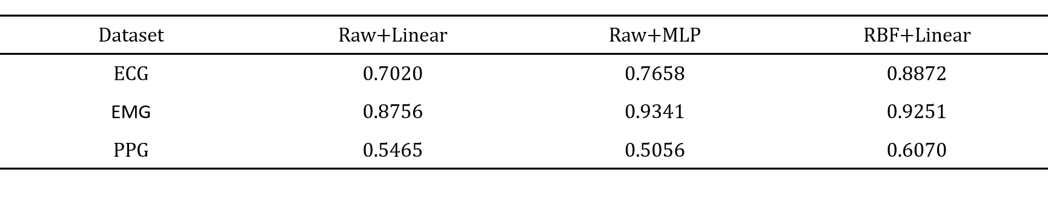

Supplementary Table S2. Error-Detection AUROC by Method and Evaluation Subset Comparison of error-detection AUROC across deterministic, stochastic, and hybrid RBF uncertainty methods under full-test and low-margin evaluation subsets. Full indicates evaluation on the entire test set, whereas Bottom 10% and Bottom 30% indicate low-margin subsets containing the most ambiguous test samples according to the deterministic classifier.
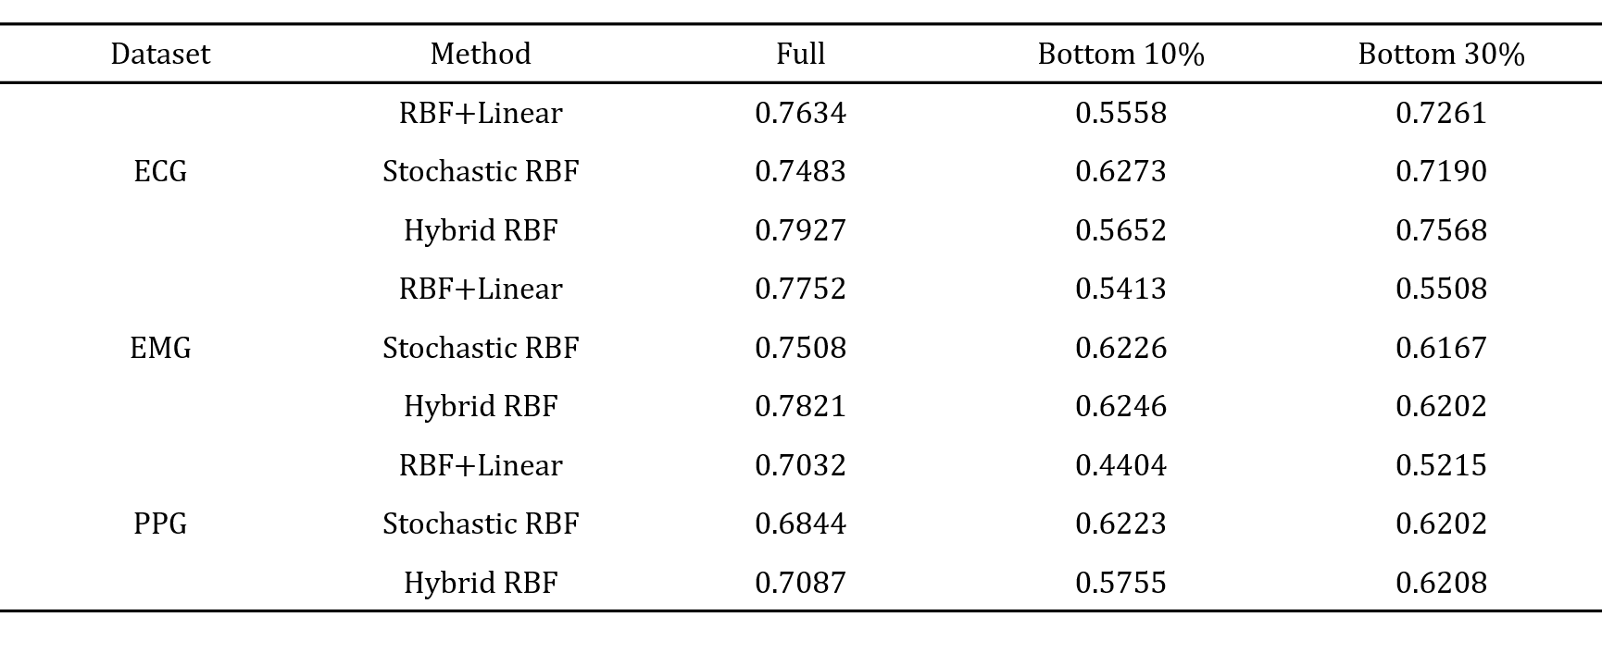

Supplementary Table S3. AUROC Gain versus Read Cost for Hybrid RBF Comparison of AUROC gain for Hybrid RBF across representative datasets as stochastic read cost increases. Read cost denotes the relative number of RBF feature-read operations required to compute stochastic uncertainty. A cost of x1 corresponds to the deterministic single-read baseline, whereas x6, x11, x31, x51, and x101 correspond to one deterministic read plus 5, 10, 30, 50, and 100 stochastic reads, respectively.
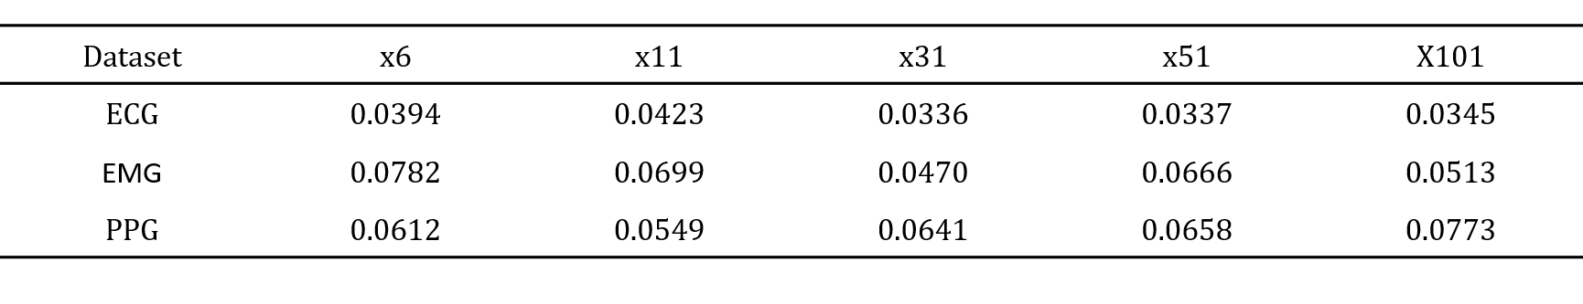

Supplementary Table S4. AUROC Gain versus Noise Scale for Hybrid RBF Comparison of Hybrid RBF AUROC gain across representative datasets as the stochastic RBF noise scale is varied. Noise scale denotes the multiplicative factor applied to the measured RBF read-noise level during stochastic sampling. A scale of x1 uses the measured noise magnitude, while x2 and x4 use two-fold and four-fold amplified noise, respectively.
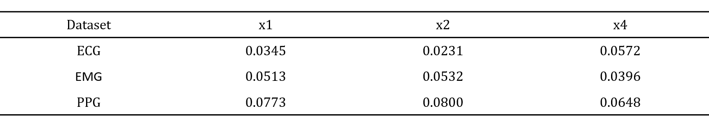

Supplementary Table S5. Selective Accuracy after Deferring High-Uncertainty Samples Comparison of selective classification accuracy across representative datasets after deferring increasingly uncertain test samples. Deferred samples are test samples with the highest uncertainty scores that are withheld from automatic prediction. A deferred fraction of 20% means that the most uncertain 20% of test samples are excluded from the automatic accuracy calculation, and accuracy is computed on the remaining 80% lower-uncertainty samples.
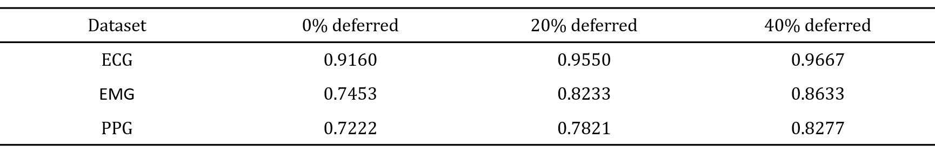

Supplementary Note 1. Carrier-Number Fluctuation
Carrier-number fluctuation is one of the dominant low-frequency noise mechanisms in field-effect transistors. It originates from random trapping and detrapping of charge carriers at trap states located near the gate dielectric/channel interface, at surface states, or in the dielectric close to the channel. When a carrier is captured by a trap, it is removed from the conduction channel, directly reducing the number of mobile carriers and locally modifying the electrostatic potential. When the carrier is emitted back to the channel, the channel carrier population recovers. Therefore, carrier-number fluctuation describes drain-current noise caused by time-dependent fluctuation in the number of mobile carriers. For a single trap with a well-defined capture/emission time constant, the current fluctuation can appear as random telegraph noise. In contrast, when many traps with different time constants contribute simultaneously, the superposition of these trapping/detrapping events produces a 1/f low-frequency noise spectrum. This is the basis of the McWhorter-type carrier-number fluctuation model.^{[1-4]}
The key principle of carrier-number fluctuation is that trap-induced charge fluctuation can be represented as an equivalent gate-voltage or threshold-voltage fluctuation. The drain current responds to this equivalent voltage fluctuation through the transconductance. Therefore, the drain-current noise is written as:
$\frac{S_{ID}}{I_{D}^{2}}= {(\frac{g_{m}}{I_{D}})}^{2}S_{VG}$,
where S_{ID} is the drain-current noise power spectral density, I_{D} is the drain current, g_{m} is the transconductance, and S_{VG} is the equivalent gate-voltage noise spectral density induced by trapping/detrapping events. For a 1/f-type trap distribution, the equivalent gate-voltage noise is often expressed in a simplified form as:
$S_{VG}∝\frac{q^{2}k_{B}TN_{t}λ}{WLC_{i}^{2}f}$,
where q is the elementary charge, k_{B} is the Boltzmann constant, T is temperature, N_{t} is the trap density, $λ$ is the tunneling attenuation length, W and L are the channel width and length, C_{i} is the gate insulator capacitance per unit area, and f is frequency. Thus, the normalized drain-current noise in the carrier-number fluctuation model can be written as:
$\frac{S_{ID}}{I_{D}^{2}}∝ {(\frac{g_{m}}{I_{D}})}^{2}\frac{q^{2}k_{B}TN_{t}λ}{WLC_{i}^{2}f}$.
The most important diagnostic feature of carrier-number fluctuation is the dependence of normalized noise on gate electrostatic sensitivity. Since the term (g_{m}/I_{D})² changes strongly with gate bias, especially near subthreshold or high-transconductance regions, carrier-number fluctuation generally produces a strong V_{GS}-dependent normalized noise. Therefore, if carrier-number fluctuation dominates, S_{ID}/I_{D}² is expected to follow the gate-dependent trend of (g_{m}/I_{D})². Conversely, when the drain current is weakly sensitive to gate-voltage fluctuation, the carrier-number-fluctuation contribution becomes smaller. Therefore, carrier-number fluctuation is a gate-bias-dependent noise mechanism, and S_{ID}/I_{D}² is expected to track (g_{m}/I_{D})² as a function of V_{GS.}

Supplementary Note 2. Hooge Mobility Fluctuation
Hooge mobility fluctuation is another representative model for low-frequency noise in conducting channels. Unlike carrier-number fluctuation, which originates from fluctuation in the number of mobile carriers, Hooge mobility fluctuation describes noise caused by time-dependent fluctuation in carrier mobility. In this model, the total number of mobile carriers is assumed to remain constant at a given bias, while individual carrier scattering rates fluctuate in time. Since the drain current depends on mobility, mobility fluctuation directly produces current fluctuation. The Hooge model is empirical and is commonly written for resistance or current fluctuation as:
$\frac{S_{ID}}{I_{D}^{2}}∝ \frac{α_{H}}{Nf^{γ}}$,
where S_{ID} is the drain-current noise power spectral density, I_{D} is the drain current, $α_{H}$ is the Hooge parameter, N is the total number of free carriers participating in conduction, f is frequency, and $γ$ is the frequency exponent, which is taken as unity ($γ$ = 1) throughout this work for the 1/f noise regime. In a field-effect transistor, the total number of mobile carriers in the channel can be approximated by the gate-induced channel charge. In a simple accumulation or linear-regime approximation:
$N ≈\frac{WLC_{i}\left|V_{GS}-V_{th}\right|}{q}$,
where W and L are the channel width and length, C_{i} is the gate-insulator capacitance per unit area, V_{GS} is the gate-source voltage, V_{th} is the threshold voltage, and q is the elementary charge. Substituting this expression into the Hooge relation gives:
$\frac{S_{ID}}{I_{D}^{2}}∝ \frac{α_{H}q}{WLC_{i}\left|V_{GS}-V_{th}\right|f^{γ}}$.
This equation shows that the normalized current noise decreases as the number of conducting carriers increases. Therefore, in a channel dominated by Hooge mobility fluctuation, increasing the gate overdrive and increasing the carrier density should generally reduce S_{ID}/I_{D}². The key physical picture of Hooge mobility fluctuation is that current fluctuation is caused by mobility fluctuation:
$\frac{δI_{D}}{I_{D}}≈\frac{δμ}{μ}$,
where μ is carrier mobility. Therefore, the normalized current noise reflects the normalized mobility noise:
$\frac{S_{ID}}{I_{D}^{2}}≈\frac{S_{μ}}{μ^{2}}$,
and the Hooge relation gives:
$\frac{S_{μ}}{μ^{2}}≈\frac{α_{H}}{Nf^{γ}}$.
The diagnostic feature of Hooge mobility fluctuation is its inverse dependence on the number of carriers. Since N changes with gate bias in a field-effect transistor, Hooge mobility fluctuation generally produces a gate-bias-dependent normalized noise. However, its bias dependence differs from carrier-number fluctuation. Carrier-number fluctuation is governed mainly by the transconductance factor (g_{m}/I_{D})², whereas Hooge mobility fluctuation is governed mainly by 1/N scaling. Thus, if Hooge mobility fluctuation dominates, S_{ID}/I_{D}² is expected to decrease as the channel carrier density increases.

Supplementary Note 3. Contact/Access-Region Noise
Contact/access-region noise refers to low-frequency current fluctuation originating from the source/drain contact, metal/semiconductor interface, or contact-adjacent access region, rather than from the gate-controlled channel bulk. In a field-effect transistor, the drain current is determined not only by the channel resistance but also by the contact resistance and carrier-injection efficiency. Therefore, temporal fluctuation in the contact resistance, injection barrier, or local transmission probability can modulate the entire drain current and appear as low-frequency current noise. The essential feature of contact noise is that it behaves as a multiplicative current fluctuation. When the contact resistance fluctuates in series with the channel, the fractional drain-current noise can be approximated as:
$\frac{S_{ID}}{I_{D}^{2}}≈{(\frac{R_{C}}{R_{tot}})}^{2}\frac{S_{RC}}{R_{C}^{2}}$,
where R_{C} is the contact resistance, R_{tot} is the total device resistance, and S_{RC} is the contact-resistance noise power spectral density. This relation shows that contact fluctuation can modulate the total drain current fractionally. Therefore, the absolute current noise S_{ID} can change with the drain current, while the normalized noise S_{ID}/I_{D}² remains approximately constant when the fractional contact fluctuation is nearly unchanged.
Microscopically, contact noise can originate from several processes near the metal/semiconductor interface. In organic and low-dimensional semiconductor devices, the source/drain contact often forms a Schottky-like injection barrier. Local trap dynamics, interface charge fluctuation, and barrier inhomogeneity can modulate this injection barrier temporally. As a result, the carrier injection probability fluctuates, producing drain-current noise. Because the contact region is connected in series with the channel, contact-origin fluctuation can dominate the total current fluctuation and mask weaker gate-dependent channel-noise signatures. A single contact trap with a well-defined time constant may produce random telegraph noise. However, when many contact or interface traps with broadly distributed time constants contribute simultaneously, their superposition produces a smooth 1/f noise spectrum. Therefore, a 1/f spectrum without a clear Lorentzian peak is consistent with distributed contact/interface fluctuators rather than one dominant trap.
Contact noise can be distinguished from typical channel-noise models by its weak bias dependence. Carrier-number fluctuation is usually sensitive to gate electrostatic control, and Hooge mobility fluctuation depends on the number of carriers in the channel. In contrast, contact/access-region noise can show nearly bias-invariant S_{ID}/I_{D}² if the dominant fractional fluctuation occurs at the contact or access region. In that case, changing V_{GS} or V_{D} may change the absolute current level, but the normalized noise S_{ID}/I_{D}² can remain approximately constant.

Supplementary Note 4. Gaussianity Score
To quantify how closely the measured GSE-T transfer response resembles a radial-basis-function-like Gaussian profile, a Gaussianity score was defined from the normalized drain-current trace. For each bias condition, the absolute drain current is first normalized to the range [0, 1]:
$I_{norm}(V_{GS1}) =\frac{\left|I_{D}\right|-\min\left(\left|I_{D}\right|\right)}{max(\left|I_{D}\right|)-\min\left(\left|I_{D}\right|\right)}$.
The normalized response is then fitted using a Gaussian model:
$G\left(V_{GS1}\right)=Ae^{-0.5{\left(\frac{V_{GS1}-μ}{σ}\right)}^{2}}+b$,
where A, μ, σ, and b represent the amplitude, center voltage, width, and baseline offset, respectively. The Gaussianity score is calculated from the coefficient of determination of this fit:
$Gaussianity score=100×R^{2}$.
Thus, a score close to 100 indicates a near-perfect Gaussian profile, whereas a lower score reflects deviation from Gaussian shape, such as asymmetry, broadening, or multiple peaks.

Supplementary Note 5. Kolmogorov-Arnold Network Simulation
Kolmogorov-Arnold Network (KAN) simulation is performed to examine whether the measured Top-contact transfer curves can be used as hardware-compatible Gaussian-like basis functions^{[5]}. In a conventional KAN, nonlinear edge functions are typically represented by flexible software basis functions. Here, we replace this idealized basis with device-derived Gaussian-like responses extracted from measured GSE-T curves^{[6,7]}.
One-dimensional target functions are generated over the normalized input range x ∈ [-1, 1]. Each target is composed of five local Gaussian-like regions, including five profile types (symmetric, shifted, asymmetric, shouldered, and super-Gaussian). A total of 50 random target sets are used. The hardware-constrained KAN uses 100 basis centers. Basis widths are estimated from 105 measured GSE-T curves. The trainable coefficients are quantized using coefficient levels derived from the measured peak-current distribution, so both the activation shape and coefficient values reflect device-level constraints. Training is performed sequentially over five incremental stages, each corresponding to the progressive introduction of new input regions. At each stage, 1000 new samples are added and the model is trained cumulatively on all previously introduced regions. The fitted output is compared with the ideal target function using RMSE. Across 50 random Gaussian-like target sets, the final full-domain RMSE ranges from 0.00263 to 0.04422. This result shows that the measured GSE-T response can approximate ideal Gaussian KAN basis functions with low fitting error while fully respecting hardware-derived constraints on both basis shape and coefficient resolution.

Supplementary Note 6. RBF Encoder Operation for Classification Simulation
The radial basis function (RBF) encoder transforms each compact biosignal feature into multiple localized nonlinear responses using the measured GSE-T transfer curve. Each input sample is represented as an 8-dimensional feature vector,
$x=[x_{1}, x_{2}, …, x_{8}]$.
Each feature is first normalized and mapped to the device voltage domain:
$V_{j}=M(x_{j})$,
where $x_{j}$ is the j-th input feature and $M(∙)$ denotes the normalization and voltage-mapping operation. For each mapped feature $V_{j}$, six shifted RBF responses are generated:
$ϕ_{j,p}=f_{TC}\left(V_{j}+Δ_{p}\right), j=1, …, 8, p=1, …,6$.
Here, $f_{TC}\left(∙\right)$ is the normalized measured GSE-T transfer response, and $Δ_{p}$ is the voltage shift for the p-th RBF phase. Since six RBF phases are applied to each of the eight input features, the encoder expands the raw input into a 48-dimensional feature vector:
$ϕ=\left[ϕ_{1,1}, …, ϕ_{1,6}, ϕ_{2,1}, …, ϕ_{8,6}\right]∈R^{48}$
Because $f_{TC}$ has a Gaussian-like current response, each shifted response acts as a localized basis function. When $V_{j}+Δ_{p}$ is close to the peak region of the measured transfer curve, $ϕ_{j,p}$ becomes large. When it is far from the peak, $ϕ_{j,p}$ becomes small. Thus, the encoder converts each scalar feature into multiple local activation values. The encoded vector is then passed to an ideal floating-point linear readout:
$z=ϕW+b$,
$\hat{y}=arg\max_{k}{z_{k}}$.
Here, W and b are the trained linear classifier parameters, z is the class-logit vector, and $\hat{y}$ is the predicted class. This RBF+Linear configuration was used to isolate the effect of the measured RBF encoder before introducing output-layer hardware constraints.
The use of eight input features and six RBF phases is chosen as a compact trade-off between nonlinear representation and hardware/readout complexity. Each biosignal sample is represented by eight compact features, so the encoder requires eight input channels, corresponding to eight device cells or input lines in a hardware implementation. For each input feature, six phase-shifted RBF responses are generated, giving 48 encoded features. Increasing the number of phases would provide denser coverage of the input-voltage range and potentially higher nonlinear expressivity, but it would also proportionally increase the number of RBF outputs, readout weights, accumulated currents, and downstream linear-readout operations. Therefore, six phases are used to provide multiple localized responses per input while keeping the encoded feature dimensionality and readout complexity moderate.

Supplementary Note 7. Dataset Preparation and Input Feature Construction
Three representative biosignal datasets are used to evaluate the RBF encoder: ECG from the MIT-BIH Arrhythmia Database, EMG from the UCI EMG hand gesture dataset, and PPG from the BIDMC PPG and Respiration dataset. In all cases, the original time-series signals are converted into compact 8-dimensional input vectors before being passed to the RBF encoder.
For the ECG task, heartbeat segments are extracted from MIT-BIH ECG records using beat annotations. Paced-heavy records are excluded, and beats are grouped into four AAMI-style classes: normal, supraventricular, ventricular, and fusion. For each beat window, eight morphology and spectral features are calculated, including normalized mean, standard deviation, minimum, maximum, range, RMS, maximum absolute derivative, and a mixed spectral-power feature. Thus, each ECG beat is represented as
$x_{ECG}∈R^{8}$.
For the EMG task, raw 8-channel EMG recordings from the UCI gesture dataset are segmented into 64-sample windows. Rest segments are excluded, and gesture classes are used as classification labels. To preserve the physical channel structure, one variance feature is extracted from each of the eight EMG channels. Therefore, each EMG window is represented by eight channel-wise variance values:
$x_{EMG}=\left[{var}_{ch1}, {var}_{ch2}, …, {var}_{ch8}\right]∈R^{8}$.
For the PPG task, PLETH signals from the BIDMC PPG and Respiration dataset are divided into 5-second windows. Eight pulse morphology features are extracted from each PPG window, including pulse amplitude, normalized standard deviation, rise slope, fall slope, curvature, positive pulse area, pulse-rate estimate, and a combined variability, AC-DC, and respiratory spectral feature. The binary label is derived from the simultaneously recorded RESP signal by classifying windows into low and high respiratory-rate groups based on the dominant frequency of the RESP signal. Thus, the PPG task is used as a derived morphology-to-respiratory-rate classification task rather than a direct clinical diagnosis task. After feature extraction, each sample from ECG, EMG, or PPG has the same input form:
$x=[x_{1}, x_{2}, …, x_{8}]∈R^{8}$.

Supplementary Note 8. Raw-Feature Baseline Classifiers
Two raw-feature baseline classifiers are used to compare against the RBF-encoded readout: Raw+Linear and Raw+MLP. Both baselines use the same 8-dimensional input feature vector as the RBF encoder,
$x=[x_{1}, x_{2}, …, x_{8}]∈R^{8}$.
Before classification, each feature is standardized using the training-set mean and standard deviation:
$\tilde{x_{j}}=\frac{x_{j}-μ_{j}}{σ_{j}}$,
where $μ_{j}$ and $σ_{j}$ are calculated only from the training set.
In the Raw+Linear baseline, the standardized 8-dimensional feature vector is directly passed to a linear classifier:
$z= \tilde{x}W_{lin}+b_{lin}$,
$\hat{y}=arg\max_{k}{z_{k}}$.
Here, $W_{lin}$ and $b_{lin}$ are the trained linear classifier parameters. This baseline tests how well the original compact features can be separated without any nonlinear feature expansion.
In the Raw+MLP baseline, the same standardized raw features are passed through a one-hidden-layer multilayer perceptron. The hidden layer contains 32 units with ReLU activation:
$h=ReLU(\tilde{x}W_{1}+b_{1})$,
$z=hW_{2}+b_{2}$,
$\hat{y}=arg\max_{k}{z_{k}}$.
This baseline tests how well a software-nonlinear model can classify from the same compact input, providing an upper-bound reference for the hardware RBF encoder.

Supplementary Note 9. ECG Ablation Study for RBF Encoding
To verify that the classification gain originates from the localized GSE-T RBF encoding rather than from simply increasing the feature dimension, an ablation study is conducted on the ECG task. The original ECG input consists of eight compact features. In the RBF condition, each feature is expanded with six phase-shifted GSE-T responses, resulting in a 48-dimensional encoded feature vector. As a dimensionality control, we also construct a 48-dimensional raw baseline by simply repeating the eight raw features to match the RBF feature dimension. All models use the same linear readout and are evaluated over 50 random seeds. The 8-dimensional Raw+Linear baseline achieves a mean Macro-F1 of 0.7019. Repeating the raw features to 48 dimensions increases Macro-F1 only slightly to 0.7309. In contrast, the measured GSE-T RBF encoder with the same 48-dimensional readout achieves a substantially higher mean Macro-F1 of 0.8484.
The repeated raw-feature control provides only a marginal gain, confirming that the larger feature dimension alone does not explain the performance improvement, whereas the GSE-T RBF encoder achieves a substantially higher Macro-F1 under the same 48-dimensional linear-readout setting. Therefore, the main source of the ECG performance gain is the localized Gaussian-like basis encoding produced by the GSE-T transfer response.

Supplementary Note 10. MC Noise-Assisted Inference Simulation
Monte Carlo (MC) noise-assisted inference is used to test whether measured GSE-T read noise can provide an additional uncertainty signal for detecting incorrect predictions. The deterministic classifier is first constructed using the GSE-T RBF encoder and an ideal linear readout:
$z_{det}=ϕW+b$,
${\hat{y}}_{det}=arg\max_{k}{z_{det, k}}$.
Here, $ϕ$ is the deterministic GSE-T RBF feature vector. Importantly, this deterministic prediction is kept fixed throughout the MC noise-assisted simulation. The noisy readout is used only to estimate uncertainty, not to change the final class label. For each test sample, measured GSE-T noise is injected into the RBF feature vector. At the m-th MC trial, the noisy feature vector is modeled as
$ϕ^{(m)}=ϕ+ϵ^{(m)}$,
$ϵ_{j,p}^{(m)}\sim N(0,σ_{j,p}^{2})$,
where $σ_{j,p}$ is estimated from the measured GSE-T current-noise statistics and scaled according to the selected noise-scale condition. The corresponding noisy logits are then calculated using the same fixed linear readout:
$z^{(m)}=ϕ^{(m)}W+$b.
This process is repeated M times per sample. In the main simulation, M=100. The stochastic uncertainty score is primarily defined by the class-flip rate:
$U_{noise}=\frac{1}{M}\sum_{m=1}^{M}{I}[arg\max_{k}{z_{k}^{\left(m\right)}}≠{\hat{y}}_{det}]$.
This value measures how often the noisy GSE-T readout changes the deterministic class decision. A high class-flip rate indicates that the sample is close to a decision boundary or sensitive to device-level perturbation, and is therefore more likely to be misclassified. For comparison, the deterministic uncertainty baseline is computed from the top-two logit margin:
$U_{det}=-(z_{top1 }-z_{top2 })$.
A smaller margin corresponds to a less confident deterministic prediction, so the negative margin is used as an uncertainty score. The hybrid uncertainty score U_{hybrid} combines deterministic confidence and stochastic noise sensitivity:
$U_{hybrid}=z\left(U_{det }\right)+{λz(U}_{noise })$,
where $z\left(∙\right)$ denotes z-score standardization across the test set and $λ$ controls the contribution of the stochastic uncertainty score. The quality of each uncertainty score is evaluated using error-detection AUROC. Correct and incorrect predictions are defined relative to the fixed deterministic prediction ${\hat{y}}_{det}$. Therefore, a higher AUROC means that the uncertainty score better separates misclassified samples from correctly classified samples. Evaluations are performed on the full test set and on low-margin subsets, where Bottom 10% and Bottom 30% denote the most ambiguous test samples according to the deterministic margin.

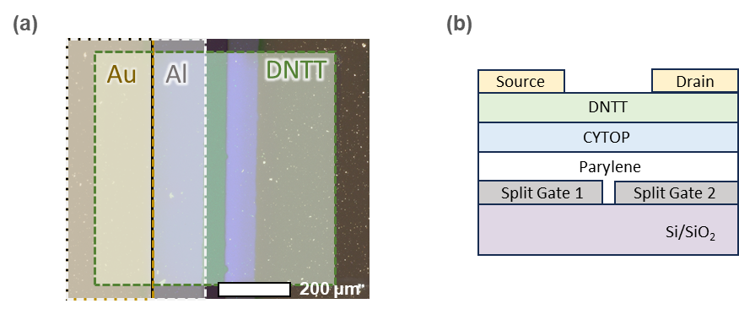
Figure S1. Device optical image and structure. (a) Optical microscope image of Gaussian device. (b) Schematic illustration of the overall structure of the Gaussian device.

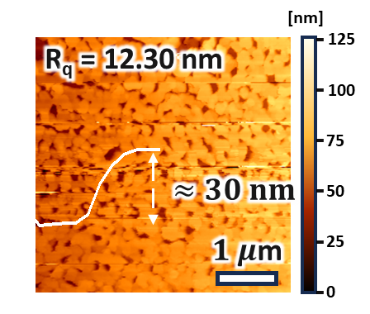
Figure S2. AFM image of DNTT channel on device. AFM surface morphology and step-height measurements performed to analyze the channel surface and thickness of the device.

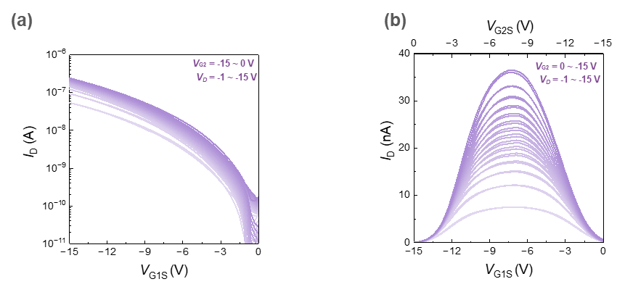
Figure S3. Transfer curve and reversal curve of split gate device. Electrical characteristics obtained by sweeping VG1S and VG2S in the (a) same direction and under (b) reversal-bias conditions.

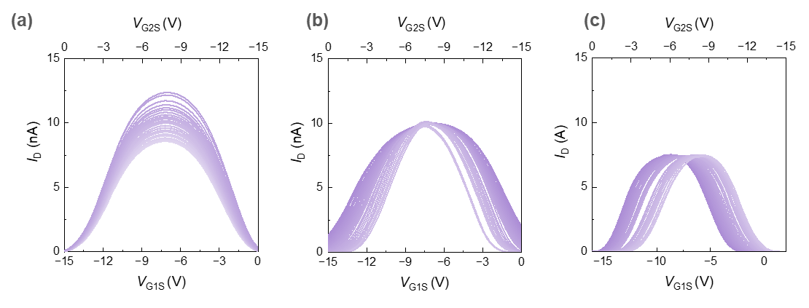
Figure S4. Gaussian parameter tunability Thirty parameter-tuning datasets for each of (a) A, (b) μ, and (c) σ, demonstrating fine control of the Gaussian parameters.

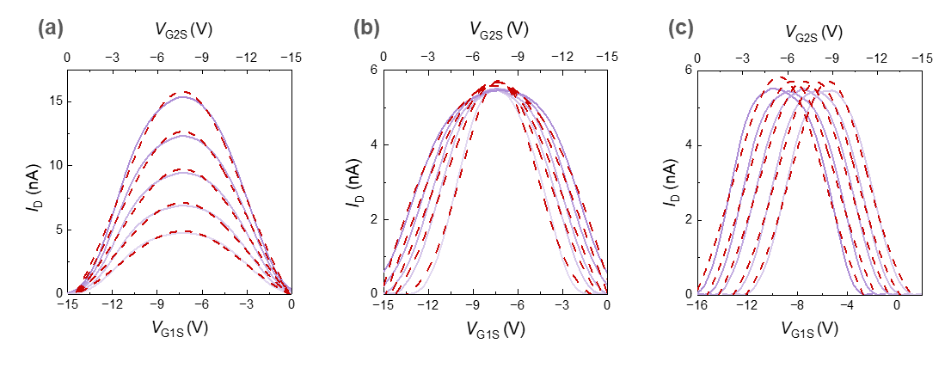
Figure S5. Gaussian fitting Gaussian fitting data for analyzing the electrical characteristics with individually controlled (a) A, (b) μ, and (c) σ.

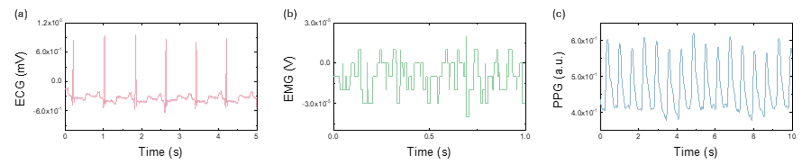
Figure S6. Representative raw biosignal waveforms used for feature extraction (a) ECG waveform from the MIT-BIH Arrhythmia Database, (b) EMG waveform from the UCI hand gesture dataset, and (c) PPG/PLETH waveform from the BIDMC PPG and Respiration dataset. The y-axis shows the original signal amplitude for each modality and the x-axis indicates time in seconds. These raw waveforms are subsequently segmented and converted into compact 8-dimensional feature vectors before GSE-T RBF encoding and classification.

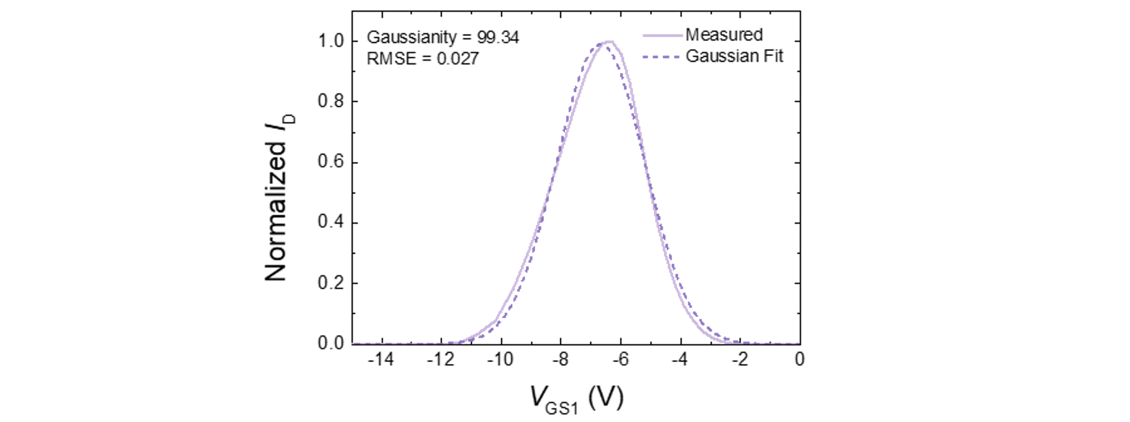
Figure S7. Gaussian fitting example for the measured GSE-T transfer response A representative normalized GSE-T drain-current response is plotted as a function of V_{GS1}, together with its Gaussian fit. The measured trace shows a localized peak-like response that can be approximated by a Gaussian basis function, supporting its use as a physical RBF encoding element. The normalized current response is used to quantify Gaussian-like shape agreement through the Gaussianity score and fitting RMSE.

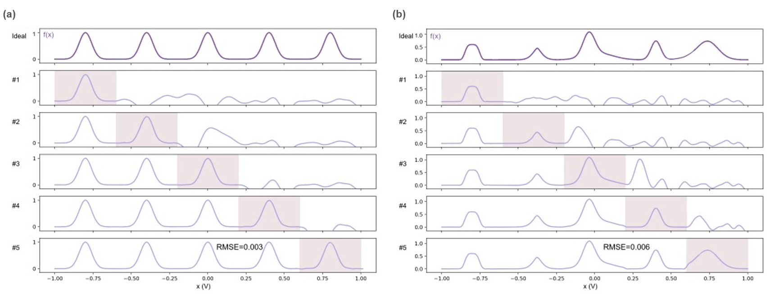
Figure S8. Sequential cumulative fitting using device-derived Gaussian-like responses for KAN-type hardware simulation (a) Sequential cumulative fitting of a five-region one-dimensional Gaussian target using measured GSE-T Gaussian-like responses as hardware-constrained basis functions. The top row shows the ideal target function, and rows #1–#5 show the cumulative fitted outputs at each successive stage. Shaded regions indicate the newly added training domain at each stage. The final fitted response reproduces the full target with RMSE = 0.003. (b) Representative fitting result for a randomly generated Gaussian-like target. The same sequential cumulative procedure is applied to a target composed of irregular Gaussian-like regions. The final full-domain fit achieves RMSE = 0.006, demonstrating that the measured device response can approximate KAN-like univariate basis functions under hardware-derived constraints.

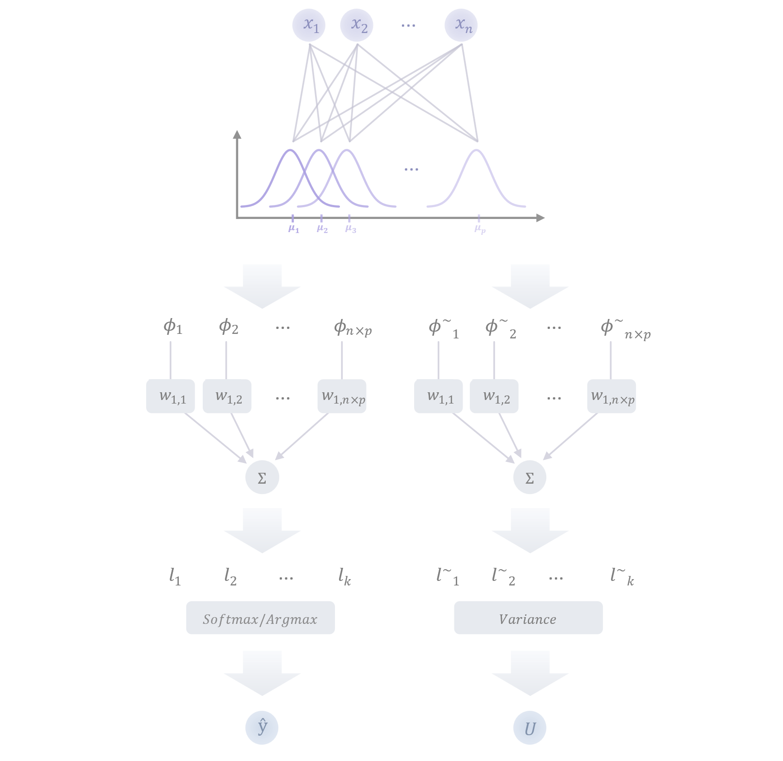 Figure S9. Schematic of deterministic and noise-assisted GSE-T RBF inference Input features $x_{1}, x_{2}, …, x_{n}$ are expanded by phase-shifted Gaussian GSE-T responses to form RBF-encoded features $ϕ$. In the deterministic branch, the encoded features are multiplied by linear readout weights and summed to generate class logits $l_{1}, l_{2}, …, l_{k},$ from which the final prediction $\hat{y}$ is obtained by taking the argmax of the softmax output. In the noise-assisted branch, stochastic GSE-T readout perturbations generate repeated noisy encoded features $\tilde{ϕ}$ and corresponding noisy logits $\tilde{l}$. The final class label is always taken from the deterministic prediction, while the variation across noisy logits provides an uncertainty score U. In the experiments, n = 8 input features and p = 6 RBF phases are used, producing n $×$ p = 48 encoded features.
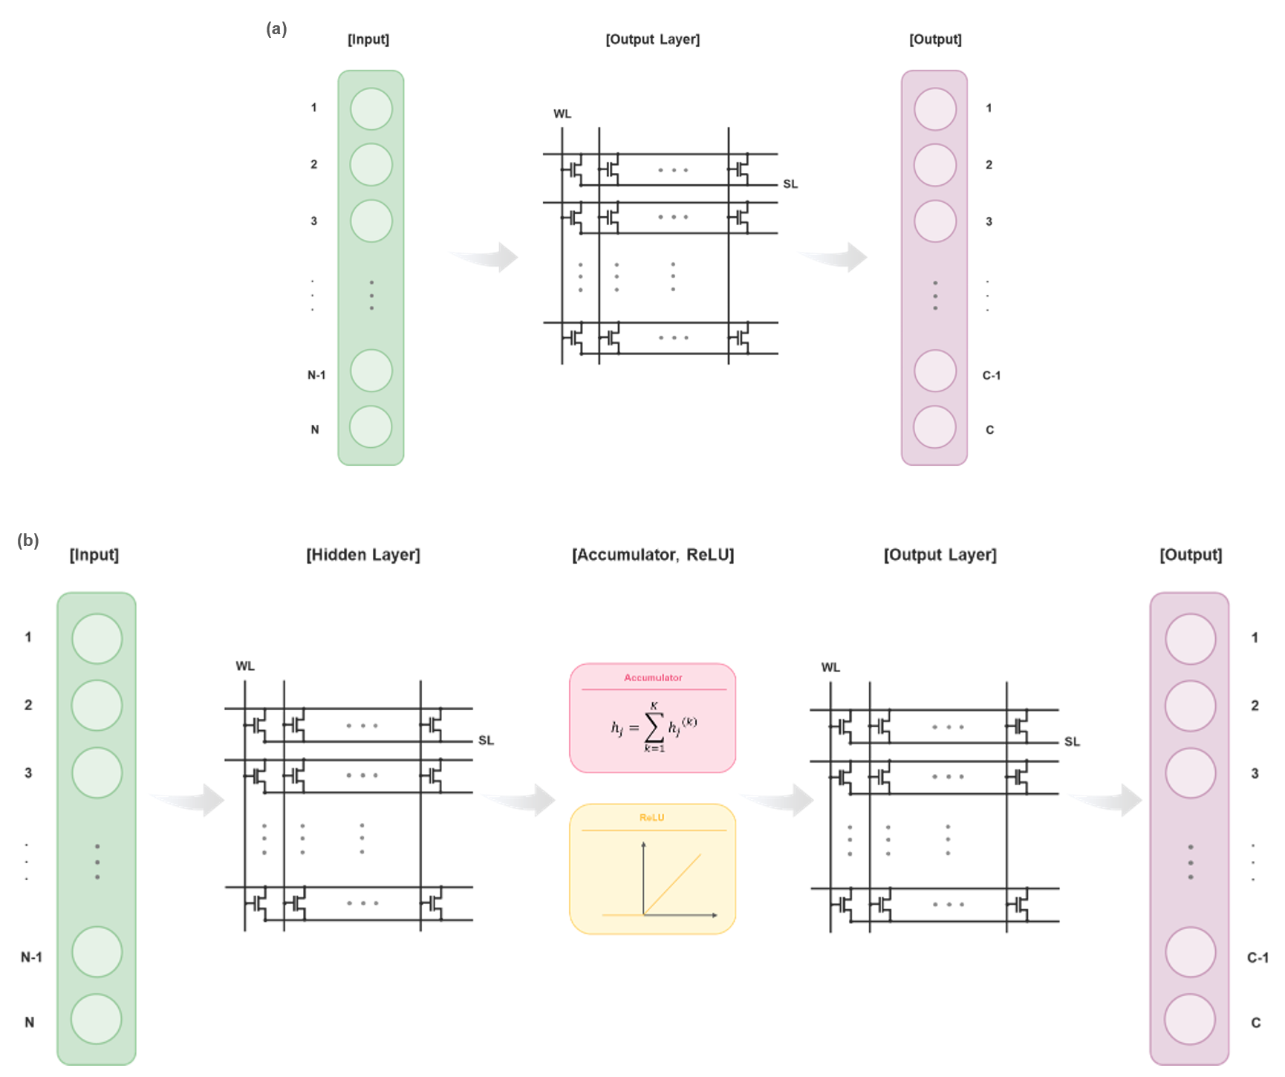
Figure S10. Baseline raw-feature classifier architectures Schematic diagrams of the two raw-feature baseline classifiers used for comparison. (a) Raw+Linear directly maps the input feature vector to class logits through a single linear output layer, without hidden nonlinear transformation or RBF encoding. (b) Raw+MLP uses the same raw input features but adds a hidden layer with weighted accumulation followed by ReLU activation before the final output layer. Thus, Raw+Linear evaluates the linear separability of the original feature space, whereas Raw+MLP serves as a conventional software nonlinear baseline that introduces an additional hidden transformation before the output layer.

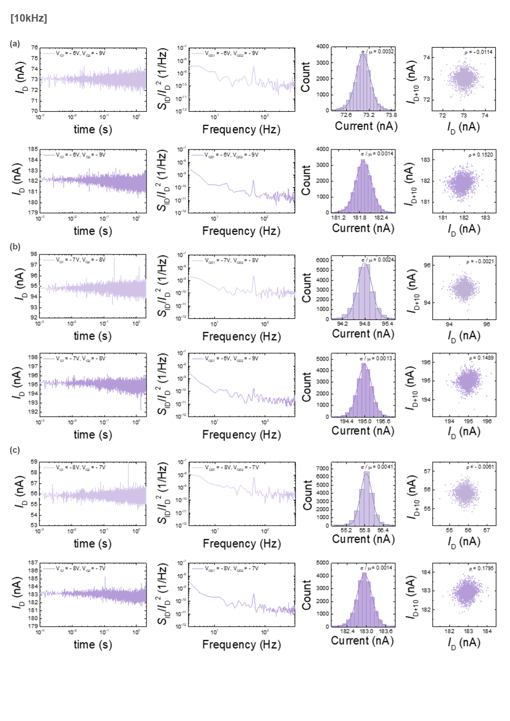
Figure S11. Noise and temporal stability characteristics of the GSE-T device measured at 10kHz For each bias condition, the columns show the drain-current transient trace, normalized low-frequency noise spectrum S_{ID}/I_{D}², current distribution with Gaussian fitting, and lag plot of I_{D} and I_{D+10}. The upper and lower rows in each panel correspond to V_{D} = −5V and −30V, respectively. Measurements are performed at (a) V_{GS1} = −6V and V_{GS2} = −9V, (b) V_{GS1} = −7V and V_{GS2} = −8V, and (c) V_{GS1} = −8V and V_{GS2} = −7V. The Gaussian-fitted current distributions and lag plots summarize the current fluctuation amplitude and temporal correlation under each bias condition.

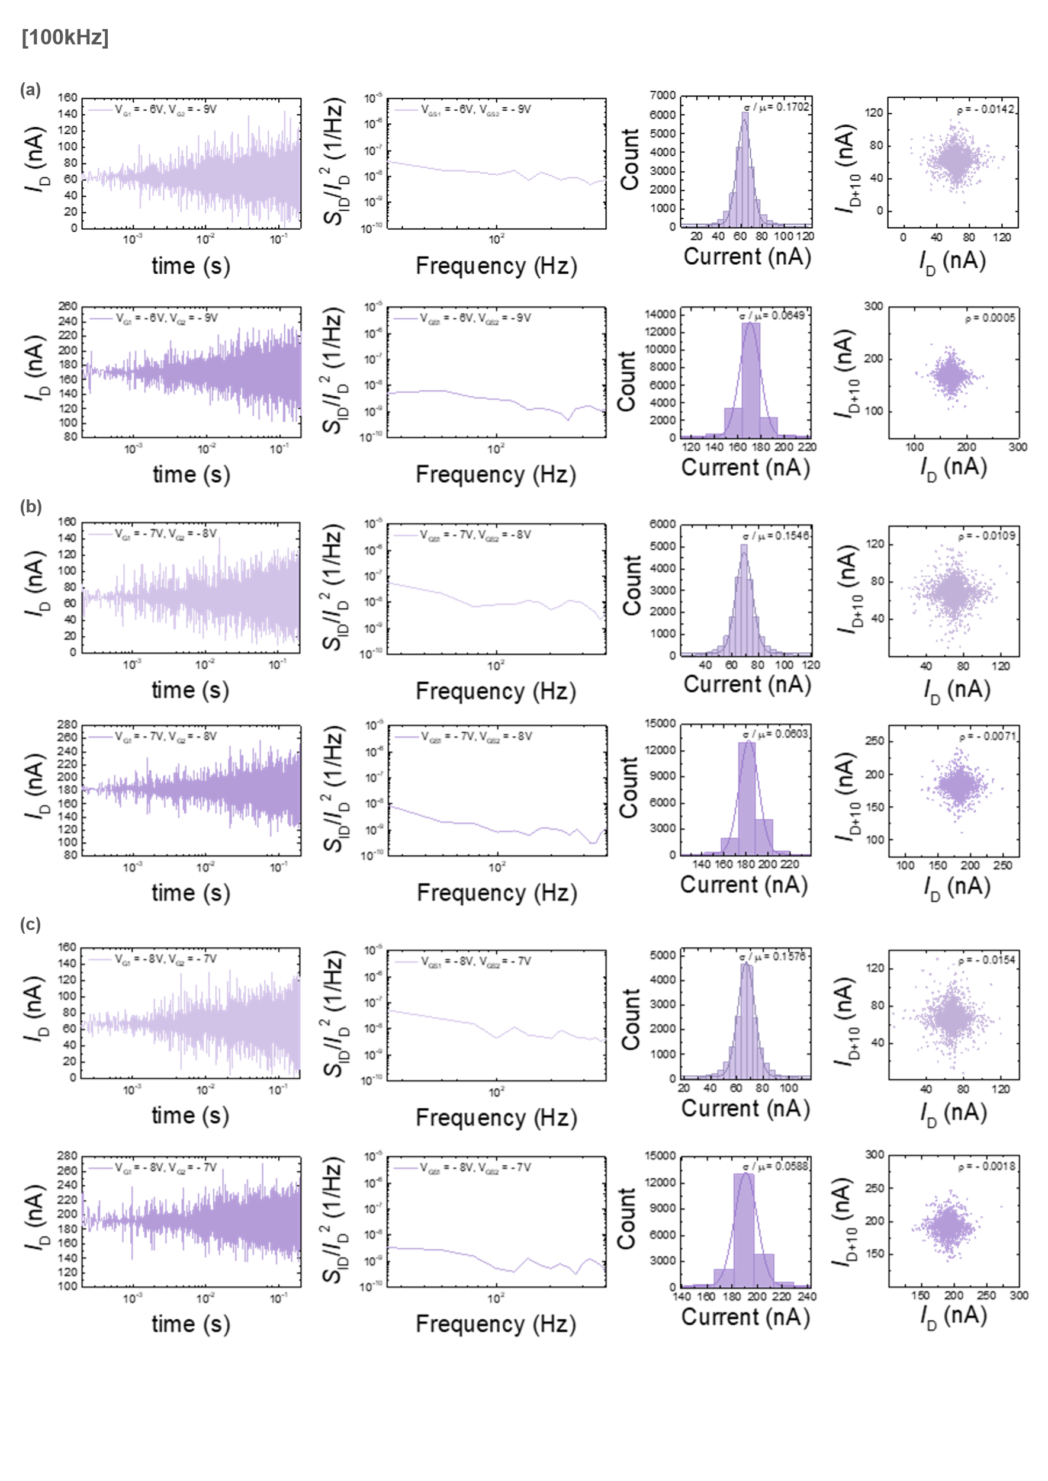
Figure S12. Noise and temporal stability characteristics of the GSE-T device measured at 100kHz For each bias condition, the columns show the drain-current transient trace, normalized low-frequency noise spectrum S_{ID}/I_{D}², current distribution with Gaussian fitting, and lag plot of I_{D} and I_{D+10}. The upper and lower rows in each panel correspond to V_{D} = −5V and −30V, respectively. Measurements are performed at (a) V_{GS1} = −6V and V_{GS2} = −9V, (b) V_{GS1} = −7V and V_{GS2} = −8V, and (c) V_{GS1} = −8V and V_{GS2} = −7V. The Gaussian-fitted current distributions and lag plots summarize the current fluctuation amplitude and temporal correlation under each bias condition.

References
[1] A. L. McWhorter, In Semiconductor Surface Physics (Ed.: Kingston, R. H.), University of Pennsylvania Press, Philadelphia, PA, USA 1957, pp. 207–228.
[2] M. J. Kirton, M. J. Uren, Adv. Phys. 1989, 38, 367.
[3] K. K. Hung, P. K. Ko, C. Hu, Y. C. Cheng, IEEE Trans. Electron Devices 1990, 37, 654.
[4] J. Renteria, R. Samnakay, S. L. Rumyantsev, P. Goli, M. S. Shur, A. A. Balandin, Appl. Phys. Lett. 2014, 104, 153104.
[5] Z. Liu, Y. Wang, S. Vaidya, F. Ruehle, J. Halverson, M. Soljacic, T. Y. Hou, M. Tegmark, arXiv 2024, arXiv:2404.19756.
[6] Z. Li, arXiv 2024, arXiv:2405.06721.
[7] Z. Wen, Q. Zhang, J. Chen, T. Yang, F. Yang, X. Wang, Q. Liu, X. Luo, P. Lin, L.-J. Deng, F. Liu, Nat. Commun. 2026, 17, 3496.

