Assessment of Sewage Sludge application with Beneficial Microbial Inoculates on Fenugreek Productivity in Sandy Loam soil.
Raj Sharma^{1*}, Neha Kumari¹, Raghvendra Kumar Kushwaha¹, Jugul Kishor Tiwari¹, Ram Bharose^{2,} Anurag Singh Suman¹, Anamika Singh¹
¹Department of Soil Science and Agricultural Chemistry, Banda University of Agriculture and Technology, Banda, Uttar Pradesh, 210001, India
²Sam Higginbottom University of Agriculture, Technology and Science, Prayagraj, Uttar Pradesh, 211007, India
Corresponding author: rajsharma1234.g@gmail.com
Abstract
Nitrogen, phosphorus and potassium are main limiting elements for achieving optimum plant health and agricultural crop potential yield. Proper balance of nitrogen, phosphorus and potassium in the soil is essential for plant growth and agricultural input use efficiency. The dynamics of soil characteristics was studied in winter (Rabi) season 2023-24 at Prayagraj, Uttar Pradesh. The treatments 0% NPK+0+0 (T₁), 0% NPK+0+RH (T₂), 0% NPK+15+PSB (T₃), 0% NPK+15+RH (T₄), 0% NPK+30+PSB (T₅), 0% NPK+30+RH (T₆), 50% NPK+0+PSB (T₇), 50% NPK+0+RH (T₈), 50% NPK+15+PSB (T₉), 50% NPK+15+RH (T₁₀), 50% NPK+30+PSB (T₁₁), 50% NPK+30+RH (T₁₂), 50% NPK+30+RH (T₁₃), 100% NPK+0+RH (T₁₄), 100% NPK+15+PSB (T₁₅), 100% NPK+15+RH (T₁₆), 100% NPK+30+PSB (T₁₇) and 100% NPK+30+RH (T₁₈) are replicated three times in randomised block design. The application of sewage sludge and biofertilizers enhanced nutrient concentration, especially phosphorus and nitrogen, reflecting more growth and increased quality of seeds in fenugreek over control. This study points out the possibility of integration between chemical and organic amendments with biofertilizers for sustainable increase in crop yields, based on a suggestion that this type of management practices can greatly enhance soil fertility and agricultural productivity without posing threats to the environment. The maximum value of the observed data were showed by application of (100% + NPK + 30SS+ RH) in plant height (cm), pod length (cm) number of pods plant⁻¹, weight of seed pod⁻¹, seed yield (q ha⁻¹) and Cost Benefit Ratio over control.
Keywords: sewage sludge; bio fertilizers; soil properties; fenugreek.
- INTRODUCTION
Native to West Asia and South-Eastern Europe, fenugreek (Trigonella foenum graecum L.) is an annual leguminous herbaceous seed spice belonging to the Fabaceae family (Pal & Mukherjee 2020). Its secondary center of origin is believed to be the Indian subcontinent (Petropoulos 2002). There are around fifty species in the genus Trigonella (Anywar et al. 2023). In both tropical and temperate parts of India, two commercially grown varieties of the genus Trigonella foenum-graecum, also known as fenugreek, and corniculata, also known as pan methi or Kasuri methi are used as seed spices Sewage sludge, when applied properly, offers several benefits to soil health and fertility (Sharma et al. 2024). The main reason fenugreek (Trigonella foenum-graecum L.) is cultivated for leaves and seeds, which are used in both medicine and cooking purpose. It has various names on the basis of different languages, viz., Fenugreek (French), Methi (Hindi), Bockshorklee (German), Fieno greco (Italian), Pazhitnik (Russian), Alholva (Spanish), Koroha (Japanese), Hulba (Ara bian), Halba (Malaya), and K’u-Tou (China). The seeds are used to a variety of foods as a spice. The extractable oil from fenugreek, which is about 6–8%, has a foetid odour and bitter taste with marked drying properties. It has a specific gravity of 0.91, acid value 1–2, saponification value 178–183, iodine value 115, unsaponifiable matter 3.9%, and fatty acid composition of palmitic 9.6%, stearic 4.9%, arachidic 2%, oleic 35.1%, linoleic 33.7%, and α-linolenic 13.8%. About 0.02% is volatile oil (sp.gr. 0.87) with anethole as the major component (Hamidioglu 2017). As a leguminous crop, fenugreek develops a symbiotic association with rhizobia bacteria, which improves soil fertility by converting atmospheric nitrogen into forms that plants can utilize (Giridhar et al. 2023).
Sewage sludge, an inevitable byproduct generated during wastewater treatment, is considered a valuable organic supplement due to its high organic carbon content and the presence of essential macro and micronutrients required for plant growth (Latare et al. 2014). In sandy loam soils, which are generally characterized by low organic matter and poor nutrient-retention capacity, the application of sewage sludge can significantly improve soil physicochemical and biological properties. The addition of sewage sludge enhances soil structure, increases water holding capacity, improves cation exchange capacity and stimulates microbial activity, thereby creating favorable conditions for nutrient availability and plant development. Furthermore, sewage sludge serves as a supplementary nutrient source that can partially reduce dependence on chemical fertilizers while improving nutrient use efficiencies. Its organic constituents contribute to soil carbon sequestration, which plays an important role in maintaining soil sustainability and mitigating climate change impacts (Kumar et al. 2020). The integration of sewage sludge with inorganic fertilizers and beneficial microbial inoculants further promotes nutrient mineralization, phosphorus solubilization and biological nitrogen fixation, leading to enhanced nutrient uptake and crop productivity. Previous studies also reported substantial improvements in the growth and yield of several agricultural crops, including cereals, legumes and vegetables with the combined application of sewage sludge and nutrient management practices (Singh and Agrawal 2010).
Biofertilizers represent an environmentally sustainable and economically viable approach for improving crop productivity by minimizing dependence on non-renewable agricultural inputs (Vessey 2013). These microbial inoculants enhance nutrient availability and stimulate plant growth through the production of vitamins, phytohormones and other bioactive compounds essential for crop development. In leguminous crops such as fenugreek (Trigonella foenum-graecum L.), inoculation with Rhizobium meliloti promotes symbiotic nitrogen fixation, thereby supplementing the nitrogen requirement of the crop and improving plant growth, biomass accumulation and seed yield (Husain et al., 2022). Phosphorus deficiency is a major constraint in Indian soils, where a considerable proportion of phosphorus exists in insoluble and unavailable forms. In this context, phosphate solubilizing bacteria play a crucial role in transforming sparingly soluble phosphatic compounds into forms readily available for plant uptake. Enhanced phosphorus solubilization by PSB contributes to improved root proliferation, nutrient absorption and overall crop performance. Therefore, the combined application of Rhizobium and PSB may significantly improve nutrient use efficiency and productivity in fenugreek cultivation.In the present investigation, Rhizobium inoculation was carried out as a seed treatment at the rate of 2 g kg⁻¹ seed, while PSB was applied to the soil at 3 kg ha⁻¹ during sowing. The integrated application of sewage sludge, inorganic fertilizers and beneficial microbial inoculants exhibited a synergistic influence on nutrient availability, crop growth and yield attributes of fenugreek grown in sandy loam soil, thereby indicating its potential as a sustainable nutrient management strategy for enhancing soil fertility and agricultural productivity.
- MATERIALS AND METHODS
The field experiment was conducted to "Assessment of of Sewage Sludge and Beneficial Microbial Inoculates on Fenugreek Productivity in Sandy Loam Soil" was conducted as a field experiment at the Soil Science Research Farm, of Sam Higginbottom University of Agriculture, Technology, and Sciences, Prayagraj during the Rabi season of 2023-24.
2.1 Application of Sewage Sludge
Broadcast Method: Spread the Sewage sludge uniformly across the field by hand or using mechanical spreaders.
2.2 Experimental Site and Climatic condition
The experiment was conducted at the Research Farm of Sam Higginbottom University of Agriculture, Technology and Sciences, under the Department of Soil Science and Agricultural Chemistry. The site is located at 25°24′30″ N latitude, 81°51′10″ E longitude, and 98 m above mean sea level, falling within the North Alluvium Plain Zone (Agro-Ecological Sub Region) with a gentle slope of 0–1%, and situated in the Agro-Climatic Zone of the Upper Gangetic Plain Region. The Prayagraj district, where the site is located, experiences a subtropical climate characterized by extremely hot summers with temperatures reaching up to 46°C, and cold winters with minimum temperatures of about 4–5°C. Relative humidity ranges from 20 to 94% and the region receives approximately 1100 mm of annual rainfall, which markedly influences its climatic conditions.

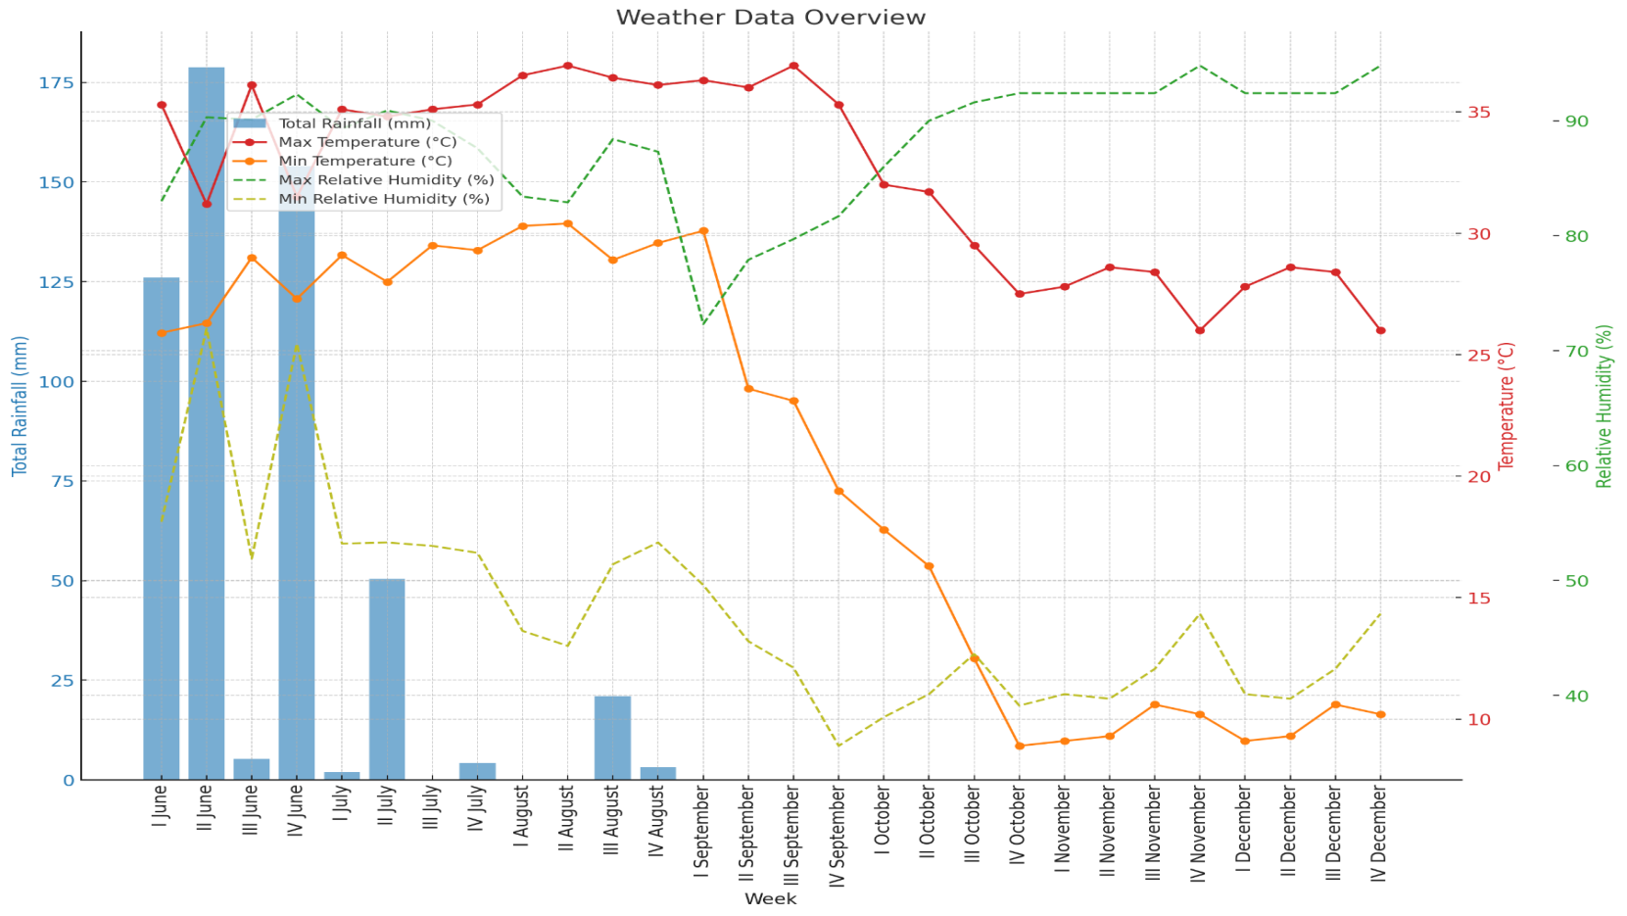

Figure 1. Observations of total rainfall and Meteorological (weekly) during the experimental period (Kharif 2023).
2.4 Methodology
2.4.1 Plant height (cm)
Five plants were selected randomly from each plot and tagged. The heights of these plants were measured from base of plant to tip of the plant at 30, 50 DAS and at harvest. The height was measured from the base of the plant of tip of upper most expended leaf or foliage leaf and height of the plant was recorded in centimeters.
2.5 Yield Studies
2.5.1 No. of Branches plant⁻¹
Number of primary branches were counted from randomly ten selected plants at 15 days interval such as 30, 50 DAS from each plot. After that mean values were calculated and recorded.
2.5.2 Pod Length (cm)
For measuring pod length, pods of ten randomly selected plants of each replication were counted and the length of the individual pod was measured from the base to the tip of the pod and finally the measured lengths were recorded as per treatments and expressed in cm.
2.5.3 No. of pod plant⁻¹
Number of pods were counted from each selected plant of each replication then average of this is calculated.
2.5.4 No. of seed pod⁻¹
From each of the plot one plant was selected and randomly five pods were seperated and seeds were counted and the average was recorded, that was the average number of seed pod⁻¹.
2.5.5 Grain yield (kg ha⁻¹)
After taking the weight of total biomass, the produce of each net plot was threshed separately and clean grains were sun dried. The grain yield thus recorded in kg plot⁻¹ was finally converted into kg ha⁻¹.
2.5.6 Test weight (g)
The weight of 1000 seeds from all treatments was recorded on electronic plan balance and it was expressed in gm.
2.5.7 Seed Yield (q ha⁻¹)
The average seed yield (q ha⁻¹) was worked out on the basis of yield obtained from all treatments. Then converted to average yield yield of each treatment.
- Result and Discussion
  - Growth attributes
3.1.1 Plant height
The treatment T₁₈ (100% NPK+30+RH) recorded significantly maximum plant height 39.1cm at 30 DAS and 54.1cm at 50 DAS. It was found to be at par with the treatment T₁₄ 37.5 cm, T₁₅ 37.6 cm, T₁₆ 38.1 cm and T₁₇ 39.1cm at 30 DAS and maximum plant height 54.1cm at 50 DAS as compared to minimum plant height 28.2cm at 30 DAS and 47.1cm at 50 DAS in T₁. This might be due to the combined application of inorganic fertilizer and biofertilizers (Rh+PSB) which increased nutrients availability, photosynthetic activity, chlorophyll formation, nitrogen metabolism in plants which ultimately improving plant height resulting in vigorous plant growth. Similar beneficial combined effect of inorganic and bio-inoculant on growth parameters similar result was also recorded by (Jat et al. 2006; Bhunia et al. 2006; Mehta et al. 2012; Rizvi et al. 2013).
  - Yield attributes
3.2.1 Branches plant⁻¹
A critical review of observation showed that both NPK and Sewage sludge has significant effect on the number of branches. Here, highest number of branches was recorded at level 100% NPK+30+RH, the number of branches was 4.1 and 5.2 at 30 DAS and 50 DAS as compared to minimum the number of branches 2.1 at 30 DAS and 3.5 at 50 DAS in control. Bio-fertilizers improved root nodulation and provided the congenial soil environment for plant rhizosphere, increased nitrogen fixation and phosphorous solubilization, increased more growth there by increased number of branches⁻¹. Similar combined beneficial effect of organic manures, inorganic fertilizers and bio-fertilizers on growth parameters was recorded by (Bhunia et al. 2006; Choudhary et al. 2011).
3.2.2 Length of pod (cm)
A persual of data showed that length of pod increased from 8.2 cm to 10.2 cm with the increased leavel of NPK, Sewage sludge and biofertilizers. Maximum length of the pod was noticed with T₁₈ 100% NPK+30+RH, the length of pod was 13.86 cm as compared to minimum 8.2 at 30 DAS and 10.5 at 50 DAS. The organic manures and bio-fertilizers increased the soil microbial activity, availability of phosphorous and in turn played unique role in energy conversion and transfer increased the length of pod per plant. Similar result was recorded by (Khiriya et al. 2003).
3.2.3 Number of pod plant⁻¹
The significantly highest pods per plant⁻¹ 24.9 at 30 DAS and 27.8 at 50 DAS were recorded in the treatment T₁₈ 100% NPK + 30t SS + Rh, and it was found at par with T₁₅ 24.1 treatment, T₁₆ 24.3 treatment and T₁₇ 24.7 at 30 DAS. However, significantly minimum number of pods per plant 20.3 at 30 DAS and 24.1 at 50 DAS were recorded in treatment T₁. The organic manures and bio-fertilizers increased the soil microbial activity, improved the availability of phosphorous and played unique role in energy conversion, transfer and increased the number of pods per plant. Similar result was recorded by (Choudhary et al. 2011).
Table 1. Effect of NPK and sewage sludge conjugated with bio-fertilizers on growth and yield attributes of fenugreek.
Treatment | Plant height (cm) |  | No. of Branches plant⁻¹ |  | Length of Pod (cm) |  | No. of pod plant⁻¹
Treatment | 30 DAS | 50 DAS | 30 DAS | 50 DAS | 30 DAS | 50 DAS | 30 DAS | 50 DAS
T₁ | 28.2 | 47.1 | 2.1 | 3.5 | 8.2 | 10.5 | 20.3 | 24.1
T₂ | 29.1 | 47.3 | 2.2 | 3.2 | 8.3 | 10.5 | 20.5 | 24.6
T₃ | 29.5 | 47.5 | 3.1 | 4.4 | 8.5 | 10.7 | 20.8 | 24.5
T₄ | 29.5 | 48.3 | 2.3 | 3.5 | 8.6 | 10.4 | 20.7 | 24.7
T₅ | 30.1 | 48.6 | 2.1 | 5.4 | 8.9 | 10.5 | 20.6 | 24.8
T₆ | 32.1 | 48.8 | 3.2 | 3.6 | 9.1 | 10.6 | 21.1 | 25.1
T₇ | 32.4 | 49.6 | 2.3 | 4.7 | 9.5 | 10.8 | 21.6 | 24.3
T₈ | 32.5 | 48.7 | 3.2 | 3.5 | 9.4 | 10.9 | 21.4 | 24.5
T₉ | 33.7 | 48.9 | 2.3 | 4.4 | 9.6 | 11.0 | 23.5 | 24.6
T₁₀ | 33.8 | 49.1 | 2.2 | 4.5 | 9.7 | 11.5 | 23.4 | 24.8
T₁₁ | 35.6 | 49.6 | 2.4 | 4.2 | 9.2 | 11.6 | 22.5 | 25.7
T₁₂ | 35.8 | 49.5 | 3.5 | 4.3 | 9.5 | 11.7 | 23.4 | 25.6
T₁₃ | 35.9 | 50.1 | 2.1 | 3.6 | 9.4 | 11.5 | 23.7 | 25.8
T₁₄ | 37.5 | 51.2 | 3.6 | 5.4 | 9.8 | 11.9 | 23.9 | 25.4
T₁₅ | 37.6 | 51.6 | 3.5 | 4.6 | 9.7 | 11.4 | 24.1 | 26.3
T₁₆ | 38.1 | 52.1 | 3.4 | 4.5 | 9.4 | 12.1 | 24.3 | 26.7
T₁₇ | 39.1 | 52.5 | 3.6 | 5.1 | 9.8 | 12.3 | 24.7 | 26.9
T₁₈ | 39.1 | 54.1 | 4.1 | 5.2 | 10.2 | 12.5 | 24.9 | 27.8

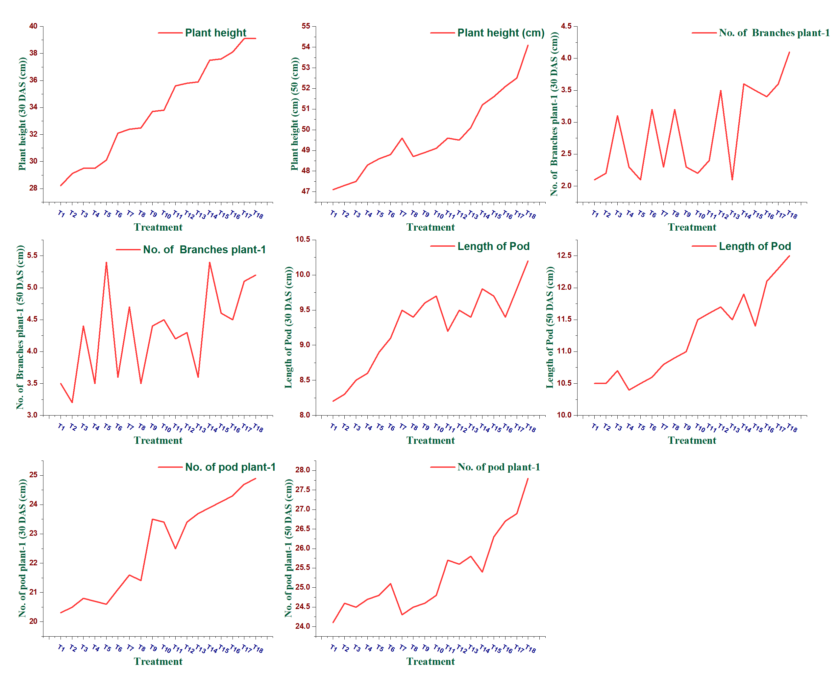
Figure 2. Graphical Representation of the Effect of Different Treatments on Plant Growth and Yield Parameters.
The graphical trends indicated that integrated nutrient management significantly improved the growth and yield attributes of fenugreek. Plant height at 45 DAS and 60 DAS showed a gradual increase across treatments, reflecting enhanced nutrient availability and improved vegetative growth under combined application of NPK, sewage sludge and biofertilizers. Similarly, the number of branches plant⁻¹ increased with advanced treatments, suggesting improved physiological activity and nutrient uptake. Pod length and number of pods plant⁻¹ also exhibited a positive response to integrated nutrient application. The superior performance observed under combined treatments may be attributed to balanced nutrient supply, enhanced microbial activity and improved soil fertility conditions. The synergistic interaction of inorganic fertilizers, organic amendments and microbial inoculants promoted better reproductive growth and yield performance compared with control treatments (Figure 2).
3.2.4 Number of seed pod⁻¹
Number of seeds per pod increased with an increment in level of NPK, Sewage sludge with biofertilizers. Maximum number of seeds was observed in T₁₈ 100% NPK + 30t SS + Rh 12.9 at 30 DAS and 14.9 DAS. However, significantly minimum number of pods per plant 10.5 at 30 DAS and 12.3 at 50 DAS were recorded in treatment T₁. This might be due to the combined response of organic manures, inorganic fertilizers along with bio fertilizers inoculation that ensured readily availability of nutrients mainly nitrogen, phosphorous and potassium accelerated the growth of microbial population in rhizosphere which provide the efficient frame work for high rates of nutrient absorption and net assimilation, Similar result was recorded by (Choudhary et al. 2011).
3.2.5 Test weight (gm)
The data related to test weight of seed exhibited significant differences among the various treatments. The maximum test weight of seed 12.47 g was recorded by the treatment T₁₈ 100% NPK + 30t SS + Rh. The least test weight of seed 10.14 g was recorded by the treatment T₁. The combined use of inorganic fertilizers and bio-inoculants enhanced growth and yield in fenugreek by improving nutrient availability, particularly nitrogen and phosphorus. As a legume, fenugreek got benefits from biological nitrogen fixation, leading to a steady nutrient supply that supports flowering, pod formation and assimilate partitioning. Adequate phosphorus further aids energy transfer within the plant. This balanced nutrient supply reduced leaf senescence, increases assimilate flow to sinks, and ultimately improved test weight, similar results was recorded by (Meena et al. 2014).
3.2.6 Seed Yield (q ha⁻¹)
The data related to seed yield ha⁻¹ exhibited significant difference among the various treatments under study. The treatment T₁₈ 100% NPK + 30t SS + Rh, produced significantly the maximum 19.92 q ha⁻¹ and which was found superior over all other treatments closely followed by the treatment T₁₇ 19.78 q ha⁻¹. However, the minimum seed yield 13.27 q ha⁻¹ was recorded in the treatment T₁.
These graphs revealed that integrated nutrient management positively influenced the yield attributes and seed yield of fenugreek. The number of seeds pod⁻¹ and test weight increased progressively across treatments, indicating improved seed development and nutrient utilization. Similarly, seed yield showed a consistent increasing trend under combined application of NPK fertilizers, sewage sludge and biofertilizers. The enhanced performance may be attributed to balanced nutrient supply, improved soil fertility and increased nutrient uptake efficiency under integrated nutrient application (Figure 3).

Table 2. Effect of NPK and sewage sludge conjugated with bio-fertilizers on growth and yield attributes of fenugreek.
Treatment | No. of seed pod⁻¹ |  | Test Weight (gm) | Seed Yield (q ha⁻¹)
Treatment | 30DAS | 50DAS | Test Weight (gm) | Seed Yield (q ha⁻¹)
T₁ | 10.5 | 12.3 | 10.14 | 13.27
T₂ | 10.6 | 12.4 | 10.23 | 13.62
T₃ | 10.7 | 12.5 | 10.25 | 14.71
T₄ | 10.4 | 124 | 10.45 | 14.35
T₅ | 10.8 | 12.7 | 10.56 | 15.67
T₆ | 10.9 | 12.8 | 10.48 | 15.66
T₇ | 11.5 | 12.9 | 10.67 | 16.24
T₈ | 11.4 | 13.2 | 10.87 | 15.28
T₉ | 11.6 | 13.5 | 10.98 | 16.29
T₁₀ | 11.8 | 13.7 | 11.25 | 16.17
T₁₁ | 11.9 | 13.9 | 11.27 | 17.20
T₁₂ | 11.5 | 13.8 | 11.56 | 17.22
T₁₃ | 11.7 | 13.7 | 11.47 | 16.41
T₁₄ | 12.2 | 14.1 | 11.65 | 17.24
T₁₅ | 12.4 | 14.3 | 11.89 | 17.89
T₁₆ | 12.6 | 14.5 | 12.14 | 18.33
T₁₇ | 12.7 | 14.7 | 12.35 | 19.78
T₁₈ | 12.9 | 14.9 | 12.47 | 19.92
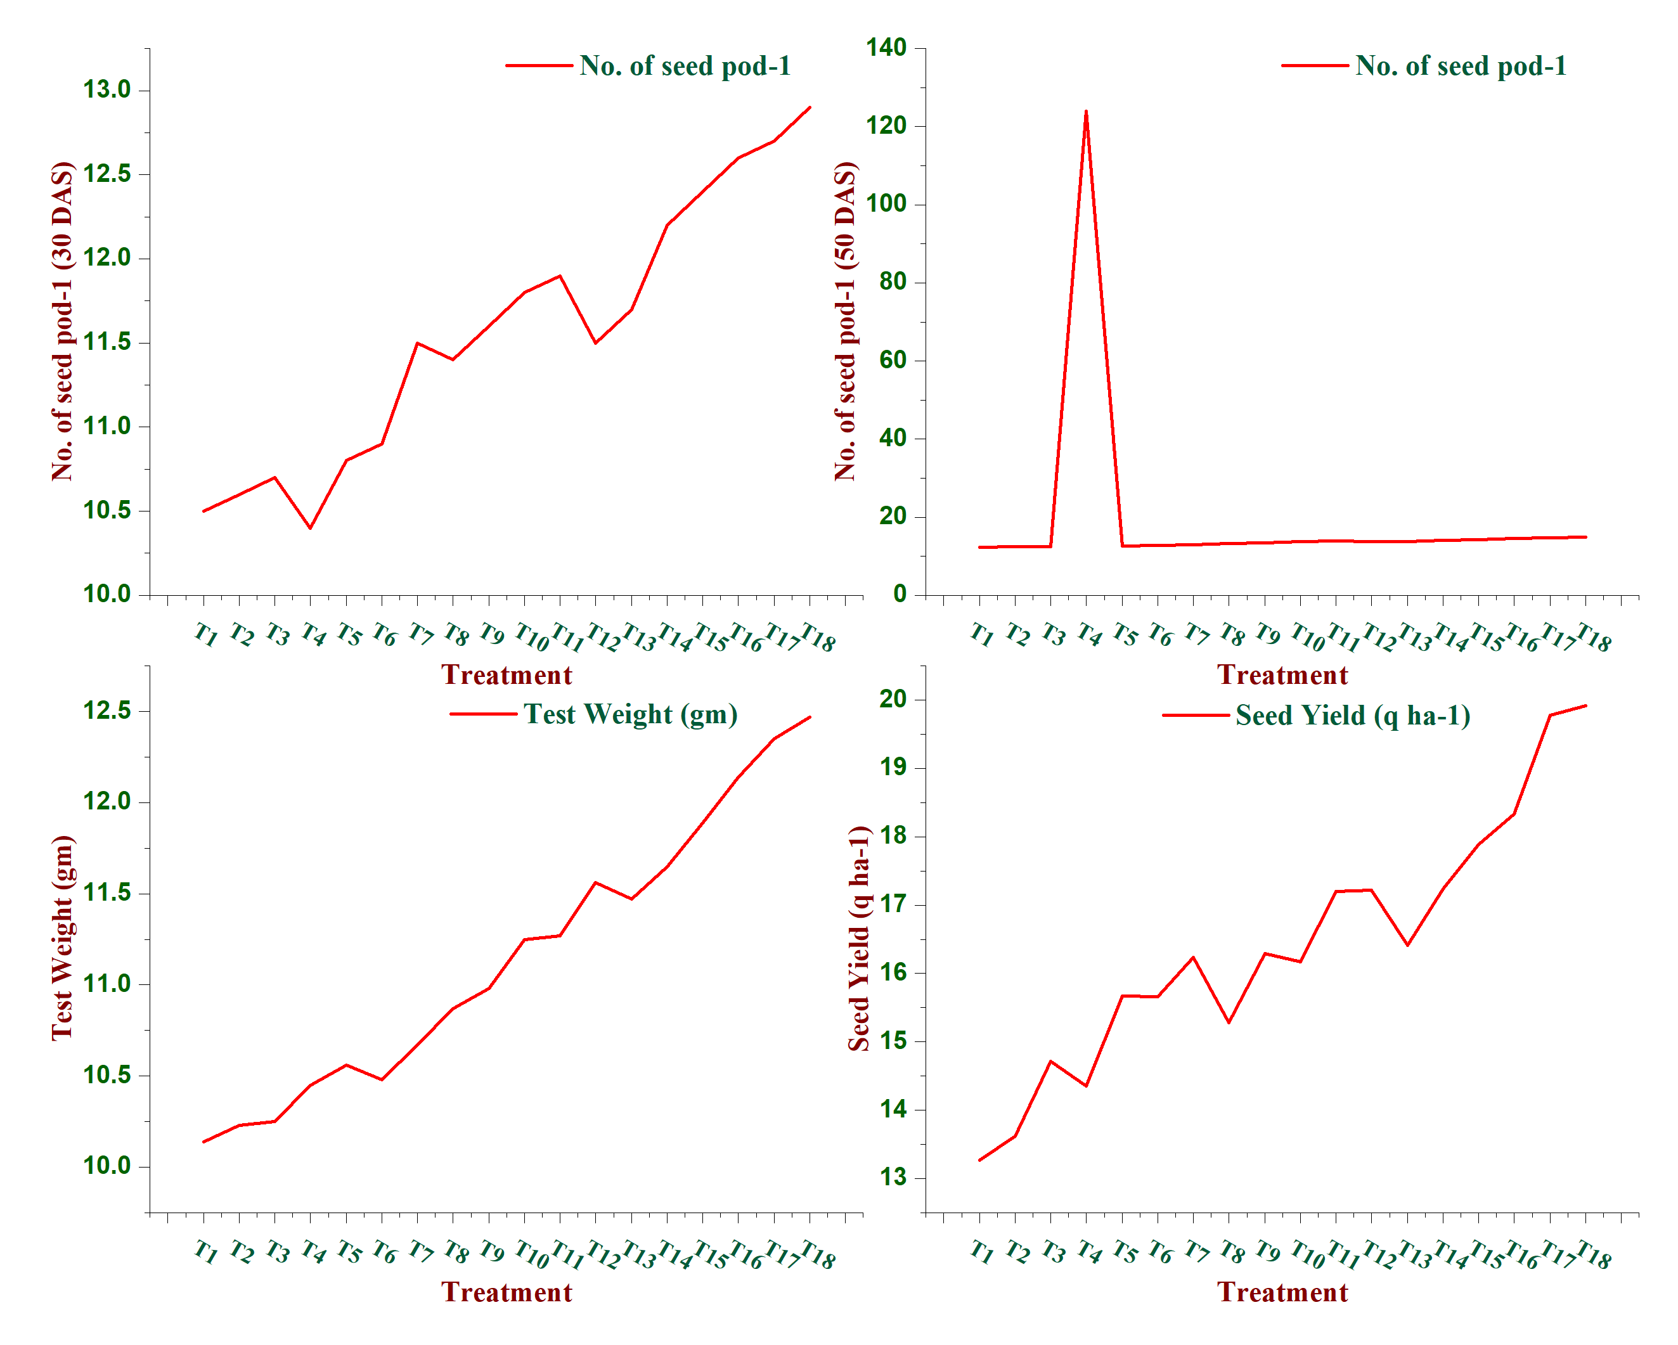 Figure 3. Graphical Representation of the Effect of Different Treatments on Plant Growth and Yield Parameters.

Conclusion

Thus, it could be concluded that the combined application of NPK, sewage sludge, phosphorus solubilizing bacteria and Rhizobium significantly improved the growth and yield parameters of fenugreek. The Treatment T₁₈ (100% NPK + 30t SS + Rh) yielded the best results, with maximum improvements in plant height (cm), pod length (cm), no. of pods plant⁻¹, weight of seed pod⁻¹, seed yield (q ha⁻¹). These results highlight the effects of NPK, sewage sludge and biofertilizers for improvement in the fenugreek.
Acknowledgements
I an grateful to the Department of Soil Science and Agricultural Chemistry, Banda University of Agriculture and Technology, for providing the necessary laboratory and field facilities for conducting the present investigation.
Authors’ contributions
RS and RB conceived the idea and edited the manuscript, JKT, NK wrote the review manuscript, RKK assembled the data, ASS designed the graph and all authors read, revised and approved of the manuscript.
Compliance and ethical standards
Ethical issues
The study bassed on fenugreek productivity and all procedures were adopted by Sam higginbottom University of Agriculture, Technology and Science, Prayagraj, UP.
Funding
This research article essentially supports and resources were provided by Sam higginbottom University of Agriculture, Technology and Science.
Ethics approval and consent to participate
Not applicable
Consent for Publication
All authors have read and given their approval to thr final version of the manuscript for publication.
Conflict of Interest
The authors declare that there is no conflict of interest regarding the publication of this manuscript.
Reference
- Pal, D. and Mukherjee, S., 2020. Fenugreek (Trigonella foenum) seeds in health and nutrition. In Nuts and seeds in health and disease prevention (pp. 161-170). Academic Press. https://doi.org/10.1016/B978-0-12-818553-7.00013-9
- Petropoulos, G.A. ed., 2002. Fenugreek: the genus Trigonella. CRC Press.
- Anywar, G., Ssenku, J.E. and Tugume, P., 2023. Trigonella foenum-graceum and Stressful Conditions. In Medicinal plant responses to stressful conditions (pp. 437-450). CRC Press.
- Bhunia, S.R., Chauhan, R.P.S., Yadav, B.S. and BHAT, A., 2006. Effect of phosphorus, irrigation and Rhizobium on productivity, water use and nutrient uptake in fenugreek (Trigonella foenum-graecum). Indian Journal of Agronomy, 51(3), pp.239-241. https://doi.org/10.59797/ija.v51i3.5018
- Choudhary, B.R., Gupta, A.K., Parihar, C.M., Jat, S.L. and Singh, D.K., 2011. Effect of integrated nutrient management on fenugreek (Trigonella foenum-graecum) and its residual effect on fodder pearlmillet (Pennisetum glaucum). Indian Journal of Agronomy, 56(3), pp.189-195. https://doi.org/10.59797/ija.v56i3.4693
- Jatav, H.S., Singh, S.K., Singh, Y. and Kumar, O., 2018. Biochar and sewage sludge application increases yield and micronutrient uptake in rice (Oryza sativa L.). Communications in Soil Science and Plant Analysis, 49(13), pp.1617-1628. .https://doi.org/10.1080/00103624.2018.1474900
- Kumar, D.E.E.P.A.K., Singh, S.K. and Mann, S.A.R.D.U.L., 2020. Assessment of sewage water quality and its effect on soil properties of south eastern citis of Harayana. Annals of Plant and Soil Research, 22(2), pp.182-185.
- Latare, A.M., Kumar, O., Singh, S.K. and Gupta, A., 2014. Direct and residual effect of sewage sludge on yield, heavy metals content and soil fertility under rice–wheat system. Ecological engineering, 69, pp.17-24. .https://doi.org/10.1016/j.ecoleng.2014.03.066.
- Meena, S.S., Mehta, R.S., Bairwa, M. and Meena, R.D., 2014. Productivity and profitability of fenugreek (Trigonella foenum-graecum L.) as influenced by bio-fertilizers and plant growth regulators. https://doi.org/10.5958/0976-0571.2014.00690.0
- Mehta, R.S., Anwer, M.M. and Malhotra, S.K., 2012. Influence of sheep manure, vermicompost and biofertilizer on growth, yield and profitability of cumin (Cuminum cyminum L.) production.
- Rizvi, R., Mahmood, I. and Tiyagi, S., 2013. Potential role of organic matters and phosphate solubilizing bacteria (PSB) on the growth and productivity of fenugreek. Journal of Agricultural science and Technology, 15(3), pp.639-647.
- Panse, V.G. and Sukhatme, P.V., 1954. Statistical methods for agricultural workers.
- Singh, R.P. and Agrawal, M., 2010. Biochemical and physiological responses of rice (Oryza sativa L.) grown on different sewage sludge amendments rates. Bulletin of environmental contamination and toxicology, 84(5), pp.606-612.. https://doi.org/10.1016/j.chemosphere.2006.12.019.
- Singh, R.P. and Agrawal, M., 2007. Effects of sewage sludge amendment on heavy metal accumulation and consequent responses of Beta vulgaris plants. Chemosphere, 67(11), pp.2229-2240.
- Khiriya, K.D. and Singh, B.P., 2003. Effect of phosphorus and farmyard manure on yield, yield attributes and nitrogen, phosphorus and potassium uptake of fenugreek (Trigonella foenum-graecum). Indian journal of Agronomy, 48(1), pp.62-65.
- Jat, N.L., Jain, N.K. and Choudhary, G.R., 2006. Integrated nutrient management in fenugreek (Trigonella foenum-graecum). Indian Journal of Agronomy, 51(4), pp.331-333. https://doi.org/10.59797/ija.v51i4.5042
- Sharma, R., Bharose, R., David, A.A., Kumari, N. and Yadav, D.K., Effect of NPK and sewage sludge on the physico chemical properties of soil for fenugreek (Trigonella foenum-graecum) var. bold inoculated with rhizobium and phosphorus solubilizing bacteria at Prayagraj. https://doi.org/10.33545/26174693.2024.v8.i7i.1578
- Hamidioglu, I., 2017. Fractionation of fenugreek (Trigonella foenum-graecum L.) seeds and analyses of their fractions composition and properties (Doctoral dissertation, Kauno technologijos universitetas.).
- Giridhar, K., Tanuja Priya, B. and Sastry, E.D., 2023. Fenugreek. In Handbook of Spices in India: 75 Years of Research and Development (pp. 2209-2348). Singapore: Springer Nature Singapore. https://doi.org/10.1007/978-981-19-3728-6_31.
- Vessey, J.K., 2003. Plant growth promoting rhizobacteria as biofertilizers. Plant and soil, 255(2), pp.571-586.
- Husain, N., Nair, R., Verma, B.K. and Yadav, B., 2022. Growth, yield and economics of fenugreek (Trigonella foenum-graecum L.) as influenced by inorganic fertilizers and bio-inoculant (Rhizobium, PSB and KSB). In Biological Forum–An International Journal (Vol. 14, No. 2, pp. 80-83).

