Maternal Risk Factors and Neonatal Outcomes of Uncomplicated Spontaneous Preterm Birth in Ghana: A Multicentre Case–Control Study

Peter Nuro-Ameyaw^{1,2,3}, Kwame Adu-Bonsaffoh^{5,6}, Joshua Afari Yeboah^{1,2}, Solomon Gumanga⁷, Raymond Atuguba⁸, Ernest Ameyaw⁹, Yaw Owusu¹⁰, Francis Dzabeng¹, Collins Misita Morang’a¹, Edward Tieru Dassah^{10,11}, Lucas Amenga-Etego (PhD)^{1,2}, Lily Paemka (PhD)^{1,2,4*}

SUPPLEMMENTARY INFORMATION
Table S1: Comparison of means between variables of participants with SPTB and those with term birth
Variables | SPTB (277) |  | Term birth (327) |  | p - value^{µ}
Variables | Mean (±SD) | Range | Mean (±SD) | Range | p - value^{µ}
Age (years) | 27.08 ± 6.73 | 12 – 44 | 28.63 ± 6.27 | 16 – 46 | 0.004**
Height (cm) | 158.90 ± 6.27 | 141 – 180 | 159.70 ± 6.20 | 140 – 181 | 0.12
Age at menarche (years) | 13.10 ± 1.33 | 10 – 16 | 13.27 ± 1.27 | 10 – 17 | 0.10
Hb at booking (g/dl) | 10.94 ± 0.93 | 7.6 – 14.3 | 11.13 ± 0.93 | 7.7 – 13.9 | 0.01*
µ = Welch’s t-test

Table S2: Demographic and Clinical characteristics of study participants
Indicator | SPTB (277)  n (%) | Term (327)  n (%) | Total (604)  n (%) | χ ² | p - value
Age (Years)
<20 | 43 (15.52) | 23 (7.03) | 66 (10.93) | 12.69 | 0.013
20-25 | 72 (25.99) | 83 (25.38) | 155 (25.66) | 12.69 | 0.013
26-30 | 77 (27.80) | 99 (30.28) | 176 (29.14) | 12.69 | 0.013
31-35 | 50 (18.05) | 78 (23.85) | 128 (21.19) | 12.69 | 0.013
>35 | 35 (12.64) | 44 (13.46) | 79 (13.08) | 12.69 | 0.013
Ethnicity
Akan | 103 (37.18) | 125 (38.23) | 228 (37.75) | 10.19 | 0.68
Dagomba | 90 (32.49) | 102 (31.19) | 192 (31.79) | 10.19 | 0.68
Ga | 17 (6.14) | 25 (7.65) | 42 (6.95) | 10.19 | 0.68
Hausa | 14 (5.05) | 20 (6.12) | 34 (5.63) | 10.19 | 0.68
Ewe | 12 (4.33) | 9 (2.75) | 21 (3.48) | 10.19 | 0.68
Other ethnic groups | 41 (14.80) | 46 (14.07) | 87 (14.40) | 10.19 | 0.68
Height (cm)
<155 | 53 (19.13) | 57 (17.43) | 110 (18.21) | 1.62 | 0.66
155-159 | 95 (34.30) | 101 (30.89) | 196 (32.45) | 1.62 | 0.66
160-165 | 77 (27.80) | 103 (31.50) | 180 (29.80) | 1.62 | 0.66
>165 | 52 (18.77) | 66 (20.18) | 118 (19.54) | 1.62 | 0.66
Education
No formal education | 44 (15.88) | 38 (11.62) | 82 (13.58) | 3.26 | 0.35
Primary | 52 (18.77) | 50 (15.29) | 102 (16.89) | 3.26 | 0.35
Junior High School | 72 (25.27) | 93 (28.44) | 165 (27.32) | 3.26 | 0.35
Senior High School | 67 (24.19) | 88 (26.91) | 155 (25.66) | 3.26 | 0.35
Tertiary | 42 (15.11) | 58 (17.74) | 100 (16.56) | 3.26 | 0.35
Parity
Nulliparity^{α} | 89 (32.13) | 73 (22.32) | 162 (26.82) | 7.37 | 0.03*
Para (1-4) | 184 (66.43) | 248 (75.84) | 432 (71.52) | 7.37 | 0.03*
Grand multiparity | 4 (1.44) | 6 (1.83) | 10 (1.66) | 7.37 | 0.03*
Maternal Hb at booking (g/dl)
Binary classification of Hb status
< 11 (Anaemia) | 126 (45.49) | 120 (36.70) | 246 (40.73) | 4.44 | 0.04*
≥ 11 (Non-anaemia) | 151 (54.51) | 207 (63.30) | 358 (59.27) | 4.44 | 0.04*
Severity classification of Hb status
Moderate (7.0 – 9.9) | 22 (7.94) | 14 (4.28) | 36 (5.96) | 6.48 | 0.09
Mild (10 – 10.9) | 104 (37.55) | 105 (32.11) | 209 (34.60) | 6.48 | 0.09
Normal (11 – 13.5) | 147 (53.06) | 202 (61.77) | 349 (57.78) | 6.48 | 0.09
High (≥13.6) | 4 (1.44) | 6 (1.83) | 10 (1.66) | 6.48 | 0.09
Antenatal visits
Visits based on WHO-recommended threshold
< 8 | 261 (94.22) | 294 (89.91) | 555 (91.89) | 3.19 | 0.07
≥ 8 | 16 (5.78) | 33 (10.09) | 49 (8.11) | 3.19 | 0.07
Visit frequency categories
≤ 3 | 97 (35.02) | 75 (22.94) | 172 (28.48) | 16.09 | 0.001
4 - 5 | 102 (36.82) | 115 (35.17) | 217 (35.93) | 16.09 | 0.001
6 - 7 | 62 (22.38) | 104 (31.80) | 166 (27.48) | 16.09 | 0.001
≥ 8 | 16 (5.78) | 33 (10.09) | 49 (8.11) | 16.09 | 0.001
Marital status
Not married | 69 (24.91) | 53 (16.21) | 122 (20.20) | 6.52 | 0.01*
Married | 208 (75.09) | 274 (83.79) | 482 (79.80) | 6.52 | 0.01*
Previous pregnancy outcomes
Miscarriage | 33 (11.91) | 34 (10.40) | 67 (11.09) | 0.21 | 0.64
No miscarriage | 244 (88.09) | 293 (89.60) | 537 (88.91) | 0.21 | 0.64
Stillbirth | 8 (2.89) | 6 (1.83) | 14 (2.32) | 0.34 | 0.56
No stillbirth | 269 (97.11) | 321 (98.17) | 590 (97.68) | 0.34 | 0.56
Age at menarche (years)
Early (< 12) | 30 (10.83) | 21 (6.42) | 51 (8.44) | 4.71 | 0.09
On-time (12 – 14) | 208 (75.09) | 248 (75.84) | 456 (75.50)
Late (≥ 15) | 39 (14.08) | 58 (17.74) | 97 (16.06)
Pearson’s Chi-squared test

Table S3: Neonatal characteristics of the SPTB and term groups.
Neonate  Variable | SPTB n = 277 |  |  | Term n = 327 |  |  | p - value
Neonate  Variable | Mean ± SD | Median (IQR) | Range | Mean ± SD | Median (IQR) | Range | p - value
Gestational age  (Completed weeks) | 32.56 ± 3.10 | 33 (31 - 35) | 24 - 36 | 39.06 ± 1.40 | 39  (38 - 40) | 37 - 42 | <0.00001*
Birth weight (kg) | 1.86 ± 0.60 | 1.90  (1.43 - 2.30) | 0.50 - 3.20 | 3.08 ± 0.40 | 3.09  (2.80 - 3.45) | 2.21 - 4.31 | <0.00001*
H.C. (cm) | 29.82 ± 2.93 | 29.80  (28.0 - 32.1) | 21.70 - 35.90 | 33.53 ± 1.35 | 33.60  (32.70 - 34.45) | 29.50 - 37.40 | <0.00001*
Length (cm) | 42.51 ± 4.61 | 43.30  (39.50 - 45.60) | 29.20 - 52.60 | 49.60 ± 2.50 | 49.50  (48.00 - 51.40) | 41.80 - 55.60 | <0.00001*
Apgar score at 1 minutes | 5.37 ± 1.58 | 6 (4 - 7) | 2 - 8 | 7.77 ± 0.58 | 8 (7 - 8) | 6 - 9 | <0.00001*
Apgar score at 5 minutes | 6.42 ± 1.78 | 7 (5 - 8) | 1 - 9 | 8.72 ± 0.48 | 9 (8 - 9) | 7 - 9 | <0.00001*
H.C. = head circumference

Table S4: Distribution of birth weights among Ghanaian male neonates per gestational age
Gestational age (Weeks) | n | Mean ± SD | Median (IQR) | Range
24 | 2 | 0.66 ± 0.57 | 0.66 (0.64 – 0.68) | 0.62 – 0.70
25 | 2 | 0.93 ± 0.12 | 0.93 (0.89 – 0.98) | 0.85 – 1.02
26 | 3 | 0.85 ± 0.25 | 0.84 (0.72 – 0.97) | 0.60 – 1.10
27 | 4 | 1.01 ± 0.08 | 1.03 (0.97 – 1.07) | 0.90 – 1.09
28 | 6 | 1.13 ± 0.22 | 1.15 (0.10 – 1.28) | 0.80 – 1.40
29 | 8 | 1.18 ± 0.31 | 1.17 (0.90 – 1.35) | 0.81 – 1.61
30 | 9 | 1.46 ± 0.30 | 1.50 (1.32 – 1.58) | 0.85 – 1.90
31 | 11 | 1.58 ± 0.31 | 1.55 (1.39 – 1.76) | 1.05 – 2.17
32 | 10 | 1.66 ± 0.20 | 1.67 (1.55 – 1.80) | 1.30 – 1.92
33 | 15 | 1.89 ± 0.31 | 1.99 (1.69 – 2.10) | 1.27 – 2.40
34 | 24 | 2.15 ± 0.21 | 2.13 (2.00 – 2.30) | 1.70 – 2.50
35 | 25 | 2.27 ± 0.21 | 2.29 (2.16 – 2.38) | 1.75 – 2.68
36 | 24 | 2.56 ± 0.40 | 2.61 (2.39 – 2.87) | 1.40 – 3.20
37 | 24 | 2.89 ± 0.34 | 2.84 (2.65 – 3.12) | 2.46 – 3.56
38 | 35 | 3.04 ± 0.41 | 2.95 (2.71 – 3.25) | 2.50 – 4.00
39 | 40 | 3.16 ± 0.40 | 3.11 (2.90 – 3.48) | 2.40 – 3.81
40 | 36 | 3.25 ± 0.44 | 3.20 (2.90 – 3.52) | 2.56 – 4.30
41 | 18 | 3.32 ± 0.31 | 3.31 (3.11 – 3.52) | 2.69 – 3.93
42 | 11 | 3.29 ± 0.31 | 3.27 (3.08 – 3.51) | 2.75 – 3.67

Table S5: Distribution of birth weights among Ghanaian female neonates per gestational age
Gestational age  (Weeks) | n | Mean ± SD | Median (IQR) | Range
24 | 2 | 0.70 ± 0.21 | 0.70 (0.63 – 0.78) | 0.55 – 0.85
25 | 4 | 0.76 ± 0.20 | 0.79 (0.67 – 0.88) | 0.50 – 0.95
26 | 2 | 0.90 ± 0.12 | 0.91 (0.86 – 0.95) | 0.82 – 0.99
27 | 3 | 0.93 ± 0.22 | 0.90 (0.81 – 1.03) | 0.72 – 1.15
28 | 6 | 1.05 ± 0.13 | 1.08 (0.99 – 1.12) | 0.84 – 1.20
29 | 9 | 1.28 ± 0.33 | 1.26 (1.14 – 1.42) | 0.73 – 1.78
30 | 8 | 1.43 ± 0.33 | 1.45 (1.38 – 1.50) | 0.92 – 1.90
31 | 10 | 1.56 ± 0.21 | 1.55 (1.45 – 1.71) | 1.20 – 1.81
32 | 11 | 1.59 ± 0.30 | 1.55 (1.45 – 1.74) | 1.20 – 2.26
33 | 14 | 1.72 ± 0.34 | 1.77 (1.56 – 1.98) | 1.08 – 2.20
34 | 19 | 2.01 ± 0.22 | 2.00 (1.85 – 2.16) | 1.62 – 2.41
35 | 22 | 2.29 ± 0.33 | 2.22 (2.00 – 2.50) | 1.70 – 2.50
36 | 24 | 2.50 ± 0.32 | 2.57 (2.33 – 2.68) | 1.79 – 3.11
37 | 26 | 2.80 ± 0.37 | 2.72 (2.53 – 3.02) | 2.21 – 3.50
38 | 36 | 2.95 ± 0.30 | 2.86 (2.74 – 3.22) | 2.40 – 3.60
39 | 46 | 3.01 ± 0.41 | 3.00 (2.70 – 3.28) | 2.30 – 3.94
40 | 32 | 3.17 ± 0.30 | 3.16 (3.00 – 3.30) | 2.60 – 3.98
41 | 16 | 3.19 ± 0.36 | 3.20 (3.00 – 3.42) | 2.50 – 3.80
42 | 7 | 3.24 ± 0.52 | 3.16 (2.91 – 3.30) | 2.77 – 4.31

Table S6: Distribution of head circumference among Ghanaian male neonates per gestational age
Gestational age (Weeks) | n | Mean ± SD | Median (IQR) | Range
24 | 2 | 22.25 ± 0.78 | 22.25 (21.98 – 22.53) | 21.70 – 22.80
25 | 2 | 24.20 ± 0.99 | 24.20 (23.85 – 24.55) | 23.50 – 24.90
26 | 3 | 23.70 ± 0.56 | 23.80 (23.45 – 24.00) | 23.10 – 24.20
27 | 4 | 25.00 ± 1.12 | 24.85 (24.48 – 25.38) | 23.80 – 26.50
28 | 6 | 26.22 ± 1.22 | 26.30 (25.28 – 26.58) | 24.90 – 28.20
29 | 8 | 26.86 ± 0.80 | 26.75 (26.40 – 27.13) | 25.80 – 28.50
30 | 9 | 27.92 ± 0.75 | 27.90 (27.40 – 28.30) | 26.70 – 28.30
31 | 11 | 29.13 ± 1.80 | 28.70 (28.30 – 30.40) | 26.00 – 31.80
32 | 10 | 29.36 ± 1.10 | 29.10 (28.83 – 29.50) | 28.00 – 31.80
33 | 15 | 30.71 ± 1.33 | 30.80 (30.05 – 31.65) | 27.50 – 32.70
34 | 24 | 31.08 ± 1.54 | 30.95 (30.15 – 32.50) | 27.60 – 33.60
35 | 25 | 32.05 ± 1.46 | 32.20 (31.50 – 32.90) | 28.70 – 34.50
36 | 24 | 32.81 ± 1.25 | 32.60 (32.28 – 33.65) | 30.60 – 36.20
37 | 24 | 32.93 ± 1.42 | 33.20 (31.98 – 33.73) | 29.50 – 35.50
38 | 35 | 33.42 ± 1.37 | 33.50 (32.55 – 34.30) | 30.50 – 36.20
39 | 40 | 33.89 ± 1.10 | 33.80 (33.08 – 34.70) | 31.60 – 35.60
40 | 36 | 34.32 ± 1.39 | 34.20 (33.45 – 35.05) | 31.70 – 37.10
41 | 18 | 34.42 ± 1.14 | 34.25 (33.73 – 34.83) | 32.80 – 37.40
42 | 11 | 34.01 ± 1.24 | 34.10 (33.60 – 34.90) | 31.10 – 35.30

Table S7: Distribution of head circumference among Ghanaian female neonates per gestational age
Gestational age  (Weeks) | n | Mean ± SD | Median (IQR) | Range
24 | 2 | 22.45 ± 0.07 | 22.45 (22.43 – 22.48) | 22.40 – 22.50
25 | 4 | 23.18 ± 0.87 | 23.00 (22.55 – 23.63) | 22.40 – 24.30
26 | 2 | 24.20 ± 0.85 | 24.20 (23.90 – 24.50) | 23.60 – 24.80
27 | 3 | 24.60 ± 0.53 | 24.80 (24.40 – 24.90) | 24.00 – 25.00
28 | 6 | 25.52 ± 1.38 | 25.45 (24.43 – 26.55) | 23.90 – 27.30
29 | 9 | 26.77 ± 1.02 | 26.50 (26.10 – 27.40) | 25.50 – 28.30
30 | 8 | 27.41 ± 0.82 | 27.30 (27.00 – 27.88) | 26.40 – 28.80
31 | 10 | 28.03 ± 1.23 | 28.05 (27.48 – 28.35) | 25.70 – 30.00
32 | 11 | 29.23 ± 1.15 | 29.20 (28.25 – 29.95) | 27.60 – 29.80
33 | 14 | 29.74 ± 1.47 | 29.65 (29.20 – 30.45) | 27.30 – 32.60
34 | 19 | 30.64 ± 1.72 | 30.30 (29.55 – 31.55) | 27.70 – 33.50
35 | 22 | 32.10 ± 1.84 | 32.00 (30.65 – 33.60) | 29.00 – 35.40
36 | 24 | 32.23 ± 1.30 | 32.15 (31.68 – 32.73) | 30.20 – 35.80
37 | 26 | 32.81 ± 1.42 | 32.65 (31.80 – 33.50) | 30.70 – 36.10
38 | 36 | 32.94 ± 1.25 | 32.95 (32.28 – 33.33) | 30.10 – 35.30
39 | 46 | 33.33 ± 1.19 | 33.55 (23.30 – 34.20) | 29.90 – 35.50
40 | 32 | 33.74 ± 1.19 | 33.75 (32.98 – 34.53) | 31.00 – 36.10
41 | 16 | 33.84 ± 0.96 | 33.80 (33.08 – 34.48) | 31.80 – 35.30
42 | 7 | 33.67 ± 0.93 | 33.80 (32.80 – 34.50) | 32.60 – 34.70

Table S8: Distribution of length of Ghanaian male neonates per gestational age
Gestational age (Weeks) | n | Mean ± SD | Median (IQR) | Range
24 | 2 | 31.10 ± 2.69 | 31.10 (30.15 – 32.05) | 29.20 – 33.00
25 | 2 | 34.75 ± 2.76 | 34.75 (33.78 – 35.73) | 32.80 – 36.70
26 | 3 | 34.53 ± 2.02 | 34.20 (33.45 – 35.45) | 32.70 – 36.70
27 | 4 | 35.25 ± 2.02 | 35.65 (34.25 – 26.65) | 32.61 – 37.10
28 | 6 | 37.52 ± 1.69 | 37.55 (36.63 – 38.70) | 35.00 – 39.60
29 | 8 | 36.90 ± 1.83 | 36.90 (35.83 – 37.75) | 34.10 – 39.80
30 | 9 | 39.93 ± 3.32 | 40.20 (36.90 – 41.90) | 36.30 – 45.30
31 | 11 | 41.48 ± 2.74 | 41.00 (40.05 – 43.60) | 35.80 – 45.10
32 | 10 | 41.30 ± 2.32 | 41.70 (39.33 – 43.08) | 37.50 – 44.70
33 | 15 | 43.82 ± 1.94 | 43.80 (42.50 – 44.85) | 40.80 – 47.50
34 | 24 | 44.46 ± 2.40 | 44.10 (42.08 – 46.55) | 41.10 – 49.60
35 | 25 | 46.06 ± 2.98 | 46.20 (44.20 – 48.10) | 39.80 – 50.30
36 | 24 | 47.00 ± 2.96 | 47.10 (45.05 – 48.90) | 39.70 – 52.60
37 | 24 | 48.67 ± 2.69 | 48.80 (47.60 – 49.90) | 42.80 – 53.20
38 | 35 | 49.83 ± 2.38 | 49.70 (48.35 – 51.40) | 43.90 – 54.10
39 | 40 | 50.00 ± 2.84 | 49.95 (48.45 – 51.90) | 41.80 – 54.30
40 | 36 | 50.51 ± 2.63 | 50.55 (49.10 – 52.43) | 44.60 – 53.60
41 | 18 | 50.79 ± 1.63 | 50.85 (49.73 – 52.23) | 47.40 – 53.40
42 | 11 | 50.62 ± 2.71 | 50.60 (48.30 – 52.05) | 47.10 – 54.70

Table S9: Distribution of lengths of Ghanaian female neonates per gestational age
Gestational age  (Weeks) | n | Mean ± SD | Median (IQR) | Range
24 | 2 | 31.40 ± 1.13 | 31.40 (31.00 – 31.80) | 30.60 – 32.20
25 | 4 | 32.73 ± 2.10 | 33.20 (31.78 – 34.15) | 29.90 – 34.60
26 | 2 | 34.70 ± 1.70 | 34.70 (34.10 – 35.30) | 33.50 – 35.90
27 | 3 | 34.67 ± 2.40 | 34.60 (33.45 – 35.85) | 32.30 – 37.10
28 | 6 | 36.23 ± 2.20 | 35.95 (35.38 – 37.50) | 33.00 – 39.30
29 | 9 | 37.21 ± 1.99 | 37.80 (36.80 – 38.10) | 32.80 – 39.80
30 | 8 | 39.35 ± 2.50 | 39.65 (37.80 – 41.53) | 35.70 – 42.30
31 | 10 | 40.73 ± 2.57 | 40.75 (38.50 – 42.73) | 37.00 – 44.00
32 | 11 | 41.14 ± 2.87 | 40.90 (38.60 – 43.45) | 37.80 – 46.70
33 | 14 | 42.83 ± 1.96 | 42.95 (42.08 – 44.30) | 37.80 – 45.50
34 | 19 | 44.33 ± 1.77 | 44.30 (43.20 – 45.70) | 40.50 – 47.40
35 | 22 | 45.42 ± 2.40 | 45.70 (43.73 – 47.08) | 40.80 – 50.70
36 | 24 | 46.27 ± 2.65 | 46.25 (44.50 – 48.40) | 41.00 – 50.60
37 | 26 | 47.85 ± 2.15 | 47.60 (46.80 – 48.30) | 43.90 – 54.50
38 | 36 | 49.16 ± 2.10 | 49.25 (48.40 – 50.23) | 44.30 – 55.20
39 | 46 | 49.43 ± 2.70 | 49.45 (47.80 – 51.20) | 44.30 – 55.00
40 | 32 | 49.73 ± 1.85 | 49.70 (48.48 – 51.08) | 46.40 – 52.90
41 | 16 | 50.14 ± 2.19 | 50.10 (48.40 – 51.43) | 46.70 – 53.90
42 | 7 | 49.94 ± 2.25 | 49.70 (48.25 – 51.00) | 47.50 – 53.90

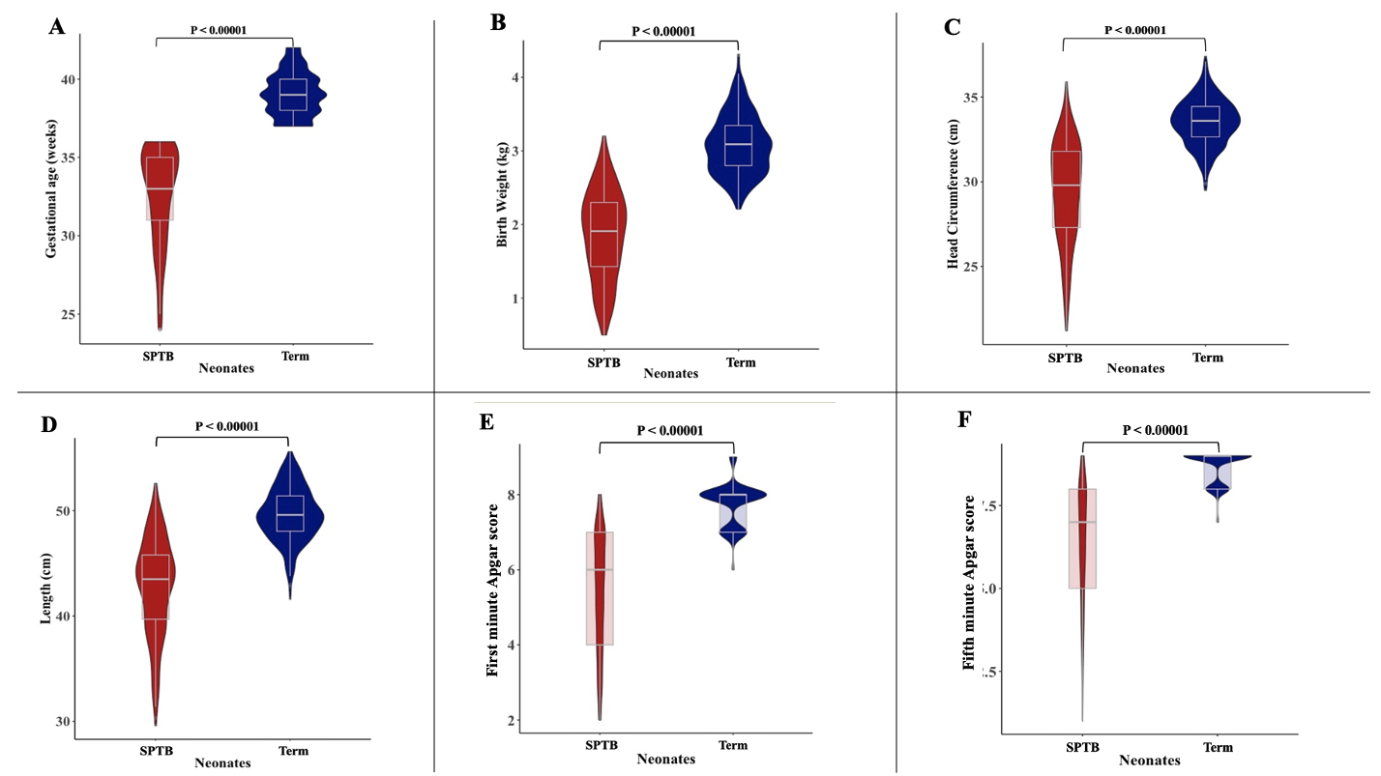
Figure S1: Anthropometrics of SPTB and term neonates. The violin and box plot compares the medians of gestational ages (panel A), birth weight (panel B), head circumference (panel C), length (panel D), first minute Apgar Score (panel E) and fifth minute Apgar Score (panel F) of SPTB and term neonates using the Mann-Whitney U test. The anthropometrics of the term neonates were significantly different from the SPTB neonates in all parameters assessed (p < 0.00001).

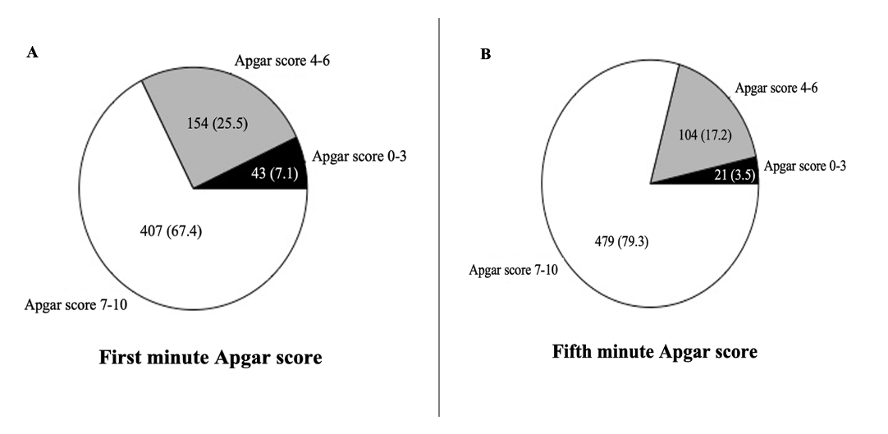
Figure S2: Distribution of the neonates’ first- and fifth-minute Apgar scores. Panels A and B illustrate the proportions of neonates’ first- and fifth-minute Apgar scores, respectively categorised into 7 – 10 (reassuring or good to excellent health), 4 – 6 (fair or moderately abnormal), and 0 – 3 (very low) outcomes.

