Extended Data Table 1: Animals, session types, and odor mixtures for all recording sessions analyzed.
For one rat (ID: TC10), recordings were performed in a block design, with several short-delay sessions conducted consecutively followed by several long-delay sessions. For all other animals, short- and long-delay sessions were alternated across recording days. We excluded sessions without detectable single units from all analyses.
 | n sessions |  | Typical odor set (left odor %; right odor: 100-left odor %)
Animal | Long delay | Short delay | Easy right | Medium right | Difficult right | Difficult left | Medium left | Easy left
TC10 | 5 | 7 | 5 | 42 | 48 | 52 | 58 | 95
TC13 | 6 | 7 | 5 | 44 | 48 | 52 | 56 | 95
TC18 | 2 | 3 | 5 | 42 | 47 | 53 | 58 | 95
TC20 | 23 | 20 | 5 | 44 | 49 | 51 | 56 | 95
TC21 | 10 | 9 | 5 | 44 | 48 | 52 | 56 | 95
TD01 | 12 | 11 | 5 | 42 | 49 | 51 | 58 | 95
TD02 | 9 | 10 | 5 | 44 | 49 | 51 | 56 | 95

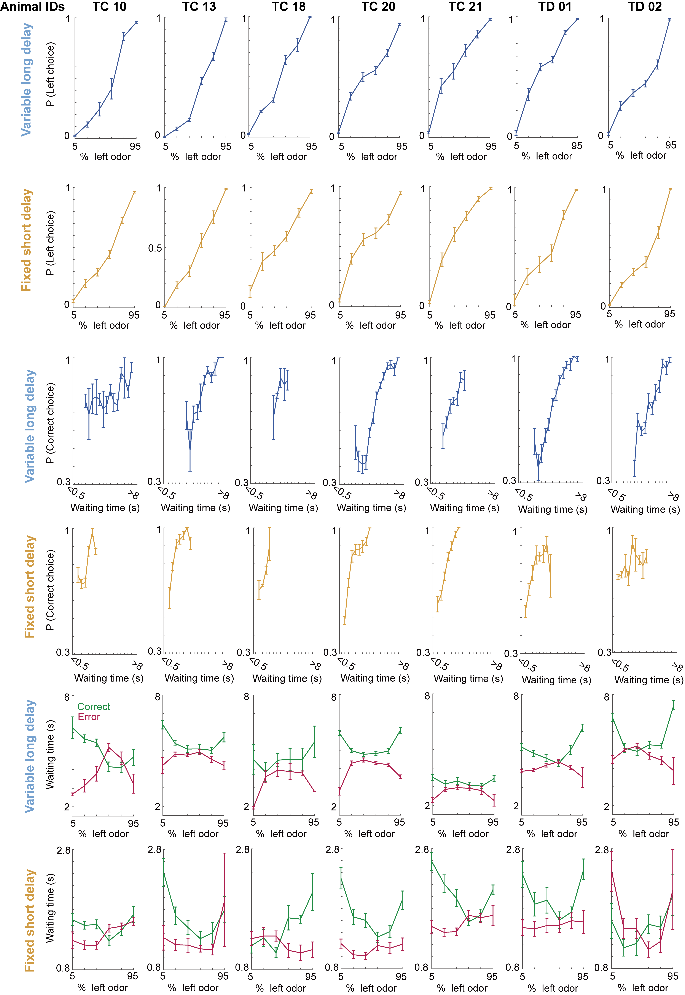
Extended Data Fig. 1: Individual animals show consistent trends across behavioral measurements.
Each column corresponds to an individual animal, showing behavioral measures presented in Fig. 1. The first and second rows show odor discrimination performance in the long- and short-delay conditions, respectively. The third and fourth rows display the correlation between reward waiting time and choice accuracy in the long- and short-delay conditions, respectively. The fifth and sixth rows present reward waiting time in the long- and short-delay conditions, respectively, conditioned on combinations of odor condition and choice outcome.

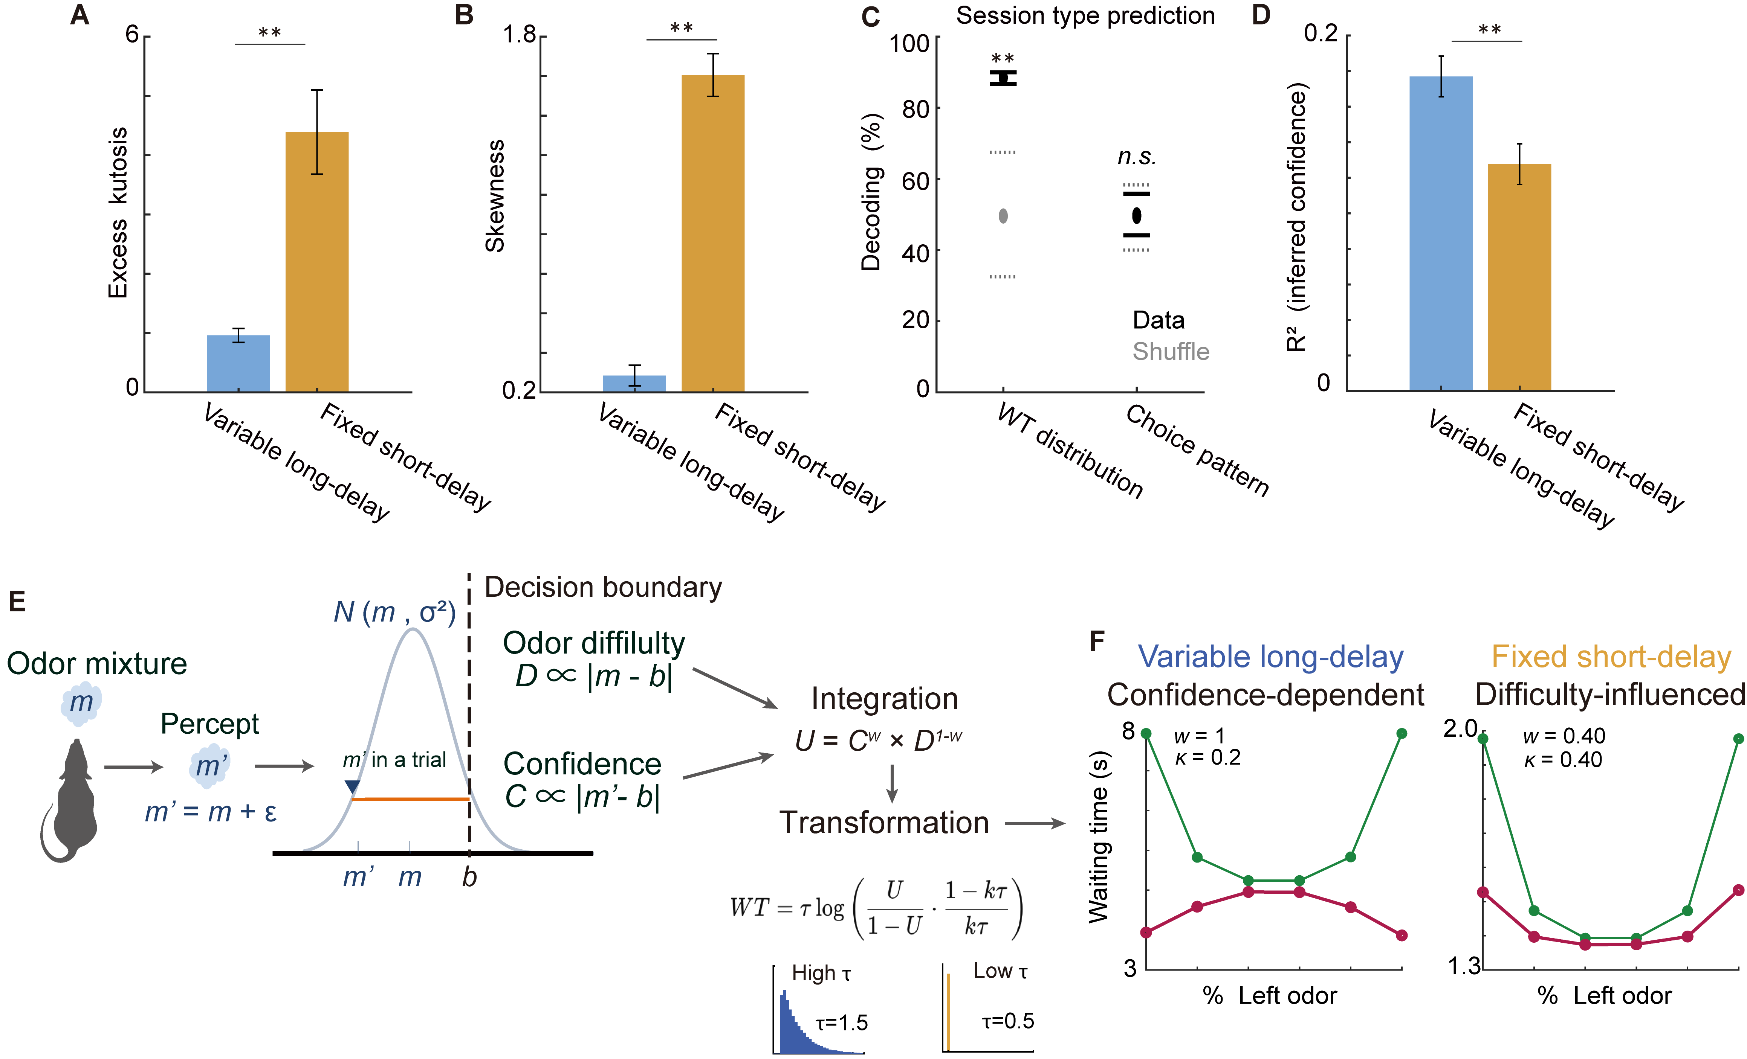Extended Data Fig. 2: Waiting behavior dynamically shifted between the long- and short-delay conditions.
(A) The short-delay condition exhibited significantly higher kurtosis of the waiting-time distribution than the long-delay condition, indicating a more peaked waiting-time distribution (Long: 0.961 ± 0.117; Short: 4.392 ± 0.71; z = −4.33, Mann–Whitney U test, p = 1.49 × 10⁻⁵). (B) The short-delay condition exhibited significantly higher skewness of the waiting-time distribution than the long-delay condition, indicating a more right-skewed waiting-time distribution (Long: 0.085 ± 0.053, Short: 1.606 ± 0.108; t(95.9) = -12.671, Welch’s t-test, p = 3.335 × 10⁻²²). (C) Decoding accuracy of delay conditions based on waiting-time distribution features (kurtosis and skewness) or choice patterns (left-choice probability across odor mixtures). Black circles and lines indicate the mean and 95% range (2.5th–97.5th percentiles) for the real data, compared with models trained on label-shuffled data (gray). (D) The long-delay condition exhibited higher R² when trial-by-trial reward waiting times regressed onto inferred confidence levels (Long: R² = 0.18 ± 0.01, Short: R² = 0.13 ± 0.01; z = 2.999, Mann–Whitney U test, p = 0.003). (E) Computational model for flexible switching between confidence-dependent and difficulty-influenced waiting behavior (Methods). The model builds on a previously described confidence-dependent waiting framework by Lak et al.¹⁶ and computes the utility function (U) by integrating decision confidence (C) with an odor-difficulty term (D). The relative contribution of confidence and odor difficulty is controlled by a weighting parameter (w), whereas an additional parameter (κ) adjusts the overall waiting-time scale. (F) Waiting patterns across odor and outcome conditions produced by the model. With confidence dominating in the long-delay condition and odor difficulty contributing in the short-delay condition, the model reproduces X-shaped and U-shaped waiting patterns resembling animal behavior (Fig. 1F–G). As in the behavioral data, odor conditions are plotted at evenly spaced positions for visualization, although the odor mixture ratio was nonlinearly spaced. (A–D) Asterisks indicate statistical significance (p < 0.05; see Methods). n.s. indicates non-significance.

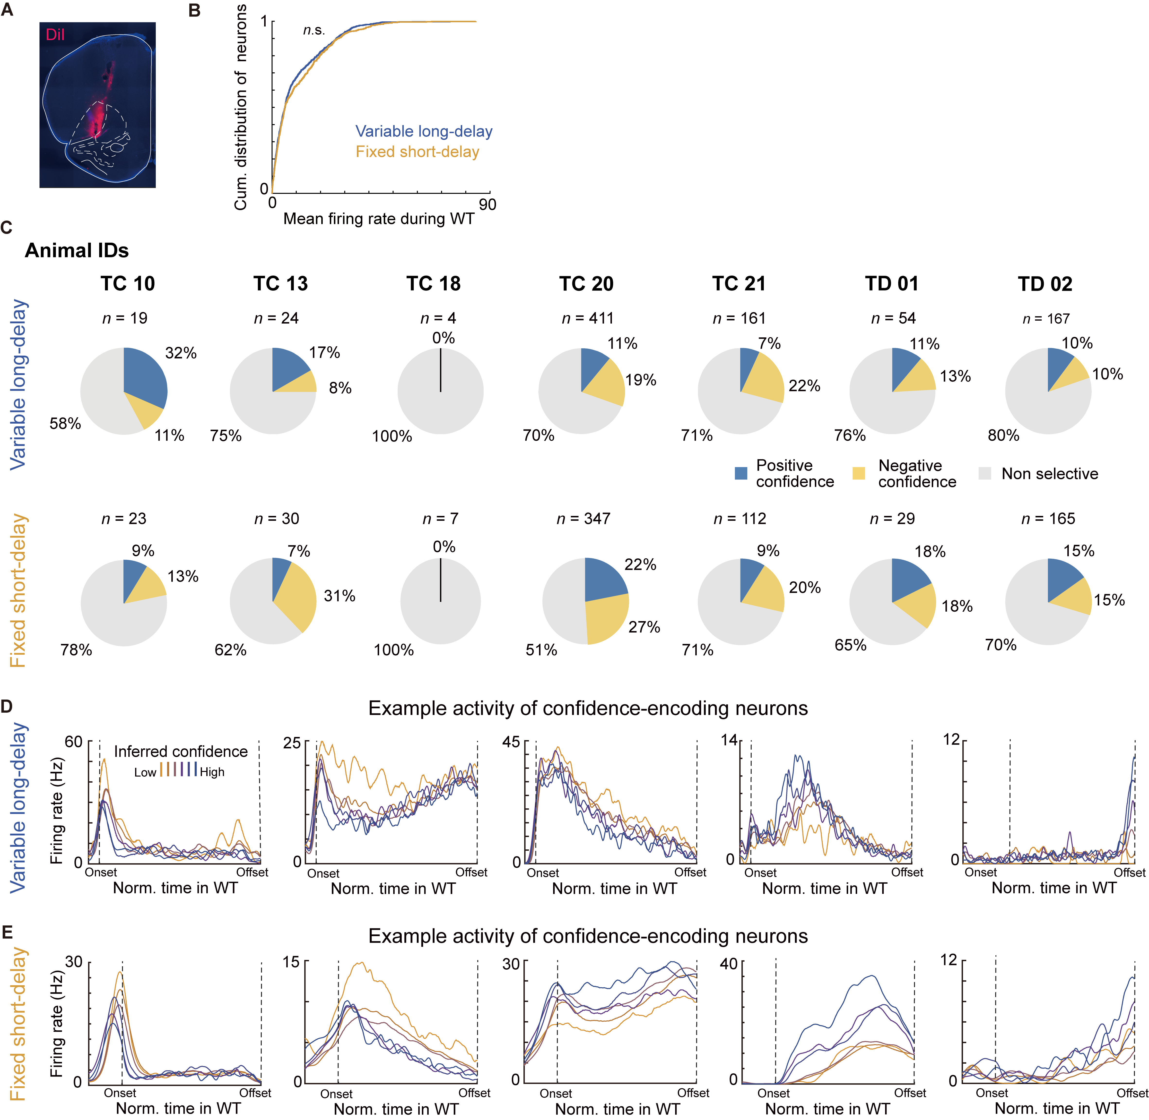
Extended Data Fig. 3: Identification of confidence-encoding neurons in the OFC.
(A) Example of electrode placement in the ventrolateral OFC. (B) Comparison of time-averaged firing rates of all neurons during the reward waiting period between reward-delay conditions (Kolmogorov–Smirnov test, p = 0.115). (C) Proportion of confidence-encoding neurons determined by the statistical significance of the regression coefficient for inferred confidence (t-test, p < 0.05). Each column represents an individual animal, and each row corresponds to a reward-delay condition. (D) Activity of example confidence-encoding neurons in the long-delay condition. Individual neurons showed graded firing rates across inferred confidence levels at different time points during the reward waiting period. (E) The same as D but for the short-delay condition.

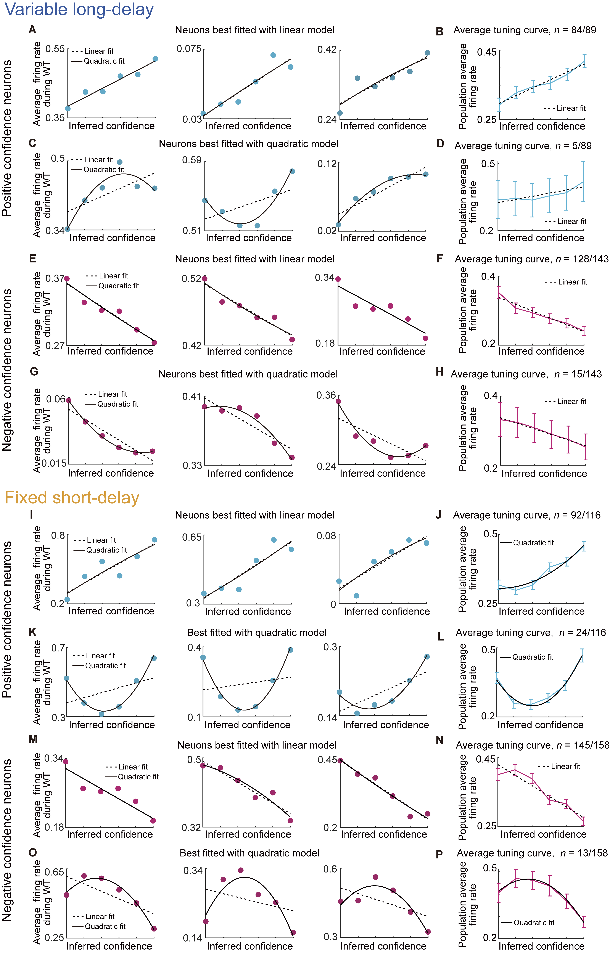 Extended Data Fig. 4: Tuning profiles of confidence-encoding neurons.
(A) Three example neurons showing positive confidence-encoding during the reward waiting period in the long-delay condition whose tuning was sufficiently explained by a linear model (Mandel’s test, p ≥ 0.05). (B) Average tuning curve of positively confidence-encoding neurons best fit by a linear model. (C) Three example neurons showing positive confidence-encoding whose tuning was better explained by a quadratic model (Mandel’s test, p < 0.05). (D) Average tuning curve of positively confidence-encoding neurons best fit by a quadratic model. Despite nonlinear tuning in individual neurons, the population-average activity increased monotonically across inferred confidence levels and was better explained by a linear model (Mandel’s test, p ≥ 0.05). (E) Three example neurons showing negative confidence-encoding during the reward waiting period in the long-delay condition whose tuning was sufficiently explained by a linear model (Mandel’s test, p ≥ 0.05). (F) Average tuning curve of negatively confidence-encoding neurons best fit by a linear model. (G) Three example neurons showing negative confidence-encoding whose tuning was better explained by a quadratic model (Mandel’s test, p < 0.05). (H) Average tuning curve of negative confidence-encoding neurons best fit by a quadratic model. As in D, population-average activity showed a monotonic dependence on inferred confidence and was better explained by a linear model (Mandel’s test, p ≥ 0.05). (I–P) Same as (A–H), but for neuronal activity in the short-delay condition. In J, although individual neurons were classified as linearly tuned, the population-averaged activity exhibited a statistically significant curvature, reflecting weak but systematic nonlinearities shared across neurons in this condition. (A–P) For population average tuning curves, only predictions from the better-fitting model are shown.

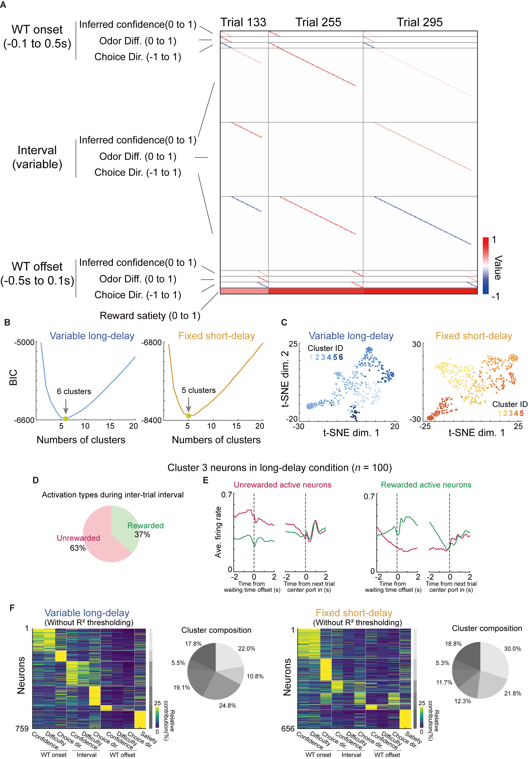 Extended Data Fig. 5: GLM analysis and GMM clustering.
(A) Design matrix for the kernel-based GLM used to fit instantaneous firing rates of individual neurons using task variables and events. For illustration, three randomly sampled trials from a session are concatenated across columns. Each row represents a distinct kernel capturing either time-dependent or time-independent effects of task variables. (B) Bayesian information criterion (BIC) values used for GMM clustering in Fig. 2. Arrows indicate the cluster numbers that minimized the BIC. (C) Visualization of functional neuronal clusters identified by GMM-based clustering. The same clusters are shown in Fig. 2. t-SNE was used solely for two-dimensional visualization of high-dimensional population data. (D) Analysis of inter-trial interval activity of cluster 3 neurons, which were enriched in the long-delay condition (Fig. 2H). To facilitate qualitative comparison with activity patterns of OFC– Str projection neurons reported previously by Hirokawa et al.³, cluster 3 neurons were classified based on their mean firing rates following rewarded or non-rewarded trials. The majority of cluster 3 neurons showed increased firing rates after unrewarded trials, resembling the activity pattern of OFC–Str neurons reported by Hirokawa et al.³ (E) Average peri-event time histograms (PETHs) of neurons preferentially activated following non-rewarded trials (left) or rewarded trials (right). (F) Results of GMM clustering performed without applying the fit-quality threshold, yielding cluster structures qualitatively similar to those shown in Fig. 2.
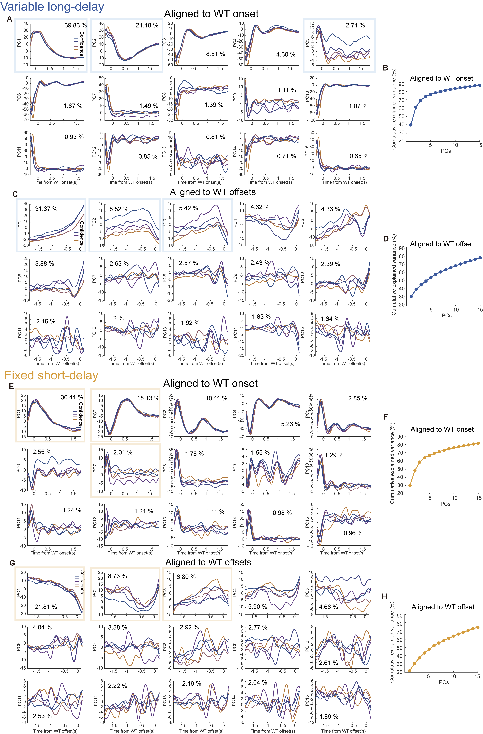 Extended Data Fig. 6: Principal components (PCs) capturing OFC cluster dynamics. (A) Temporal profiles of the top 15 PCs derived from OFC cluster activity (n = 353 neurons) after waiting-time onset in the long-delay condition. Line colors indicate population activity across inferred confidence levels. Pale blue rectangles highlight PCs shown in Fig. 2M. (B) Explained variance of the 15 PCs shown in A. (C–D) Same as A–B but for OFC cluster activity aligned to waiting-time offset. Pale blue rectangles highlight PCs shown in Fig. 2N. (E–F) Same as A–B but for OFC cluster activity (n = 253 neurons) after waiting-time onset in the short-delay condition. Pale orange rectangles highlight PCs shown in Fig. 2S. (G–H) Same as E–F but for OFC cluster activity aligned to waiting-time offset. Pale orange rectangles highlight PCs shown in Fig. 2T.
Extended Data Fig. 7: PCs capturing representational geometry of OFC population.
(A) Unsupervised dimensionality reduction testing whether OFC population activity follows a linear representational structure with respect to decision confidence. Time- and trial-averaged firing rates during the reward waiting period across task conditions were used for PCA. Because combinations of odor condition and choice outcome define different levels of inferred confidence, conditions are expected to align along a linear population axis if OFC activity linearly covaries with confidence, producing the canonical X-shaped geometry predicted by the SDT framework (top row). In contrast, a linear axis is not expected if population activity does not covary monotonically with inferred confidence level (bottom row). (B) Principal components (PCs) and their explained variance (EV) derived from time-averaged OFC population firing rates (n = 840 neurons) during the reward waiting period in the long-delay condition. Colored circles indicate odor conditions and colored lines indicate trial outcome. Pale blue rectangles highlight PCs shown in Fig. 4B. (C) Explained variance of PCs in the long-delay condition. (D) Same as B but for PCs obtained from OFC population firing rates in the short-delay condition (n = 713 neurons). Pale orange rectangles highlight PCs shown in Fig. 4D. Lower-ranked PCs also did not exhibit explicit representations of task variables. (E) Explained variance of PCs in the short-delay condition.

