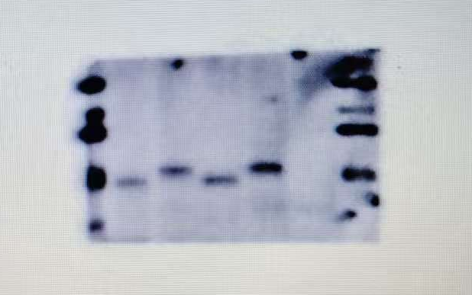 FOXL2
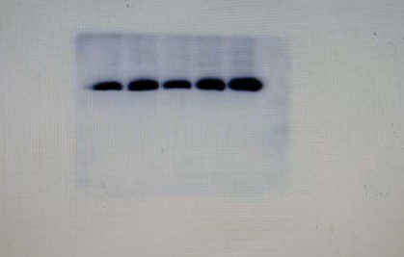GAPDH
Mut1 Wt1 Mut2 Wt2 EV
1 and 2 are two repeated experiments

