Supplementary Figure S1A: Overlap of key dysregulated genes between public datasets and in vitrovalidation

Supplementary Figure S1B: Differentially expressed genes (DEGs) in Foxl2knockdown vs. control murine granulosa cells GO Enrichment Bar Chart.

Supplementary Figure S1C: Gene Ontology (GO) enrichment analysis of DEGs.

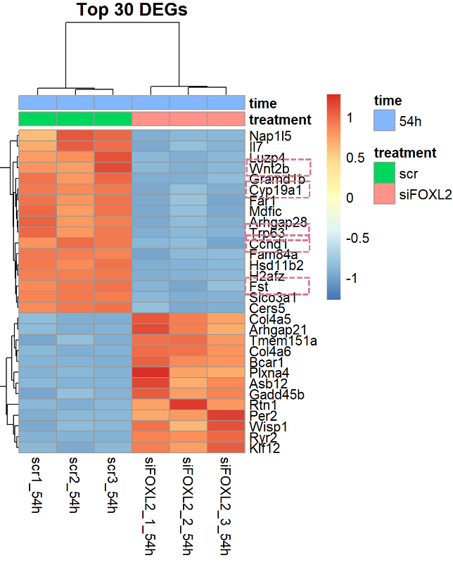
A
Heatmap

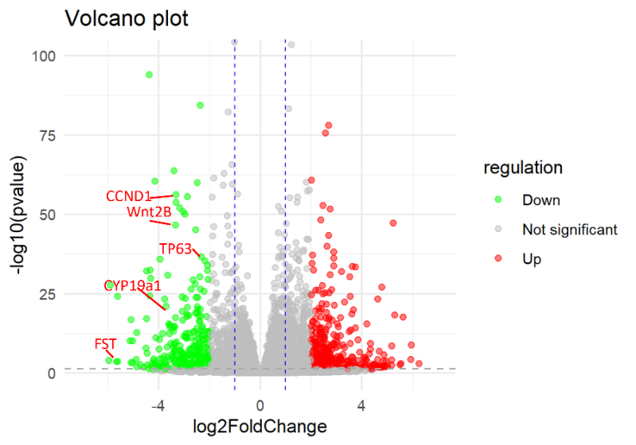 | 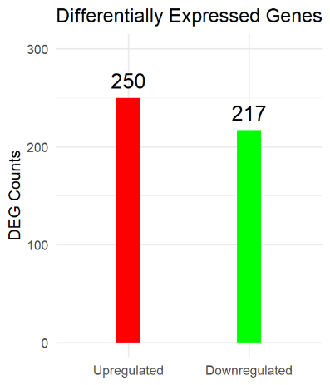

B
Volcano Plot​ of DEGs from GSE154185.

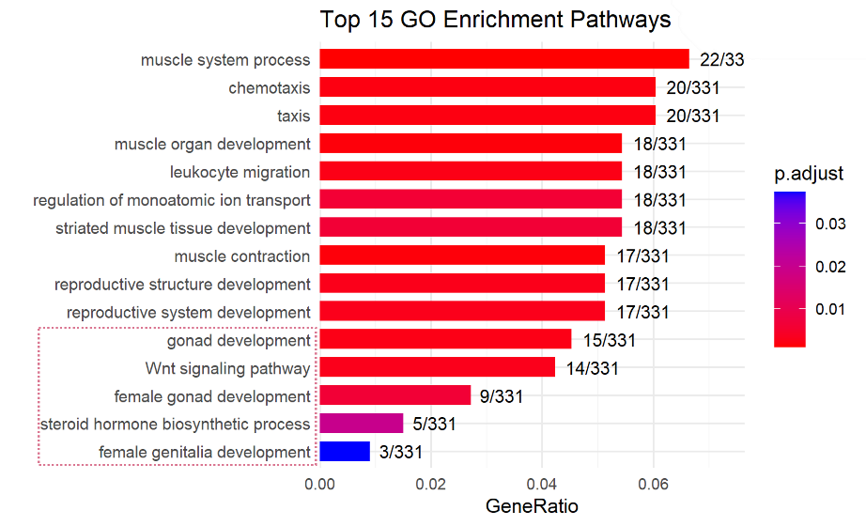
C
GO Enrichment Bar Chart

Supplementary Figure S1. Bioinformatic analysis of public transcriptomic data validates the pathogenicity of the FOXL2 variant.
(A) Heatmap showing the expression levels of key FOXL2 target genes in the GSE154185 dataset. The downregulation of these genes in the knockout model parallels the downregulation observed in our in vitrotransfection assays (Figure 2D), confirming the functional impact of the p.Gln321Profs*34 variant on ovarian signaling pathways. (B) Volcano plot depicting differentially expressed genes (DEGs) in murine granulosa cells after Foxl2 knockdown (GSE154185). Red dots represent significantly upregulated genes, green dots represent significantly downregulated genes (adj. P< 0.05, |log2FC| > 1). Key ovarian marker genes are labeled. (C) Gene Ontology (GO) enrichment analysis of the top 15 biological processes associated with the DEGs. Bars represent the Gene Ratio (number of DEGs in term / total number of DEGs).

