Supporting Information
Flexible FeCo@(SiO₂/C) hybrid nanofibers with hierarchical interfaces for microwave absorption and ablation-resistant property
Bo Xiong^{a,b}, Qihui Sun^{a,b}, Tao Zeng^{b,c}, Chuankai Yang^{b}, Xiong He^{d}, Jingsong Zhang ^{e}, Yang Guo ^{f, ∗}, Shengzhe Zhao^{b}, Suyun Tian^{b}, Junwei Wang^{b}, Xian Jian^{a, ∗}
ª School of Materials and Energy, University of Electronic Science and Technology of China, Chengdu 611731, China.
^{b} Yangtze Delta Region Institute (Huzhou), University of Electronic Science and Technology of China, Huzhou 313001, China.
^{c} School of Materials Science and Engineering, University of Science and Technology Beijing, Beijing 100083, China.
^{d} Sichuan Hanglong Aviation Industry Co., Ltd. Chengdu 610100, China.
^{e} Baowu Carbon Technology Co., Ltd. 201900，shanghai，China.
^{f} School of Electrical and Information Engineering, Panzhihua University, Panzhihua 617000, China.

Equations:
$$\begin{aligned}\text{ɑ=(}\frac{\sqrt{\text{2}}\text{πf}}{\text{c}}\text{)×}\sqrt{\left(\text{μ}\text{׳׳}\text{ε}\text{״}\text{-μ}\text{׳}\text{ε}\text{׳}\right)\text{+}\sqrt{{\text{(μ}\text{״}\text{ε}\text{״}\text{-μ}\text{׳}\text{ε}\text{׳}\text{)}}^{\text{2}}\text{+}{\text{(μ}\text{״}\text{ε}\text{״}\text{+μ}\text{׳}\text{ε}\text{׳}\text{)}}^{\text{2}}}}\#S\left(1\right)\end{aligned}$$
$$\begin{aligned}{\left(ε׳-\frac{ε_{s}+ε_{∞}}{2}\right)}^{2}+{\left(ε״\right)}^{2}={\left(\frac{ε_{s}-ε_{∞}}{2}\right)}^{2}\#S\left(2\right)\end{aligned}$$
Where ε_{s} represents the static dielectric constant, and ε∞ represents the relative dielectric constant. Each semicircle on the plot of ε′-ε″ is referred to as a Cole-Cole semicircle.
$$\begin{aligned}\left|∆\right|=\left|\sin{h^{2}}\left(Kfd\right)-M\right|\#S(3)\end{aligned}$$

$$\begin{aligned}\text{K=}\frac{\text{4π}\sqrt{{\text{μ}}^{\text{'}}{\text{ε}}^{\text{'}}}\text{sin}{\frac{{\text{δ}}_{\text{e}}\text{+}{\text{δ}}_{\text{m}}}{\text{2}}} }{\text{c}\text{cos}{{\text{δ}}_{\text{e}}}\text{cos}{{\text{δ}}_{\text{m}}}}\#S(4)\end{aligned}$$

$$M=\frac{4μ^{'}cos{ δ}_{e}{ ε}^{'}cos δ_{m}}{{\left(μ^{'}cos δ_{e}-ε^{'}cos δ_{m}\right)}^{2}+{\left[\tan\left(\frac{δ_{m}}{2}-\frac{δ_{e}}{2}\right)\right]}^{2}{\left(μ^{'}cos δ_{e}+ε^{'}cos{ δ}_{m}\right)}^{2}} S(5)$$
Where d represents the thickness of the materials, while |Δ| represents the impedance matching of the materials. The larger range of |Δ| less than 0.4 indicates the better impedance matching characteristics. The ɑ value indicates the ability of materials to attenuate electromagnetic waves.
$$\begin{aligned}t_{m}=\frac{λ}{4}=\frac{1}{4f_{m}\sqrt{ε_{r}μ_{r}}}\#S\left(6\right)\end{aligned}$$

Figures:
Fig. S1 The optical images of (a) SiO₂, (b) FeCo@ (SiO₂/PVA)-5%, (c) FeCo@ (SiO₂/PVA)-10%, (d) FeCo@ (SiO₂/PVA)-15%.

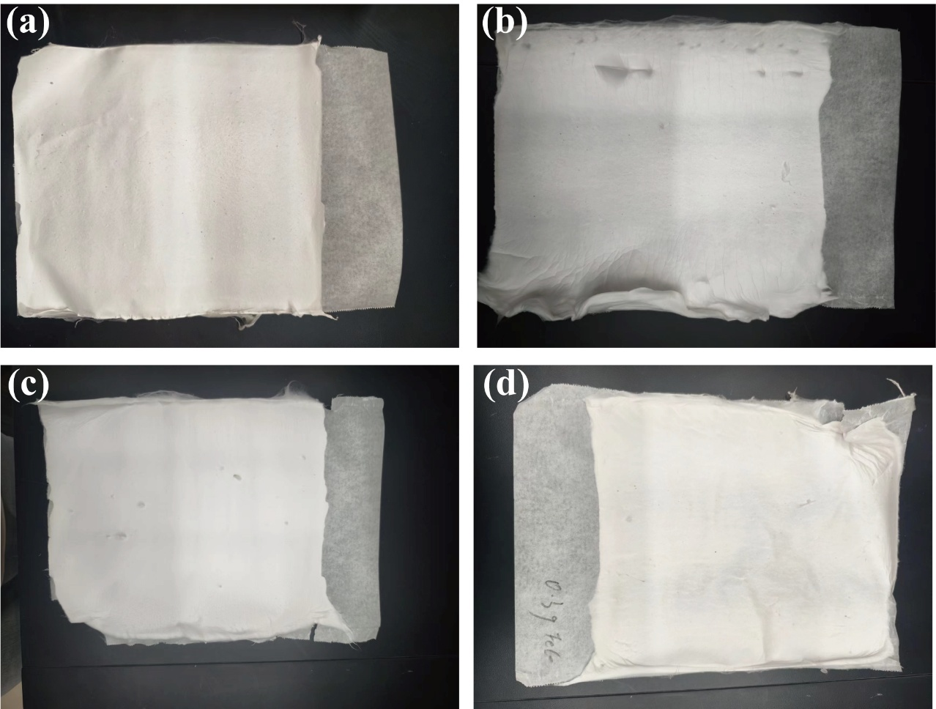

Fig. S2 SEM image and (insert) fiber size distribution of SiO₂/C.

Fig. S3 (a) 3D RL plots of SiO₂/C. (b) The 2D RL curves with discrepant colors of SiO₂/C; FeCo@ (SiO₂/C)-5%; FeCo@ (SiO₂/C)-10%; d FeCo@ (SiO₂/C)-15%.
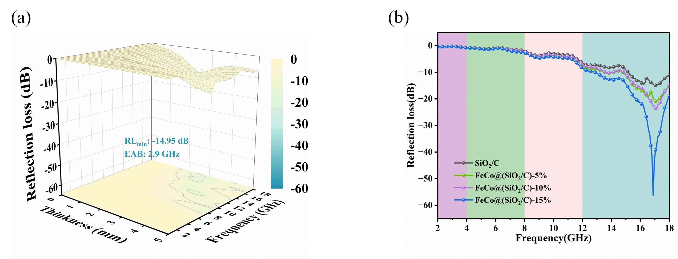
Fig. S4 The C₀ values of SiO₂/C, FeCo@(SiO₂/C)-5%, FeCo@(SiO₂/C)-10%, and FeCo@(SiO₂/C)-15%.

Fig. S5 Cole–Cole plots of SiO₂/C, FeCo@(SiO₂/C)-5%, FeCo@(SiO₂/C)-10%, and FeCo@(SiO₂/C)-15%.

Fig. S6 Impedance matching of SiO₂/C (a), FeCo@(SiO₂/C)- 5% (b), FeCo@(SiO₂/C)-10% (c), FeCo@(SiO₂/C)-15% (d), and rGNC-8 (e).
Fig. S7 Open-circuit voltages of FeCo and FeCo@(SiO₂/C)-15%.

Table S1 The comparison of FeCo-based composite absorber performance involves RL and EAB values.
Materials | Minimum RL (dB) | EAB (GHz) | Frequency (GHz) | Thickness (mm) | Range | Refs
FeCo nanocapsules | -29.00 | 4.00 | / | 5.00 | 2-18 | [1]
(FeCo/PVP)@GO | -40.94 | 4.90 | 14.25 | 2.00 | 2-18 | [2]
FeCo/graphene hybrids | 40.20 | 5.90 | 8.90 | 2.50 | 0.1-18 | [3]
FeCo/PPy | -52.30 | 5.06 | 13.40 | 2.15 | 1-18 | [4]
FeCo/CNF | -24.05 | 2.87 | 14.88 | 4.00 | 2-18 | [5]
FeCo@SnO₂@graphene@PANI | -39.80 | 3.10 | 6.40 | 3.00 | 2-18 | [6]
FeCo@porous carbon | -54.70 | 5.48 | / | 1.90 | 2-18 | [7]
FeCo/CNTs | -46.50 | 3.92 | 12.56 | 1.70 | 2-18 | [8]
FeCo-BN | -46.40 | 5.04 | 11.30 | 1.50 | 0.5-18 | [9]
Fe0.9Co0.1 nano-alloys | -48.70 | 4.20 | 4.20 | 3.20 | 2-18 | [10]
This work | -56.25 | 5.3 | 12.23 | 2.50 | 2-18 | #

References:
[1] Han Z, Li D, Wang H, Liu XG, Li J, Geng DY and Zhang ZD, Broadband electromagnetic-wave absorption by FeCo/C nanocapsules, Applied Physics Letters, 2009, 95(2):023114. https://doi.org/10.1063/1.3177067.
[2] Cui E, Pan F, Xiang Z, Liu Z, Yu L, Xiong J, Li X and Lu W, Engineering Dielectric Loss of FeCo/Polyvinylpyrrolidone Core‐Shell Nanochains@Graphene Oxide Composites with Excellent Microwave Absorbing Properties, Advanced Engineering Materials, 2020, 23(1): 2000827. https://doi.org/10.1002/adem.202000827.
[3] Li X, Feng J, Du Y, Bai J, Fan H, Zhang H, Peng Y and Li F, One-pot synthesis of CoFe₂O₄/graphene oxide hybrids and their conversion into FeCo/graphene hybrids for lightweight and highly efficient microwave absorber, Journal of Materials Chemistry A, 2015, 3(10): 5535. https://doi.org/10.1039/c4ta05718j.
[4] Wang H, Yan Z, An J, He J, Hou Y, Yu H, Ma N, Yu G and Sun D, Iron cobalt/polypyrrole nanoplates with tunable broadband electromagnetic wave absorption, RSC Advances, 2016, 6(95): 92152. https://doi.org/10.1039/c6ra16003d.
[5] Huang B, Yue J, Wei Y, Huang X, Tang X and Du Z, Enhanced microwave absorption properties of carbon nanofibers functionalized by FeCo coatings, Applied Surface Science, 2019, 483: 98. https://doi.org/10.1016/j.apsusc.2019.03.301.
[6] Wang Y, Zhang W, Luo C, Wu X and Yan G, Superparamagnetic FeCo@SnO₂ nanoparticles on graphene-polyaniline: Synthesis and enhanced electromagnetic wave absorption properties, Ceramics International, 2016, 42(10): 12496. https://doi.org/10.1016/j.ceramint.2016.05.038.
[7] Wu Y, Tan S, Zhang T, Zhou M, Fang G and Ji G, Alkali and ion exchange co-modulation strategies to design magnetic–dielectric synergistic nano-absorbers for tailoring microwave absorption, Nano Research, 2023, 16(7): 8522. https://doi.org/10.1007/s12274-023-5799-3.
[8] Yang B, Wu Y, Li X and Yu R, Surface-oxidized FeCo/carbon nanotubes nanorods for lightweight and efficient microwave absorbers, Materials & Design, 2017, 136: 13. https://doi.org/10.1016/j.matdes.2017.09.055.
[9] Se Chang M, Hwang S-s, Jeong S-J, Won Jeong J, Park B, Yang S, Rae Park C and Kwon Y-T, FeCo-BN magnetic composite membrane prepared via an atomized aerosol process for electromagnetic wave absorption and thermal management, Chemical Engineering Journal, 2023, 475: 146496. https://doi.org/10.1016/j.cej.2023.146496.
[10] Hu R, Li L, Xu X, Pan D, Dong J, Zhen C, Gu MD and Wang H, Dimensional design of Fe0.9Co0.1 nano-alloys with enhanced low-frequency microwave absorption, Chemical Engineering Journal, 2024, 482: 148864. https://doi.org/10.1016/j.cej.2024.148864.

∗ Corresponding authors. E-mail addresses: jianxian@uestc.edu.cn (X. Jian), guoyangchn@126.com (Y. Guo).

