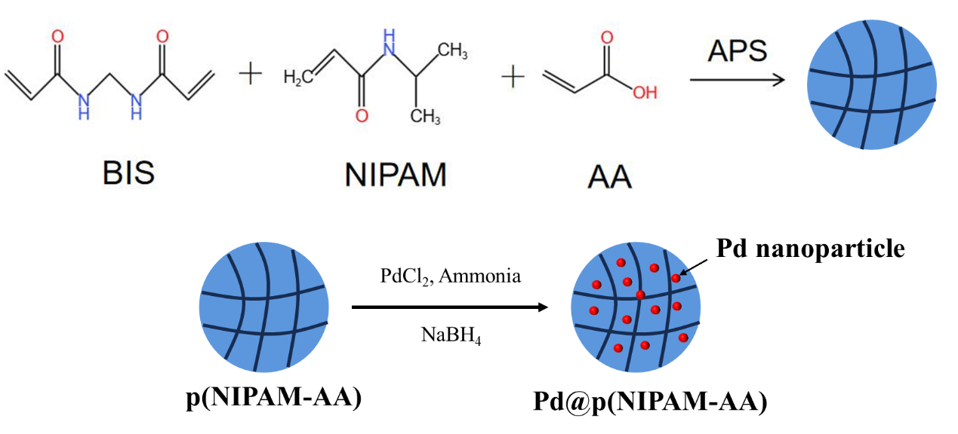
Scheme1. Preparation of p(NIPAM-AA) and Pd@p(NIPAM-AA) microgel

