Supplementary Information for “A single early-life herbivory event increases nodule investment in African savanna woody legumes”

Species | Herbivory Treatment | Plants measured for nodulation (n) | Plants measured for δ¹⁵N
 | 3m | 5 | 3
Senegalia | 4m | 8 | 5
nigrescens | 5m | 12 | 5
 | C | 11 | 3
 | 3m | 3 | 4
Vachellia | 4m | 7 | 4
exuvialis | 5m | 7 | 2
 | C | 7 | 2
 | 3m | 3 | 2
Vachellia | 4m | 10 | 5
sieberiana | 5m | 12 | 2
 | C | 9 | 5

SI Table 1. The number of replicates used in this study to compare the N dynamics of Senegalia nigrescens, Vachellia exuvialis and V. sieberiana exposed to clipping at different ages. Herbivory treatment corresponds to the age when plants were clipped (3 months (3m), 4 months (4m), 5 months (5m), and an unclipped control (C)). The unbalanced sampling size for excavated for nodulation is due to mortality and for δ¹⁵N represents funding constraints.

Species | Herbivory Treatment | Number of plants with  nodules | Number of plants with no nodules | Percentage nodulated
 | 3m | 5 | 3 | 62%
Senegalia | 4m | 8 | 7 | 53%
nigrescens | 5m | 12 | 9 | 57%
 | C | 11 | 3 | 78%
 | 3m | 3 | 2 | 60%
Vachellia | 4m | 7 | 2 | 78%
exuvialis | 5m | 7 | 3 | 70%
 | C | 7 | 4 | 64%
 | 3m | 3 | 0 | 100%
Vachellia | 4m | 10 | 2 | 83%
sieberiana | 5m | 12 | 0 | 100%
 | C | 9 | 2 | 82%

SI Table 2. The proportion (%) of excavated saplings that had nodules on their roots. Herbivory treatment corresponds to the age when plants were clipped (3 months (3m), 4 months (4m), 5 months (5m), and an unclipped control (C)).

Response variable | Candidate model | df | AIC | ΔAIC
Nodule presence | Species | 4 | 122.7 | 0
Nodule presence | Null | 2 | 128.11 | 5.41
Nodule presence | Species + treatment | 7 | 124.47 | 1.76
Nodule presence | Treatment | 5 | 129.38 | 6.68
Nodule presence | Treatment × species | 13 | 129.2 | 6.5
Nodule biomass | Species + treatment | 9 | −13.37 | 0
Nodule biomass | Species | 6 | −12.24 | 1.13
Nodule biomass | Treatment × species | 15 | −5.40 | 7.97
Nodule biomass | Treatment | 7 | 0.8 | 14.17
Nodule biomass | Null | 4 | 1.56 | 14.93
NMF | Species + treatment | 9 | 208.28 | 0
NMF | Treatment | 7 | 210.69 | 2.41
NMF | Treatment × species | 15 | 214.58 | 6.31
NMF | Species | 6 | 215.12 | 6.85
NMF | Null | 4 | 216.56 | 8.28
Leaf δ¹⁵N | Treatment | 5 | 161.47 | 0
Leaf δ¹⁵N | Treatment + species | 7 | 163.55 | 2.08
Leaf δ¹⁵N | Null | 2 | 163.72 | 2.25
Leaf δ¹⁵N | Species | 4 | 165.79 | 4.32
Leaf δ¹⁵N | Treatment × species | 13 | 173.08 | 11.61

SI Table 3. Model selection for the effects of early-life herbivory (stimulated via clipping) and species on nodule presence, nodule biomass, nodule mass fraction and leaf δ¹⁵N.
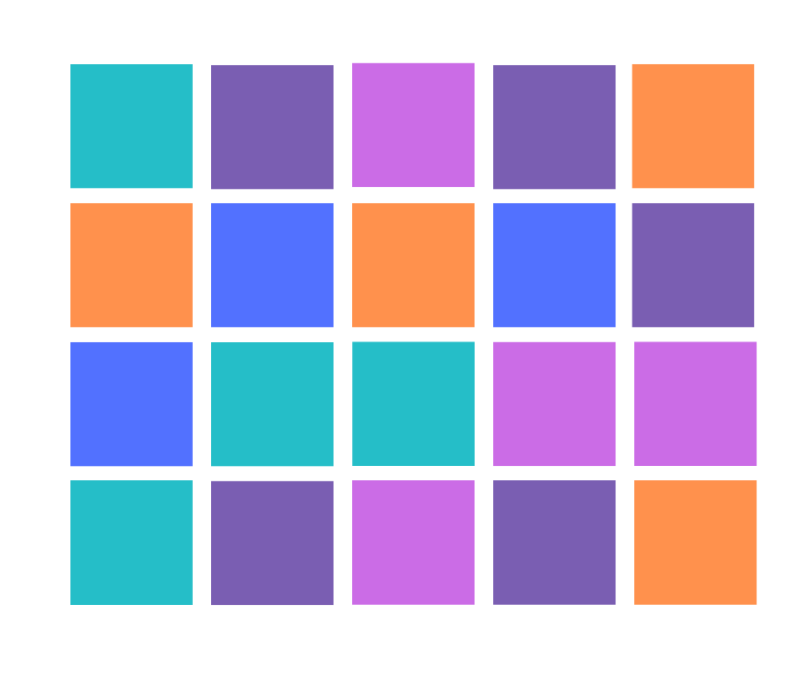
SI Fig. 1. A map of the Wits Rural Facility experimental plot layout. The experiment consisted of five herbivory treatments (clipped at 2 (pink), 3 (blue), 4 (turquoise) and 5 (purple) months and an unclipped control). This experiment was part of a wider study by Archibald et al (2021); this experiment used a subset of treatments and species described in SI Table 1.

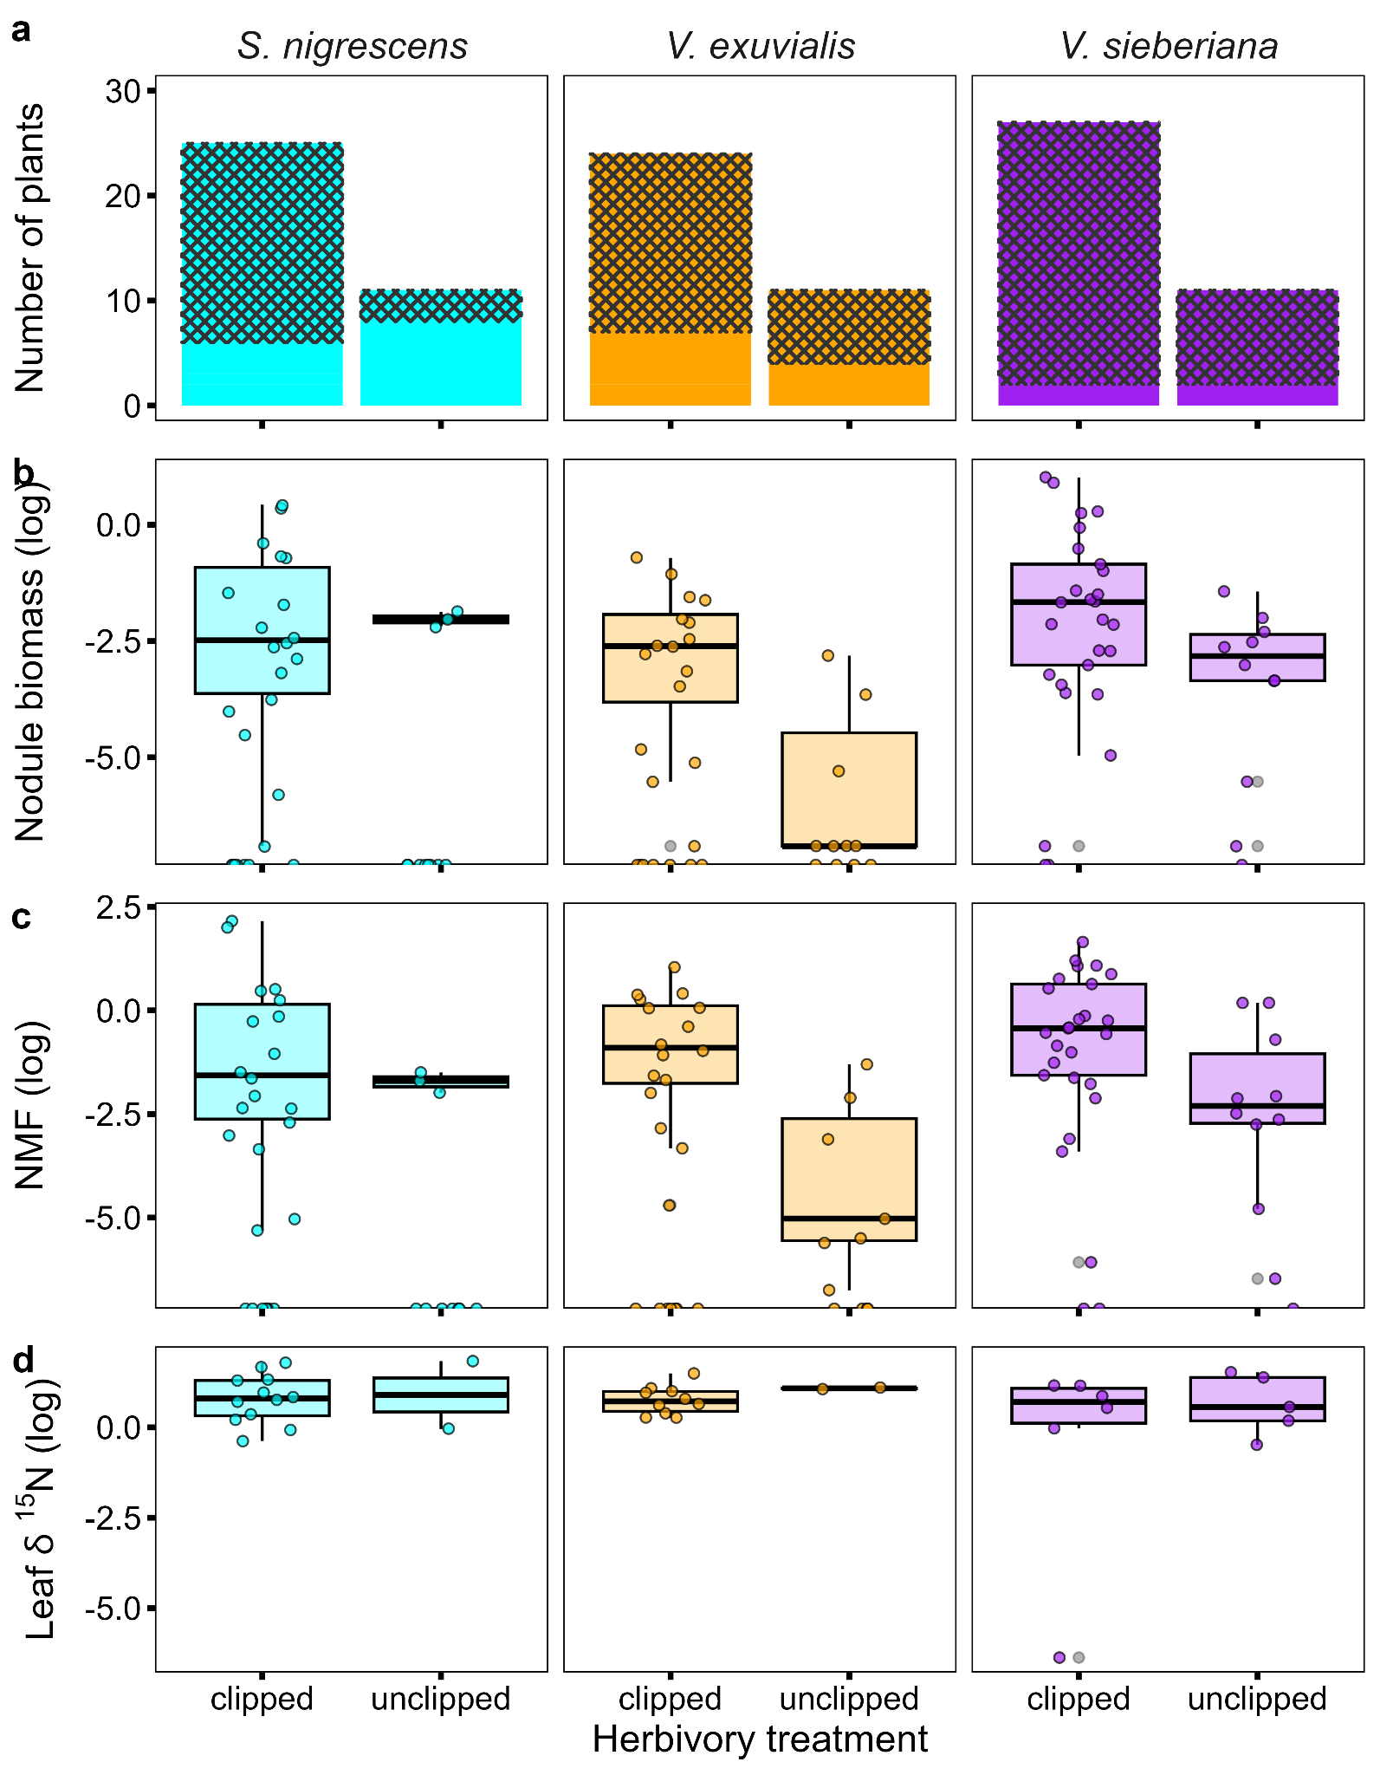
SI Fig. 2. Nodulation and N₂ fixation traits for Senegalia nigrescens, Vachellia exuvialis, and V. sieberiana clipped versus unclipped. (a) a stacked bar chart showing the proportion of saplings developing nodules (crosshatched bars indicate nodules present), boxplots showing (b) nodule biomass (g), (c) nodule mass fraction (%), and (d) leaf δ¹⁵N values. Herbivory treatment corresponds to whether the plants were clipped or unclipped. The Y-axes (b-d) have been log transformed.

