Supplementary Materials for
Modular additive manufacturing of ceramics via solvent assisted interfacial joining
Ji-Chi Zhang, Yun Liu, Yi-Jie Liu, Ming-Yue Fan, Hao-Lei Shi, Li-Ping Ren, Ya-Dong Wu, Yuan Ji*, Guo-Lin Gao*, Zai-Xing Jiang*.
*Corresponding author. Email: jiangzaixing@hit.edu.cn

The PDF file includes:

Materials and Methods
Figs. S1 to S16

Materials and Methods
Materials
Isobornyl acrylate (IBOA) was purchased from Sigma-Aldrich. Spherical alumina powders (D₅₀ = 5 μm and D₅₀ = 500 nm) were purchased from CMP Advanced Materials Co., Ltd. Zirconia powders (D₅₀ = 500 nm) and silicon nitride powders (D₅₀ = 500 nm) were purchased from Sigma-Aldrich. The photoinitiator 2, 4, 6-trimethylbenzoyldiphenylphosphine oxide (TPO) was obtained from Sigma-Aldrich.The dispersant 2310B was purchased from Foshan Qianyou Chemical Co., Ltd (China).
Methods
Photoresin preparation
The photoresin was prepared by first adding 0.05 wt% TPO to IBOA, and then obtaining poly (isobornyl acrylate) (PIBA) via DLP printing. Subsequently, the polymer was added to IBOA at 3 wt%, and the mixture was heated with stirring at 100 °C until complete dissolution.
Ceramic slurry preparation
The alumina ceramic slurry was prepared by mixing spherical alumina powders (85 wt%, obtained by mixing 5 μm and 500 nm powders in a 1:19 ratio), photoresin (about 14 wt%), 2310B (1.5 wt% of the powder), and TPO (0.03 wt% of the photoresin). The zirconia slurry was prepared by mixing the ceramic powders (81 wt%), photoresin (about 18 wt%), 2310B (0.5 wt% of the powder), and TPO (0.05 wt% of the photoresin). The silicon nitride slurry was prepared by mixing the ceramic powders (73 wt%), photoresin (about 26 wt%), 2310B (3 wt% of the powder), and TPO (1 wt% of the photoresin). All the slurries were prepared by stirring in a spherical mixer for 12 hours.
DLP printing of the green bodies
The ceramic green bodies were printed using a commercial DLP 3D printer with a UV wavelength of 405 nm (Nanjing Wiiboox 3D Technology Co., Ltd, W110). PIBA was also printed using this printer.
The joining process of the modules
For in-situ printed rectangular samples, the dimensions of the green body samples were 3.5mm × 2.2mm × 40mm. After sintering, the obtained ceramic samples measured 3 mm × 1.8 mm × 36 mm.
For G-G module joining, the dimensions of the green body module were 3.5mm × 2.2mm × 20mm. The joining process was conducted by first sanding the surface with sandpaper to ensure flatness. The joining surfaces of the two modules were then wetted with butyl acetate and pressed together under a force of approximately 0.1 N for at least 10 seconds. This process was repeated for different wetting times of 15 s, 30 s, 60 s, and 90 s, respectively. The joining samples were dried at 60 ℃ for 12 h to remove the residual solvent.
For G-C module joining, the dimensions of the green body modules were 3.5 mm × 2.2 mm × 20 mm. Ceramic modules with dimensions of 3.5 mm × 2.2 mm × 20 mm were obtained by sintering the green body modules at 1200 ℃ for 1 h after the binder was removed. Before joining, the ceramic modules were immersed in molten paraffin for 1 h at 100 ℃, after cooling, the modules were polished with sandpaper to remove the surface paraffin. The surface of the sanded green body module was wetted with butyl acetate, and then joined to the ceramic module under a pressure of approximately 0.1 N for at least 20 seconds. This process was repeated under different wetting times of 15 s, 30 s, 90 s, and 300a. In control group 1, the ceramic modules were directly sanded without paraffin immersion, followed by joining them to the green body module. Surface wetting times 300 s, 600 s, 900 s, and 1200 s were applied to the green body module, respectively. In control group 2, the ceramic modules were immersed in butyl acetate at least 1 minute until just before joining with the green body. The green body wetting time was 300 s.
The debinding and sintering process
After printing, the ceramic green bodies were washed with water and ethanol to remove the residual slurry. After drying, the green bodies were debinded in a thermal debinding furnace (FMJ-07/12, Hefei Fischero Thermal Equipment Co., Ltd, China) and sintered in a sintering furnace (MF-1700C-II, Anhui BEQ Equipment Technology Co., Ltd, China).
Rheological Characterization
The rheological test was conducted by using a rotational rheometer (HAAKE MARS60). The viscosity tests were measured from 0.01 to 100 1/s at room temperature. Oscillatory sweep tests were performed at strain amplitudes from0.01 % to 100 % at an angular frequency of 10 rad/s. Frequency sweep tests were performed from 100 to 0.1 rad/s at a strain amplitude of 0.1.
Photocuring Characterization
The curing depth test was conducted by depositing a certain amount of slurry on a glass slide, irradiating it from the bottom with UV light of different intensities, washing away the unreacted slurry, and measuring the curing depth with a micrometer. The printing precision test was performed by irradiating the ceramic slurry on the glass slide with a designed pattern, washing away the unreacted slurry, converting to obtain pattern into a two-dimensional image using a microscope, and measuring its size with the ImageJ software.
Thermogravimetric analysis (TGA)
TGA was performed by heating samples to 600 ℃ at a rate of 1, 3, and 5 ℃/min in air (Netzsch TG309).
Three-point bending test
Three‑point bending tests were conducted at room temperature on a universal testing machine (FL6204EX, Fule Test Technology (Shanghai) Co., Ltd) at a bending speed of 0.7 mm/min.
SEM and EDS
SEM and EDS were performed using the same instrument (Gemini SEM 560). The samples were fractured perpendicular to the joining interface to reveal the cross-sectional microstructure.

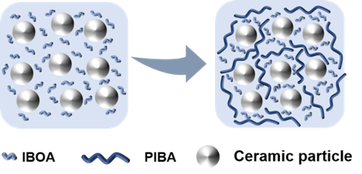
Fig. S1. Schematic illustration of the two types of slurry systems. The dispersed polymer chains in the monomer facilitate the formation of a three-dimensional network within the slurry,

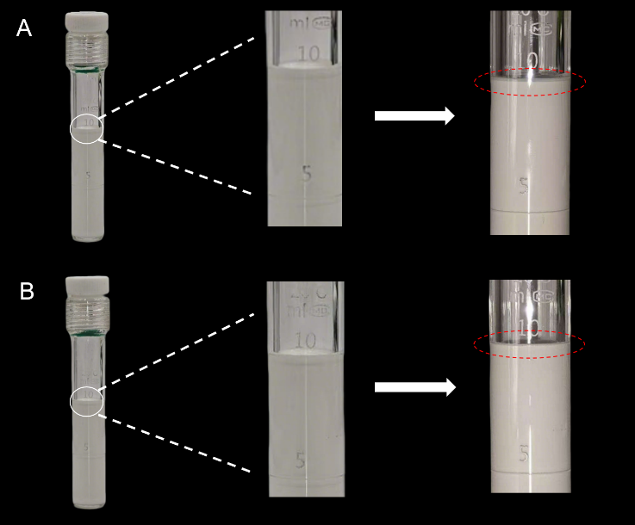
Fig. S2. 72-hour sedimentation test of two types of slurries. (A) Monomer-based slurry with observed upper clear liquid, (B) stable resin‑based slurry with no sedimentation.

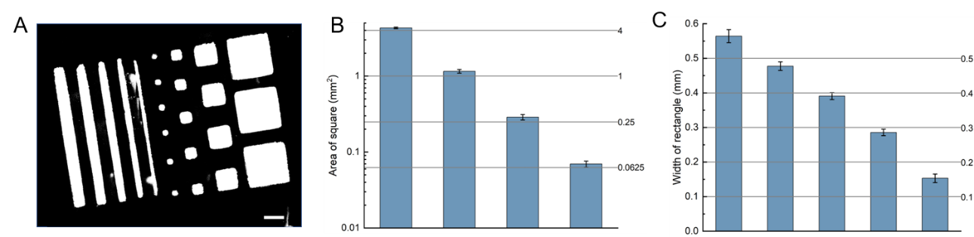
Fig. S3. Determination of the printing accuracy of the alumina ceramic slurry. (A) A photograph obtained through single-layer exposure with an exposure energy of about 92 mJ/cm². (B and C) Determination of the printing accuracy by comparing areas of the printed squares and the widths of the rectangles with the theoretical value. Scale bar in (A): 1 mm.

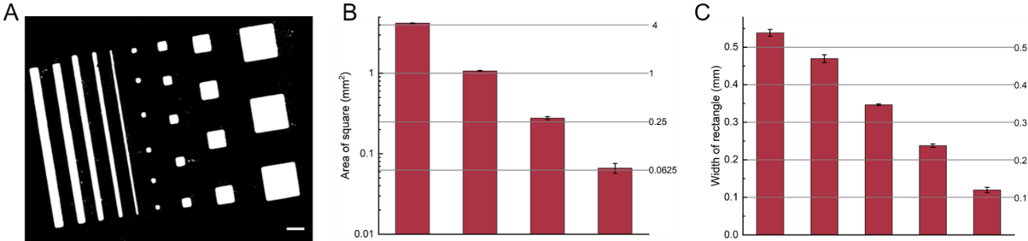
Fig. S4. Determination of the printing accuracy of the zirconia ceramic slurry. (A) A photograph obtained through single-layer exposure with an exposure energy about 154 mJ/cm². (B and C) Determination of the printing accuracy by comparing areas of the printed squares and the widths of the rectangles with the theoretical value. Scale bar in (A): 1 mm.

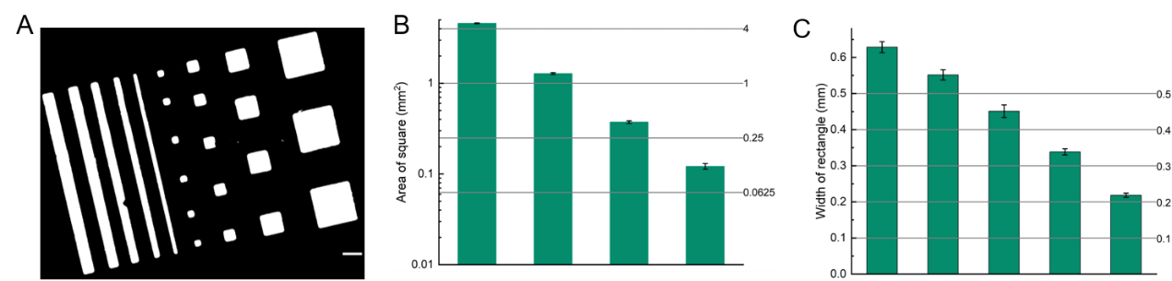
Fig. S5. Determination of the printing accuracy of the silicon nitride ceramic slurry. (A) A photograph obtained through single-layer exposure with an exposure energy about 538 mJ/cm². (B and C) Determination of the printing accuracy by comparing areas of the printed squares and the widths of the rectangles with the theoretical value. Scale bar in (A): 1 mm.

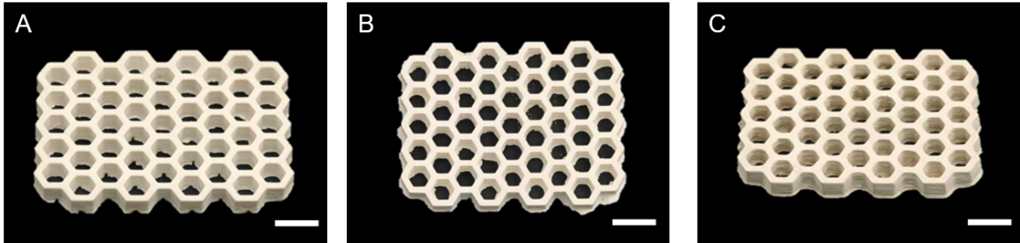
Fig. S6. Printed honeycomb ceramic green bodies fabricated with the three different slurries. (A) the alumina‑based slurry, (B) the zirconia‑based slurry, and (C) the silicon nitride‑based slurry.

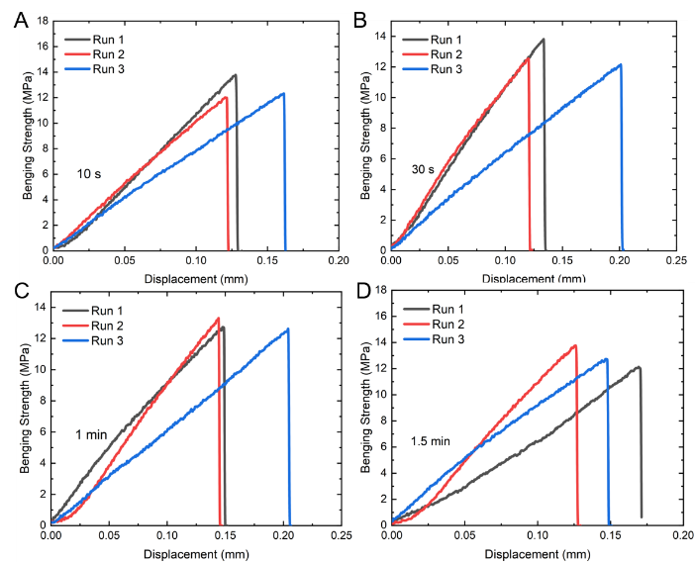
Fig. S7. Three-point bending strength of G-G module joining specimens. Wetting times of the green bodies: 10 s (A), 30 s (B), 1 min (C), 1.5 min (D).

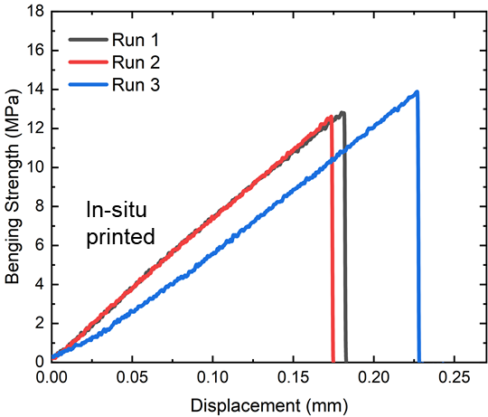
Fig. S8. Three-point bending strength of in-situ printed green body.

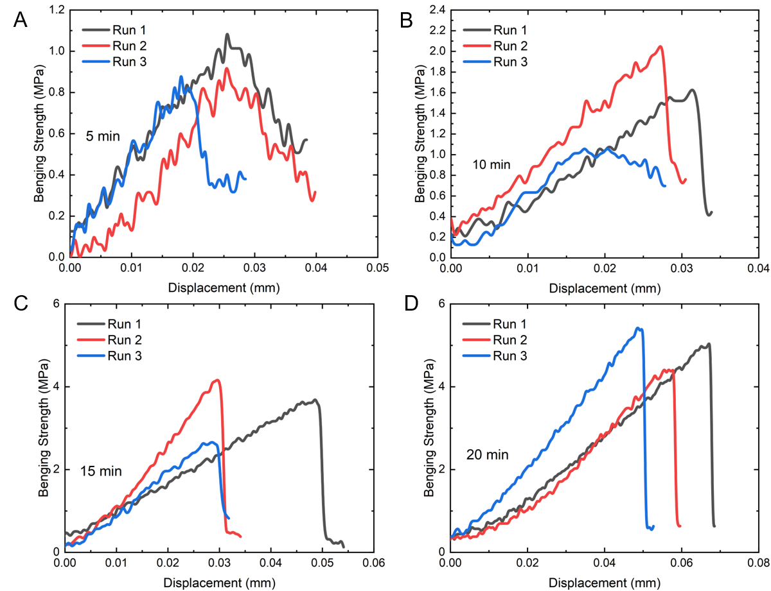
Fig. S9. Three-point bending strength of G-C module joining specimens using ordinary ceramic modules. Wetting times of the green bodies: 5 min (A), 10 min (B), 15 min (C), 20 min (D).

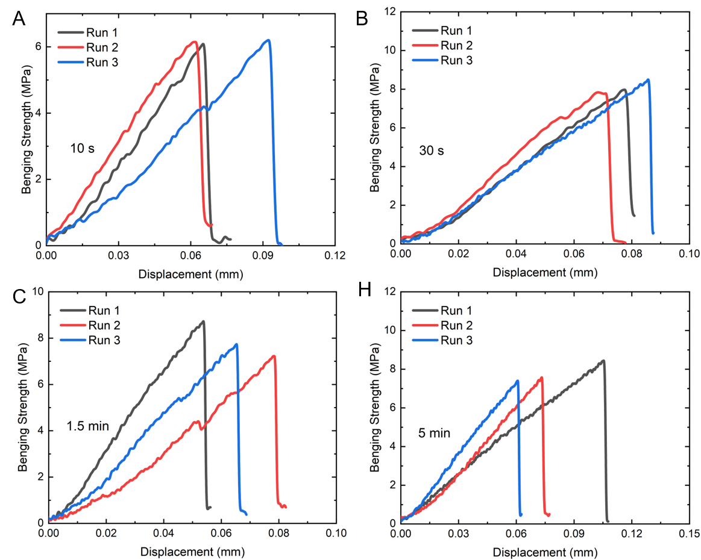
Fig. S10. Three-point bending strength of G-C module joining specimens using wax-immersed ceramic modules. Wetting times of the green bodies: Wetting times of the green bodies: 10 s (A), 30 s (B), 1.5 min (C), 5 min (D).

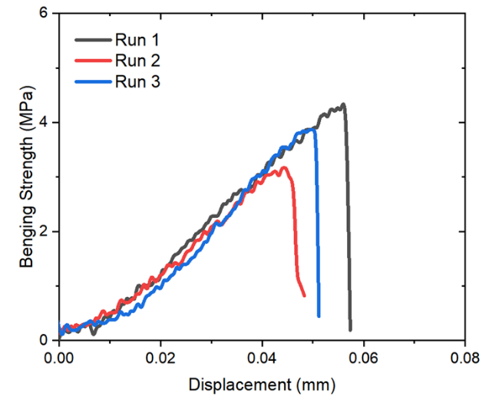
Fig. S11. Three-point bending strength of G-C module joining specimens joined using solvent pre-immersed ceramic module. The ceramic module was immersed in butyl acetate for at least 1 minute until just before joining with the green body, the wetting time of green bodies is 5 min.

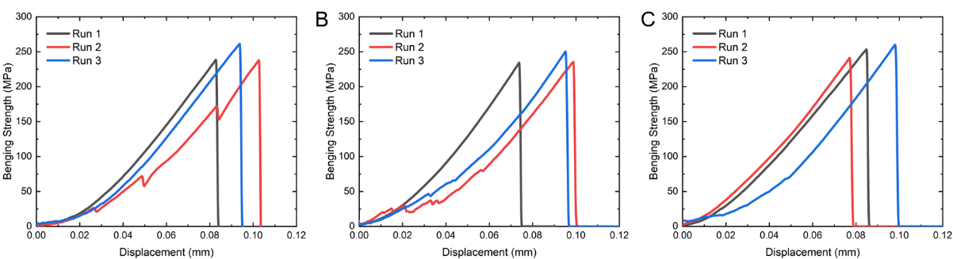
Fig. S12. Three-point bending strength of the sintered ceramics. (A) The in-situ printed, (B) G-G module joining with wetting time of 15 s, (C) G-C module joining with wetting time of 30 s.

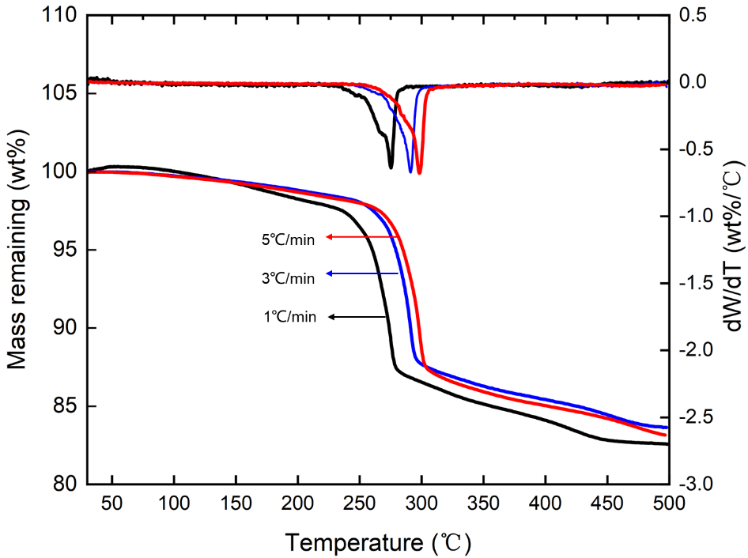
Fig. S13.TGA profiles of the green body. Temperatures from 25°C to 500°C at a ramp rate of 1, 2, and 5 °C/ min.

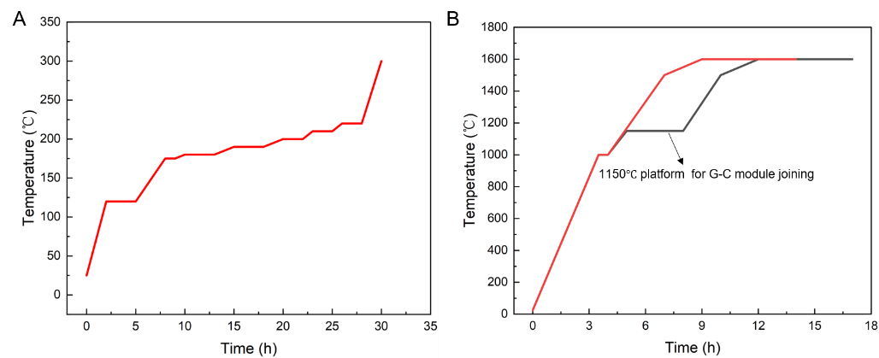
Fig. S14. Debinding and sintering profiles. (A) Debinding profile of green body. (B) Sintering profile of G-G joint and G-C joint (with extra platform in 1150 ℃).

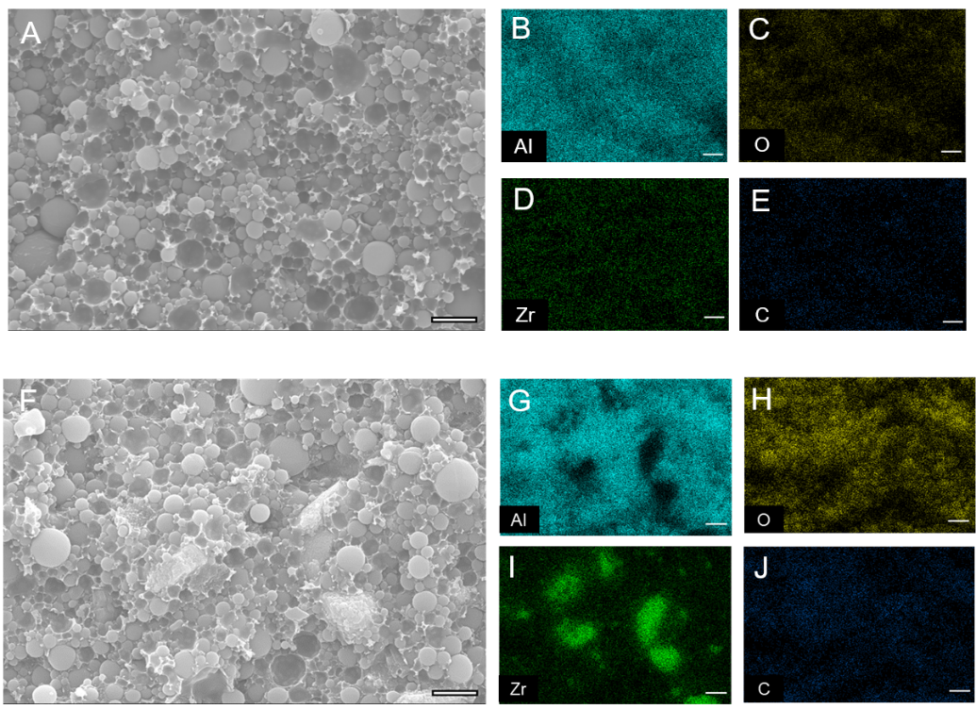
Fig. S15. Cross-section morphology of the two composition green body modules. SEM image of the module consists of pure alumina (A) and the EDS elemental mapping of Al, C, Zr, O (B-E). SEM image of the module consists of 20 wt.% zirconia (F) and the EDS elemental mapping of Al, C, Zr, O (G-J). Scale bars: A-J, 2 µm.

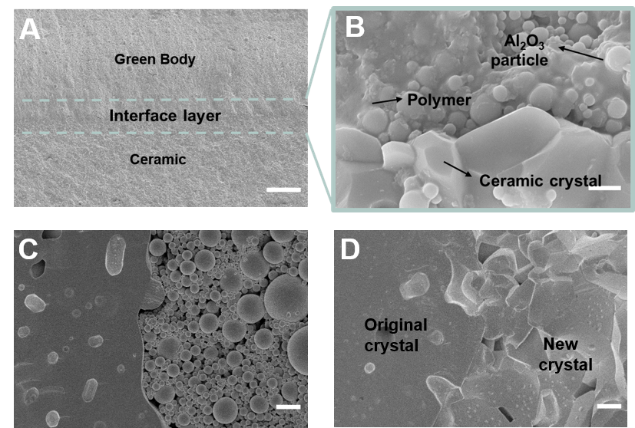
Fig. S16. Cross-section morphology of the G-C joining interface using high‑density ceramic module. (A) The overall joining interface, (B) the interface after debinding, (C) the interface after sintering. Scale bars: A, 100 µm; B, 1 µm; C and D, 2 µm.

