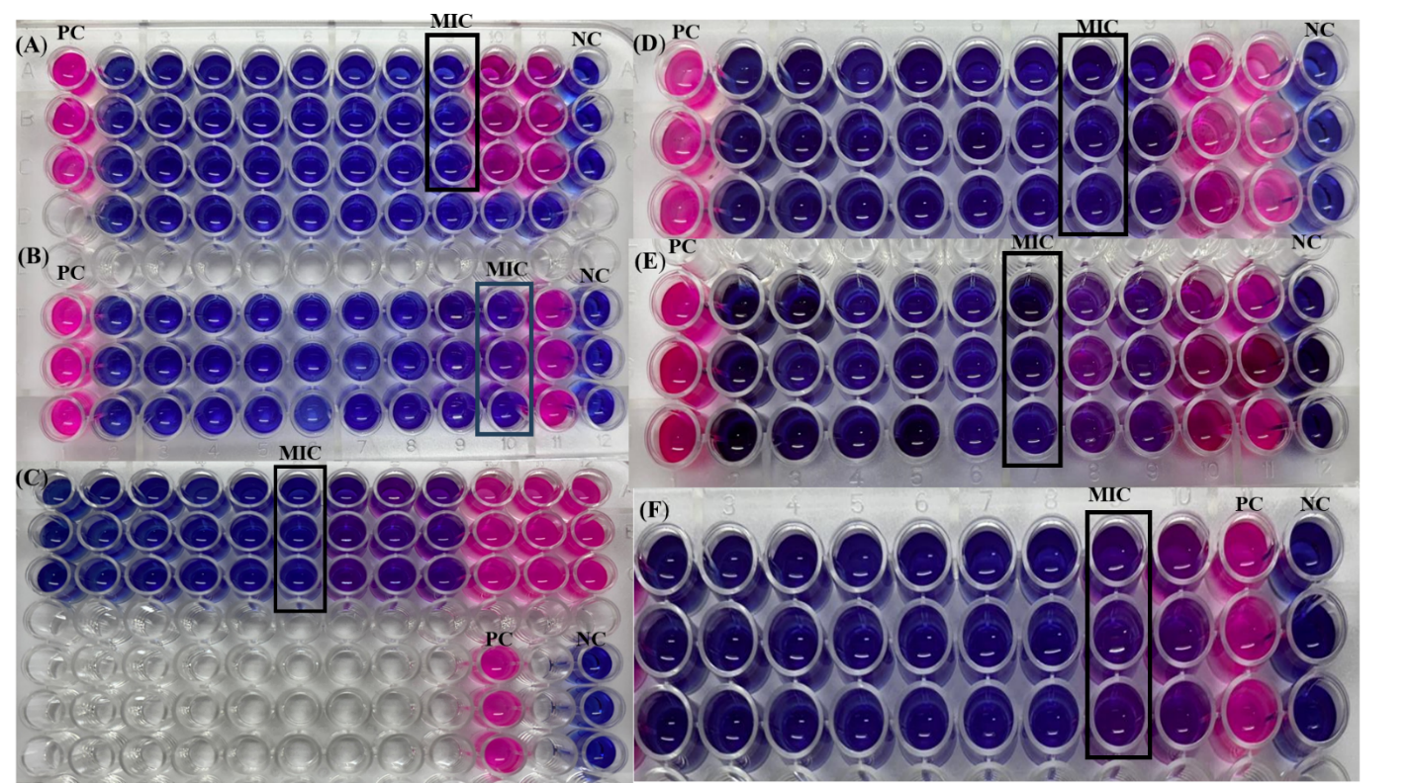

Supplementary fig. 1: Minimum inhibitory concentration (MIC) and Minimum bactericidal concentration (MBC) ZnONPs synthesized using BE against (a) S. aureus, (b) E. coli, (c) K. pneumoniae (d) MDR S. aureus, (e) MDR E. coli and (f) MDR K. pneumoniae.

