Case 1
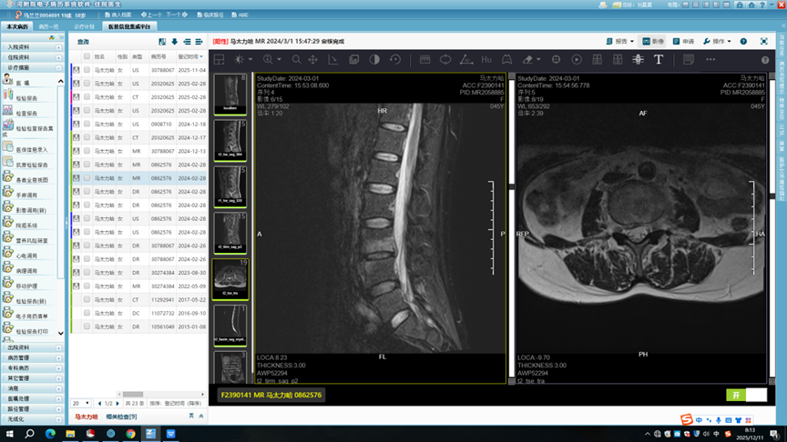  a | b
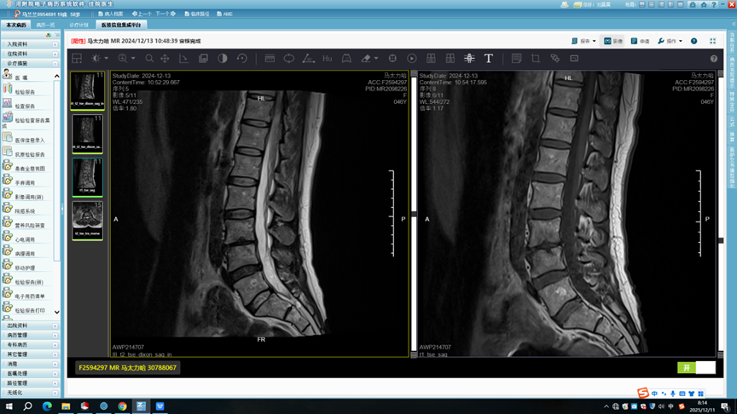  c | d
A 45-year-old female patient diagnosed with brucellosis-induced L3–L4 spondylitis
underwent percutaneous decompression combined with radiofrequency ablation. (a)
Preoperative sagittal magnetic resonance imaging (MRI) showed inflammatory
infiltration and localized destruction of the vertebral bodies, with mixed hyperintense
signals on T2-weighted imaging. (b) Preoperative sagittal MRI revealed mild
destruction of the vertebral body and intervertebral disc, accompanied by a small
intervertebral abscess; no obvious epidural abscess was identified, and the lesion
exhibited slightly hyperintense heterogeneous signals on T2-weighted images. (c, d)
MRI obtained 2 months postoperatively demonstrated significant resolution of
vertebral inflammatory infiltration and the small abscess,with satisfactory healing of
bone destruction, regular alignment of spinal nerves within the dural sac, and intact
spinal stability. The patient’s postoperative VAS score was 2.

Case 2
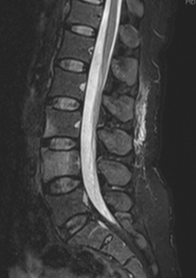  a | 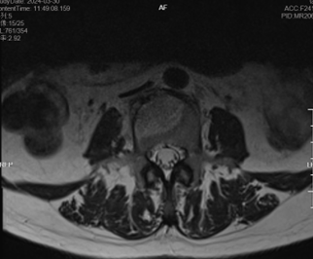  b
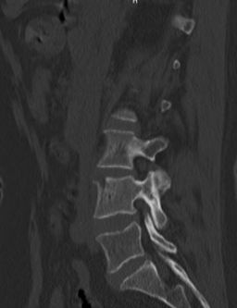  c | 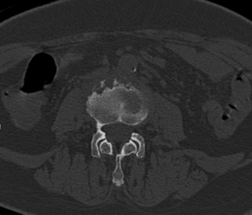  d
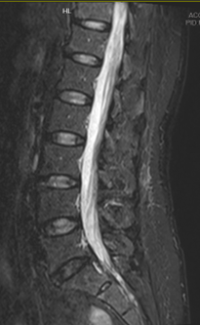  e | 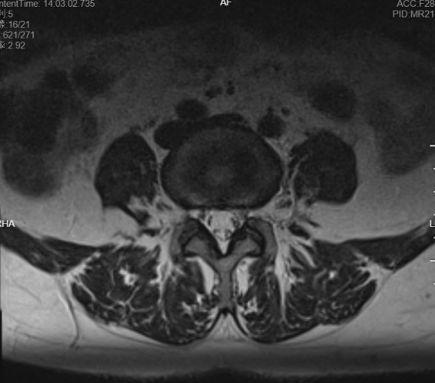  f

A 51-year-old female patient diagnosed with brucellotic spondylitis involving the L3–L4 vertebral bodies underwent percutaneous decompression combined with radiofrequency ablation. (a) Preoperative sagittal magnetic resonance imaging (MRI)
revealed extensive inflammatory infiltration and localized destruction of the inferior
margin of the L3 vertebral body and the L4 vertebral body, showing mixed hyperintense
signals on T2-weighted imaging and high signal intensity on fat-suppressed T2-weighted imaging. (b) Preoperative sagittal MRI demonstrated mild destruction of the
vertebral bodies and intervertebral discs, without obvious intervertebral or epidural
abscesses; heterogeneous slightly hyperintense signals were observed on T2-weighted
images. (c, d) Preoperative lumbar computed tomography (CT) showed irregular
margins at the inferior border of the L3 vertebral body and the superior border of the L4 vertebral body, with osteolytic bone destruction and mild swelling of the
surrounding soft tissues. (e, f) MRI obtained 2 months postoperatively revealed significant resolution of vertebral inflammatory infiltration, favorable repair of bone destruction, regular alignment of the spinal nerves within the dural sac, and stable spinal structure. The postoperative VAS score of the patient was 2.

