Supplemental Figures
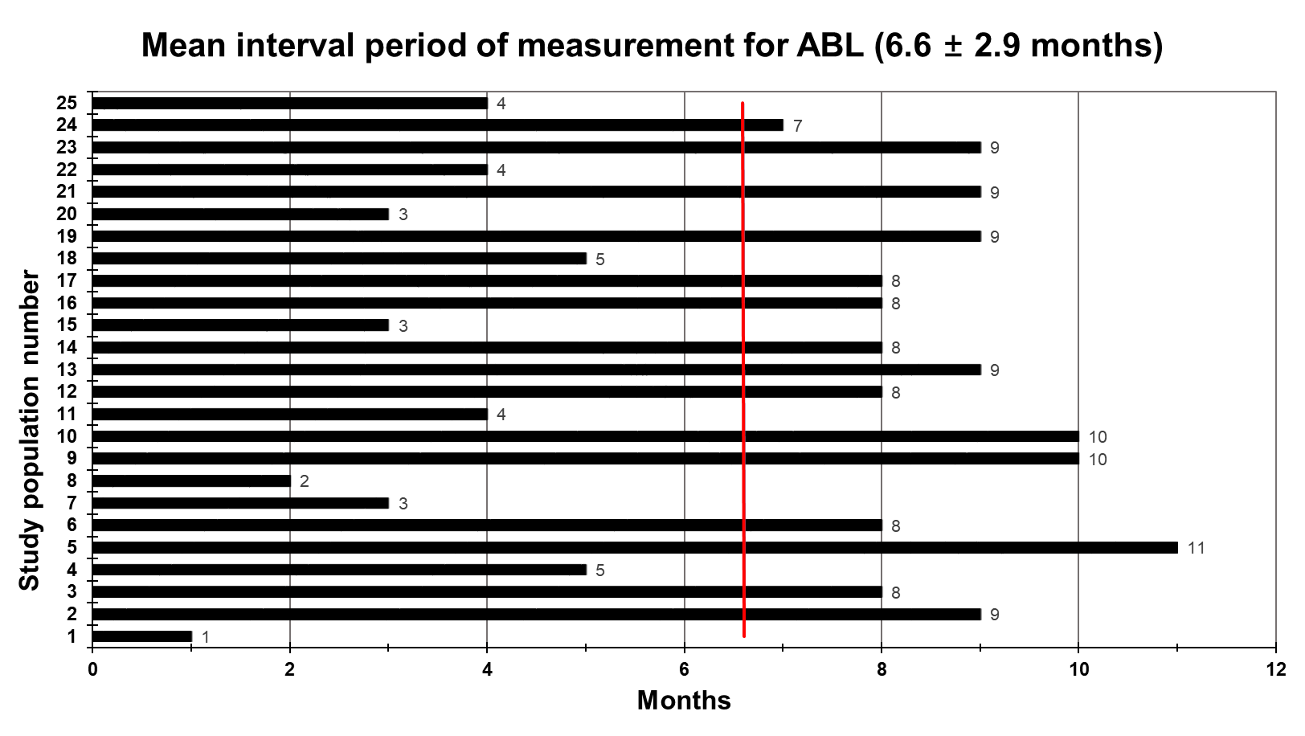
Supplemental Figure 1. Mean interval period of the measurement for ABL. Red-line represents the value of Mean ± standard deviation (SD). ABL, alveolar bone loss.

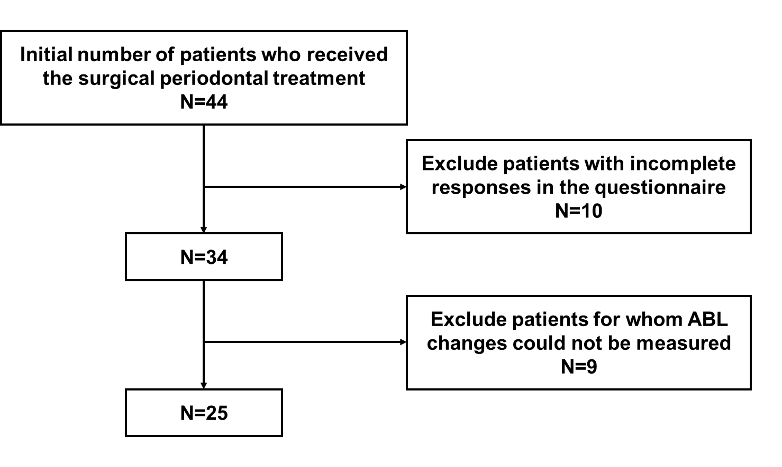
Supplemental Figure 2. Flow-chart of the study population for final analysis. ABL, alveolar bone loss.

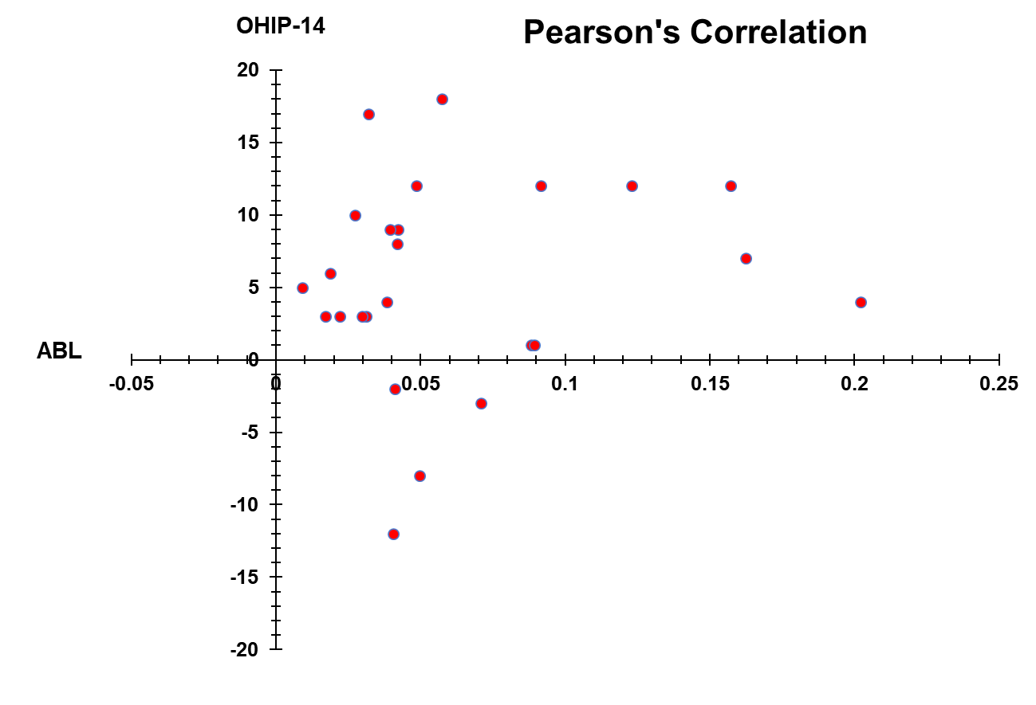
Supplemental Figure 3. Correlation coefficients of the alveolar bone loss (ABL) and the Oral Health Impact Profile-14 (OHIP-14) on pre- and post-treatment for the surgical periodontal treatment (N=25).

