Supplementary information

Insecticidal and enzyme inhibition activities of leaf/bark extracts, fractions, seed oil and isolated compounds from Triadica sebifera (L.) Small against Aphis craccivora Koch

Shudh Kirti Dolma^{1,3}, Prithvi Pal Singh^{2,3} and S. G. Eswara Reddy^{1,3*}

¹Entomology Laboratory, Agrotechnology Division, CSIR-Institute of Himalayan Bioresource Technology, Palampur, Himachal Pradesh, India
²Chemical Technology Division, CSIR-Institute of Himalayan Bioresource Technology, Palampur, Himachal Pradesh, India
³Academy of Scientific and Innovative Research, CSIR-HRDC Campus, Ghaziabad, India
*Corresponding author E-mail: ereddy@ihbt.res.in, ereddy2001@yahoo.com (SGE Reddy)

Contents
Fig. S1. ESI-MS of Kaempferol-3-O-glucoside
Fig.S2.Chemical structures of isolated compounds from Triadica sebifera from ethyl acetate and n-butanol fractions of the leaf a Kaempferol-3-O-glucoside b Quercetin-3-O-glucoside c Gallic acid d Shikimic acid
Fig. S3. ¹H-NMR spectrum of Kaempferol-3-O-glucoside
Fig. S4. ¹³C NMR spectrum of Kaempferol-3-O-glucoside
Table S1.Observed data and reported data of kaempferol-3-O-glucoside and quercetin 3-O-glucoside from Triadica sebifera
Fig. S5. ESI-MS of Quercetin-3-O-glucoside
Fig. S6. ¹H NMR spectrum of Quercetin-3-O-glucoside
Fig. S7. ¹³C NMR spectrum of Quercetin-3-O-glucoside
Fig. S8. ESI-MS of Gallic acid
Fig. S9. ¹H NMR spectrum of Gallic acid
Fig. S10. ¹³C NMR spectrum of Gallic acid
Table S2.Observed data and reported data of gallic acid and shikimic acid from Triadica sebifera
Fig. S11. ESI-MS of Shikimic acid
Fig. S12. ¹H NMR spectrum of Shikimic acid
Fig. S13. ¹³C NMR spectrum of Shikimic acid
Table S3.Synergistic activity of leaf/bark extracts and seed oil of Triadica sebifera against Aphis craccivora (72 h); Note: LC₅₀=Lethal concentration to kill 50% of test insect; Mean of three replications; n=150 insects per treatment; LC₅₀ was calculated for fractions showing > 50% mortality using Probit analysis; FEI–Fractional effect indices
Table S4. Synergistic activity of leaf/bark extracts and seed oil of Triadica sebifera against Aphis craccivora (96 h); Note: LC₅₀=Lethal concentration to kill 50% of test insect; Mean of three replications; n=150 insects per treatment; LC₅₀ was calculated for fractions showing > 50% mortality using Probit analysis; FEI–Fractional effect indices
Table S5. Efficacy of leaf/bark ethanolic aqueous extracts and seed oil of Triadica sebifera against Aphis craccivora under plant growth chamber; Note: LC₅₀=Lethal concentration to kill 50% of test insect; Mean of three replications; n=150 insects per treatment; LC₅₀ was calculated for fractions showing > 50% mortality using Probit analysis; FEI–Fractional effect indices
Fig.S14. Bio-efficacy of compounds isolated from leaf fractions of Triadica sebifera against Aphis craccivora;Figures in the same alphabetical letters in the error bars are statistically at par by Tukey’s HSD (P < 0.05)

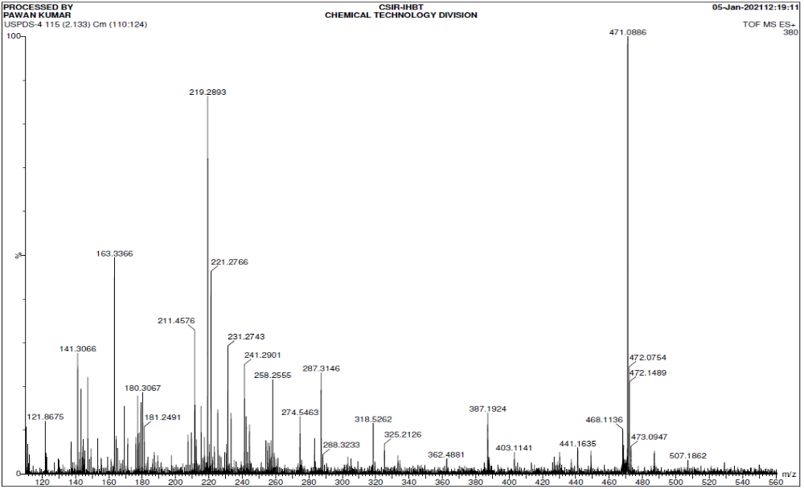

Fig. S1. ESI-MS of Kaempferol-3-O-glucoside

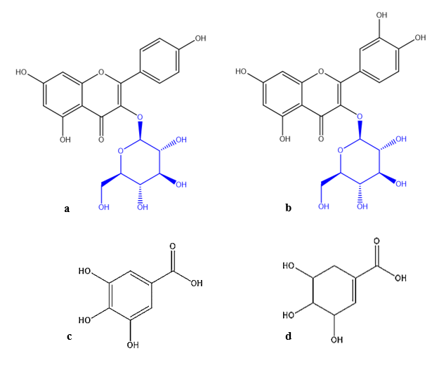

Fig. S2.Chemical structures of isolated compounds from Triadica sebifera from ethyl acetate and n-butanol fractions of the leaf a Kaempferol-3-O-glucoside b Quercetin-3-O-glucoside c Gallic acid d Shikimic acid

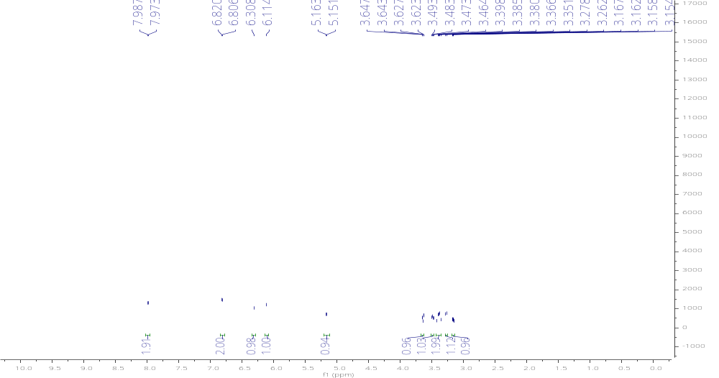

Fig. S3. ¹H-NMR spectrum of Kaempferol-3-O-glucoside

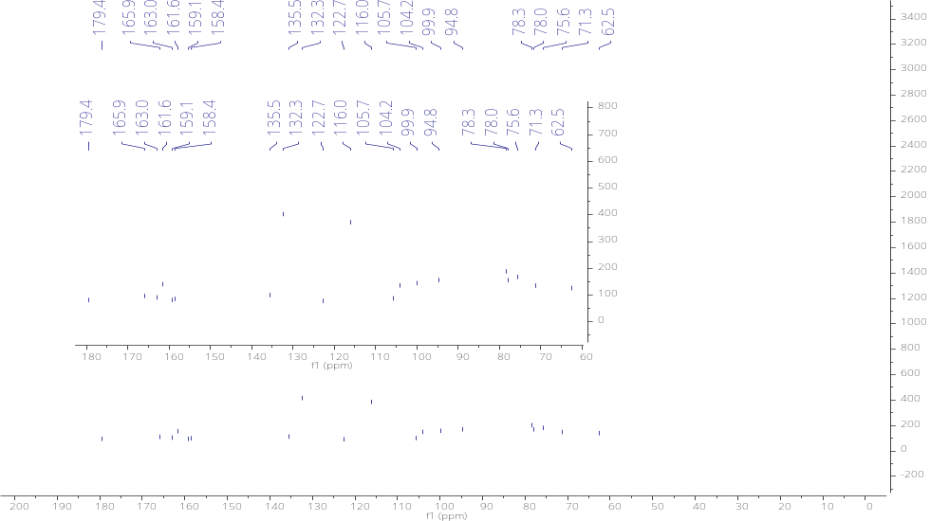

Fig. S4. ¹³C NMR spectrum of Kaempferol-3-O-glucoside

Table S1.Observed data and reported data of kaempferol-3-O-glucoside and quercetin 3-O-glucoside from Triadica sebifera

Kaempferol-3-O-glucoside |  |  |  |  | Quercetin 3-O-glucoside
Observed data |  |  | Reported data |  | Observed data |  | Reported data
Position | δC | δH | δC | δH | δC | δH | δC | δH
1 | - | - | - | - |  | - |  | -
2 | 159.1 | - | 157.6 | - | 159.1 | - | 159.3 | -
3 | 135.5 | - | 134.9 | - | 135.6 | - | 135.6 | -
4 | 179.4 | - | 177.9 | - | 179.5 | - | 179.6 | -
4a | 163.0 | - | 161.3 | - | 163.0 | - | 162.6 | -
5 | 99.9 | 6.11, s | 99.2 | 6.2 | 100.0 | 6.15 d,  (J= 2.4Hz) | 100.2 | 6.02 s
6 | 165.9 | - | 164.9 | - | 166.3 | - | 165.7 | -
7 | 94.8 | 6.30, s | 94.3 | 6.4 | 94.8 | 6.34 d,  (J= 2.4 Hz) | 95.9 | 6.21 s
8 | 158.4 | - | 157.0 | - | 158.5 | - | 158.4 | -
8a | 105.7 | - | 104.3 | - | 105.6 | - | 105.8 | -
1’ | 122.7 | - | 121.0 | - | 123.1 | - | 123.2 | -
2’ | 132.3 | 7.98, d  (J= 8.4 Hz) | 131.0 | 8.06 | 117.6 | 7.66 d,  (J= 1.8 Hz) | 116.5 | 7.59 s
3’ | 116.0 | 6.81, d  (J= 8.4 Hz) | 115.7 | 6.9 | 145.9 | - | 145.7 | -
4’ | 161.6 | - | 160.1 | - | 149.9 | - | 149.8 | -
5’ | 116.0 | 6.81, d  (J= 8.4 Hz) | 115.7 | 6.9 | 116.0 | 6.82 d,  (J= 8.4 Hz) | 117.8 | 6.71 d,  (J= 8.1 Hz)
6’ | 132.3 | 7.98, d  (J= 8.4 Hz) | 131.0 | 8.06 | 123.2 | 7.54 dd,  (J= 8.4,1.8 Hz) | 123.6 | 7.35 d,  (J= 8.1Hz)
3-O-β-D-glucose |  |  |  |  | 3-O-β-D-glucose
1’’ | 104.2 | 5.16, d  (J= 7.2 Hz) | 100.7 | 3.37 | 104.4 | 5.18 d,  (J= 7.8 Hz) | 104.2 | 4.85 d,  (J= 7.7 Hz)
2’’ | 75.6 | 3.38 m | 74.2 | 3.34 | 75.7 | 3.44 m | 75.6 | 3.11-3.68 m
3’’ | 78.0 | 3.38 m | 76.4 | 3.34 | 78.1 | 3.28 m | 77.8 | 3.11-3.68 m
4’’ | 71.3 | 3.26 m | 69.9 | 3.33 | 71.2 | 3.32 m | 71.1 | 3.11-3.68 m
5’’ | 78.3 | 3.16 m | 77.5 | 3.33 | 78.4 | 3.17 m | 78.2 | 3.11-3.68 m
6’’ | 62.5 | 3.48, 3.63 m | 60.8 | 3.32 | 62.5 | 3.53, 3.66 m | 62.4 | 3.11-3.68 m

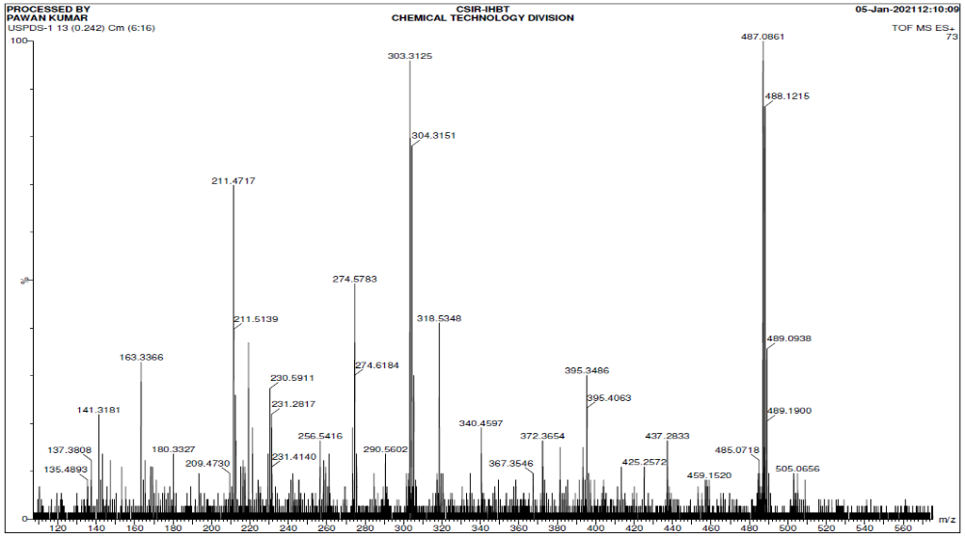

Fig. S5. ESI-MS of Quercetin-3-O-glucoside

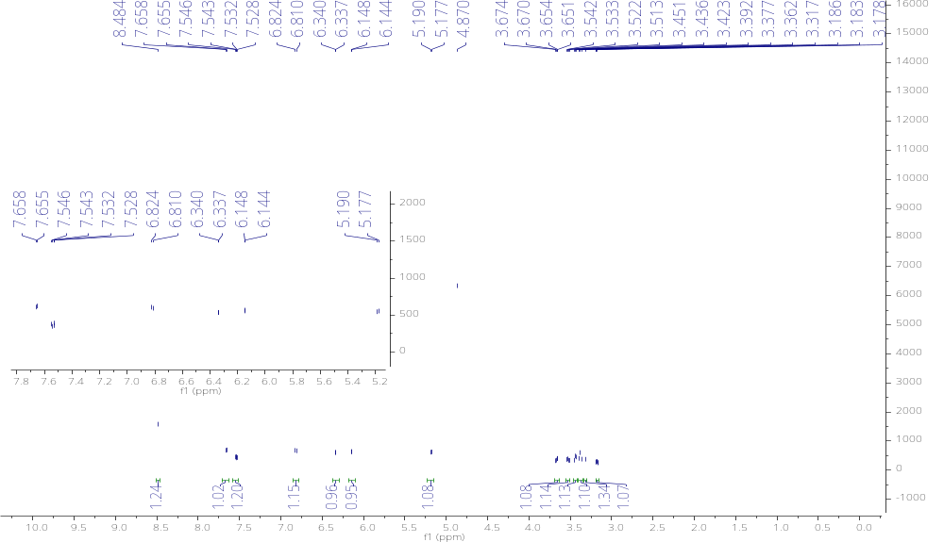

Fig. S6. ¹H NMR spectrum of Quercetin-3-O-glucoside

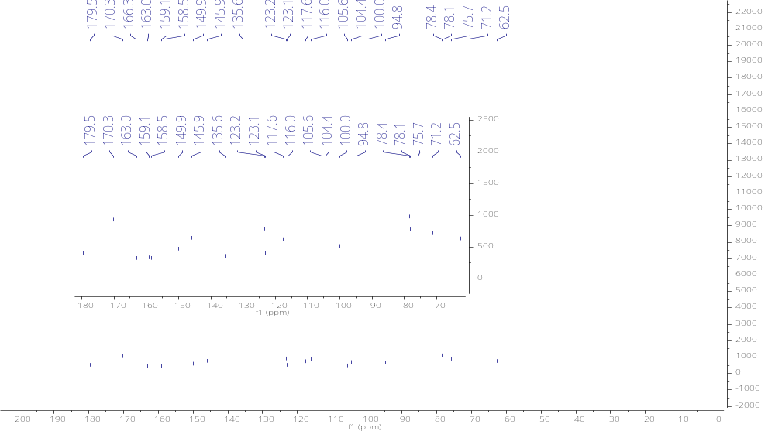

Fig. S7. ¹³C NMR spectrum of Quercetin-3-O-glucoside

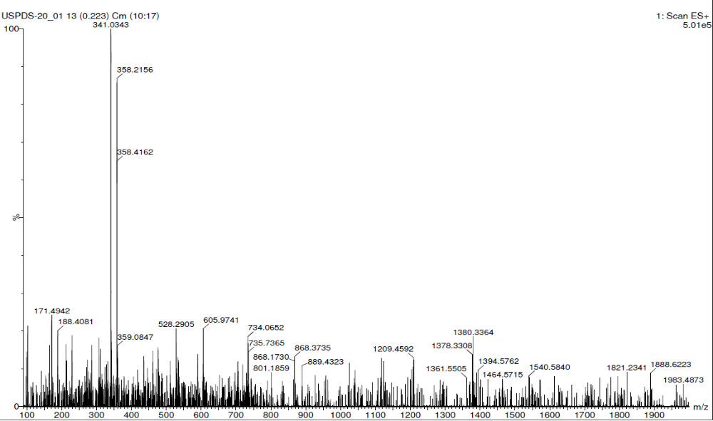

Fig. S8. ESI-MS of Gallic acid

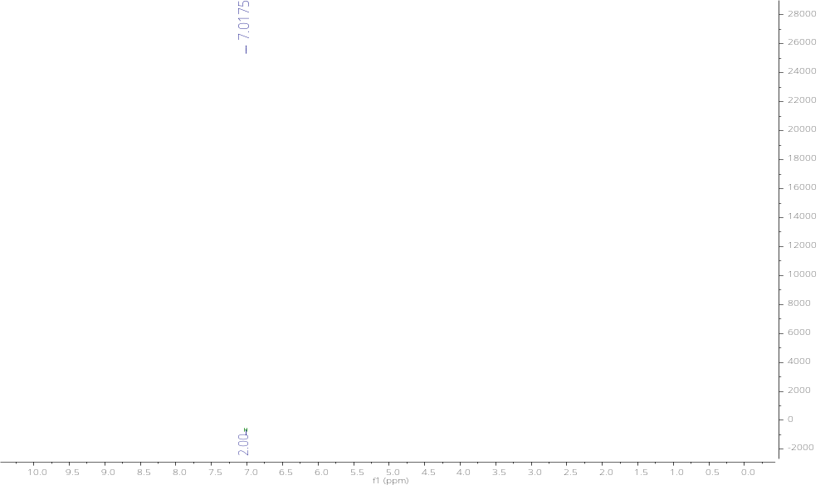
Fig. S9. ¹H NMR spectrum of Gallic acid

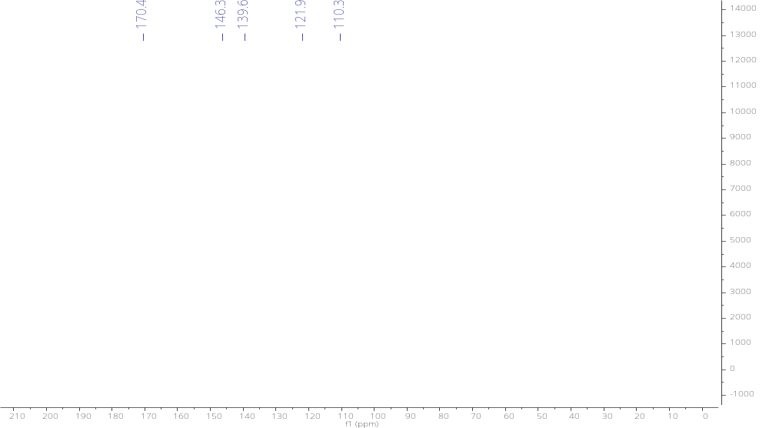
Fig. S10. ¹³C NMR spectrum of Gallic acid

Table S2.Observed data and reported data of gallic acid and shikimic acid from Triadica sebifera

Gallic acid |  |  |  |  | Shikimic acid
Observed data |  |  | Reported data |  | Observed data |  | Reported data
Position | δC | δH | δC | δH | δC | δH | δC | δH
1 | 170.4 | - | 167.3 | - | 170.0 | - | 170.1 | -
2 | 121.9 | - | 120.8 | - | 130.7 | - | 129.8 | -
3 | 110.3 | 7.01 s | 109.1 | 7.15 s, (1H) | 138.8 | 6.73 m, (1H) | 137.1 | 6.70 m, (1H)
4 | 146.3 | - | 144.9 | - | 67.3 | 4.30 m, (1H) | 65.8 | 4.30 (m, 1H)
5 | 139.6 | - | 137.7 | - | 72.7 | 3.60 (dd, J = 7.4, 4.2 Hz, 1H), | 75.1 | 3.67 (dd, J = 8.4, 4.5 Hz, 1H)
6 | 146.3 | - | 144.9 | - | 68.4 | 3.91 m, (1H) | 66.5 | 3.93 (m, 1H)
7 | 110.3 | 7.01 s | 109.1 | 7.15 s, (1H) | 31.6 | 2.12 (dd, J = 18.2, 5.6 Hz,1H), 2.61 (dd, J = 18.2, 5.0Hz, 1H), | 30.4 | 2.12 (dd, J = 18.0, 6.3 Hz,1H), 2.64 (dd, J = 18.0, 4.8 Hz, 1H),

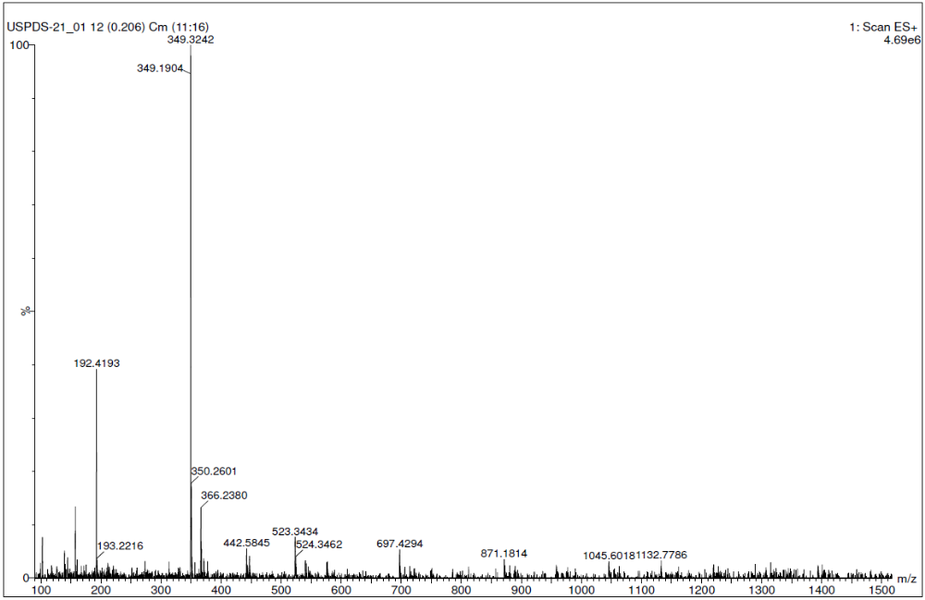
Fig. S11. ESI-MS of Shikimic acid

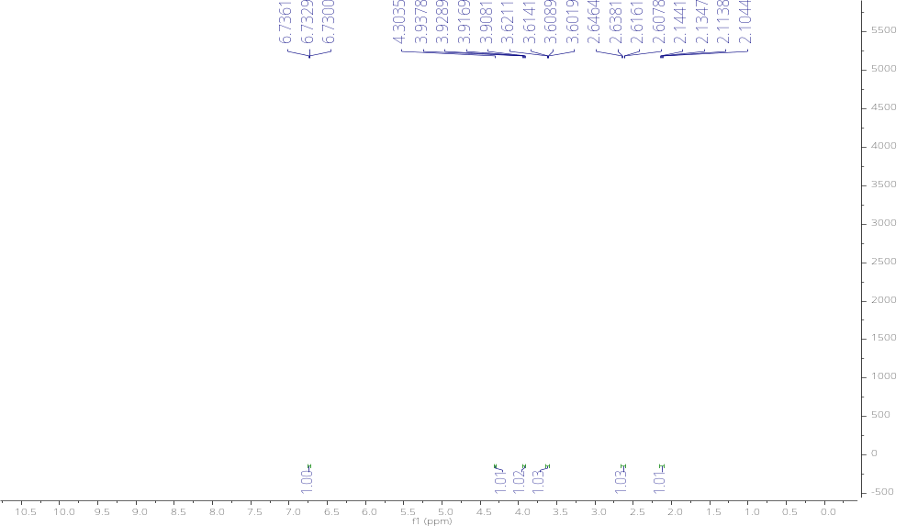
Fig. S12. ¹H NMR spectrum of Shikimic acid

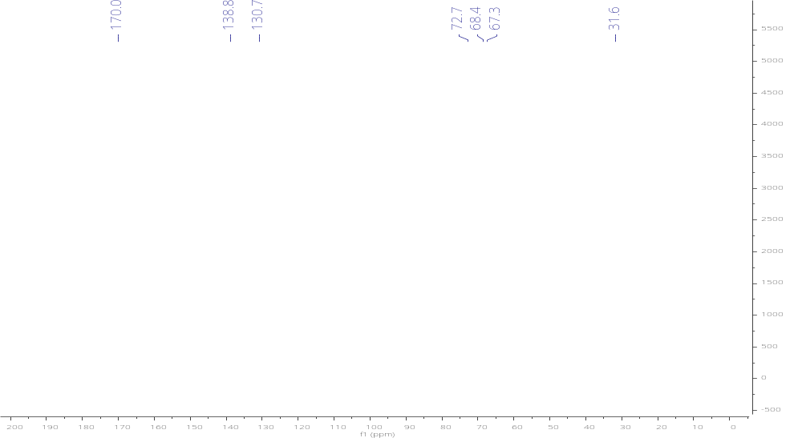
Fig. S13. ¹³C NMR spectrum of Shikimic acid

Table S3.Synergistic activity of leaf/bark extracts and seed oil of Triadica sebifera against Aphis craccivora (72 h); Note: LC₅₀=Lethal concentration to kill 50% of test insect; Mean of three replications; n=150 insects per treatment; LC₅₀ was calculated for fractions showing > 50% mortality using Probit analysis; FEI–Fractional effect indices

Extracts/Oil | LC₅₀  (mg/l) | Confidence limits (mg/l) | Slope ± SE | Chi square | P value | FEI | Interaction type
SO | 2504.59 | 1675.92 – 3562.91 | 1.18 ± 0.21 | 0.86 | 0.97 | – | –
LEE | 9590.49 | 7706.54–11128.43 | 2.91 ± 0.52 | 1.81 | 0.87 | – | –
BEE | 7300.57 | 5889.44 – 8435.86 | 3.97 ± 0.57 | 6.17 | 0.29 | – | –
SO: LEE (1:1) | 303.29 | 232.07 – 403.59 | 1.99 ± 0.30 | 1.65 | 0.65 | 0.1527 | Synergistic
SO: LEE (1:3) | 583.34 | 431.14 – 901.14 | 1.86 ± 0.32 | 2.06 | 0.56 | 0.2937 | Synergistic
SO: LEE (3:1) | 615.35 | 442.80 – 1019.69 | 1.70 ± 0.31 | 0.2 | 0.98 | 0.3099 | Synergistic
BEE:SO (1:1) | 263.56 | 203.69 – 342.51 | 2.13 ± 0.31 | 0.84 | 0.84 | 0.1413 | Synergistic
BEE: SO (1:3) | 466.8 | 362.45 – 639.14 | 2.19 ± 0.34 | 0.06 | 0.99 | 0.2503 | Synergistic
BEE: SO (3:1) | 467.39 | 348.01 – 691.26 | 1.79 ± 0.30 | 0.24 | 0.97 | 0.2506 | Synergistic
LEE: BEE (1:1) | 508.8 | 393.09 – 709.19 | 2.17 ± 0.34 | 0.4 | 0.94 | 0.1227 | Synergistic
LEE: BEE (1:3) | 368.6 | 279.48 – 510.34 | 1.89 ± 0.30 | 2.08 | 0.56 | 0.0889 | Synergistic
LEE: BEE (3:1) | 384.95 | 278.66 – 579.01 | 1.56 ± 0.28 | 1.36 | 0.71 | 0.0929 | Synergistic
LEE: BEE: SO (1:1:1) | 337.33 | 259.83 – 450.11 | 2.04 ± 0.31 | 1.45 | 0.69 | 0.2161 | Synergistic
(LEE+ SO): BEE (1+1: 2) | 239.94 | 190.06 – 301.55 | 2.49 ± 0.34 | 1.4 | 0.71 | 0.1537 | Synergistic
(LEE+ BEE): SO (1+1: 2) | 358.53 | 285.84 – 461.34 | 2.48 ± 0.35 | 4.1 | 0.25 | 0.2296 | Synergistic
(SO+ BEE): LEE (1+1: 2) | 560.04 | 412.45 – 870.53 | 1.80 ± 0.31 | 0.91 | 0.82 | 0.3587 | Synergistic

Table S4.Synergistic activity of leaf/bark extracts and seed oil of Triadica sebifera against Aphis craccivora (96 h); Note: LC₅₀=Lethal concentration to kill 50% of test insect; Mean of three replications; n=150 insects per treatment; LC₅₀ was calculated for fractions showing > 50% mortality using Probit analysis; FEI–Fractional effect indices

Extracts/oil | LC₅₀  (mg/l) | Confidence limits (mg/l) | Slope ± SE | Chi square | P value | FEI | Interaction type
SO | 850.94 | 533.52 – 1171.05 | 1.69 ± 0.25 | 3.28 | 0.66 | – | –
LEE | 6756.42 | 5342.84 –7885.95 | 3.97 ± 0.58 | 1.84 | 0.87 | – | –
BEE | 5115.98 | 3613.44 – 6219.77 | 4.04 ± 0.75 | 1.31 | 0.73 | – | –
SO: LEE (1:1) | 168.9 | 131.54 – 211.57 | 2.51 ± 0.36 | 3.35 | 0.34 | 0.2235 | Synergistic
SO: LEE (1:3) | 345.05 | 270.79 – 451.97 | 2.25 ± 0.32 | 1.14 | 0.77 | 0.4566 | Synergistic
SO: LEE (3:1) | 333.88 | 267.82 – 422.84 | 2.60 ± 0.36 | 0.05 | 0.99 | 0.4418 | Synergistic
BEE:SO (1:1) | 144.26 | 117.51 – 174.07 | 3.44 ± 0.49 | 2.34 | 0.5 | 0.1977 | Synergistic
BEE: SO (1:3) | 282.49 | 233.42 – 344.15 | 3.30 ± 0.44 | 2.4 | 0.49 | 0.3872 | Synergistic
BEE: SO (3:1) | 213.8 | 171.19 – 265.94 | 2.68 ± 0.36 | 1.88 | 0.6 | 0.2930 | Synergistic
LEE: BEE (1:1) | 293.26 | 238.81 – 362.61 | 2.92 ± 0.39 | 0.9 | 0.82 | 0.1007 | Synergistic
LEE: BEE (1:3) | 179.31 | 146.94 – 217.38 | 3.28 ± 0.45 | 0.68 | 0.88 | 0.0616 | Synergistic
LEE: BEE (3:1) | 204.28 | 159.19 – 258.70 | 2.35 ± 0.33 | 1.12 | 0.77 | 0.0702 | Synergistic
LEE: BEE: SO (1:1:1) | 216.86 | 177.44 – 264.17 | 3.14 ± 0.42 | 1.37 | 0.71 | 0.3293 | Synergistic
(LEE+ SO): BEE (1+1: 2) | 170.46 | 137.05 – 209.14 | 2.94 ± 0.41 | 0.57 | 0.9 | 0.2589 | Synergistic
(LEE+ BEE): SO (1+1: 2) | 249.47 | 204.09 – 305.04 | 3.08 ± 0.41 | 3.21 | 0.36 | 0.3789 | Synergistic
(SO+ BEE): LEE (1+1: 2) | 220.58 | 175.94 – 275.13 | 2.61 ± 0.36 | 3.34 | 0.34 | 0.3350 | Synergistic

Table S5.Efficacy of leaf/bark ethanolic aqueous extracts and seed oil of Triadica sebifera against Aphis craccivora under plant growth chamber; Note: LC₅₀=Lethal concentration to kill 50% of test insect; Mean of three replications; n=150 insects per treatment; LC₅₀ was calculated for fractions showing > 50% mortality using Probit analysis; FEI–Fractional effect indices

Oil/ Extracts | LC₅₀  (mg/l) | Confidence limits (mg/l) | Slope ± SE | Chi square | P value | FEI | Interaction type
SO (72 h) | 1100.22 | 812.86 – 1392.09 | 1.85 ± 0.23 | 2.88 | 0.58 | – | –
SO(96 h) | 706.53 | 532.34 – 976.85 | 2.06 ± 0.28 | 1.02 | 0.91 | – | –
LEE(72 h) | 1840.84 | 1199.35 – 2565.63 | 1.07 ± 0.16 | 4.44 | 0.35 | – | –
LEE(96 h) | 685.47 | 442.65 – 917.21 | 1.82 ± 0.26 | 1.45 | 0.83 | – | –
BEE(72 h) | 5073.99 | 3982.57 – 6609.45 | 1.50 ± 0.17 | 4.45 | 0.35 | – | –
BEE(96 h) | 2328.79 | 1966.60 –2741.25 | 2.68 ± 0.26 | 2.79 | 0.59 | – | –
SO + LEE(72 h) | 264.05 | 210.93 – 319.75 | 2.27 ± 0.27 | 3.03 | 0.39 | 0.383 | Synergistic
SO + LEE(96 h) | 223.82 | 178.50 – 269.53 | 2.49 ± 0.31 | 2.44 | 0.49 | 0.643 | Additive
SO + BEE(72 h) | 362.76 | 293.43 – 440.43 | 2.14 ± 0.25 | 1.94 | 0.58 | 0.401 | Synergistic
SO + BEE(96 h) | 247.54 | 201.52 – 295.38 | 2.58 ± 0.31 | 1.33 | 0.72 | 0.456 | Synergistic

Fig.S14.Bio-efficacy of isolated compounds from leaf fractions of Triadica sebifera against Aphis craccivora;Figures in the same alphabetical letters in the error bars are statistically at par by Tukey’s HSD (P < 0.05)

