Supplementary Materials

Human impacts on the 2015 equatorial Asia drought: the role of air-sea coupling in the event attribution study
  - Akira Hasegawa^{1*}, Yukiko Imada¹, Hideo Shiogama², Takahito Kataoka³, Hiroaki Tatebe³
¹Atmosphere and Ocean Research Institute (AORI), The University of Tokyo, 5-1-5, Kashiwanoha, Kashiwa-city, Chiba 277-8564, Japan.
²National Institute for Environmental Studies (NIES), 16-2, Onogawa, Tsukuba-city, Ibaraki 305-8506, Japan.
³Japan Agency for Marine-Earth Science and Technology (JAMSTEC), 2-15, Natsushima-cho, Yokohama-city, Kanagawa 237-0061, Japan.

*Corresponding author E-mail address: hakira@aori.u-tokyo.ac.jp

Relationship among HProb , NProb, FAR, and threshold
To simplify the explanation, Fig. S1a-c shows FAR(Z) when we assume that HProb(Z) is the cumulative density function (CDF) of the standard normal distribution, NProb(Z)=HProb(Z-ΔZ), where Z is the normalized variable (normalized precipitation in this study) and ΔZ=0.1, 0.5, and 1.0, respectively. When ΔZ>0 (NProb<HProb), FAR(Z) is a monotonically decreasing function, and the smaller Z (i.e., more severe drought threshold in this study) leads to the higher FAR(Z). The greater ΔZ>0 leads to the higher FAR(Z)<1 for any Z due to the smaller NProb(Z)/HProb(Z).
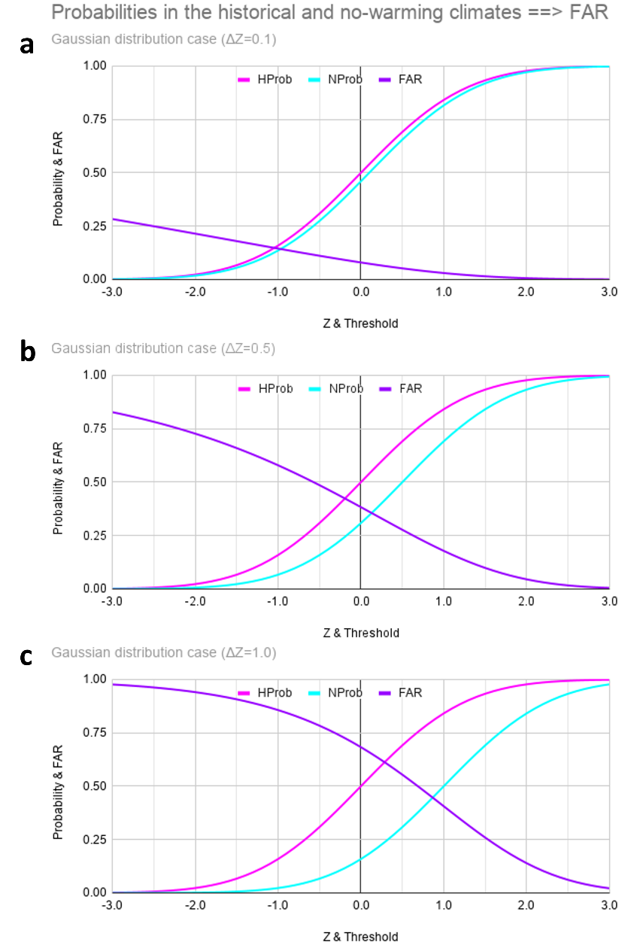
Fig S1 Examples of probabilities in the historical and no-warming climates and FAR as a function of threshold, when HProb(Z) is assumed as the cumulative distribution function of the standard normal distribution, NProb(Z)=HProb(Z-ΔZ), where ΔZ=0.1, 0.5, and 1.0 cases in a, b, and c, respectively. The HProb curves (pink) are common among the panels.

