Appendix A Pre-test and Post-test Tasks

A1 Pre-Test
The pre-test consisted of three contextualized measurement division tasks designed to examine students' initial understanding of measurement division and the solution strategies they used prior to the instructional sequence. Students were asked to illustrate their reasoning, explain their thinking, and provide an appropriate mathematical expression for each task.
Task 1
Lea has 8 liters of water that she pours into 2-liter bottles. How many 2-liter bottles does she need?
Task 2
Sivert has 20 buns that he places into bags. Each bag contains 5 buns. How many bags does he need?
Task 3
Marit has 900 grams of biscuits that she packs into boxes. Each box contains 300 grams. How many boxes does she need?

A2 Post-Test
The post-test consisted of five tasks administered after the instructional sequence. However, only Tasks 1, 2, and 5 are relevant to the present study because they assess students' understanding of measurement division and the misconception that division always produces a smaller result. Tasks 3 and 4 addressed multiplication with fractions and the misconception that multiplication always makes larger. These tasks were included as part of the broader design-based research project but are outside the scope of the present article and are therefore not reported or analyzed here.
Task 1
Asif has 2 liters of water. How many ½-liter bottles can he fill?
Students were also asked:
Can you find additional mathematical expressions that solve the same problem?
Task 2
Marit has 10 apples that she places into bags. Each bag contains 2½ apples. How many bags does she need?
Students were also asked:
Can you find additional mathematical expressions that solve the same problem?
Task 3 (not analyzed in this article)
Students compared two multiplication situations (4 × 5 liters and 8 × 2½ liters) and explained why both represented the same total amount of water.
Task 4 (not analyzed in this article)
Students evaluated the statement concerning whether multiplication always produces a larger result and justified their choice with an example.
Task 5
Students evaluated the statement concerning whether division always produces a smaller result and justified their choice with examples.

Appendix B. Representative Examples of Students’ Written Responses

B1 Pre-Test
Figure B1. Example of a student’s pre-test response using drawings and arithmetic representations.

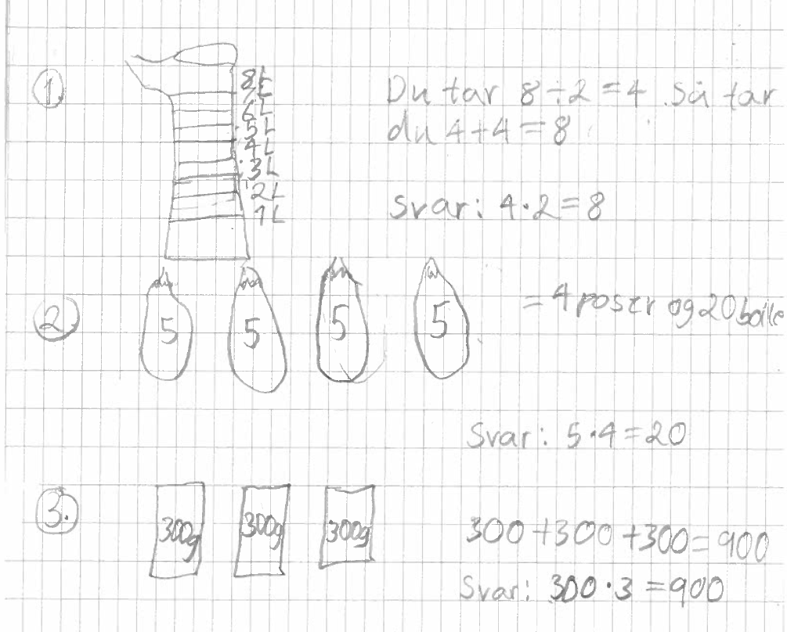
Figure B1 presents an example of a student’s written response to the pre-test. The response illustrates how the student represented the measurement division situations before participating in the instructional sequence, using drawings together with arithmetic representations. The example reflects the variation in representations identified in the pre-test, where drawings were the most frequently used strategy, while some students also used repeated addition, multiplication, and symbolic measurement division.

B2 Student Work During the Instructional Sequence
Figure B2. Example of multiple representations of fraction measurement division during the instructional sequence.
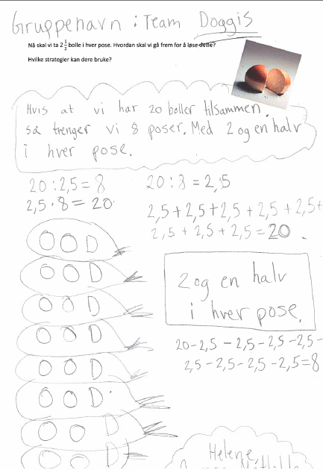
Figure B2 presents an example of student work produced during the instructional sequence. The response is from the activity in which students explored how 20 buns could be divided into groups of buns. The example illustrates how the same fraction measurement division situation was represented in multiple ways, including through drawings, repeated addition, repeated subtraction, multiplication, and symbolic measurement division.

B3 Post-Test

Figure C3 a. Example of a post-test response demonstrating multiple solution strategies.
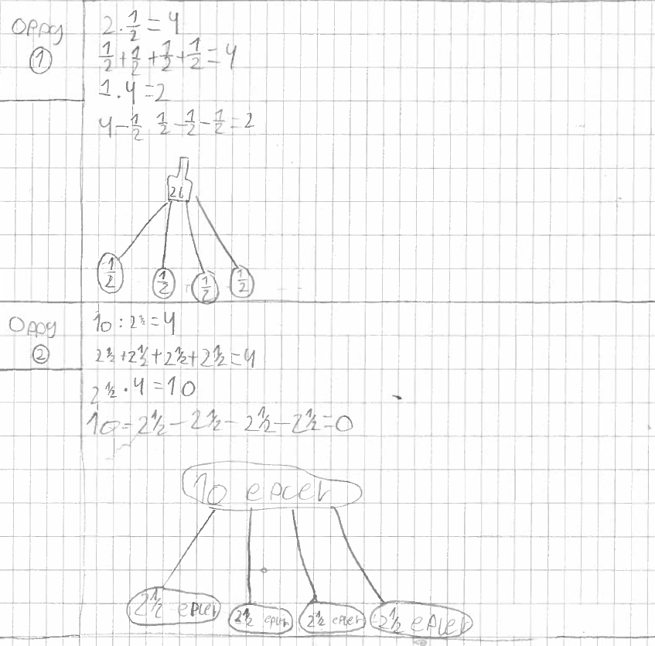
Figure B3b. Example of a student’s reasoning about the misconception that division always makes numbers smaller.
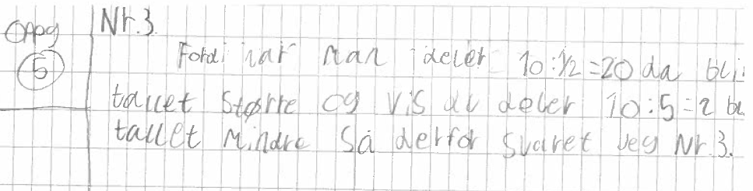
Figures B3a and B3b present examples of students’ written responses from the post-test. Figure B3a illustrates the use of multiple solution strategies for fraction measurement division, including drawings, repeated addition, repeated subtraction, multiplication, and symbolic measurement division. Figure B3b provides an example of a student’s reasoning about whether division always produces a smaller result, illustrating how the student used numerical examples to justify that the quotient may be larger than the dividend when dividing by a fraction.

