Supplementary material
Kinematic finite source inversion (FFM Delouis)
The finite fault model (FFM Delouis) is derived from regional broadband and strong-motion records. From the available seismic data, we selected 11 stations in Colombia, Venezuela, and the Caribbean surrounding the rupture zone, located at epicentral distances ranging from 280 to 1,030 km (Fig. S1). Signal processing included amplitude correction using the instrument sensitivity factor, removal of the pre-event mean, double integration to obtain displacement, and bandpass filtering; the low-frequency cutoff ranges from 0.01 to 0.02 Hz, depending on the long-period noise levels observed at each station after double integration, while the high-frequency cutoff ranges from 0.03 to 0.04 Hz, depending on signal complexity and the ability to adequately model waveforms using a simple velocity model. Synthetic seismograms were computed using the wavenumber integration method of Bouchon (1981). The 1D crustal velocity model has a 30 km thickness, with P-wave velocities varying from 5.0 to 6.7 km/s and a Vp/Vs ratio of 1.73. We opted not to use a region-specific model due to the highly variable crustal structure along the propagation paths to the regional stations, which transitions from continental in the epicentral area to Andean to the west and oceanic to the north and northeast.
The kinematic slip model was obtained using the nonlinear multiple windows approach of Delouis et al. (2002). Assuming the Venezuela earthquake of June 24, 2026 was a single event, and disregarding potential complexities in the fault geometry at this stage, we modeled the rupture as a single rectangular fault segment striking N85.5°, dipping 90° (vertical), and measuring 350 km along strike by 50 km along dip, extending to the Earth’s surface. This fault model is subdivided into small subfaults, each 18 km along strike and 10 km along dip, represented by a point source at their center for seismic waveform modeling. Along the fault, we allowed the rake to vary by ±35° around a central value of 180°, corresponding to dominant right-lateral strike-slip motion.
The local source time function associated with each point source is represented as the sum of three isosceles triangular moment rate functions, mutually overlapping, each with a total duration of 8 s. Two bounding rupture velocities, called Vrmin and Vrmax, and equal to 3.0 and 5.0 km/s respectively, limit the rupture onset times along the fault. They were adjusted after a series of initial inversions to determine the range of rupture velocities required by the seismic data.
The inverted parameters are, for each subfault, the rupture onset time, the amplitudes of the triangular functions, and the rake angle. The inversion itself is carried out with a simulated annealing algorithm. The cost function to be minimized is the normalized RMS (root mean square) misfit function of the seismic records, plus a seismic moment minimization function and a smoothing function. The weights assigned to the seismic moment minimization and smoothing functions are adjusted so as not to incorporate excess seismic moment for little gain in data fit, and to avoid incorporating a level of detail in the model that is poorly constrained by the data.
In the model, the rupture initiation (hypocenter) is located at 10.476°N, -68.528°E, at a depth of 15 km. This location was refined relative to the USGS hypocenter following a series of initial inversions, accounting for model geometry, alignment with the San Sebastian fault, and early coseismic InSAR observations.
The rupture was essentially unilateral, propagating eastward at an average speed of 3.8 km/s, with a maximum slip of 2 m and a moment magnitude of Mw 7.55. Given the relatively low-frequency regional seismic data, there is no need to assume two separate events.
This model has been initially published on Linkedin (https://www.linkedin.com/posts/bertrand-delouis-30a532369_updated-slip-model-obtained-using-regional-activity-7479113753721217025-Icfn?utm_source=social_share_send&utm_medium=member_desktop_web&rcm=ACoAAFthjjoBf5IF3hTl1-6cjmhwwD0n5-X9T2I ) for the purpose of rapid information about the earthquake source.

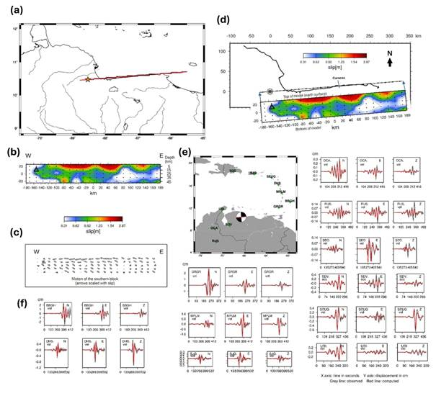Fig. S1
Results of the kinematic finite fault model. (a) Fault model in map view; orange star: epicenter; red line: top edge of the fault. (b) Slip distribution viewed from the south; black dots: point sources; open black triangle: hypocenter. (c) Fault motion vectors along the model; arrow lengths are proportional to slip amplitude. (d) Slip model viewed from the south, aligned with its surface trace in map view. (e) Regional seismic stations (green triangles) used in the inversion, with the focal mechanism. (f) Waveform modeling. vel: velocity sensor (broadband); acc: accelerometer sensor (strong motion).

References:
Bouchon, M. (1981). A simple method to calculate Green’s functions for elastic layered media, Bull. Seismol. Soc. Am. 71, no. 4, 959–971.
Delouis, B., D. Giardini, P. Lundgren, and J. Salichon (2002). Joint inversion of InSAR, GPS, teleseismic and strong motion data for the spatial and temporal distribution of earthquake slip: Application to the 1999 Izmit mainshock, Bull. Seismol. Soc. Am. 92, 278–299, doi: 10.1785/0120000806.

