Extended Data
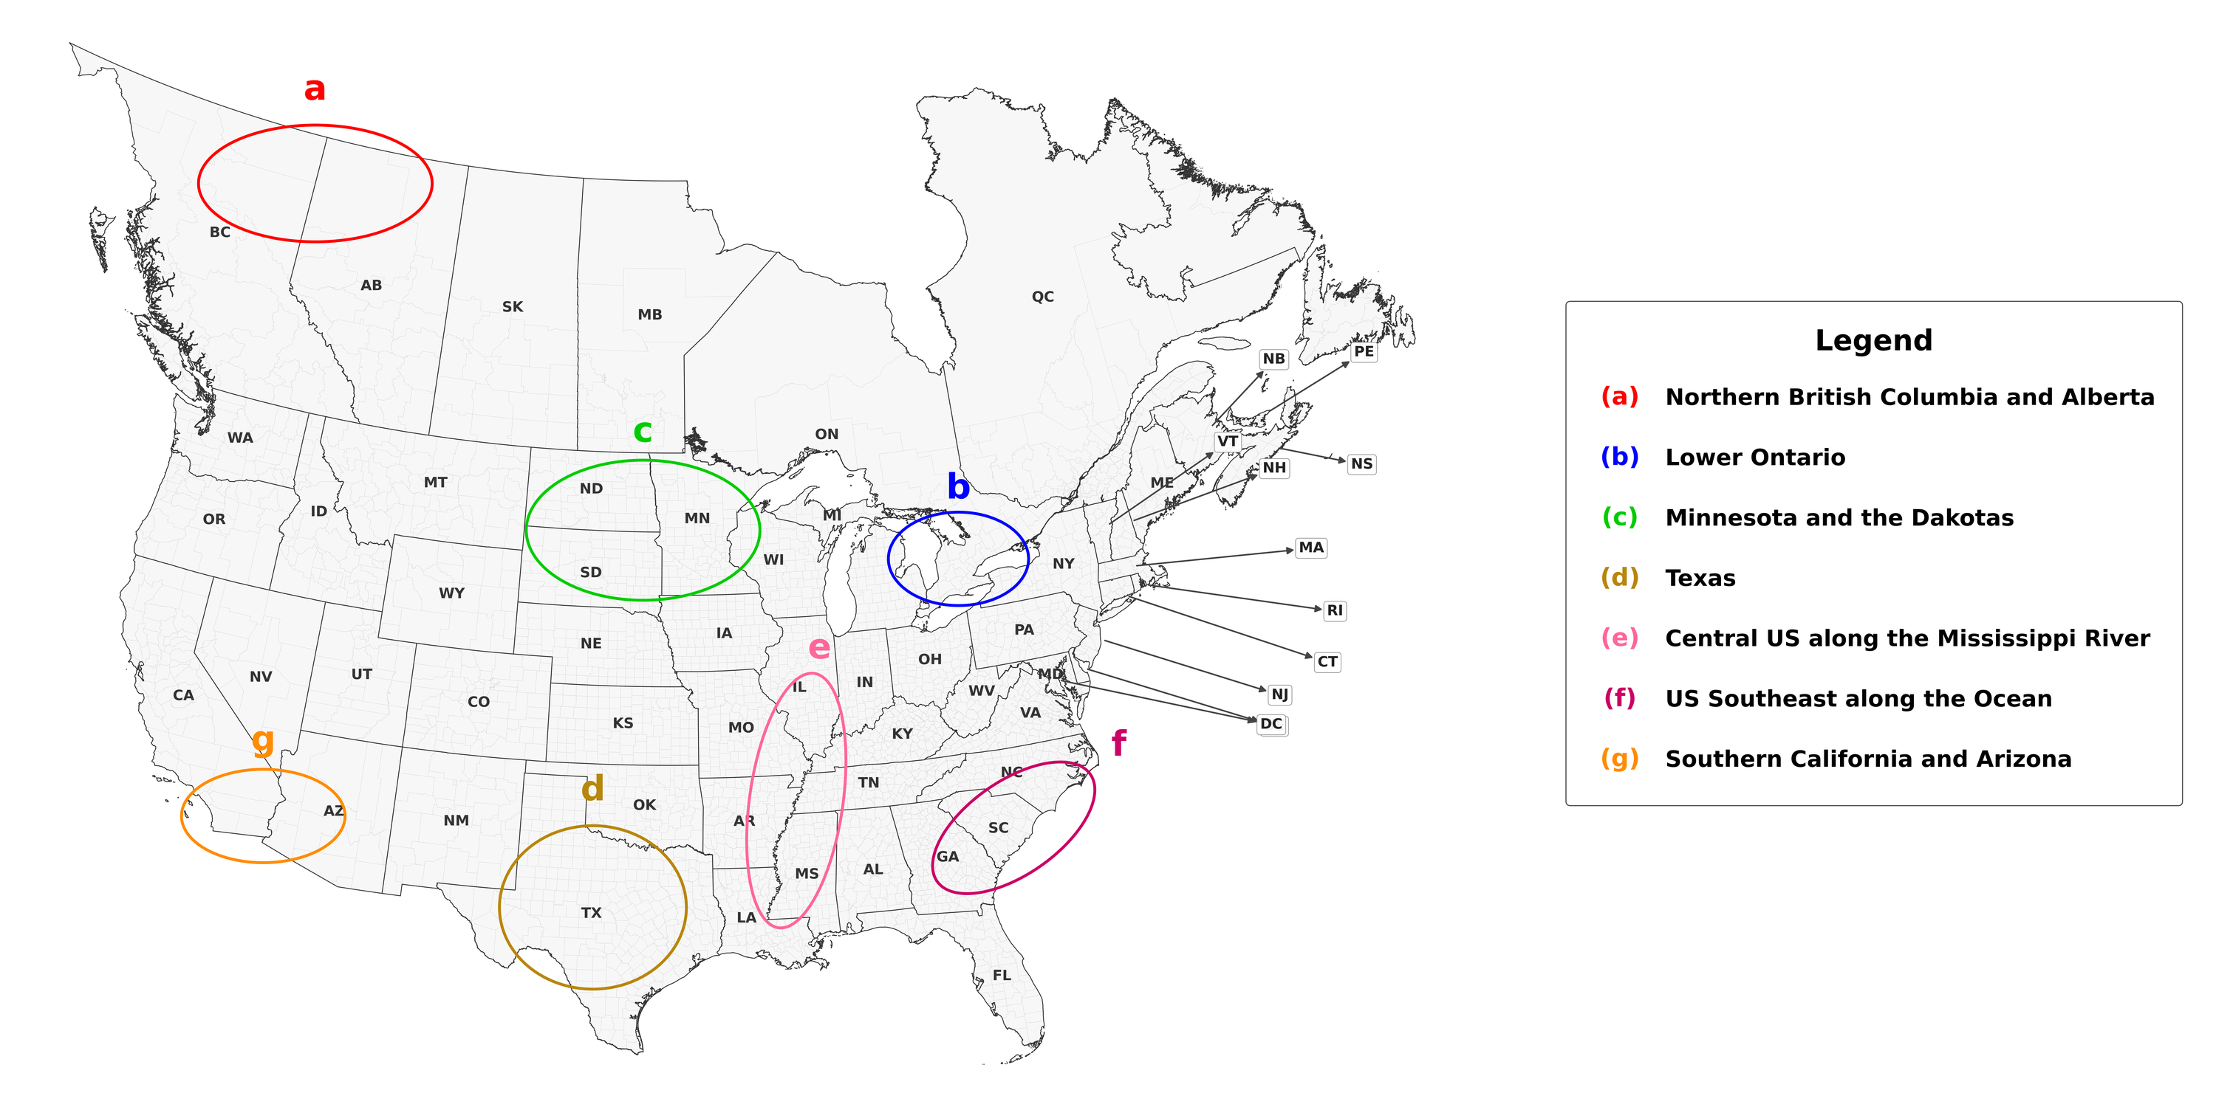
Extended Data Figure 1: Rough Outlines of the US and Canadian Regions discussed in the text

Extended Data Table 1: Centroid Shift in km and basic nature of the shift
* | --Shift in km --
Item | Total |  | North |  | West |  | Nature of Centroid Shift
Spring Wheat |  | 109 |  | 57 |  | 93 |  | WNW shift from South Central Saskatchewan to a more North and Western part of Saskatchewan
Barley |  | 272 |  | 251 |  | 106 |  | NNW shift from North Central Montana into Western Saskatchewan
Oats |  | 671 |  | 513 |  | 432 |  | NNW shift from Southwestern Minnesota to Southeastern Saskatchewan
Canola |  | 170 |  | -91 |  | -144 |  | ESE shift from Western Saskatchewan to Central Saskatchewan
Alfalfa |  | 342 |  | 124 |  | 319 |  | WNW shift from South Central South Dakota to Northwest South Dakota
Soybeans |  | 337 |  | 310 |  | 133 |  | NNW shift from South Central Illinois to Southeastern Iowa
Winter wheat |  | 78 |  | 64 |  | -46 |  | NNE shift from North Central Kansas to South Central Nebraska
Corn |  | 151 |  | 63 |  | 137 |  | WNW shift from Western Illinois to Southeastern Iowa
Pasture |  | 60 |  | 54 |  | 27 |  | NNW shift within North Central Kansas (near the Kansas-Nebraska border)
Sorghum |  | 171 |  | 85 |  | 148 |  | WNW shift from Central Oklahoma to Northwestern Oklahoma
Cotton |  | 611 |  | -25 |  | -611 |  | ESE shift from North Central Texas to South Central Arkansas
Other Hay |  | 219 |  | -149 |  | 161 |  | WSW shift from Southeastern Iowa to Northwestern Missouri
Grazing Animal AUs |  | 60 |  | 54 |  | 27 |  | NNW shift within North Central Kansas (near the Kansas-Nebraska border)
We report shifts in total, to the north and to the west in the columns labeled Total, North and West, where negative numbers for north reflect shifts to the south, and those for west reflect shifts to the east. In the column labeled Nature of Centroid Shift, we use abbreviated secondary intercardinal directions are used from the cardinal direction system³⁷. WNW, NNW, ESE, NNE, and WSW that denote West-Northwest, North-Northwest, East-Southeast, North-Northeast, and West-Southwest, respectively.

Extended Data Table 2: Average harvested area or grazing animal units in the two time periods within the US and Canada (1000 ha or 1000 AUs)
 |  |  | ----Total in US Plus Canada ----- |  |  | ---------- Total in Canada ---------- |  |  | ----------- Total in US -------------
Crop |  |  | 1976-78 | 2020-22 | Percent Change | 1976-78 | 2020-22 | Percent Change | 1976-78 | 2020-22 | Percent Change
Spring Wheat |  |  | 15647 | 10857 | -31% | 9490 | 6466 | -32% | 6157 | 4392 | -29%
Barley |  |  | 8093 | 4264 | -47% | 4407 | 3357 | -24% | 3687 | 907 | -75%
Oats |  |  | 7153 | 1825 | -75% | 2350 | 1493 | -37% | 4803 | 332 | -93%
Canola |  |  | 696 | 9837 | 1313% | 696 | 9003 | 1193% | 0 | 834
Alfalfa |  |  | 13297 | 9726 | -27% | 2622 | 3048 | 16% | 10675 | 6678 | -37%
Soybeans |  |  | 22880 | 36176 | 58% | 154 | 2073 | 1249% | 22726 | 34103 | 50%
Winter wheat |  |  | 18809 | 10493 | -44% | 341 | 598 | 76% | 18469 | 9894 | -46%
Corn |  |  | 29481 | 34722 | 18% | 702 | 1470 | 1102% | 28779 | 33252 | 16%
Pasture |  |  | 242448 | 184671 | -24% | 35672 | 18242 | -49% | 206776 | 166429 | -20%
Sorghum |  |  | 5574 | 2168 | -61% | 0 | 0 |  | 5574 | 2168 | -61%
Cotton |  |  | 4917 | 3182 | -35% | 0 | 0 |  | 4917 | 3182 | -35%
Other Hay |  |  | 17133 | 13893 | -19% | 3251 | 2175 | -33% | 13882 | 11718 | -16%
Grazing Animal AUs |  |  | 43845 | 33025 | -25% | 4463 | 3970 | -11% | 39382 | 29054 | -26%

