Additional file 1.
Supplementary methods, figures, and tables

Supplementary Methods S1. Healthy reference cohort supporting the operational discharge threshold (<4 points)

An independent healthy reference cohort was assessed at TDN Clínica using WMSSR as a preventive screening (i.e., not as patients undergoing rehabilitation for shoulder injury). Participants were volunteer students from the Public University of Navarre (UPNA). Eligibility criteria were: age ≤30 years, no shoulder pain, no self-reported limitation in shoulder movement, and no clinical signs of movement restriction at the time of testing. Each participant contributed a single episode consisting of one evaluation visit. Basic demographics were: age mean ± SD 22.84 ± 2.69 years (range 18–30); sex n (%) 43 (58.9%) men and 30 (41.1%) women. Pain at screening was negligible (VAS mean ± SD 0.01 ± 0.04; n = 73).
Assessment protocol and equipment. The evaluation followed the same standardized workflow used for the clinical cohort and applied the same 24-test shoulder assessment battery (same clusters and prespecified scoring rules) and the same equipment (MicroFET3 digital dynamometer for strength assessment and a manual goniometer for range-of-motion measurement). All episodes in the healthy cohort completed the full battery (24/24 tests; mean 24.0, SD 0.0; n = 73).
Total deficit score. The total clinical deficit score was computed as the sum of per-test deficit points across the 24-test battery. Per-test points are assigned on a discrete scale with 0.75-point increments (0, 0.75, 1.50 points) according to the predefined deficit rules implemented in WMSSR; therefore, total scores occur in multiples of 0.75.
Descriptive distribution. In the healthy cohort (n = 73), the total deficit score distribution was mean 3.89 (SD 2.49), median 3.75 (IQR 1.50–6.00), with an observed range of 0.00–9.75. The central 90% of values ranged from 0.00 (p5) to 7.50 (p95). The frequency distribution reflected the discretized scoring (0.75-point steps) (Figure S1).
Operational discharge threshold (<4 points). The operational discharge criterion in the clinical cohort was set at a total score <4 points. Because total scores are discretized in 0.75-point steps, this operational threshold corresponds to the boundary between 3.75 and 4.50 points (i.e., the highest observable score category still meeting <4 is 3.75). In the healthy cohort, 44/73 (60.3%) episodes had a total score <4 points (computed as the proportion with total score ≤3.75). This healthy reference cohort was used solely to support a pragmatic operational decision boundary within the WMSSR workflow and was not used for between-group inference.
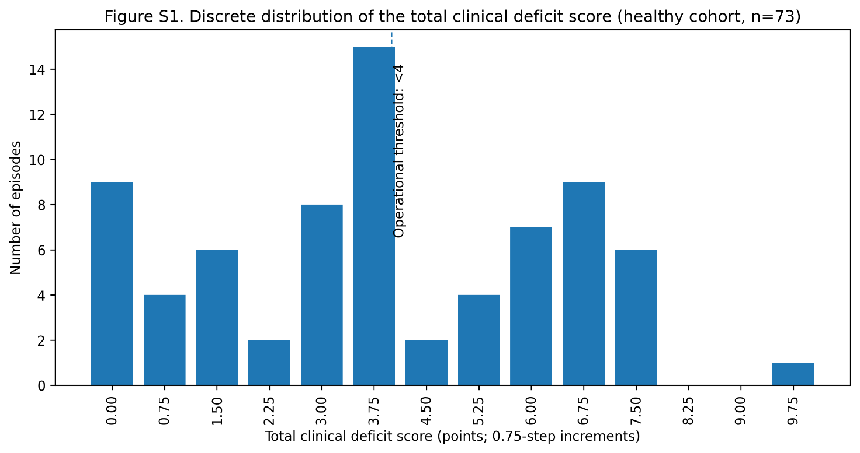
Figure S1. Distribution of total clinical deficit score in the healthy reference cohort.
Histogram of the total clinical deficit score in the healthy reference sample (n=73) assessed using the same WMSSR workflow, evaluator, scoring rules, and equipment as the analytic cohort. The figure presents the descriptive distribution supporting the pragmatic operational discharge threshold.

Figure S2. Mean maximum pain across visits by rehabilitation modality.

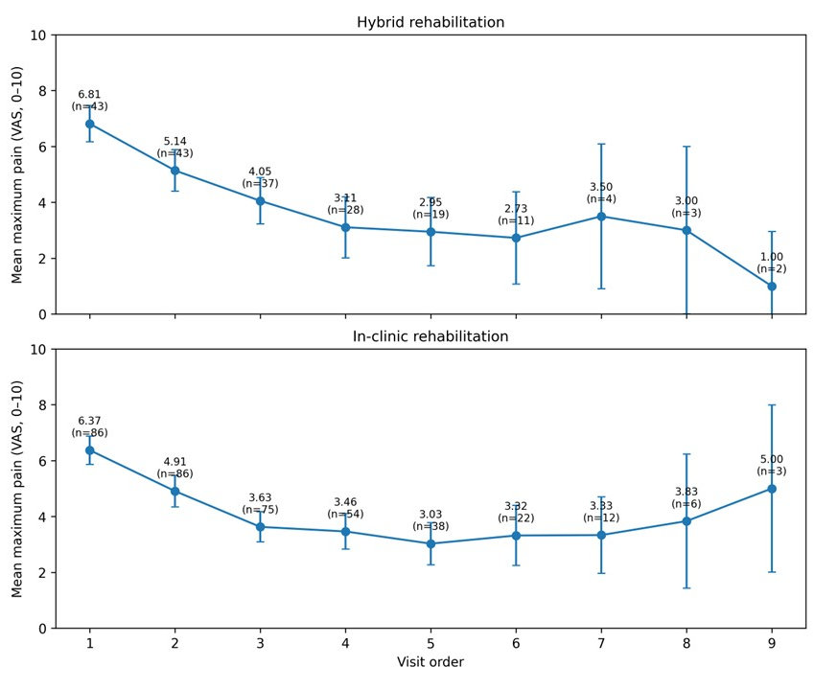
Mean maximum pain per visit (VAS 0–10), shown separately for hybrid and in-clinic rehabilitation across visit order. Error bars represent 95% confidence intervals. Each point is annotated with the mean value and the number of contributing episodes. Later visits are based on progressively fewer episodes and should therefore be interpreted descriptively.

Figure S3. Mean number of painful tests across visits by rehabilitation modality.
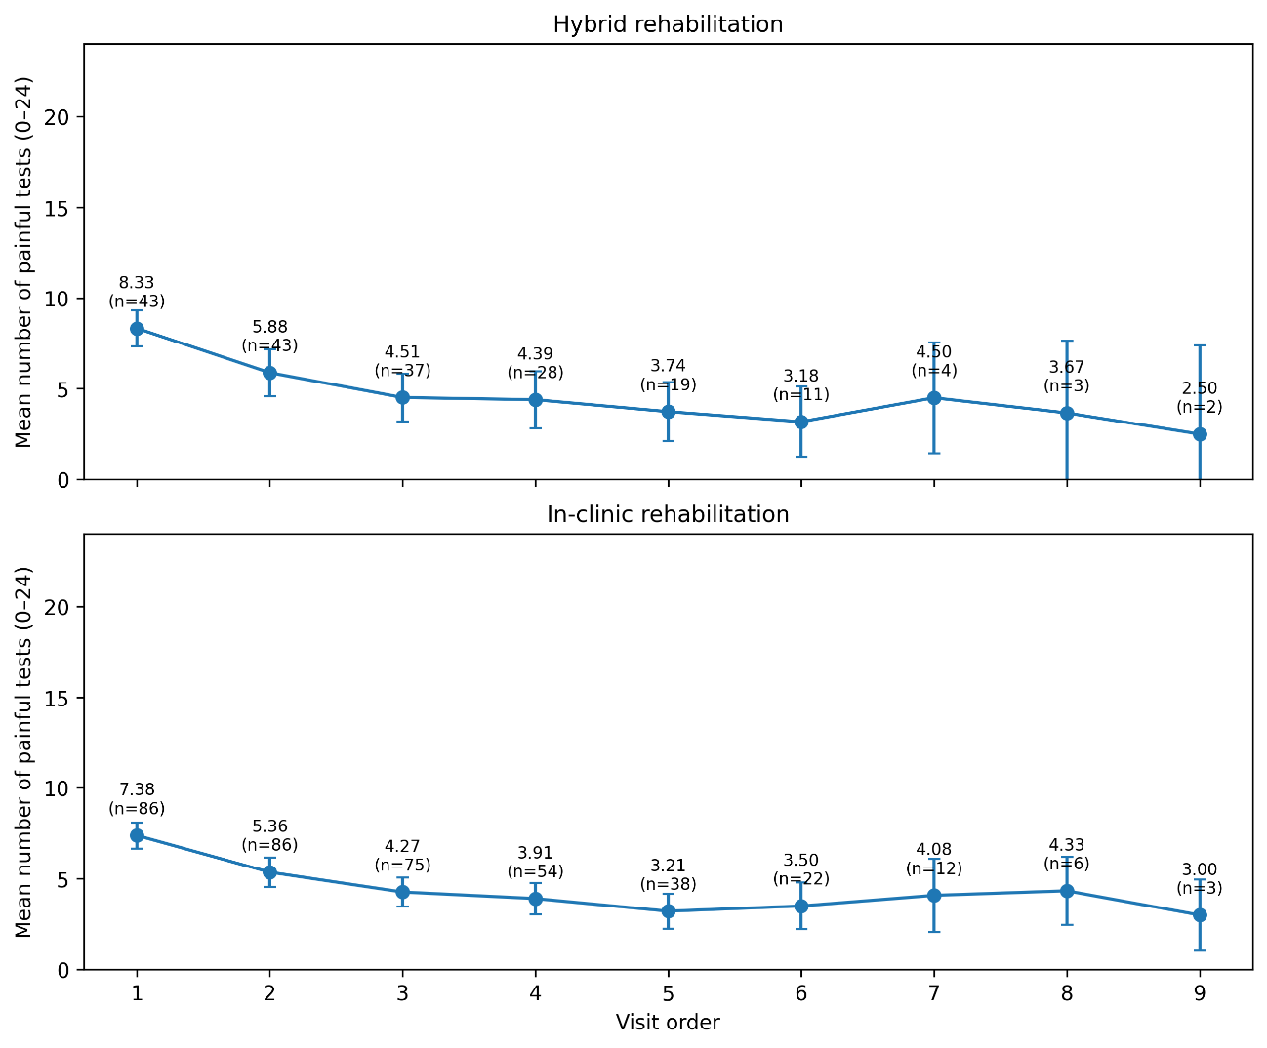
Mean number of painful tests per visit, shown separately for hybrid and in-clinic rehabilitation across visit order. Error bars represent 95% confidence intervals. Each point is annotated with the mean value and the number of contributing episodes. Later visits are based on progressively fewer episodes and should therefore be interpreted descriptively.

Figure S4. Observed total clinical deficit score trajectories before treatment discontinuation.
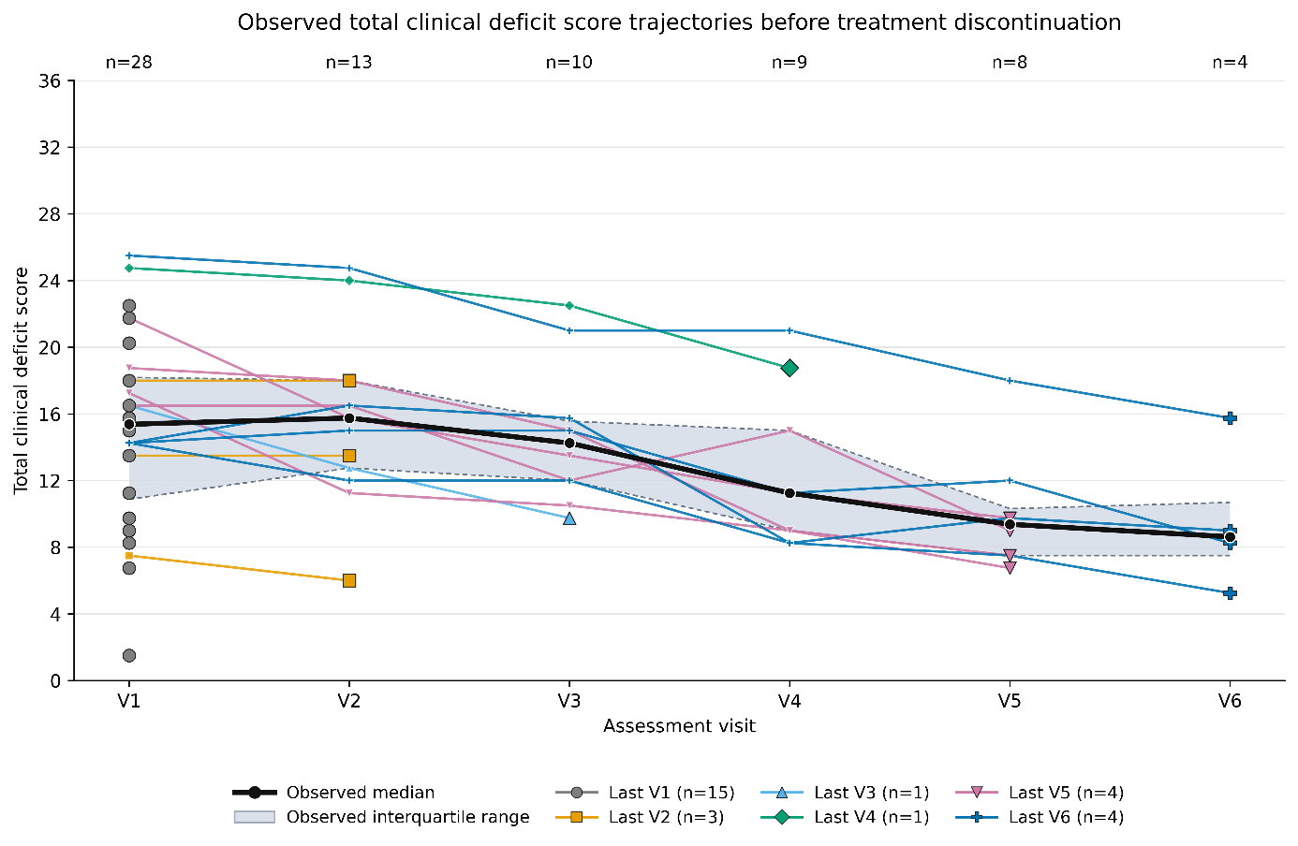
Individual lines represent the observed total clinical deficit score trajectories of rehabilitation episodes discontinued before documented clinical discharge. Colours and marker shapes identify the last observed assessment visit, and the enlarged final marker denotes the last recorded score for each episode. The black line represents the visit-specific median, and the blue-grey shaded area represents the observed interquartile range. Labels above the plotting area indicate the number of episodes contributing data at each visit. No values were imputed after the last observed assessment. Fifteen episodes had only a baseline assessment; among the 13 episodes with follow-up data, 11 had a lower last observed score than at baseline and two were unchanged. Later visits represent progressively smaller selected subsets of the discontinued cohort.

Table S1. Baseline characteristics of completed and incomplete episodes by rehabilitation modality.
Variable | Hybrid completed (n = 43) | Hybrid incomplete (n = 13) | Hybrid SMD | In-clinic completed (n = 86) | In-clinic incomplete (n = 22) | In-clinic SMD
Age (years), mean ± SD | 45.44±12.92 | 41.46±10.71 | 0.32 | 46.98±10.17 | 47.59±12.37 | −0.06
Men, n (%) | 26 (60.5%) | 9 (69.23%) | −0.18 | 41 (47.7%) | 11 (50%) | −0.05
Baseline maximum pain, mean ± SD | 6.81±2.16 | 6.85±1.95 | −0.02 | 6.37±2.39 | 6.82±1.44 | -0.2
Baseline total deficit score, mean ± SD | 15.31±6.19 | 14.71±4.96 | 0.1 | 15.40±5.30 | 15.24± 6.53 | 0.03

Table S2. Covariate balance before and after stabilized inverse probability of treatment weighting in the completed-episode cohort.
Covariate | Absolute SMD before IPTW | Absolute SMD after IPTW
Age | 0.132 | 0.022
Sex | 0.257 | 0.018
Baseline maximum pain | 0.194 | 0.052
Baseline total deficit score | 0.015 | 0.007
Baseline external-rotation deficit | 0.058 | 0.029
Baseline sleeper-test deficit | 0.119 | 0.018
IPTW, inverse probability of treatment weighting; SMD, standardized mean difference. Values are absolute SMDs comparing hybrid and in-clinic rehabilitation episodes. The propensity-score model included age, sex, baseline maximum pain, baseline total deficit score, baseline external-rotation deficit, and baseline sleeper-test deficit.

Table S3. Documented reasons for treatment discontinuation and observed total clinical deficit scores before discontinuation.
Code | Documented reason for discontinuation | Last observed assessment visit | V1 total deficit score | V2 total deficit score | V3 total deficit score | V4 total deficit score | V5 total deficit score | V6 total deficit score
D01 | Work-schedule incompatibility | V2 | 7.50 | 6.00 | — | — | — | —
D02 | Increased workload | V3 | 16.50 | 12.75 | 9.75 | — | — | —
D03 | Scheduled surgery for another condition | V1 | 22.50 | — | — | — | — | —
D04 | Work-schedule incompatibility | V4 | 24.75 | 24.00 | 22.50 | 18.75 | — | —
D05 | Intercurrent upper-limb fracture | V1 | 13.50 | — | — | — | — | —
D06 | Lost to follow-up without notification | V1 | 6.75 | — | — | — | — | —
D07 | Transfer to another rehabilitation provider because of cervical complications | V1 | 15.75 | — | — | — | — | —
D08 | Distance-related transport barriers | V1 | 21.75 | — | — | — | — | —
D09 | Extended travel | V5 | 16.50 | 16.50 | 12.00 | 15.00 | 9.00 | —
D10 | Intercurrent oncological condition | V1 | 11.25 | — | — | — | — | —
D11 | Family illness or caregiving responsibilities | V1 | 9.75 | — | — | — | — | —
D12 | Scheduled surgery for another condition | V1 | 15.00 | — | — | — | — | —
D13 | Lost to follow-up without notification | V1 | 8.25 | — | — | — | — | —
D14 | Newly identified osteoarthritis requiring a change in clinical management | V6 | 25.50 | 24.75 | 21.00 | 21.00 | 18.00 | 15.75
D15 | Lost to follow-up without notification | V1 | 20.25 | — | — | — | — | —
D16 | Intercurrent medical condition requiring prescribed rest | V6 | 14.25 | 16.50 | 15.75 | 8.25 | 9.75 | 9.00
D17 | Frequent work travel | V1 | 9.00 | — | — | — | — | —
D18 | Relocation for personal reasons | V2 | 13.50 | 13.50 | — | — | — | —
D19 | Intercurrent cerebrovascular event | V2 | 18.00 | 18.00 | — | — | — | —
D20 | Lost to follow-up without notification | V1 | 16.50 | — | — | — | — | —
D21 | Scheduled surgery for another condition | V6 | 14.25 | 15.00 | 15.00 | 11.25 | 12.00 | 8.25
D22 | Family illness or caregiving responsibilities | V6 | 14.25 | 12.00 | 12.00 | 8.25 | 7.50 | 5.25
D23 | Lost to follow-up without notification | V5 | 21.75 | 15.75 | 13.50 | 11.25 | 9.75 | —
D24 | Distance-related transport barriers | V5 | 17.25 | 11.25 | 10.50 | 9.00 | 6.75 | —
D25 | Family illness or caregiving responsibilities | V1 | 1.50 | — | — | — | — | —
D26 | Work-related relocation | V5 | 18.75 | 18.00 | 15.00 | 9.00 | 7.50 | —
D27 | Family illness or caregiving responsibilities | V1 | 18.00 | — | — | — | — | —
D28 | Lost to follow-up without notification | V1 | 9.00 | — | — | — | — | —

Values are total clinical deficit scores recorded at each observed assessment visit. Higher scores indicate greater clinical deficit. An em dash indicates that no assessment was available at that visit. “Last observed assessment visit” denotes the final visit with a recorded score and does not necessarily represent the date on which discontinuation was communicated. No values were imputed after the last observed visit. Documented reasons were grouped into non-identifying categories for descriptive reporting. Codes D01–D28 are non-identifying study codes.

