SUPPLEMENTARY FIGURES AND TABLES
Supplementary figure 1. Further characterisation of patient-derived iPSC lines carrying RYR1-pathogenic variants.
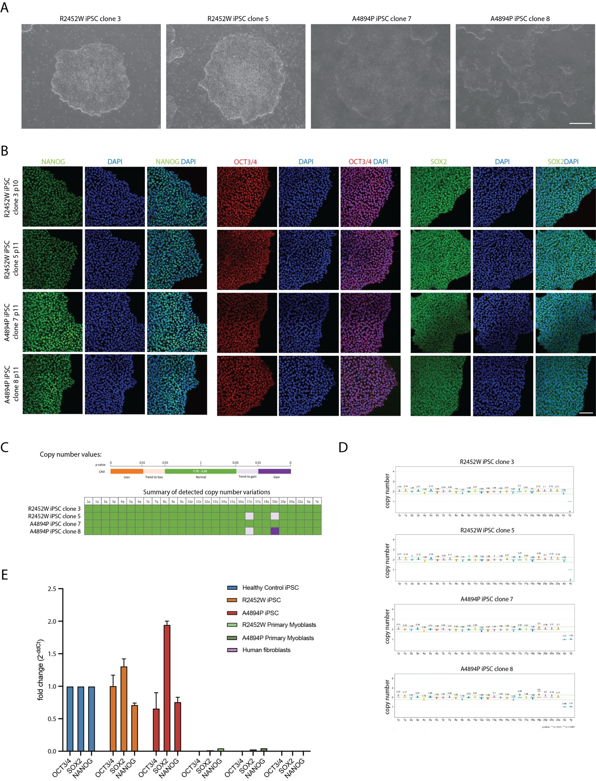
- Brightfield images of iPSC colonies showing colony morphology. Scale bar: 500 µm.
- Immunostaining for NANOG, OCT3/4 and SOX2 in R2452W iPSCs and A4894P iPSCs. 2 clones per line were characterised for pluripotency. Nuclei are counterstained with DAPI. Scale bar: 100 µm.
- Copy number variation analysis on two clones per patient-derived cell line. Analysis performed by Stem Genomics.
- Copy number variation showing single copy number values for each chromosome. Chromosomes with gain in copy number indicated with asterisks.
- Quantitative PCR analysis confirming the expression of pluripotency marker genes OCT3/4, SOX2 and NANOG. Gene expression levels assessed in comparison to a healthy control iPSC line (Healthy Ctrl). Additional controls include the patient-derived primary myoblasts before reprogramming to iPSC, and human fibroblasts.

Supplementary figure 2. Characterisation of iPSC-derived skeletal myogenic cells. 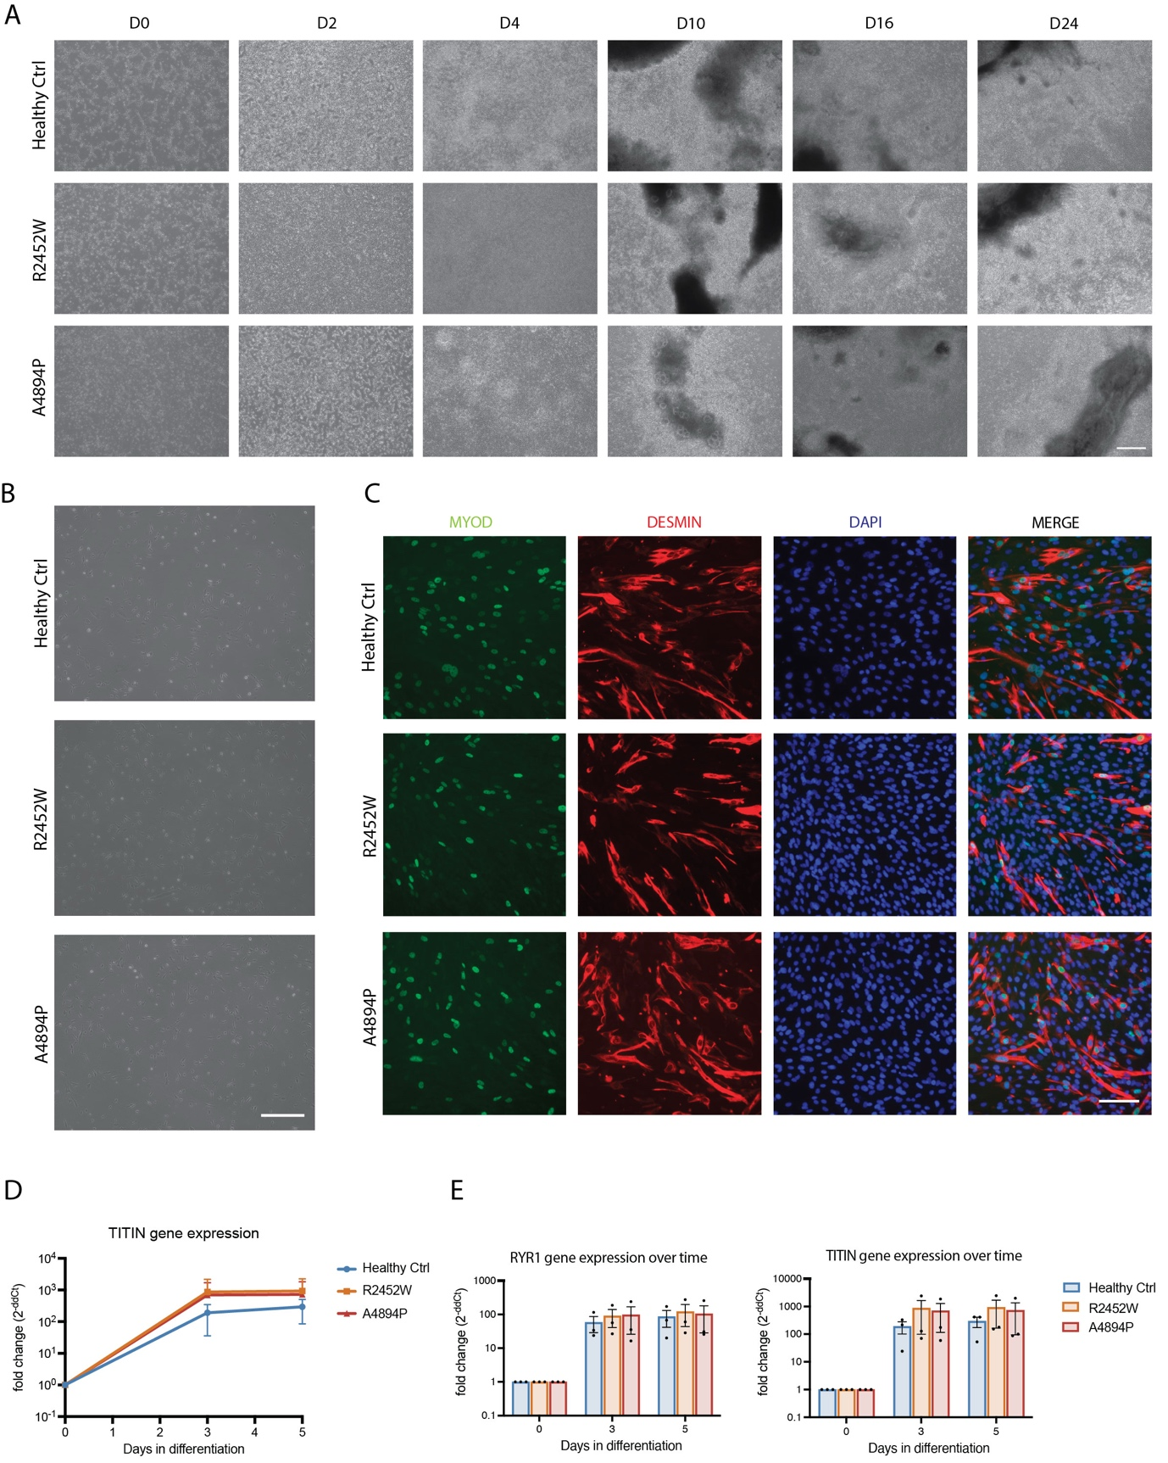
- Brightfield images showing cell morphology during iPSC to myoblasts differentiation, from Day 0 to day 24 of differentiation. Scale bar: 500 µm.
- Brightfield images showing iPSC derived myoblasts morphological appearance when cultured in cell culture flasks during cell expansion in Skeletal Muscle Growth Medium. Scale bar: 500 500 µm.
- Immunofluorescence staining for MYOD and DESMIN in Healthy Ctrl and RYR1 patient-derived myotubes. Nuclei are counterstained with DAPI. Scale bar: 100 µm.
- Quantitative PCR analysis evaluating the expression of TTN over time during terminal differentiation (myoblasts to myotubes). Gene expression levels assessed by comparing the expression at day 3 and at day 5 to the expression at D0 (myoblasts stage). N=3 independent differentiations.
- Quantitative PCR analysis evaluating the expression of TTN over time during terminal differentiation (myoblasts to myotubes). Gene expression levels assessed by comparing the expression at day 3 and at day 5 to the expression at D0 (myoblasts stage). N=3 independent differentiations.
- Bar plots comparing RYR1 and TTN gene expression over time assessed via real time PCR.

Supplementary figure 3. Additional information on phenotypic readouts in RYR1-RM iPSC-derived skeletal myotubes. 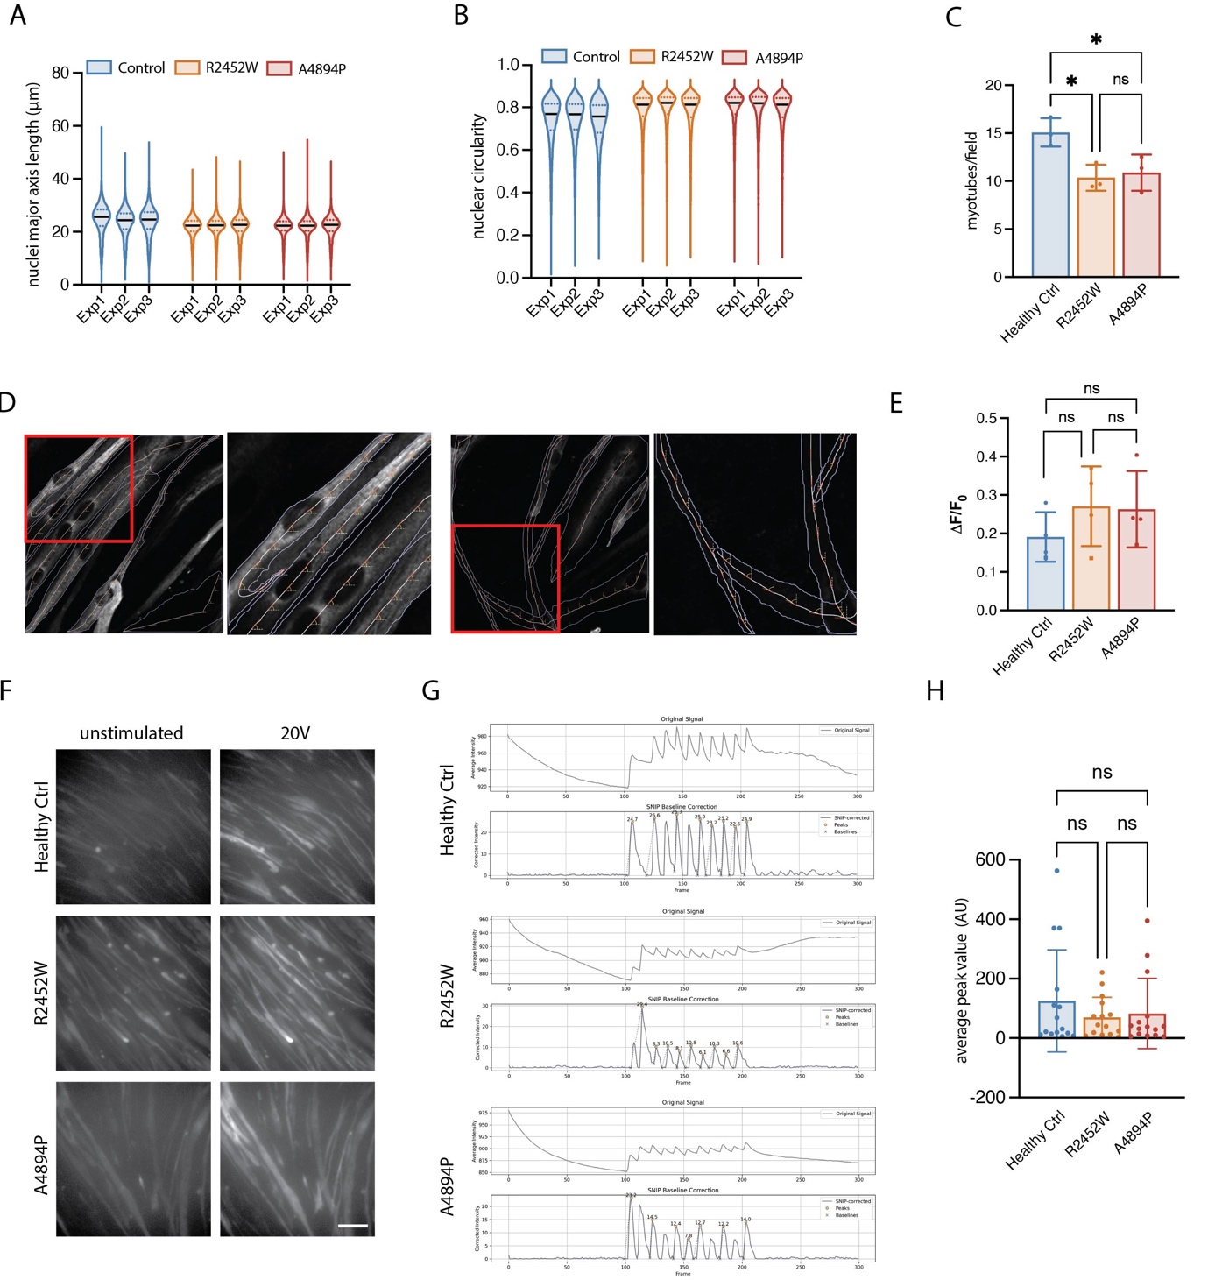
- Nuclear major axis length. Violin plots show the dispersion of nuclei quantitative parameters across three independent experiments, showing consistent behaviour within cell line. N=3 independent experiments; n>19000 nuclei measured for each cell line for each experiment.
- Nuclear circularity. Violin plots show the dispersion of nuclei quantitative parameters across three independent experiments, showing consistent behaviour within cell line. N=3 independent experiments; n>19000 nuclei measured for each cell line for each experiment.
- Quantification of number of myotubes per field, done using the same automatised pipeline. Data points represent the mean number of myotubes per field observed in each independent experiment; error bars indicate standard deviation. N=3 independent experiments. One-way Anova. Healthy Ctrl vs A4894P: *=0.0414. Healthy Ctrl vs R2452W: **=0.0255. R2452W vs A4894P: ns.
- Representative images showing how the myotube directionality analysis was performed. Orange lines represent angles. Circular SD value, quantifying myotube alignment = 8.7 (left image) and 28.4 (right image).
- Quantification of ΔF/F₀ to assess calcium transients following caffeine stimulation, analysis performed on whole field of view. Data points represent the mean value for each independent well, error bars indicate standard deviation. N=2 independent experiments, n=2 wells per cell line. One way Anova. Not significant (ns), p > 0.05.
- Representative frames from live-cell imaging showing GCaMP6 fluorescence before and at the peak of 20V electrical stimulation of myotubes. Scale bar: 100 µm.
- Representative calcium transient traces recorded from myotubes during electrical stimulation.
- Average normalised peak of fluorescence in the field upon 20V electrical stimulation. Each dot represents an independent well analysed. N=4, n=15 wells. Not significant (ns), p > 0.05.

Supplemental Table 1. List of primers used in this study.
Primers used for PCR amplification
Region of interest | forward primer | reverse primer | amplicon length
RYR1 exon 46 | GTCCAATGGGGGAGACGGA | CTTTGCCCAGGGTGGGAAT | 531
RYR1 exon 102 | TCTGGCTGTTGGTCCCTGTC | CCCAGCACTGACCCTGGATG | 335
Primers used for quantitative PCR
gene of interest | forward primer | reverse primer | amplicon length
housekeeping 18S rRNA | GTAACCCGTTGAACCCCATT | CCATCCAATCGGTAGTAGCG | 151
RYR1 | TCAACACGCCGTCTTTCCCT | GTTGGGCTTGCGCTCATTGT | 161
TITIN | GCACGTGGAGACTGTCAAGA | AGCATCTGAGGGGGAGATGT | 214

Supplemental Table 2. List of primary antibodies used in this study.
antibody | company | species | dilution
NANOG | Abcam, ab80892 | Rabbit | 1:200
OCT3/4 | Santa Cruz, sc-5279 | Mouse IgG2b | 1:100
SOX2 | Millipore, AB5603 | Rabbit | 1:200
SMA | Sigma A2547 | Mouse IgG2A | 1:500
GATA4 | Rb anti GATA4 Cell Signaling D3A3M | Rabbit | 1:400
TUJ1 (TUBB3) | Cell Signaling, SDL.3D10 | Mouse IgG2B | 1:500
PAX7 | DSHB, PAX7-s | Mouse IgG1 | 1:50
MYOD1 | Cell Signaling, D8G3 | Rabbit | 1:350
MYOG | DSHB, F5D | Mouse IgG1 | 1:50
TITIN | DSHB, 9D10-s | Mouse IgM | 1:50
MYHC | DSHB, MF20-s | Mouse IgG2b | 1:50
RYR1 | DSHB, 34C-s | Mouse IgG1 | 1:50
DESMIN | Abcam, ab8470 | Mouse IgG1 | 1:200

