Fig. S1 Change of organic acid content with time after ABA, BR and ABA+BR treatment at high temperature. a-d Content of organic acids in ABA-treated grapes was not affected by high temperature; BR had a negative effect on organic acid content at high temperature within 36 hours, while ABA+BR had a positive effect. CK, control; ABA, abscisic acid, BR, brassinolide.
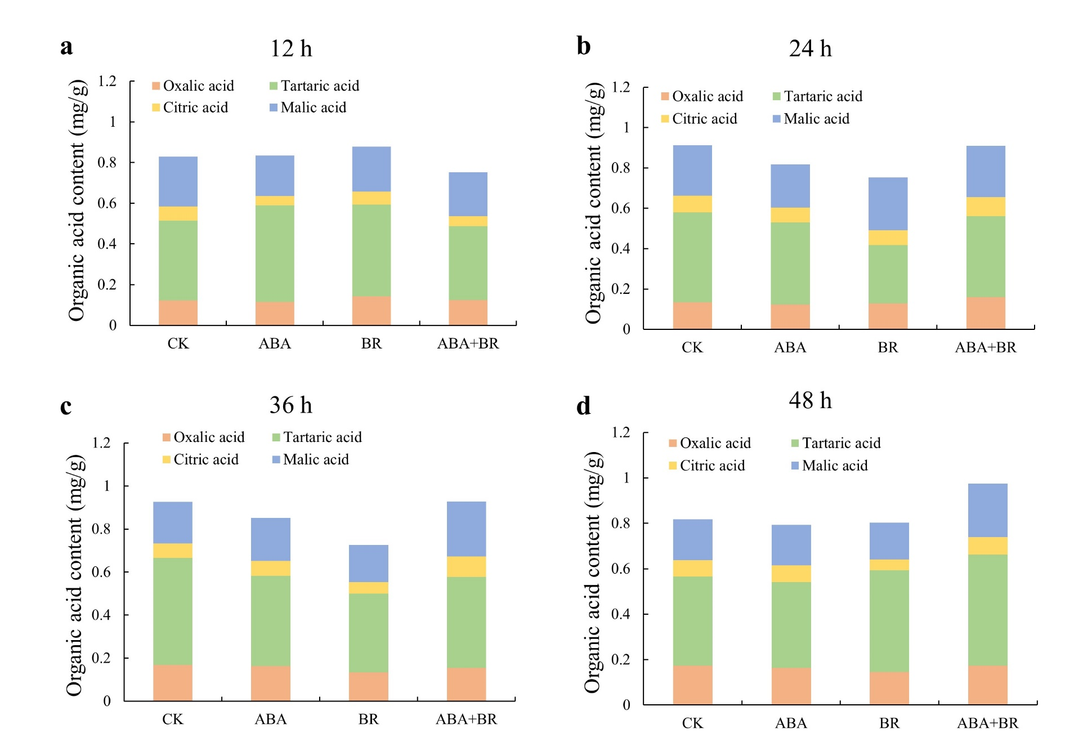

Fig. S2 Mass spectrum of volatile components of grape after ABA, BR, ABA+BR and control treatment under high storage temperature. Alcohols were the main aroma components of grape and linalool was lower in hormone-treated grape (shown by blue arrow). Aldehydes were one of the main aroma components of grape and hexanal was much higher at hormone treated grape (shown by red arrow). CK, control; ABA, abscisic acid, BR, brassinolide.
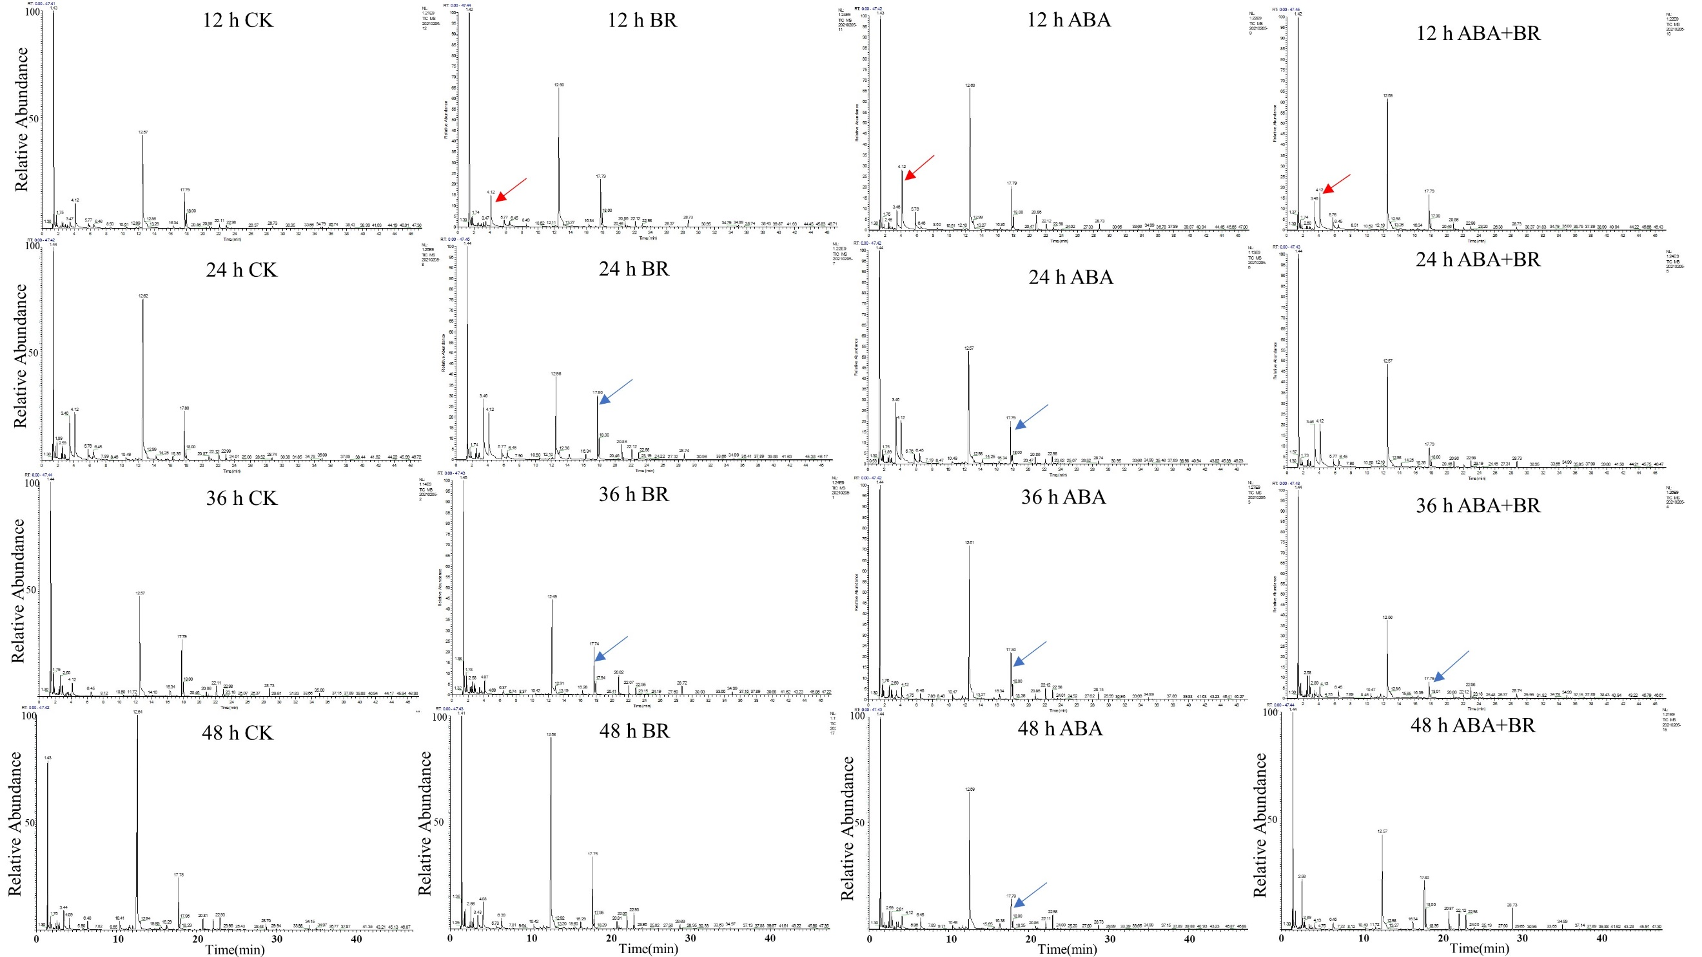

Fig. S3 Scores plot of principal component analysis (PCA) of metabolites extracted from fruit of grape under the control (CK) and the hormone treatment. a PCA of metabolites in pos mode; b PCA of metabolites in pos mode. CK, control; ABA, abscisic acid, BR, brassinolide.
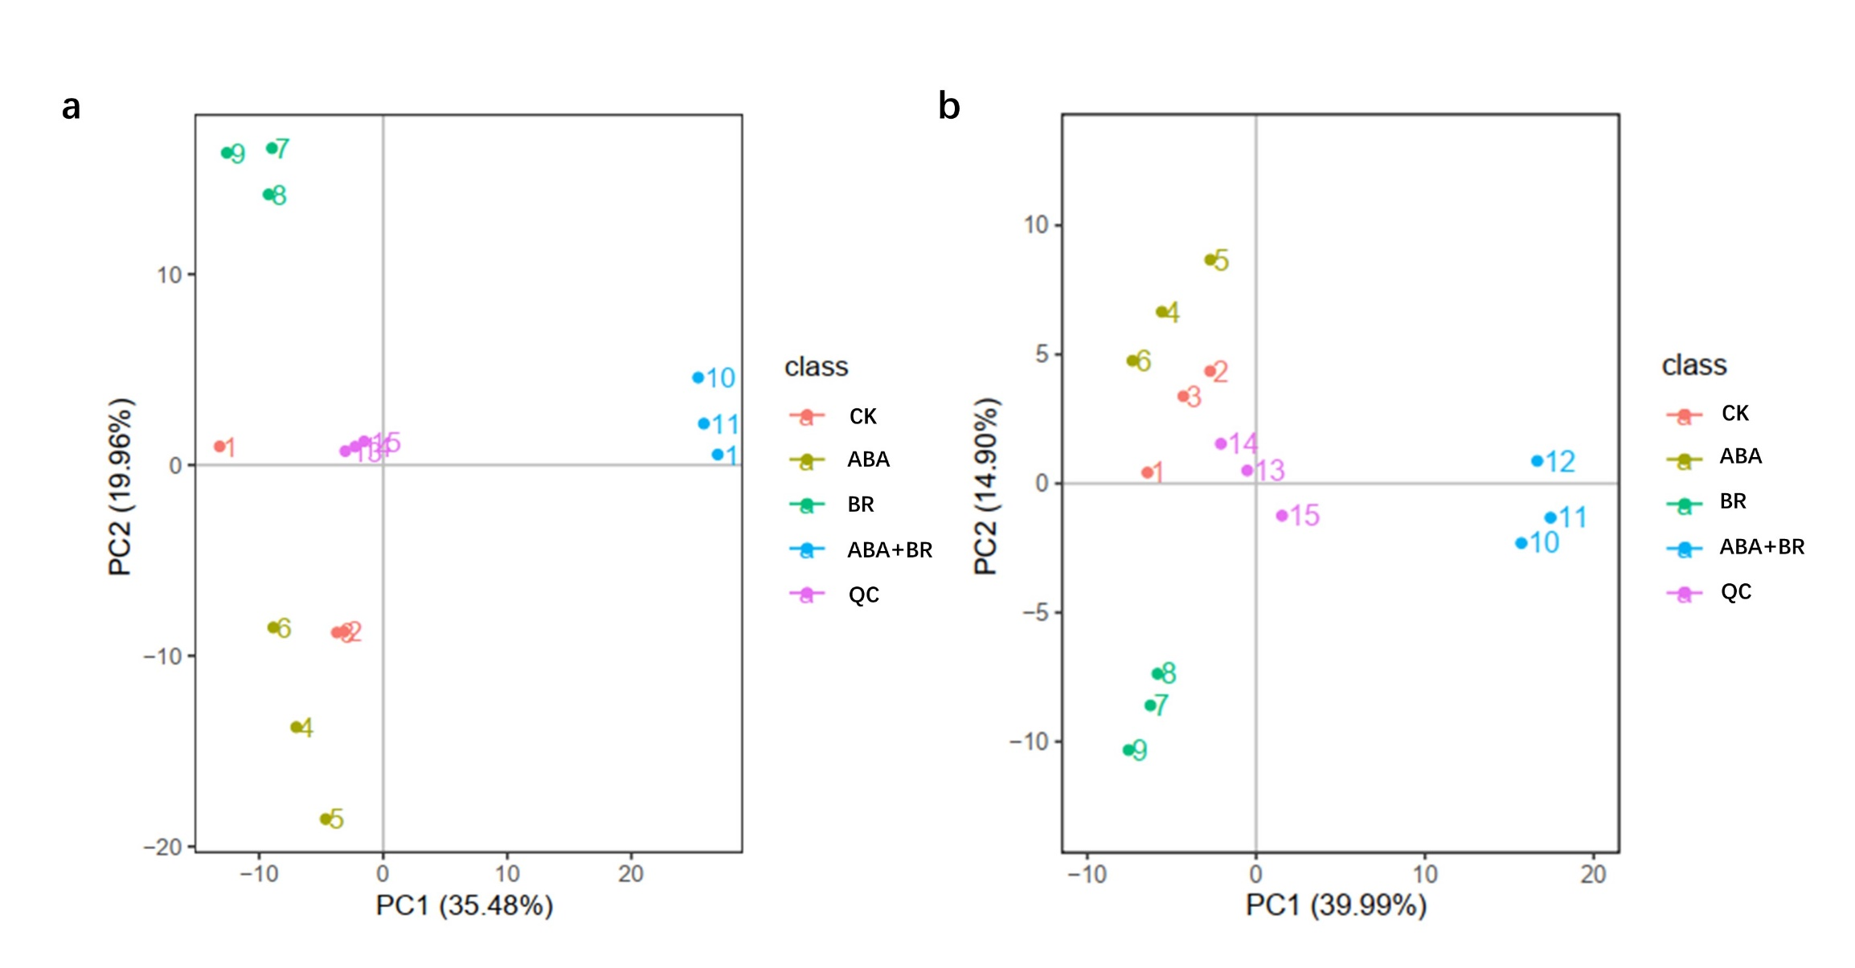

Fig. S4 Heat map analysis of differential metabolites combined with hierarchical cluster analysis of ABA treatment and control (pos and neg mode). a pos mode; b neg mode. The A1, A2, A3 represent three replicates in the control, and the B1, B2, B3 represent three replicates in ABA treatment. CK, control; ABA, abscisic acid.
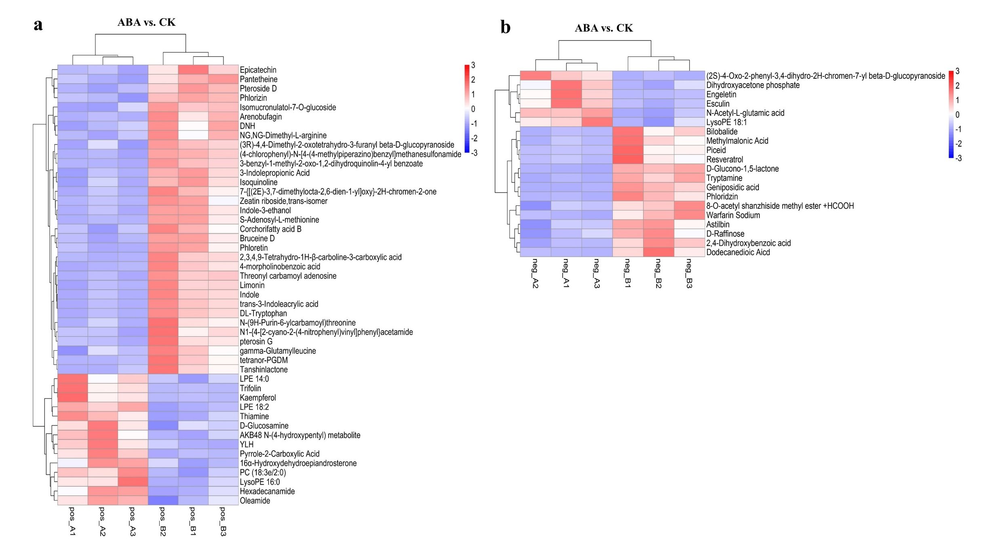

Fig. S5 Heat map analysis of differential metabolites combined with hierarchical cluster analysis of BR treatment and control (pos and neg mode). a pos mode; b neg mode. The A1, A2, A3 represent three replicates in the control, and the C1, C2, C3 represent three replicates in BR treatment. CK, control; BR, brassinolide.
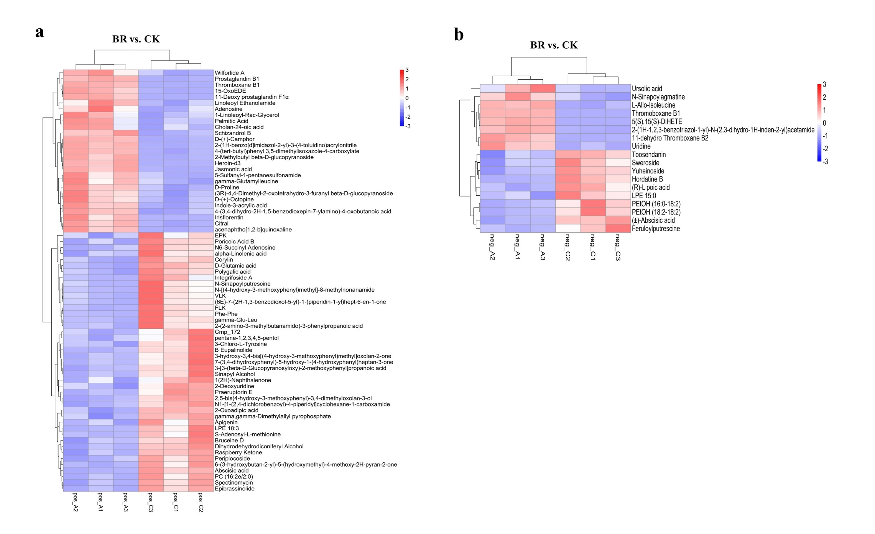

Fig. S6 Heat map analysis of differential metabolites combined with hierarchical cluster analysis of ABA+BR treatment and control (pos and neg mode). a pos mode; b neg mode. The A1, A2, A3 represent three replicates in the control, and the D1, D2, D3 represent three replicates in ABA+BR treatment. CK, control; ABA, abscisic acid, BR, brassinolide.
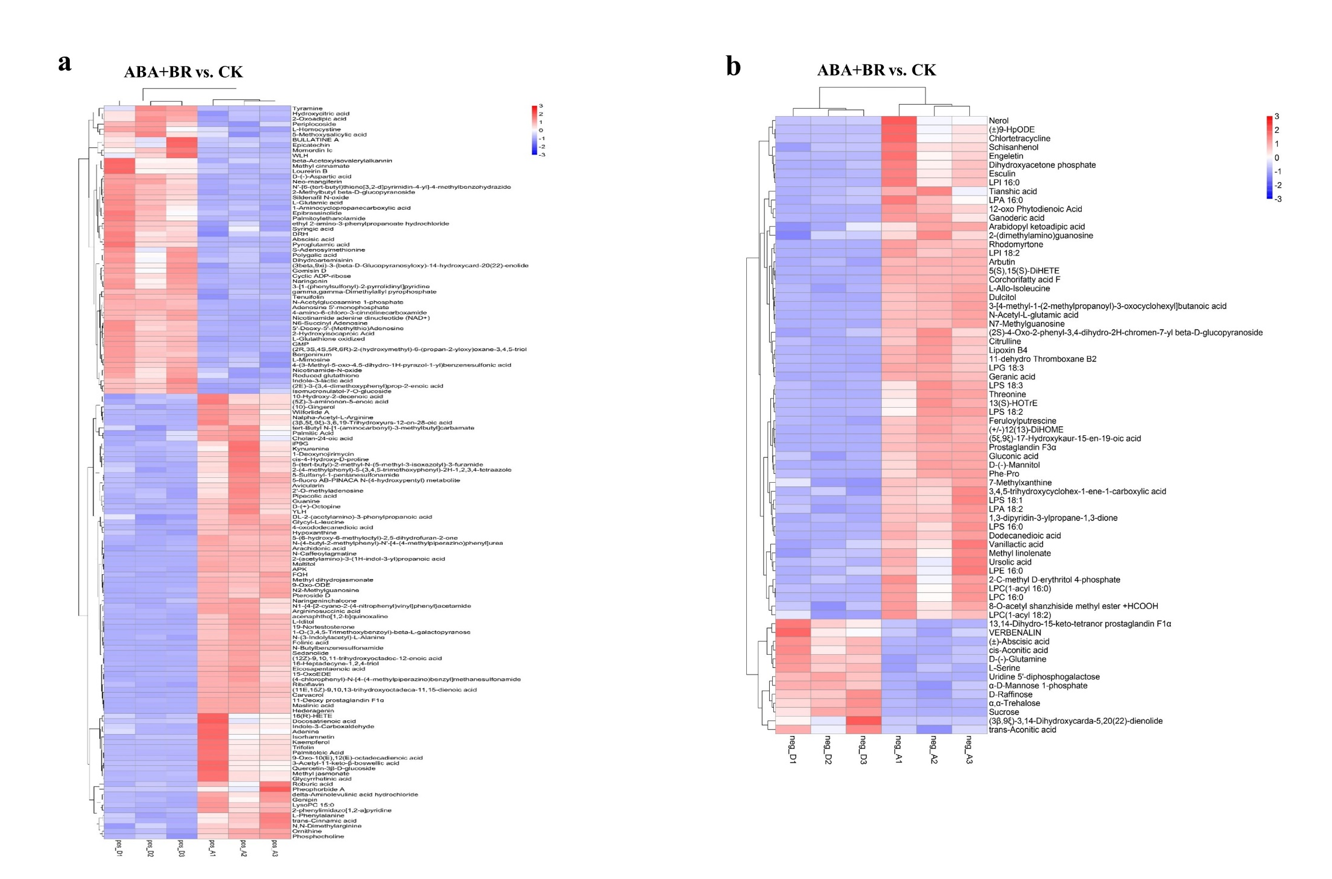

Figure S7 Scatterplot of top 20 enriched metabolic pathways under ABA , BR and ABA+BR treatment. (A, C, E) pos mode; (B, D, F) neg node. Abscissa represents the ratio of the number of differential metabolites in a metabolic pathway to the total number of metabolites identified in the pathway. The larger the value, the higher the enrichment. The size of the dot represents the number of different metabolites in the corresponding pathway. The larger the dot, the more differential metabolites in the pathway.
