Additional file 1
Additional file 1. Supplementary methods, figures, and tables. Supporting material for “Integrating single-cell and bulk transcriptomic perturbation resources reveals complementary therapeutic spaces for drug repurposing.” This file contains Supplementary Algorithms S1 and S2, Supplementary Figures S1 to S3, and Supplementary Table S1. Large reference data tables (Tables S2 to S5) are provided as separate additional files.

Supplementary methods

Algorithm S1. Calculation of the connectivity score

Algorithm S1. Calculation of the connectivity score. Pseudocode describing how disease up- and down-regulated gene sets are scored against each ranked drug perturbation signature using the modified Kolmogorov-Smirnov (KS) statistic to quantify transcriptional reversal.

Algorithm S2. Statistical assessment and candidate selection
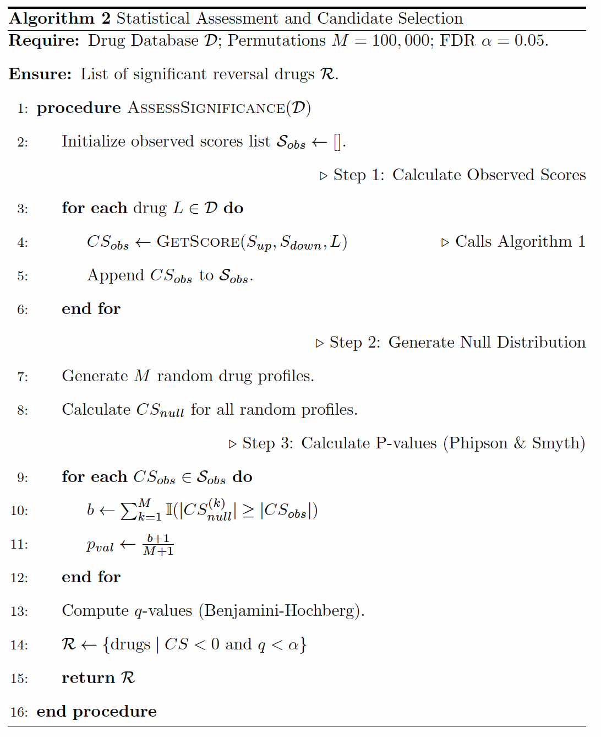
Algorithm S2. Statistical assessment and candidate selection. Pseudocode describing the empirical null model, permutation-based p-value calculation, false discovery rate correction, and thresholding used to nominate significant drug repurposing candidates.

Supplementary figures

Figure S1
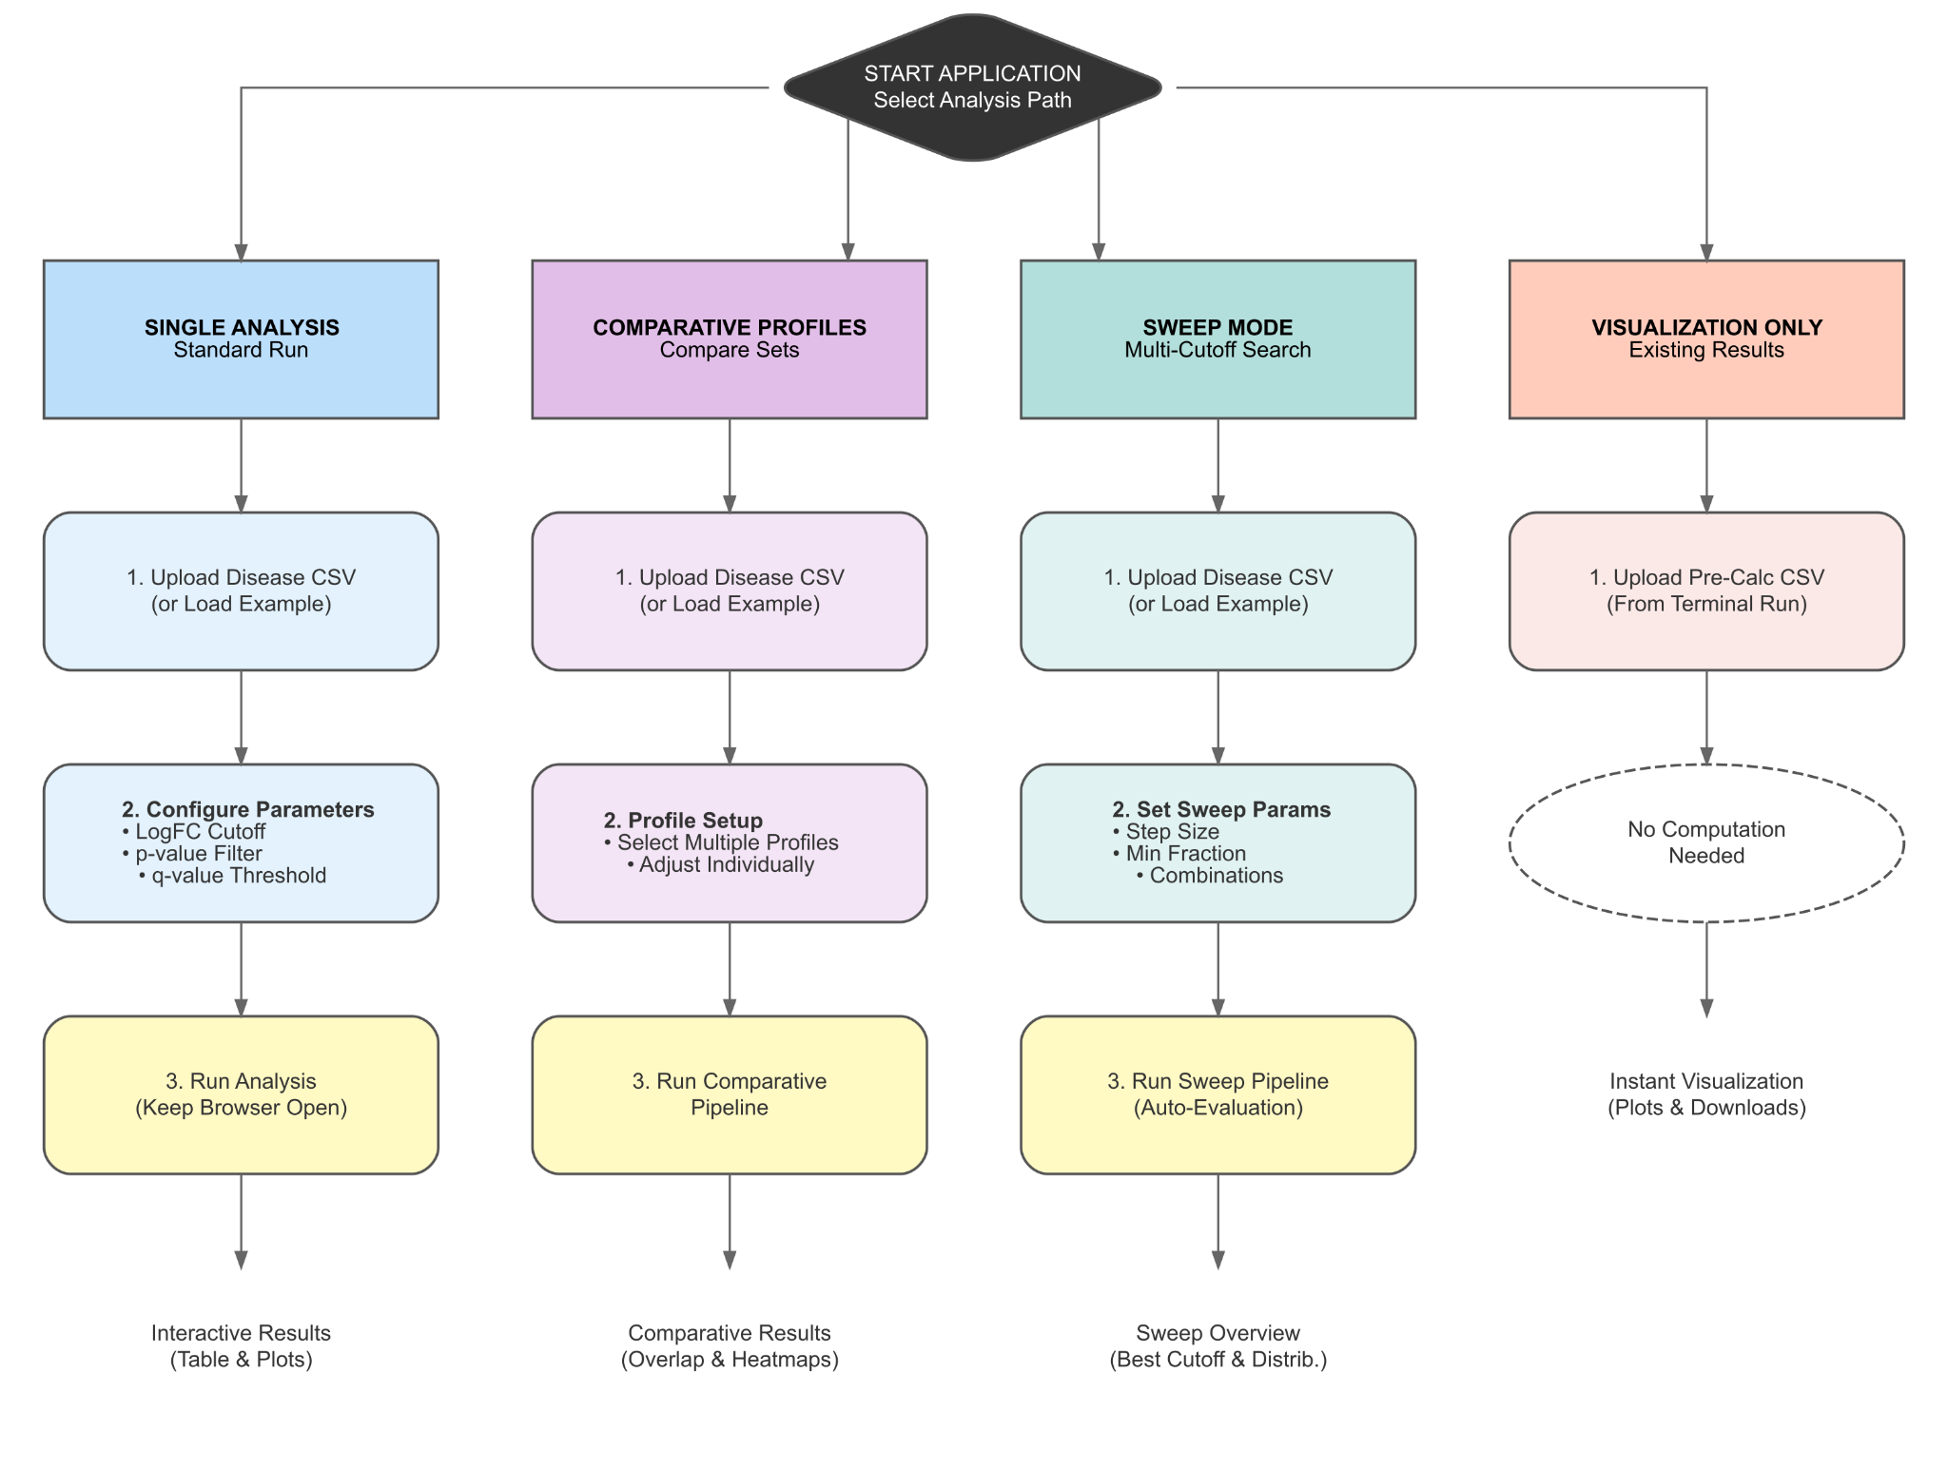
Fig. S1. CDRPipe Shiny Application Workflows. The application interface guides users through four distinct analysis modules starting from the main dashboard: (1) Single Analysis: A standard workflow for running drug repurposing on individual disease signatures. (2) Comparative Profiles: A module for analyzing and contrasting multiple disease sets simultaneously to identify shared or distinct therapeutic signals. (3) Sweep Mode: An optimization tool that performs a multi-cutoff grid search to identify ideal parameter thresholds. (4) Visualization Only: A rapid-access mode for rendering plots from pre-computed results files without re-running the computational pipeline. Each path follows a structured workflow of data upload, parameter configuration, execution, and interactive result exploration.

Figure S2
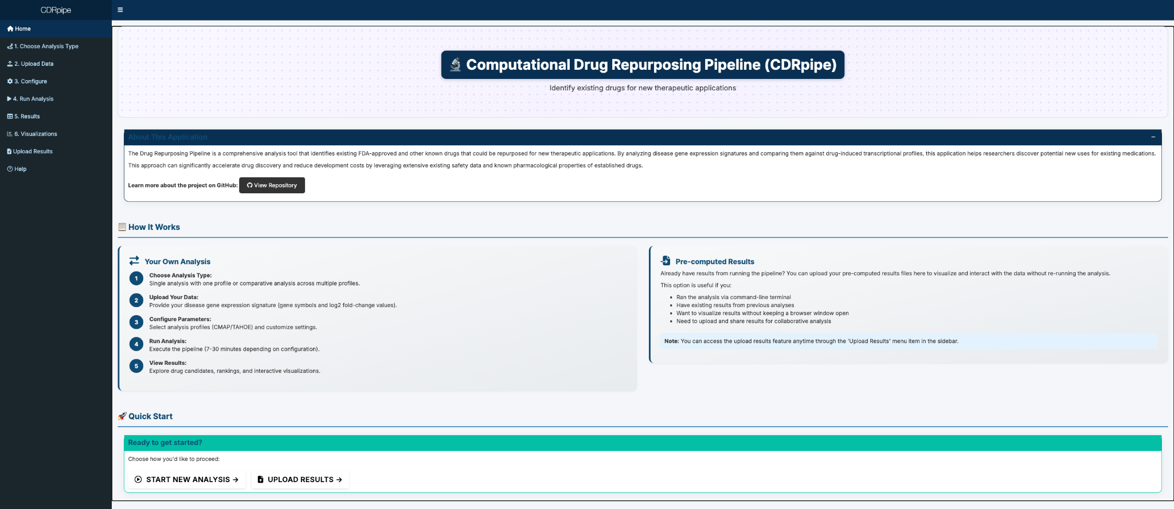
Fig. S2. CDRPipe R Shiny Application Home Page. The figure displays the landing interface of the web application, which serves as the central hub for the CDRPipe workflow. The dashboard features a "How It Works" section that outlines the step-by-step process for conducting a new analysis, from choosing an analysis mode and uploading gene expression signatures to configuring parameters and interpreting results. Additionally, the interface offers a "Pre-computed Results" pathway, allowing users to upload and visualize existing pipeline outputs without re-executing the computational steps. Navigation is facilitated through the sidebar menu and "Quick Start" action buttons.

Figure S3
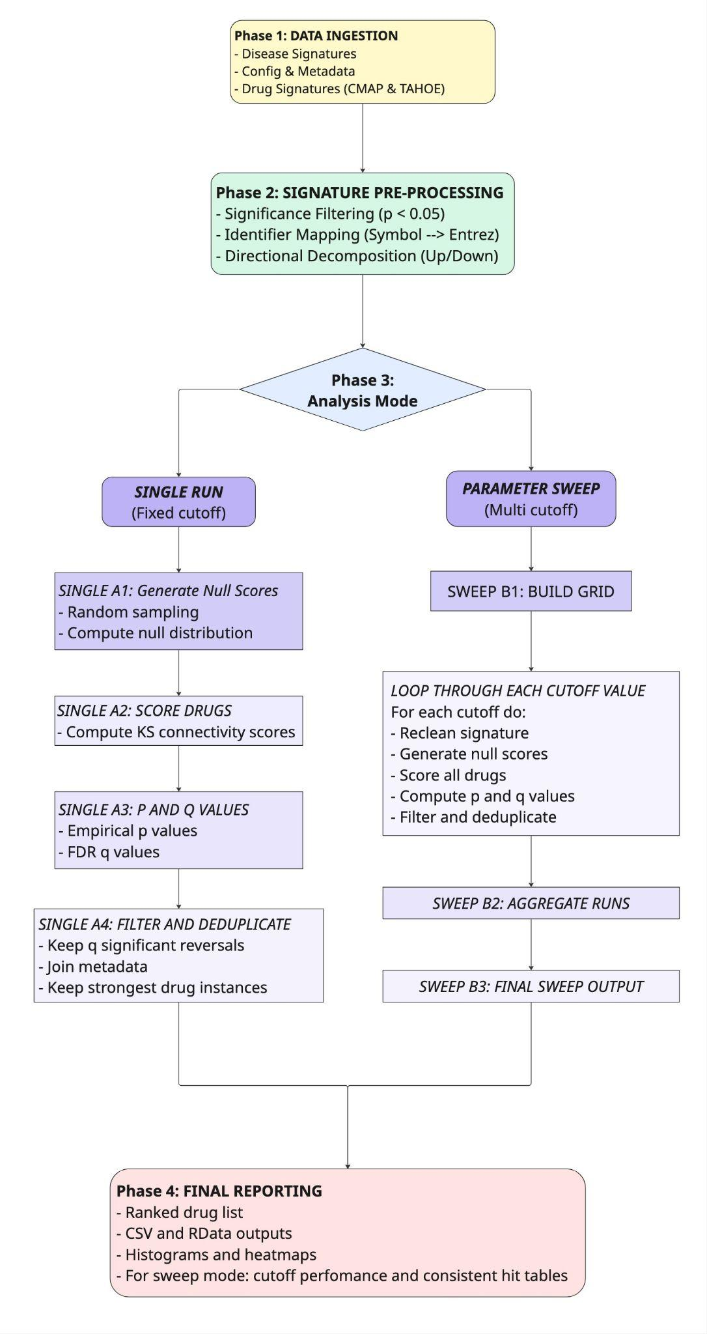
Fig. S3. Schematic overview of the CDRPipe workflow. The pipeline proceeds in four distinct phases: (1) Data Ingestion of disease signatures and drug perturbation profiles (CMAP and Tahoe-100M). (2) Signature Pre-processing, which standardizes inputs via significance filtering (p < 0.05), identifier mapping to Entrez IDs, and directional decomposition into up/down gene sets. (3) Analysis Mode, where users select between a Single Run (using fixed cutoffs) or a Parameter Sweep (optimizing thresholds via grid search). This phase executes the core algorithm: generating null distributions, computing Kolmogorov-Smirnov (KS) connectivity scores, and assessing statistical significance via empirical p-values and FDR correction. (4) Final Reporting, which outputs ranked candidate lists, visualization plots, and comprehensive result tables for downstream validation.

Supplementary tables

Table S1
Disease | Known Drugs (DB) | Available (CMAP) | Hits (CMAP) | Recovered (CMAP) | Recovery Rate (CMAP) | Available (TAHOE) | Hits (TAHOE) | Recovered (TAHOE) | Recovery Rate (TAHOE) | Total Candidates | Total Recovered | Overall Recovery Rate
Scleroderma | 18 | 4 | 300 | 2 | 50.00% | 1 | 230 | 1 | 100.00% | 978 | 3 | 16.67%
Autoimmune thrombocytopenic purpura | 53 | 16 | 28 | 2 | 12.50% | 11 | 379 | 11 | 100.00% | 474 | 13 | 24.53%
Psoriasis | 149 | 20 | 273 | 15 | 75.00% | 14 | 332 | 14 | 100.00% | 574 | 25 | 16.78%
Psoriatic arthritis | 47 | 9 | 5 | 0 | 0.00% | 6 | 365 | 6 | 100.00% | 709 | 6 | 12.77%
Inclusion body myositis | 8 | 1 | 7 | 0 | 0.00% | 1 | 357 | 1 | 100.00% | 419 | 1 | 12.50%
Discoid lupus erythematosus | 9 | 1 | 6 | 0 | 0.00% | 2 | 357 | 2 | 100.00% | 433 | 2 | 22.22%
Dermatomyositis | 29 | 4 | 93 | 0 | 0.00% | 2 | 370 | 2 | 100.00% | 463 | 2 | 6.90%
Sjogren’s syndrome | 39 | 6 | 701 | 4 | 66.67% | 4 | 315 | 4 | 100.00% | 1086 | 8 | 20.51%
Inflammatory bowel disease | 33 | 11 | 109 | 1 | 9.09% | 7 | 345 | 6 | 85.71% | 503 | 6 | 18.18%
Ankylosing spondylitis | 43 | 12 | 7 | 0 | 0.00% | 9 | 272 | 7 | 77.78% | 417 | 7 | 16.28%
Crohn’s disease | 104 | 27 | 102 | 2 | 7.41% | 12 | 332 | 9 | 75.00% | 476 | 11 | 10.58%
Relapsing-remitting multiple sclerosis | 79 | 19 | 679 | 6 | 31.58% | 9 | 248 | 6 | 66.67% | 1065 | 12 | 15.19%
Rheumatoid arthritis | 240 | 45 | 164 | 8 | 17.78% | 25 | 272 | 16 | 64.00% | 859 | 22 | 9.17%
Systemic lupus erythematosus | 103 | 20 | 268 | 8 | 40.00% | 15 | 267 | 9 | 60.00% | 894 | 16 | 15.53%
Ulcerative colitis | 115 | 24 | 68 | 3 | 12.50% | 10 | 207 | 5 | 50.00% | 619 | 8 | 6.96%
Multiple sclerosis | 145 | 43 | 247 | 12 | 27.91% | 16 | 141 | 7 | 43.75% | 774 | 18 | 12.41%
Juvenile idiopathic arthritis (sJIA) | 10 | 11 | 72 | 0 | 0.00% | 8 | 81 | 3 | 37.50% | 191 | 3 | 30.00%
Type 1 diabetes mellitus | 138 | 31 | 201 | 8 | 25.81% | 12 | 178 | 2 | 16.67% | 807 | 10 | 7.25%
Table S1. Comparative Performance Metrics Across 18 Autoimmune Diseases. The table provides a detailed breakdown of drug recovery statistics for each disease analyzed in Case Study 1. Columns quantify the Known Drugs (total validated treatments in Open Targets), the subset Available within each platform’s library, the total number of significant predictions (Hits), and the number of validated predictions (Recovered) for both CMAP and Tahoe-100M. The Recovery Rate columns highlight the performance disparity between the platforms; notably, Tahoe-100M achieves 100% recovery of available known drugs for 8 of the 18 conditions (e.g., Psoriatic Arthritis, Inclusion Body Myositis), whereas CMAP frequently shows 0% recovery for the same indications.

Additional data tables (provided as separate additional files)
- Table S2. CMap drugs list. https://drive.google.com/file/d/1-_eaCW600Tu7tE-cDOyqqC1Xn8KUprof/view
- Table S3. Tahoe-100M drugs list. https://drive.google.com/file/d/1TsjJeYhW-5p_BiENejMCv2EWiSPww0Fd/view
- Table S4. Tahoe-100M and CMap drug overlap list. https://drive.google.com/file/d/13lZhEOnQF0sCBLTutsASkUW-C8lg9Z_T/view
- Table S5. CREEDS disease names list. https://drive.google.com/file/d/1-hL2SkOfaylUiotNCU73zlv9bkxMAq0q/view

