Table S1. Summary of specimen identification numbers, sex, and geographic collection localities. Individual specimen IDs are listed alongside sex (F: female; M: male) and geographic origin (country and state/province). Collection acronyms in the catalog number column indicate the repository (ASNHC: Angelo State Natural History Collection, FMNH: Field Museum of Natural History, MSB: Museum of Southwestern Biology, University of New Mexico, TTU: Museum of Texas Tech University).
Sample ID | Sex | Country | State | Catalog Number
MSB155907 | F | Costa Rica | Guanacaste | MSB:Mamm:155907
MSB155909 | F | Costa Rica | Guanacaste | MSB:Mamm:155909
MSB155914 | F | Costa Rica | Guanacaste | MSB:Mamm:155914
MSB155916 | F | Costa Rica | Guanacaste | MSB:Mamm:155916
MSB155917 | M | Costa Rica | Guanacaste | MSB:Mamm:155917
MSB155920 | M | Costa Rica | Guanacaste | MSB:Mamm:155920
MSB155926 | M | Costa Rica | Guanacaste | MSB:Mamm:155926
TK134514 | F | Ecuador | Guayas | TTU 103604
TK134515 | F | Ecuador | Guayas | TTU 103605
TK134528 | M | Ecuador | Guayas | TTU 103618
TK134529 | M | Ecuador | Guayas | TTU 103619
TK104200 | F | Ecuador | Tungurahua | TTU 84972
TK104208 | F | Ecuador | Tungurahua | TTU 84980
TK104214 | F | Ecuador | Tungurahua | TTU 84986
TK104434 | F | Ecuador | Pastaza | TTU 85206
TK104435 | M | Ecuador | Pastaza | TTU 85207
ASNHC14036 | F | Ecuador | Napo | ASNHC 14036
ASNHC14037 | F | Ecuador | Napo | ASNHC 14037
ASNHC14038 | M | Ecuador | Napo | ASNHC 14038
ASNHC14039 | M | Ecuador | Napo | ASNHC 14039
ASNHC14040 | F | Ecuador | Napo | ASNHC 14040
ASNHC14041 | M | Ecuador | Zamora Chinchipe | ASNHC 14041
ASNHC14042 | F | Ecuador | Azuay | ASNHC 14042
ASNHC14043 | F | Ecuador | Azuay | ASNHC 14043
TK178554 | F | El Salvador | Santa Ana | TTU 137028
TK169259 | M | Guatemala | Peten | TTU 137029
TK169308 | M | Guatemala | Peten | TTU 137030
TK169320 | M | Guatemala | Peten | TTU 137031
TK217504 | M | Guyana | Mahaica-Berbice | TTU 157206
TK217505 | F | Guyana | Mahaica-Berbice | TTU 157207
TK217605 | F | Guyana | Barima-Waini | TTU 157203
TK217606 | F | Guyana | Barima-Waini | TTU 157204
TK217607 | M | Guyana | Barima-Waini | TTU 157205
DR24001 | M | Guyana | Upper Takutu-Upper Essequibo | FMNH 244241
DR24002 | M | Guyana | Upper Takutu-Upper Essequibo | FMNH 244242
DR24003 | M | Guyana | Upper Takutu-Upper Essequibo | FMNH 244243
DR24004 | M | Guyana | Upper Takutu-Upper Essequibo | FMNH 244244
DR24005 | M | Guyana | Upper Takutu-Upper Essequibo | FMNH 244245
DR24006 | M | Guyana | Upper Takutu-Upper Essequibo | FMNH 244246
TK101017 | F | Honduras | Francisco Morazan | TTU 83678
TK101022 | F | Honduras | Francisco Morazan | TTU 83683
TK101023 | M | Honduras | Francisco Morazan | TTU 83684
TK101024 | M | Honduras | Francisco Morazan | TTU 83685
TK148945 | M | Mexico | Tamaulipas | TTU 109712
TK148951 | F | Mexico | Tamaulipas | TTU 109713
TK148959 | M | Mexico | Tamaulipas | TTU 109721
TK148972 | F | Mexico | Tamaulipas | TTU 109734
TK148973 | F | Mexico | Tamaulipas | TTU 109735
TK148974 | M | Mexico | Tamaulipas | TTU 109736
TK148960 | F | Mexico | Tamaulipas | TTU 109722
TK148961 | M | Mexico | Tamaulipas | TTU 109723
ASNHC6982 | M | Mexico | Quintana Roo | ASNHC 6982
MSB262778 | M | Panama | Chiriqui | MSB:Mamm:262778
MSB347332 | F | Panama | Darien | MSB:Mamm:347332
MSB347443 | M | Panama | Darien | MSB:Mamm:347443
MSB347531 | M | Panama | Darien | MSB:Mamm:347531
MSB347532 | M | Panama | Darien | MSB:Mamm:347532
MSB347533 | M | Panama | Darien | MSB:Mamm:347533
MSB347596 | F | Panama | Darien | MSB:Mamm:347596
MSB347599 | M | Panama | Darien | MSB:Mamm:347599
MSB347605 | F | Panama | Darien | MSB:Mamm:347605
MSB347609 | F | Panama | Darien | MSB:Mamm:347609
TK108128 | F | Peru | Loreto | TTU 124736
TK108429 | F | Peru | Loreto | TTU 123879
TK109016 | F | Peru | Loreto | TTU 123880
TK109073 | F | Peru | Loreto | TTU 123881
TK109277 | M | Peru | Loreto | TTU 134498

Supplemental File S1. Detailed Bioinformatic Processing Workflow.
supplementalfileS1.html

Table S2. Alignment and read-length metrics for sequenced samples. This table details key sequencing output and quality metrics, including total aligned read counts, mean genomic coverage depth of aligned reads, and N50 mapped read lengths.
Sample | Number of reads | Mean coverage | N50
MSB155907 | 146,449 | 0.36 | 10,006
MSB155909 | 154,391 | 0.31 | 6,776
MSB155914 | 424,161 | 0.38 | 1,635
MSB155916 | 190,431 | 0.32 | 5,219
MSB155917 | 143,069 | 0.31 | 8,421
MSB155920 | 254,070 | 0.25 | 2,491
MSB155926 | 343,435 | 0.55 | 5,975
ASNHC14036 | 63,440 | 0.01 | 250
ASNHC14037 | 8,248 | 0.01 | 802
ASNHC14038 | 16,506 | 0.01 | 684
ASNHC14039 | 11,954 | 0.01 | 711
ASNHC14040 | 85,482 | 0.02 | 292
ASNHC14041 | 285,677 | 0.07 | 344
ASNHC14042 | 346,478 | 0.22 | 1,263
ASNHC14043 | 413,444 | 0.14 | 509
TK104200 | 2,064,839 | 0.83 | 563
TK104208 | 2,016,733 | 1.06 | 906
TK104214 | 450,932 | 0.43 | 1,515
TK104434 | 1,144,019 | 0.51 | 722
TK104435 | 180,778 | 0.31 | 3,432
TK134514 | 552,279 | 0.43 | 3,131
TK134515 | 146,959 | 0.29 | 7,249
TK134528 | 1,133,233 | 0.7 | 1,424
TK134529 | 270,089 | 0.39 | 4,209
TK178554 | 187,019 | 0.21 | 1,463
TK169259 | 276,873 | 0.35 | 1,789
TK169308 | 565,237 | 0.28 | 846
TK169320 | 295,728 | 0.35 | 2,793
DR24001 | 338,024 | 0.41 | 5,610
DR24002 | 117,881 | 0.15 | 5,636
DR24003 | 216,395 | 0.31 | 5,967
DR24004 | 370,751 | 0.42 | 5,290
DR24005 | 466,563 | 0.56 | 5,113
DR24006 | 301,578 | 0.37 | 5,007
TK217504 | 290,945 | 0.11 | 536
TK217505 | 503,082 | 0.21 | 555
TK217605 | 151,153 | 0.05 | 406
TK217606 | 542,612 | 0.23 | 599
TK217607 | 287,193 | 0.12 | 565
TK101017 | 464,558 | 0.36 | 1,612
TK101022 | 726,731 | 0.62 | 1,266
TK101023 | 1,304,805 | 0.69 | 782
TK101024 | 1,149,883 | 0.55 | 696
ASNHC6982 | 350,829 | 0.23 | 2,672
TK148945 | 219,003 | 0.15 | 1,900
TK148951 | 591,430 | 0.16 | 409
TK148959 | 570,342 | 0.1 | 229
TK148960 | 428,595 | 0.31 | 1,749
TK148961 | 1,107,131 | 0.68 | 1,181
TK148972 | 415,783 | 0.17 | 627
TK148973 | 324,919 | 0.2 | 1,251
TK148974 | 474,331 | 0.22 | 752
MSB262778 | 1,405,101 | 0.68 | 742
MSB347332 | 1,649,980 | 0.71 | 607
MSB347443 | 1,473,453 | 0.26 | 262
MSB347531 | 364,405 | 0.26 | 1,108
MSB347532 | 1,123,449 | 0.24 | 267
MSB347533 | 1,717,128 | 0.61 | 453
MSB347596 | 755,074 | 0.26 | 442
MSB347599 | 1,678,802 | 0.51 | 363
MSB347605 | 2,463,377 | 0.55 | 269
MSB347609 | 1,142,481 | 0.2 | 265
TK108128 | 2,526,454 | 1.1 | 588
TK108429 | 226,517 | 0.22 | 1,303
TK109016 | 404,836 | 0.3 | 1,152
TK109073 | 660,817 | 0.69 | 2,056
TK109277 | 199,105 | 0.29 | 2,017

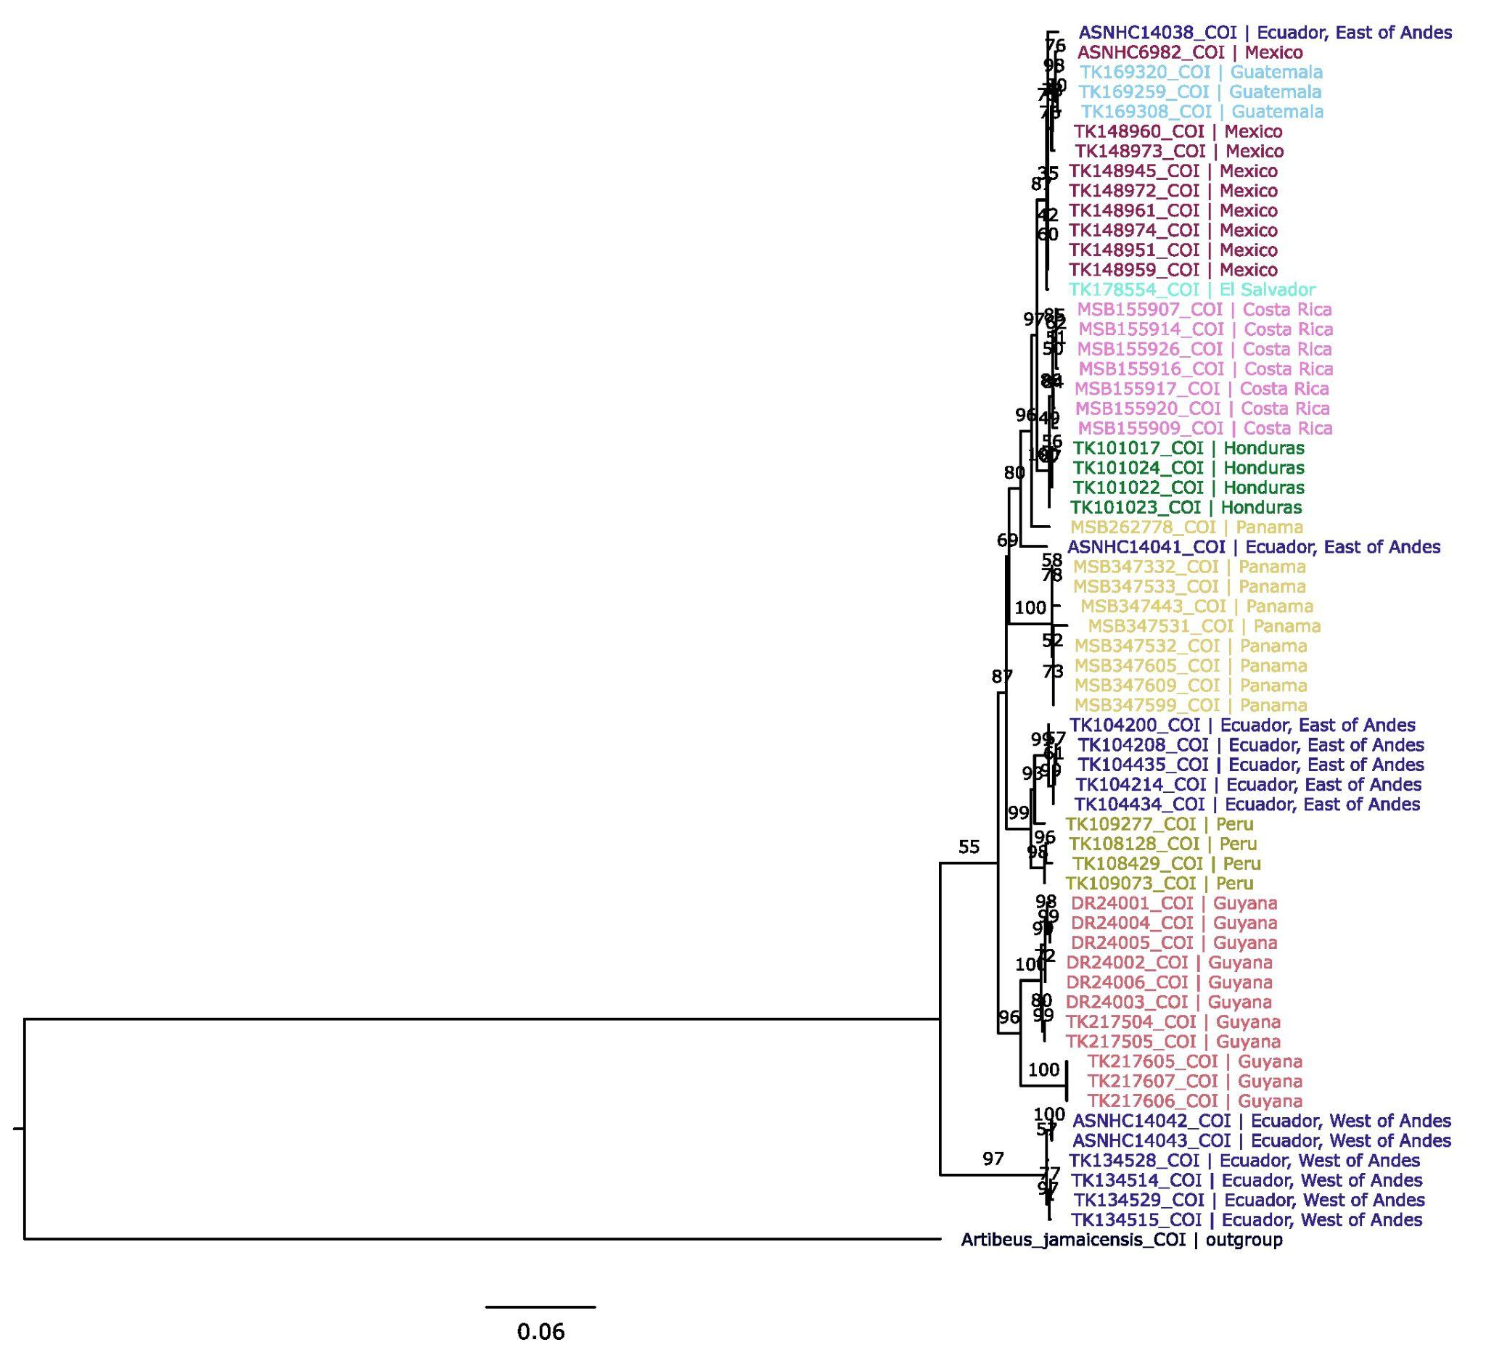
Figure S1. Maximum likelihood phylogenetic tree of Desmodus based on the COI gene. Phylogenetic relationships among Desmodus specimens based on cytochrome c oxidase subunit I (COI) mitochondrial DNA sequences. Node labels represent bootstrap support values. Individual terminal taxa are labeled by specimen voucher ID, target gene, and country of geographic origin, color-coded by country. Artibeus jamaicensis serves as the outgroup to root the tree. Scale bar represents 0.06 substitutions per site.

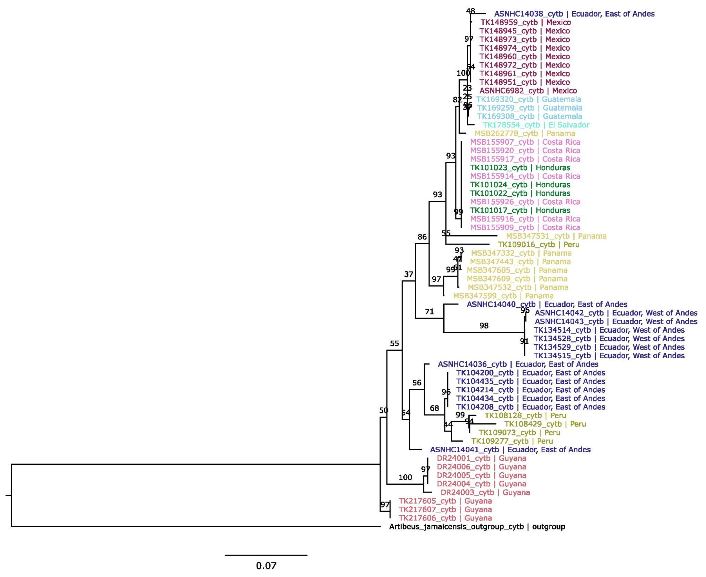
Figure S2. Maximum likelihood phylogenetic tree of Desmodus based on CYTB. Phylogenetic relationships among Desmodus based on mitochondrial cytochrome b (cytb) gene sequences. Node labels represent bootstrap support values. Terminal tips are designated by specimen voucher ID, target gene, and country of geographic origin, color-coded by country. Artibeus jamaicensis is included as the outgroup to root the tree. Scale bar represents 0.07 nucleotide substitutions per site.
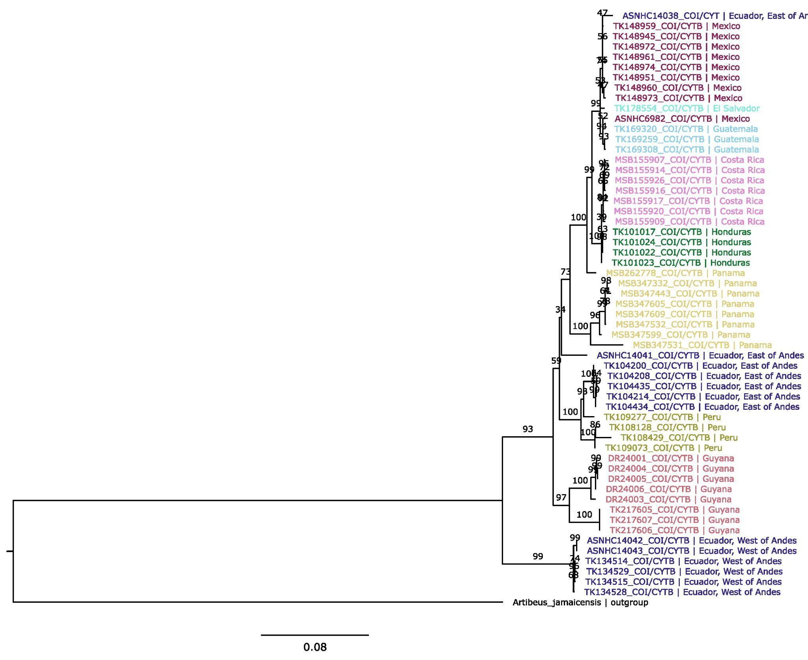
Figure S3. Maximum likelihood phylogenetic tree of Desmodus based on COI and CYTB. Phylogenetic relationships among Desmodus specimens based on a concatenated dataset of mitochondrial cytochrome c oxidase subunit I (COI) and cytochrome b (CYTB) gene sequences. Node labels represent bootstrap support values. Terminal tips are designated by specimen voucher ID, target genes, and country of geographic origin, color-coded by country. Artibeus jamaicensis is included as the outgroup to root the tree. Scale bar represents 0.08 nucleotide substitutions per site.
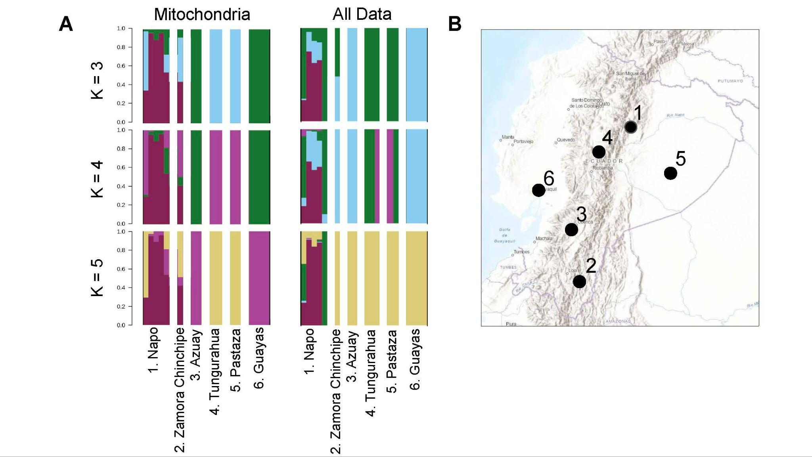

Figure S4. Genetic population structure of Desmodus rotundus across Ecuadorian provinces using mitochondrial and combined datasets. (A) Bar plots display the inferred genetic structure for assumed ancestral population sizes K = 3 through K = 5, derived from mitochondrial markers (left) and the complete genetic dataset (center). These plots reflect the same clustering analyses presented in Figure 5 (All Data) and Figure 6 (Mitochondrial Data), subset here to display only Ecuadorian samples grouped by province. Individual D. rotundus specimens are arranged along the x-axis by sampling location: 1. Napo, 2. Zamora Chinchipe, 3. Azuay, 4. Tungurahua, 5. Pastaza, and 6. Guayas. Colors denote proportional membership in each of the K ancestral clusters. (B) The topographical map of Ecuador indicates the geographic origins of the sampled populations, with numbered black nodes (1–6) corresponding directly to the province labels on the x-axis of the structure plots.

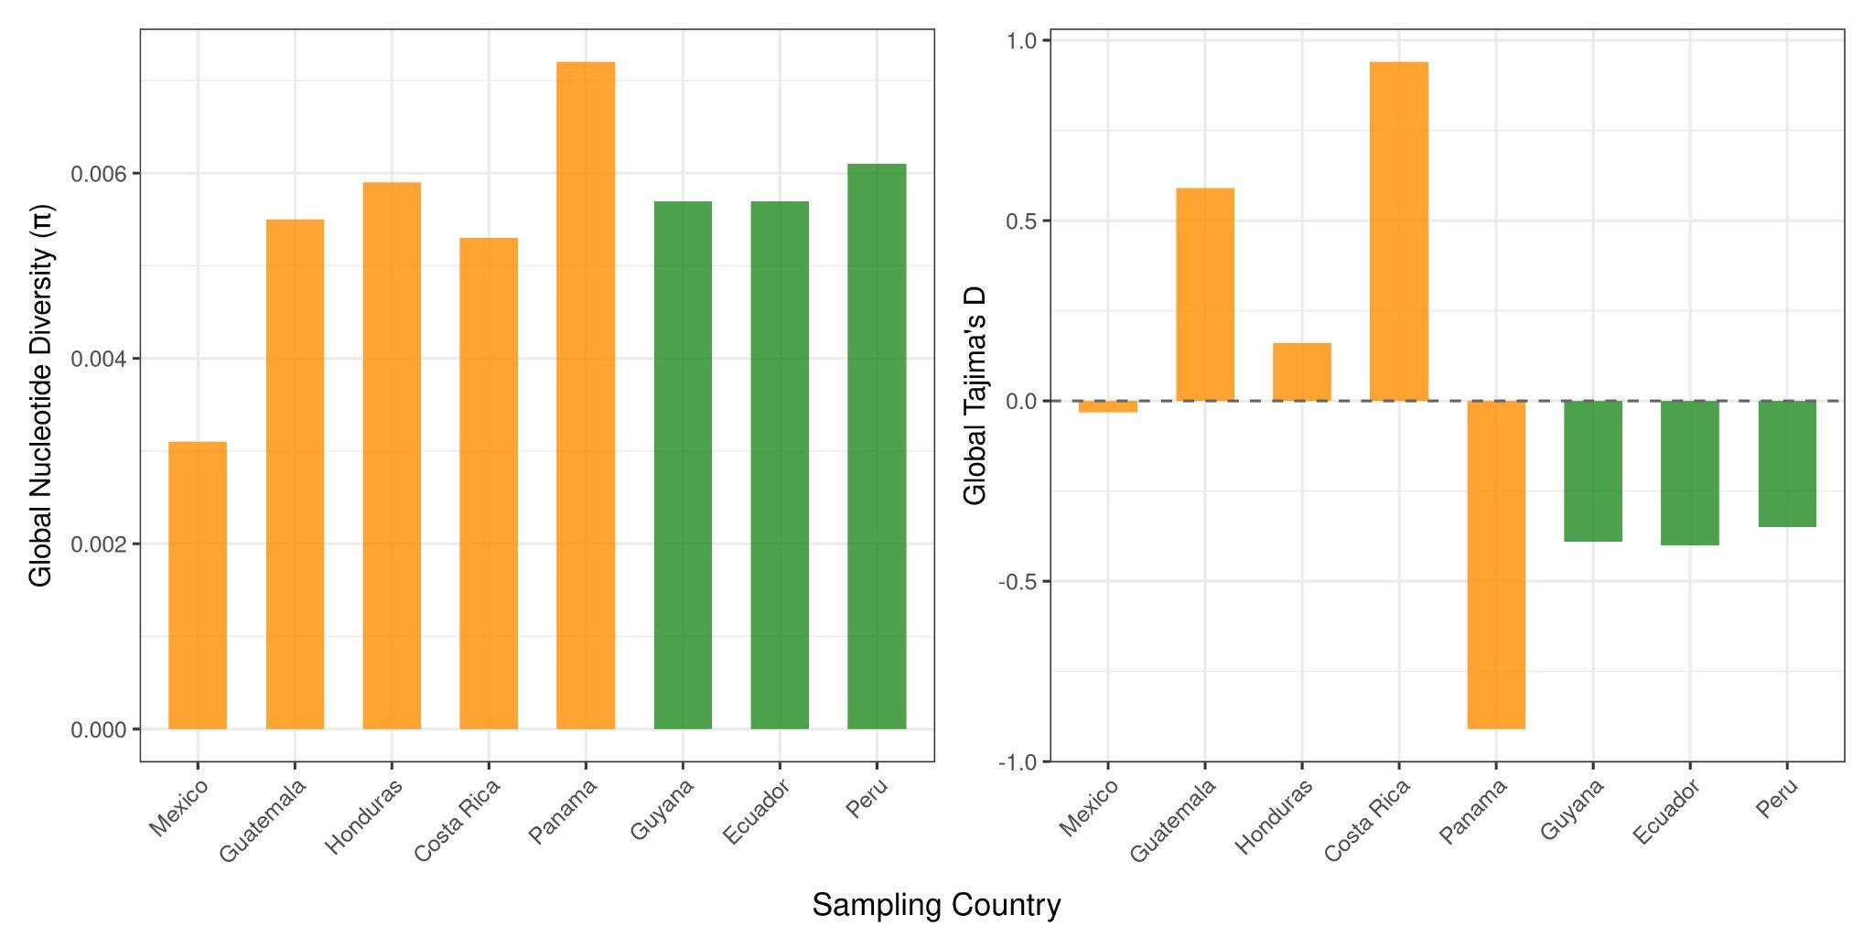
Figure S5. Global nucleotide diversity and Tajima’s D across Chromosome 1 (NC_071387.1) in Desmodus rotundus geographic populations.
Bar plots illustrating global nucleotide diversity (π) and Global Tajima’s D summary statistics calculated across sampling countries for Desmodus rotundus. Populations are color-coded by region, with Central American localities shown in orange (Mexico, Guatemala, Honduras, Costa Rica, Panama) and South American localities shown in green (Guyana, Ecuador, Peru). The left panel displays the average number of nucleotide differences per site (π). Panama exhibits the highest overall genetic diversity (π = 0.007), while the northernmost population in Mexico displays the lowest genetic diversity (π= 0.003). The right panel displays Tajima’s D. This shows deviations from neutral evolutionary expectations (dashed line at D = 0). Positive values observed in Guatemala, Honduras, and Costa Rica suggest a potential recent population bottleneck or balancing selection. The negative value in Panama (D = -0.9) and moderately negative values across South American populations (Guyana, Ecuador, and Peru) indicate an excess of rare alleles, consistent with recent population expansion or purifying selection following a bottleneck.

Table S3. Population genetic diversity and neutrality metrics for Chromosome 1 (NC_071387.1) in Desmodus rotundus.
Summary of genetic diversity metrics and neutrality tests calculated across regional populations and individual countries for Chromosome 1 in Desmodus rotundus. Columns define the sampling population, the total number of high-quality nucleotide positions analyzed (nsites) following filtering, per-site Watterson’s estimator (theta_W), and per-site nucleotide diversity (pi). Deviations from standard neutral equilibrium models are quantified via Tajima’s D.
Population | Sites Analyzed (nsites) | Per-Site theta_W | Per-Site Pi | Tajima's D
South America | 24,098 | 0.0042 | 0.0045 | 0.24
Central America | 273,091 | 0.0075 | 0.0059 | -0.73
Mexico | 207,237 | 0.0033 | 0.0031 | -0.32
Guatemala | 25,999,875 | 0.0051 | 0.0055 | 0.59
Honduras | 78,143,422 | 0.0057 | 0.0059 | 0.16
Costa Rica | 57,211,445 | 0.0044 | 0.0053 | 0.94
Panama | 16,889,963 | 0.0092 | 0.0072 | -0.91
Guyana | 8,854,623 | 0.0063 | 0.0057 | -0.39
Ecuador | 829,496 | 0.0064 | 0.0057 | -0.40
Peru | 94,079,150 | 0.0066 | 0.0061 | -0.35

