SUPPLEMENTARY MATERIALS
Mean reversion over time to the optimal group size in a colobus monkey
Julie A. Teichroeb¹, Edward Mujjuzi² & Samantha M. Stead^{1,3}
¹Department of Anthropology
University of Toronto Scarborough

²Rwenzori Colobus Project
Nabugabo, Uganda

³Department of Pediatrics and Child Health
University of Manitoba

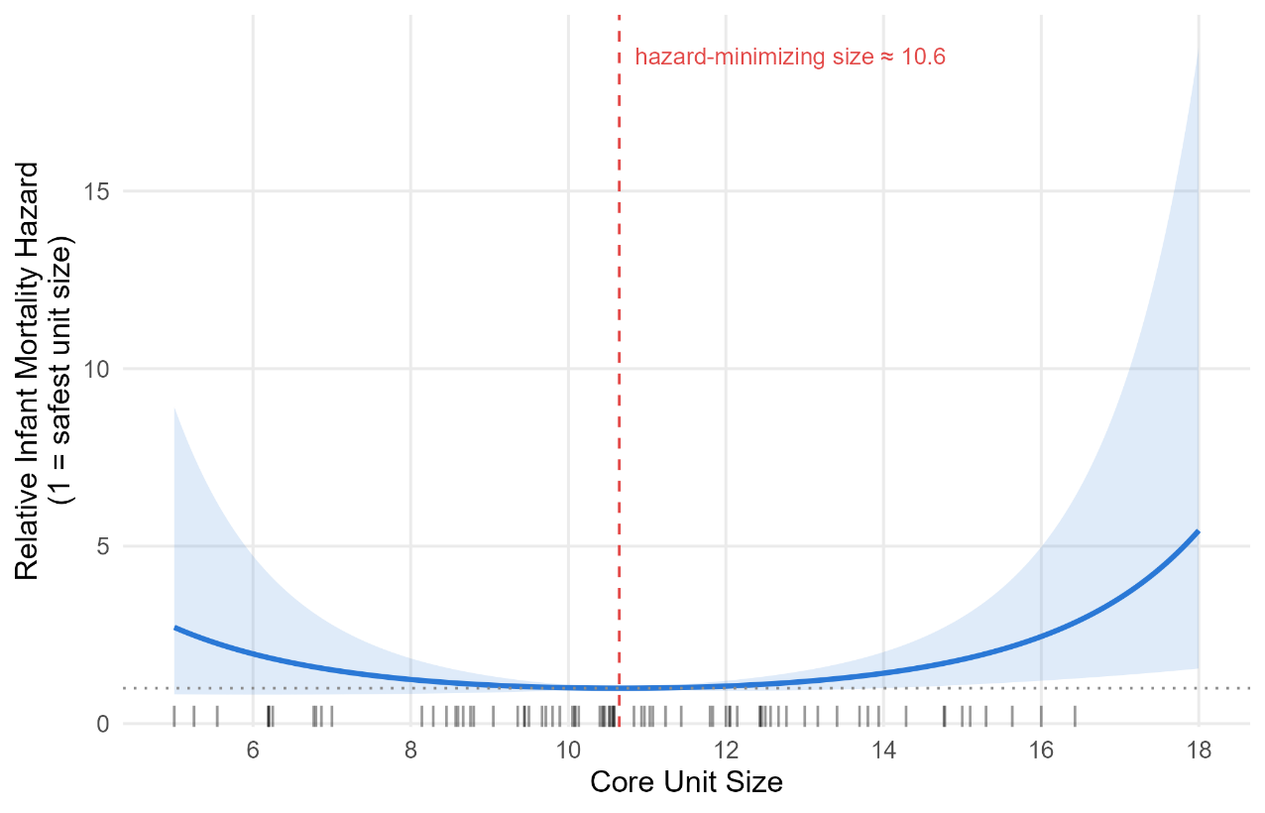
Fig. S1 Infant mortality is U-shaped relative to core unit size for Rwenzori Angolan colobus monkeys (Colobus angolensis ruwenzorii) at Nabugabo, Uganda. Fitted Cox model (size + size\u00b2) with shaded areas showing 95% Confidence Intervals (CI). CI bands are wider at the tails because they are estimated from fewer infants relative to the middle of the distribution. Tick marks show individual infants at their mean core unit sizes.
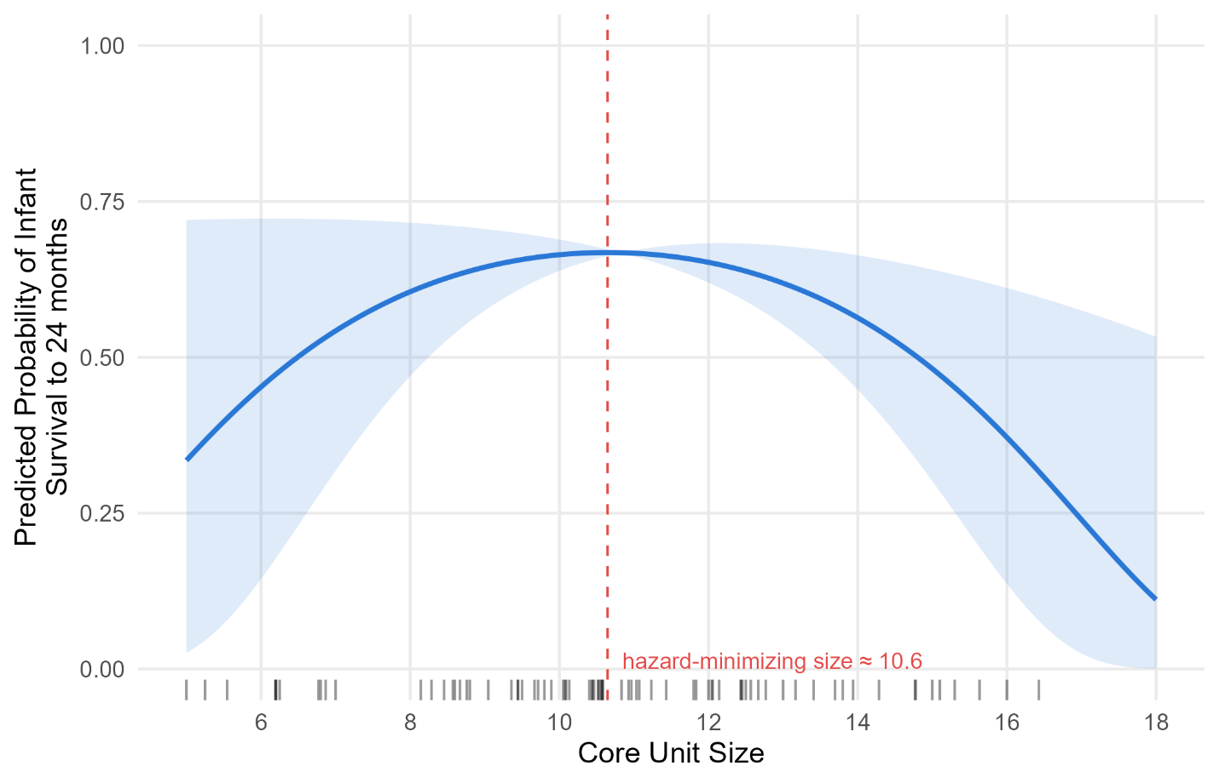
Fig. S2 Quadratic Cox model showing the predicted probability of an infant surviving to 24 months if it experienced a constant core unit size for Rwenzori Angolan colobus monkeys (Colobus angolensis ruwenzorii) at Nabugabo, Uganda. The shaded band shows 95% coefficient uncertainty and is wider at the extremes because estimates are based on fewer infants. Ticks mark show individual infants at their mean core unit size.

Table S1. Number and age-sex composition of individuals in each Rwenzori Angolan colobus (Colobus angolensis ruwenzorii) core unit within TR band at Nabugabo, Uganda as of December 2025
Core Unit | Size | # Adult Males | #  Adult Females | # Subadult Males | # Subadult Females | # Juveniles & Infants
Albizia | 13 | 2 | 4 | 0 | 1 | 6
Brighia | 6 | 2 | 1 | 1 | 1 | 1
Canariam | 9 | 2 | 3 | 1 | 2 | 1
Fagara | 9 | 2 | 2 | 1 | 1 | 3
Funtumia | 7 | 1 | 3 | 0 | 0 | 3
Liana | 15 | 1 | 6 | 0 | 0 | 8
Lovoa | 8 | 2 | 2 | 2 | 0 | 2
Maesopsis | 9 | 2 | 3 | 2 | 1 | 1
Newtonia | 9 | 1 | 4 | 0 | 0 | 4
Pheonix | 7 | 3 | 2 | 0 | 0 | 2
Polysiasis | 9 | 2 | 3 | 1 | 0 | 3
Prunus | 13 | 4 | 3 | 0 | 0 | 6
Pseudospondias | 11 | 3 | 4 | 0 | 1 | 2
Switenia | 11 | 2 | 3 | 2 | 2 | 2
Wilsonia (AMU*) | 5 | 4 | 0 | 0 | 0 | 1
*AMU = All Male Unit

